Web Messenger Configuration

- Login to your Symantec Encryption Management Server (SEMS).
- To make sure Web Email Protection is enabled, browse to “Services” and click on “Enable”.
- Next, browse to “Mail” and under “Mail Policy” click on the “Outbound: Secure Message” Policy Chain.
- Place a check in the box next to the rule labeled “Always Secure With Key Only”.
- In the lower right part of the screen, click on “Options” and select “Toggle Status For Selected”. See Image 1-1 below for a visual aid.
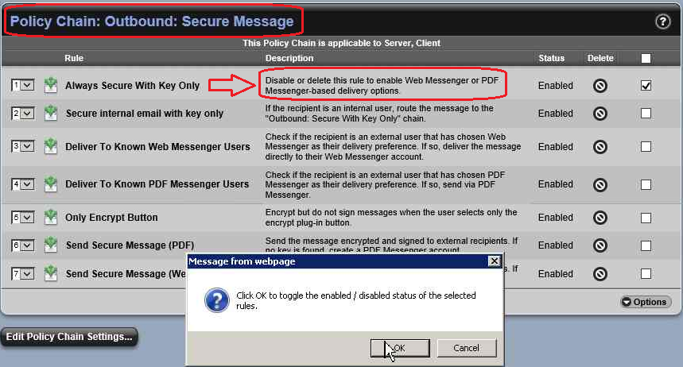
Image 1-1

- Now click on “Mail Policy” to select a different Policy Chain.
- Select the “Outbound: Secure With Key Only” Policy Chain.
- Place a check in the box next to the rule labeled “Send Secure Message”.

- In the lower right part of the screen, click on “Options” and select “Toggle Status For Selected”. See Image 1-2 below for a visual aid.
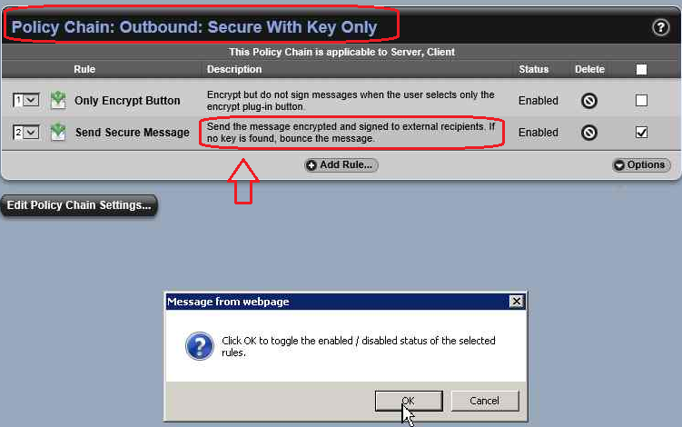
Picture 1-2

- Next, test Web Email Protection by sending an email from an “Internal User” that is part of the Self-Managing Security Architecture (SMSA) to a non-SMSA user. For example, you can send an email to “joeuser@gmail.com”. As long as gmail.com is not a “Managed Domain” in SEMS, and the user does not already exist as an “External User”, SEMS will automatically create a new External User. SEMS will then send an email to the user containing a link to follow so they can browse to a secure site in order to finish setting up their Web Email Protection account.

- In order to verify that the new External User account was created browse to Consumers, click on Users, and then select “External Users”. See Image 1-3 below for a visual aid.

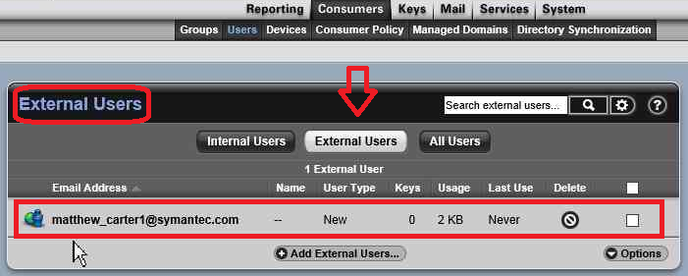
Image 1-3

- To confirm that Mail Policy is working and Web Email Protection is functioning properly, browse to “Reporting” and select “Logs” to review the “Mail” logs. In Image 1-4 below, you can see that policy was applied to this email and SEMS sent the Web Messenger message to “matthew_carter1@symantec.com”.

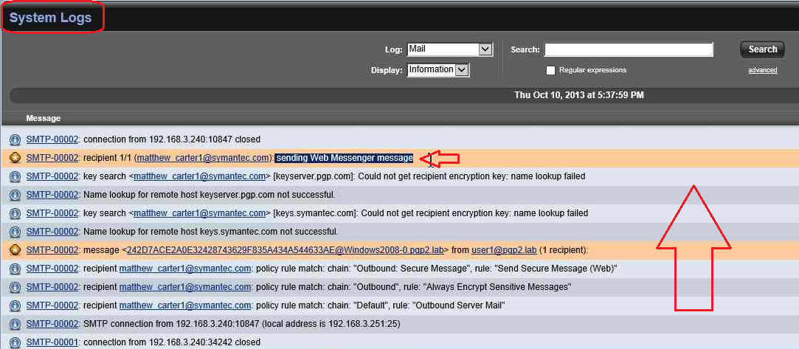
Image 1-4

- You are now finished with configuring Web Email Protection.

Note: There are many different ways to configure Web Email Protection, this method being the easiest. If the customer has any special requirements please consult the SEMS Admin guide as a reference for building a custom Web Email Protection configuration.

