Hi Hagai!
Providing the screenshots for steps 3,4
Example: I have installed and inventory-detected Foxit 9.0.0, Guid is (detected via rightclick->Properties) '6f748a19-48ef-4d41-a8da-b4e53fee926f'
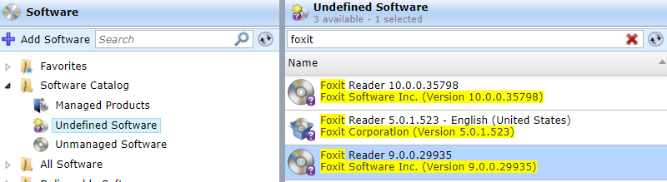

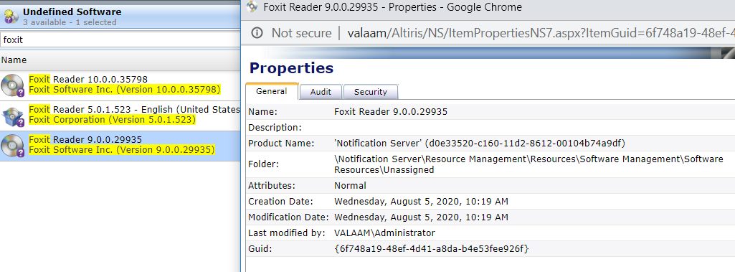

Step 3
* Open SQL Manager and run
select * from Inv_AddRemoveProgram
where _SoftwareComponentGuid = '6f748a19-48ef-4d41-a8da-b4e53fee926f'
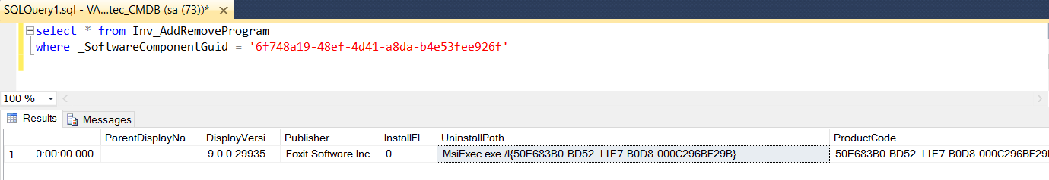
You may have multiple similar rows if software installed on multiple machines
Then copy the ‘UninstallPath’ column value.
Then open Foxit 9.0.0 for edit (doubleclick or rightclick->Actions->edit), go to packages tab and add a commandline for the component.
Make sure you mark the commandline with "Set as Default" and specify “Uninstall” type! Then click OK and once more OK.
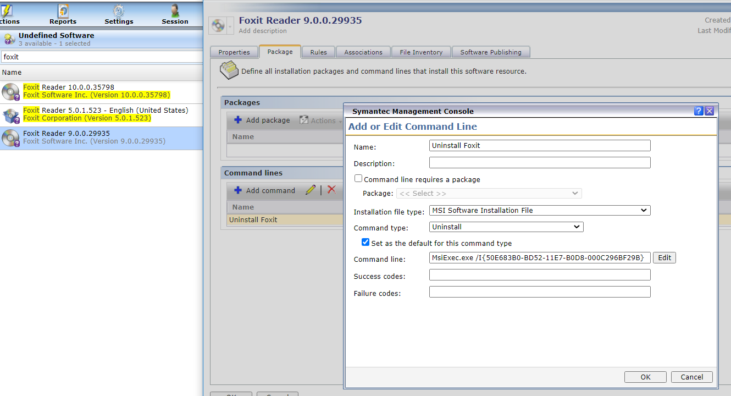
Step 4
Create new Managed Delivery Policy ( there is a wizard way, but here is a shortcut
Go to Manage->Policies->Software->Managed Delivery
Rightclick on Managed Software Delivery folder->New->Managed Software Delivery
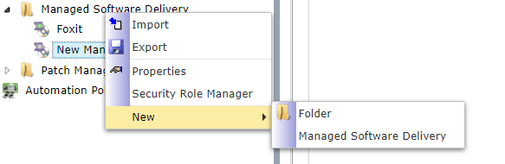

In the policy UI add Foxit 9.0.0 press Add->Software and select Foxit 9.0.0
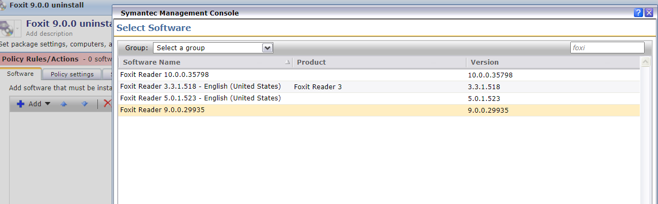
Then select “uninstall’ commandline
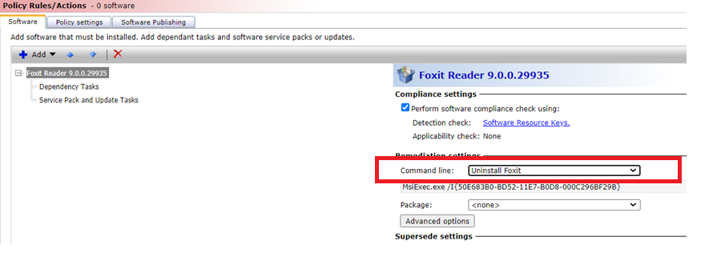

Then target the policy to the NEW! target involving the filter we created in step #2
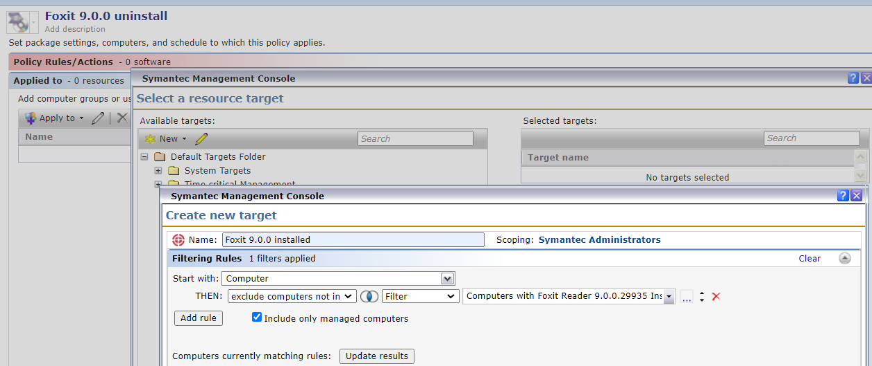

Add recurring schedule (press on “no repeat”) to specify recurrence
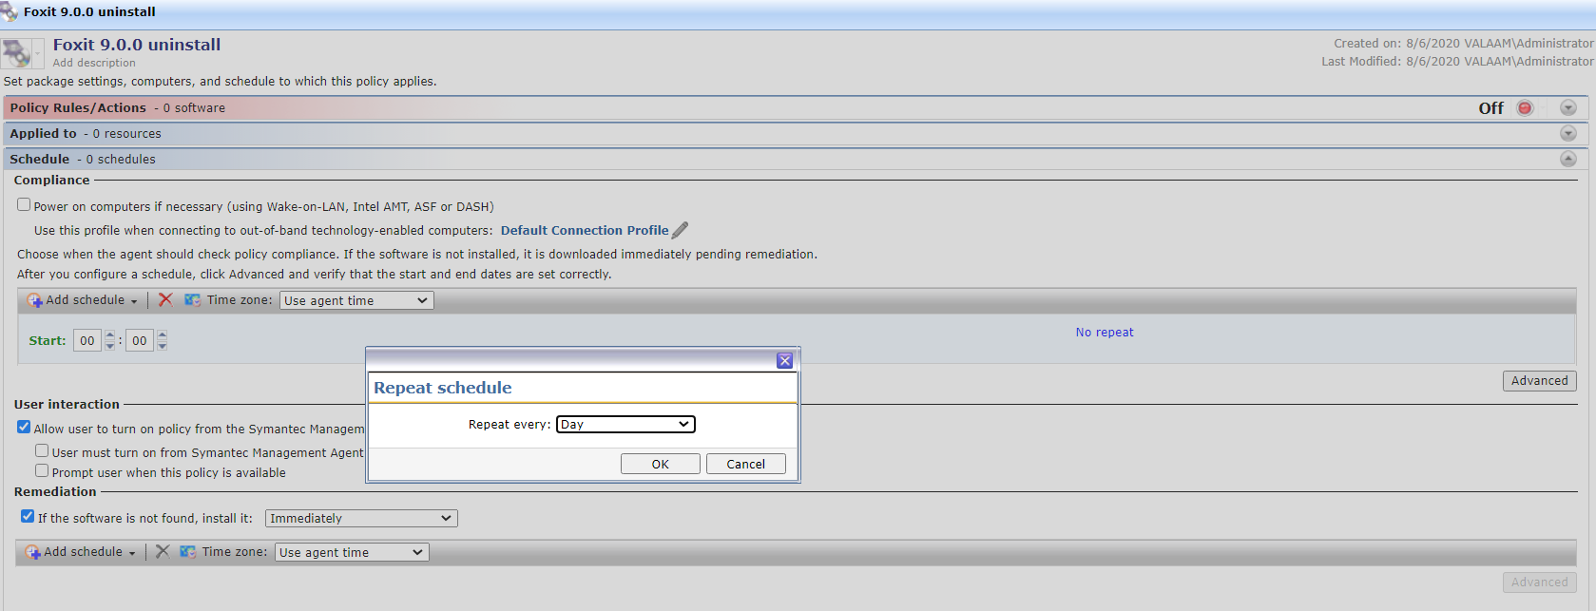
Add one more NON-recurring schedule to make sure the policy executes ASAP as it arrives – in the end you will have 2 schedules
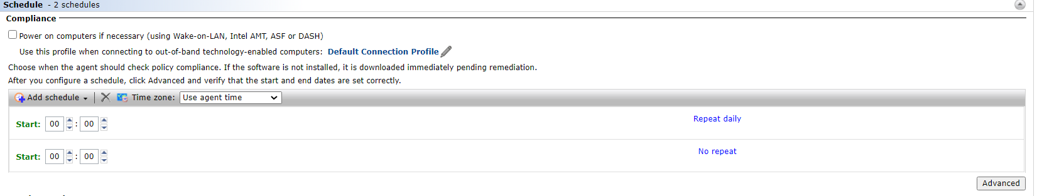

Enable policy and refresh it on any test client (well, it might take 5-10 minutes till it might be refresh and arrive)

I hope that I have not missed anything

