CA SDM 17.2 with PAM 04.3.04 Integración

Hello everyone,
I comment you, that I am working with CA SDM and PAM.
We have already installed and configured the integration of CA EEM, SDM and PAM, without problems.
Currently, we have migrated a process that updates some Duration type fields in CA SDM, through an event that triggers when the ticket is passed to the status Resolved
- Image: Fields in SDM
- Image: Fields in
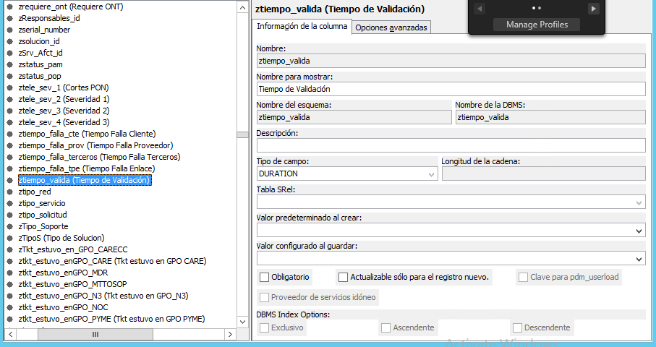

The problem we have is that the process does not show the calculation of the dates we need, even if the process ends successfully.
- Image: Process
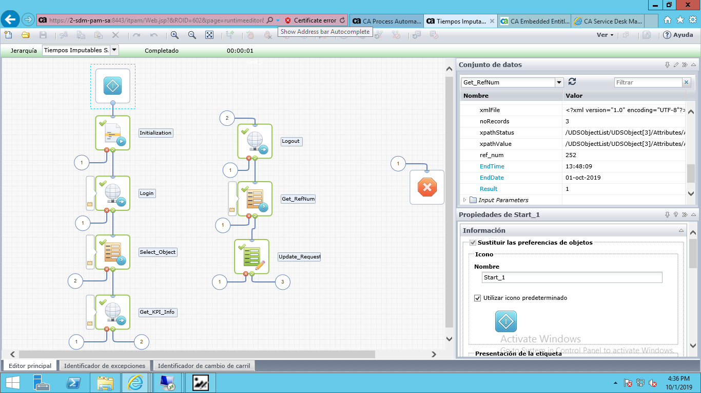

- Image: SDM fields to update
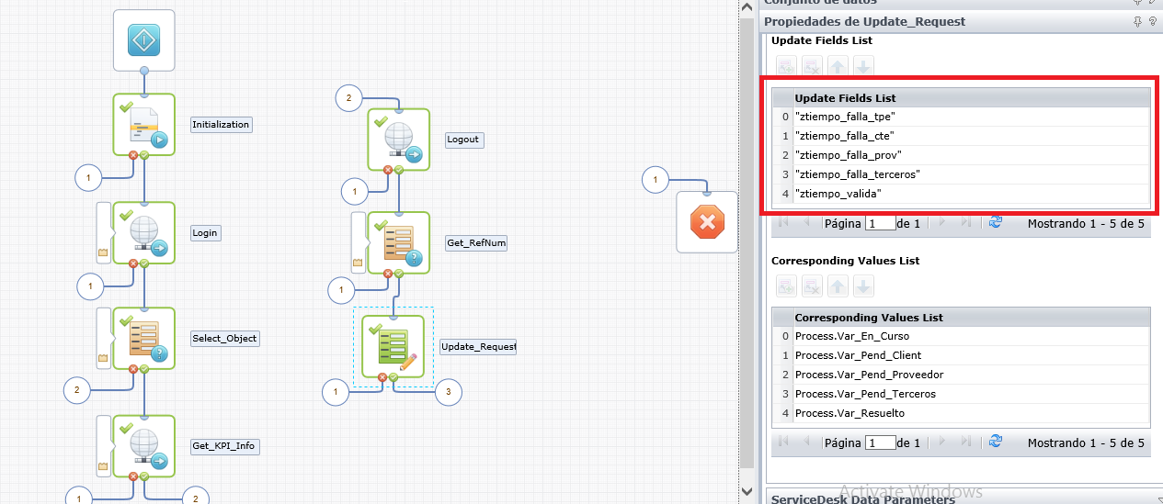

It only shows zeros, when it must show the time it was in each status

