How to upgrade from a Basic User to a Partner User in CA Support Online

Introduction:

During initial registration to CA.com, users are presented with a number of access options to various sites on CA.com. If Basic Access was selected during registration it will provide "Basic User" access to CA.com, CA Communities and limited content on CA Support Online (support.ca.com).
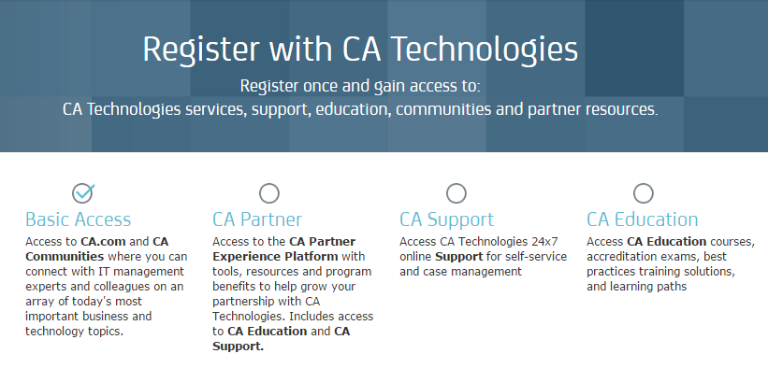

In order for a partner user to access the Partner Experience Portal, the partner user needs to enroll as a CA Partner. When enrolling as a Partner User the partner user will need to know their Partner Account ID. These advanced access requests are reviewed and processed within 24 to 48 hours.

Upgrading your profile to become a Partner User

- Log into CA.com

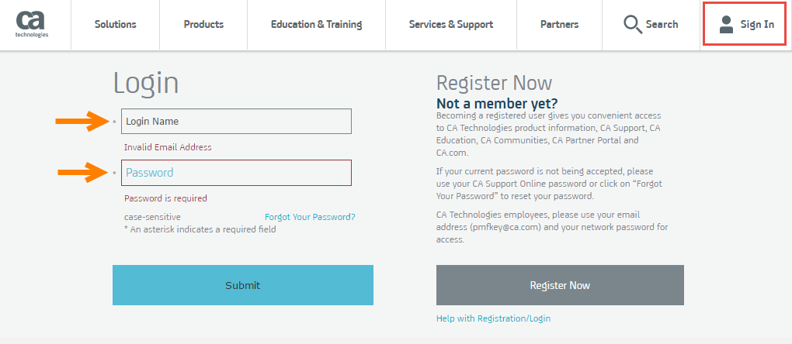

- Select “My Profile” and then “My Profile” from the dropdown as seen below:

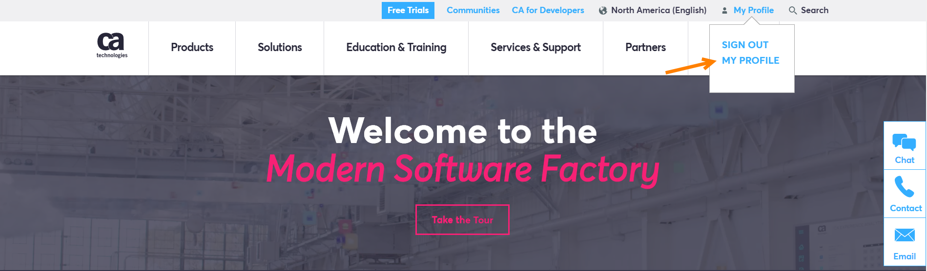

- If your “Company / Location Information” was already provided during registration, “My Profile” will look like below, click on the “CA Partner” tab and go to Step 5:

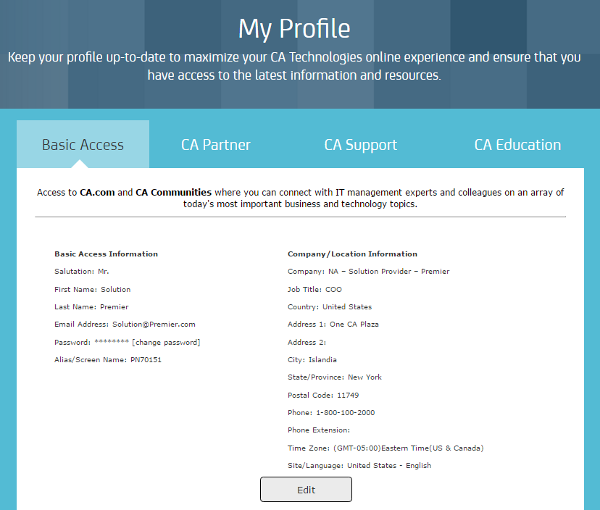

- If your “Company / Location Information” has not yet been provided, “My Profile” will look similar to the below picture. Complete the information on this tab and then click on the “CA Partner” tab.

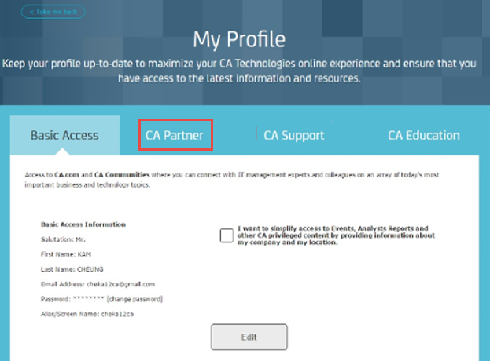

- In order to register as Partner User, please check the "CA Partner" option as below (both "CA Support" and "CA Education" will also be checked automatically).

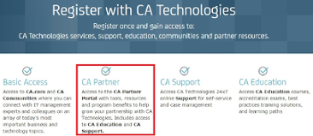

- Complete the "Partner Access Information" for Functional Role and the country of the partner company. Enter the partner company name and click "Account Search" as below:

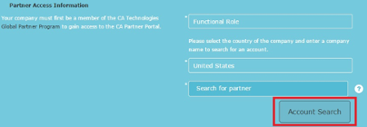

- Select the correct Partner account from the Account Search result as below:

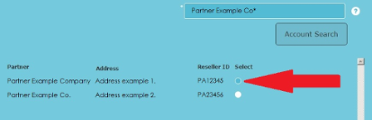

- Click "Register Now" at the bottom of the page to submit the registration request.

- After the request is submitted, user will be presented with the on-screen message as below and the registration request will be sent for processing:

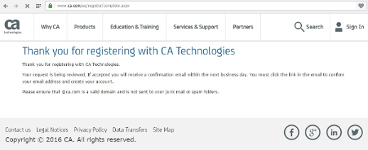

- Once the registration request has been processed, user will receive the Confirmation Email (as below) from CA Info. Remember to check Spam or Junk mail boxes if the Confirmation Email is not in In-box. Complete the registration by clicking on the link in the Confirmation Email or copy the link to a browser:

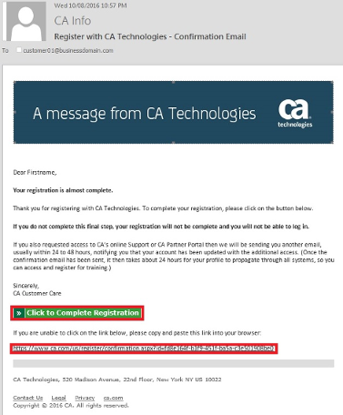

- Once the registration process completed, user will be presented with the below on-screen message:

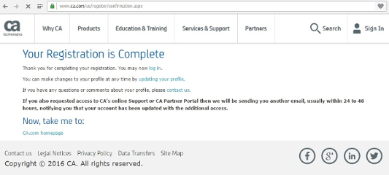

- User are now ready to log into CA.com:

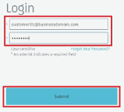

- After logging into CA.com for the first time, user will be presented the "Terms and Conditions" as below. Please review the "Terms and Conditions" using the scroll bar inside the sub view and click "Continue" to acknowledge:

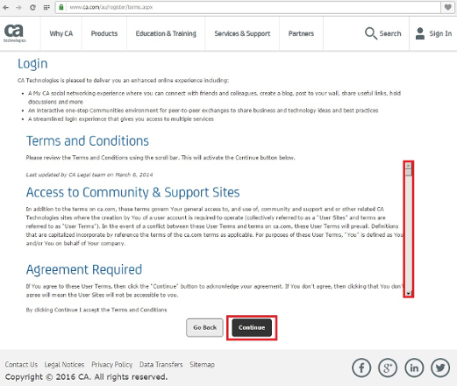

- To review the Partner User Registration status, click "My Profile" under "My Account" as below:

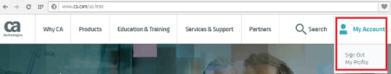

- Click "CA Partner" tab as below:

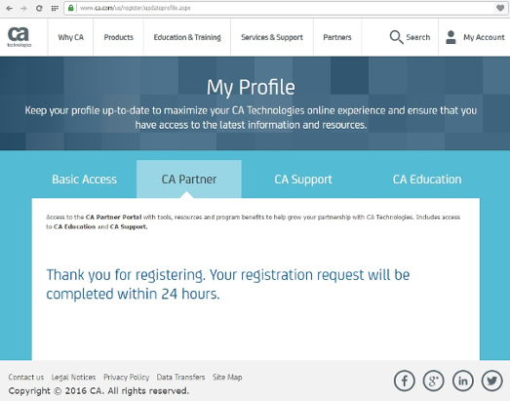

- User should receive the access to Partner Portal within 24 hours, please contact Customer Care team if assistance is needed.

