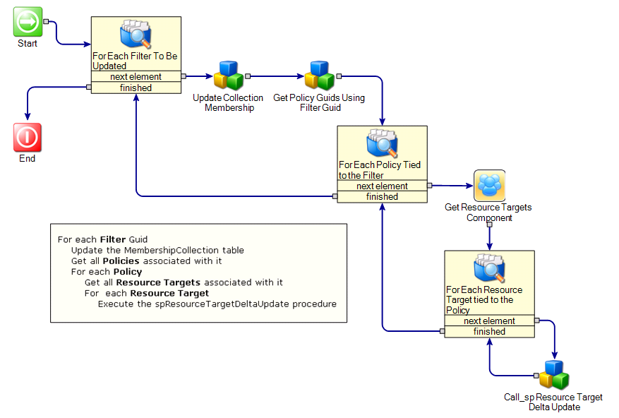

The Update Collection Membership component runs a query that executes the spDeltaUpdateCollection procedure after ensuring its two temporary tables exist. The sql used is :
if object_id('tempdb..#CurrentCollectionEval') is not null drop table #CurrentCollectionEval
create table #CurrentCollectionEval (Guid uniqueidentifier primary key)

if object_id('tempdb..#ModifiedResources') is not null drop table #ModifiedResources
create table #ModifiedResources (Guid uniqueidentifier primary key)

EXECUTE [dbo].[spDeltaUpdateCollection]
@CollectionGuid

The Get Policy Guids Using Filter Guid component executes a query that returns the policy guids associated with a single filter:
Select Distinct vI1.[Guid] as PolicyGuid
From vItem as vI1 WITH (NOLOCK)
Join ItemActive as IA WITH (NOLOCK) On vI1.[Guid] = IA.[Guid] And IA.[Enabled] = 1
Join vPolicyAppliesToResource as vPATR WITH (NOLOCK) On vPATR.PolicyGuid = vI1.[Guid]
Join TargetFilter as TF WITH (NOLOCK) On TF.ResourceTargetGuid = vPATR.ResourceTargetGuid
Join TargetFilterCollection as TFC WITH (NOLOCK) On TFC.TargetFilterGuid = TF.[Guid]
Join vItem as vI2 WITH (NOLOCK) On vI2.[Guid] = TFC.CollectionGuid
And vI2.ClassGuid = 'AECA2D91-C615-4D99-BAD5-612CA159DA4F' -- Filter Class Guid
Where vI2.[Guid] = @FilterGuid
Order by PolicyGuid

The Call_sp Resource Target Delta Update component calls the spResourceTargetDeltaUpdate procedure once for each Resource associated with the Policy being processed.

