Here are few frequently asked questions on Broadcom Case Management:
1. How to create a Support Case?
A Support case can be created either using the Support Portal Case Management or by calling Broadcom Customer Care. To create a case using the Support Portal, please follow these steps.
Note: One must have access to a valid support Site ID.

2. How to create and manage case views?
Users have the ability to create new case views and manage the existing views on Broadcom Support Portal Case Management. Please refer to the Article - How to create and customize Case Views
3. Unable to view my closed cases?
To access all your closed cases, please create a view for closed cases by following these steps.
4. The settings and filter is grayed out on my case view. How do I customize my case view?
The default case view is not editable. To have these options enabled, please create a new case view and then customize the columns.
5. How to update or add comments to an existing case?
Any case can be updated by adding comments to the case using the Support Portal Case Management. The Unified History and comments tab are available at the bottom of the page. A notification will be sent to the assigned engineer with an update.
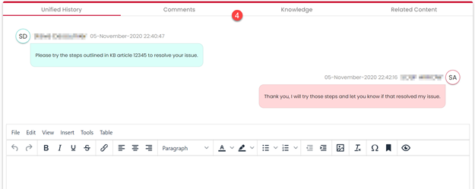
6. How to attach a file and is there any limit to attach a file to a case?
Files can be attached using the file attachment option available within the case on the Support Portal. To upload/attach the files to a case, refer to the article "How to upload files to Case Management
Note: There is no size limit for attaching a file to a case.
7. Can I change the Severity of a case on the Support Portal?
Yes, case severity can be changed in the case management online. To change the severity at the customer portal, please click the pen icon beside the severity field
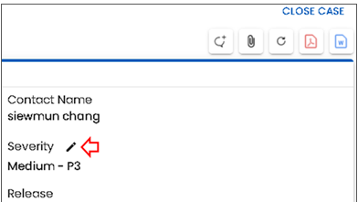

Note: To update the case to a Severity 1, please contact Broadcom Customer Care.
8. How to escalate a Support Case?
If the criticality of your case changes, you can update the severity level of that case through the Broadcom Support portal or by discussing it with the engineer handling your issue.
If you have a concern on whether your service levels are being met, you should engage Broadcom Support management about your need for increased attention, rather than simply changing the severity level, please use the Raise Concern buttonto notify the Support Management (Please Note: This is not to be used for escalating priority to SEVERITY 1).
9. Why am I unable to find a case on the support portal?
There could be multiple reasons why you are unable to see a specific case in Case Management:
Note: Ensure that the email address updated on the case is a registered email address. If not registered, please follow these Registration steps.
1. One's email address must be added to the case contact to view this case under the "My cases" tab on the Support Portal Case Management.
2. If you are trying to view the case opened by your colleagues, please click on the "All Cases" tab next to the My Cases tab.
3. Make sure the case views and filters have been set correctly depending on the status of the case.
10. Where can I find the case Timeline on the case management?
Case Timeline can be viewed under the Unified History tab within the case.
11. Can I add an alternate contact to be copied for communications on a case?
Yes, up to three email addresses can be added as alternate emails to a case. For more details, please refer to the Article "Alternate Contact"
12. Can I reopen a closed case on the support portal?
No, there is no option to reopen a closed case. We suggest that you create a new case with reference to the old case number.
13. Can I close a case on the Support Portal Case Management?
Yes, case closure can be requested online on Case Management. Please refer to the article "How to request case closure"
Note: This will not close the case, instead, it will send a notification to the Broadcom support engineer to review and close the case.
14. How can I update my phone number on the Support Portal Case Management?
Unfortunately, there's no option to update Phone number on the Case Management page under the Manage Your Profile tab.
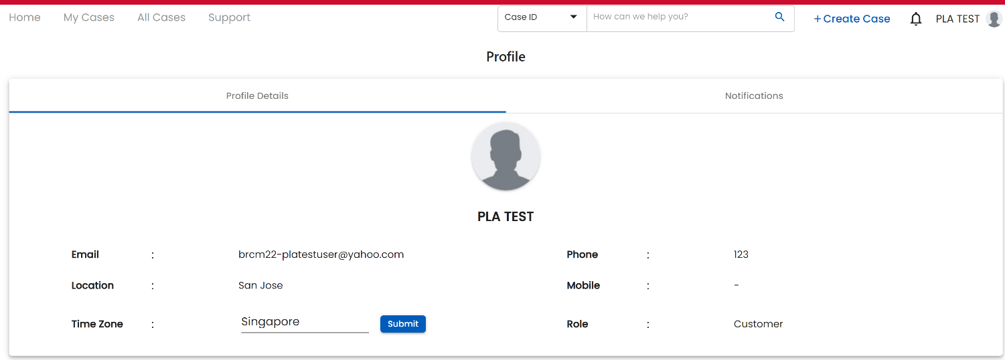
However, you can login to the Support Portal main page at support.broadcom.com/user , go to My Profile under your Login Name drop down, click the Edit button and Update the details, so that the data will get updated on the Case Management Profile page as well.
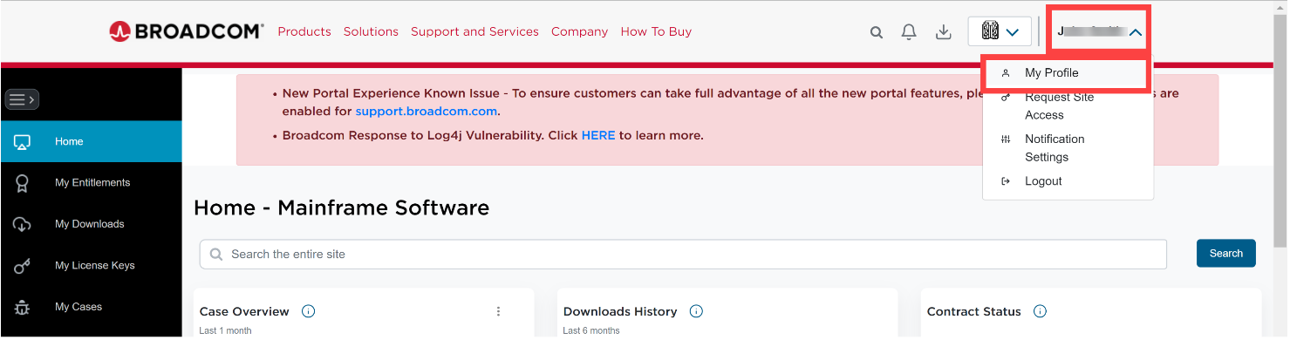
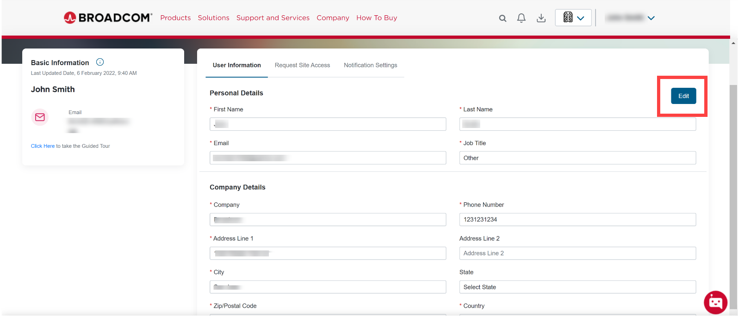
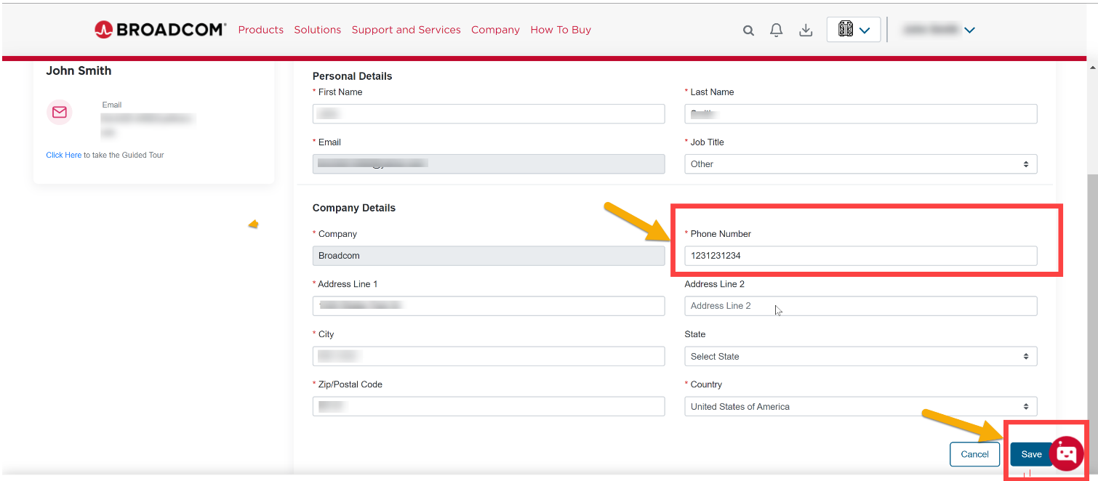

If you need help with any assistance, please contact a Broadcom Customer Care Representative by using the chatbot available on the support portal.

