- Go to Start menu -> All Programs -> Business Objects XI 3.1 -> BusinessObjects Enterprise -> Import Wizard
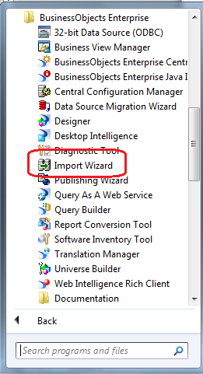

- Select the language and click Next
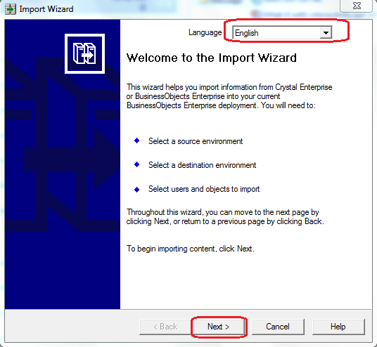

- In the Source Environment screen, From the Source drop down select Business Intelligence Archive Resource (BIAR) File
Then browse to select the BIAR file location
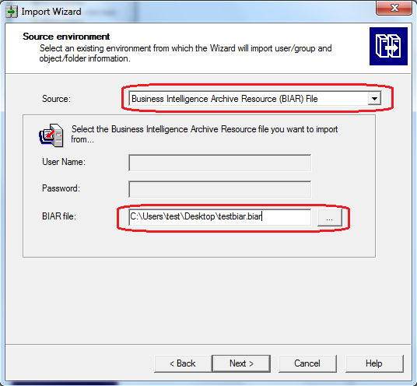

- In the Destination Environment screen, enter the details of the CABI system, where BIAR file needs to be deployed, Then click Next
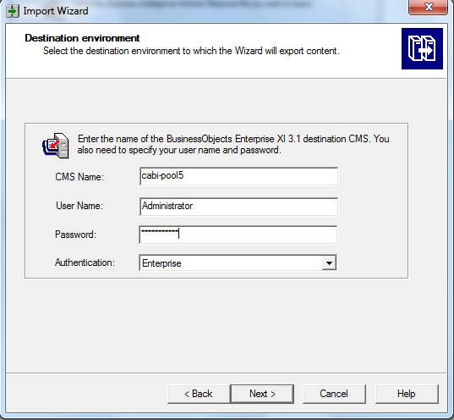

- Once BIAR file is loaded, Select Object to Import will appear. Click on Clear All
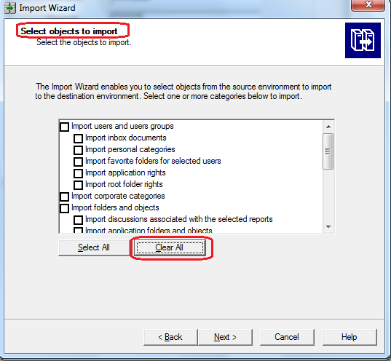

- Now select following checkboxes only
- Import application rights
- Import root folder rights
- Import application folders and objects
- Import Universes
Click Next
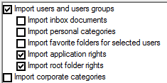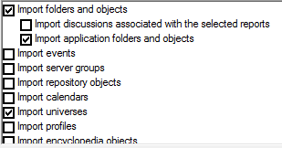

- On the next screen Import Scenario, select the 1st option “Update the destination object. In case of name conflict, rename it.” Then click Next
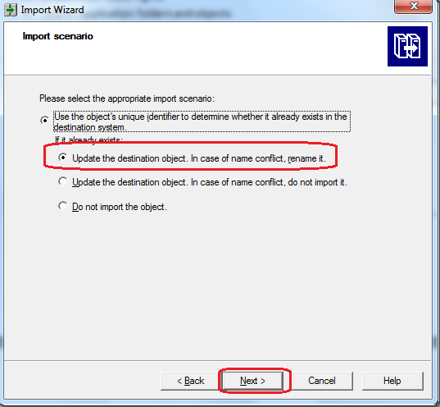

- On the next screen, Incremental import, select all the checkboxes like below and click Next
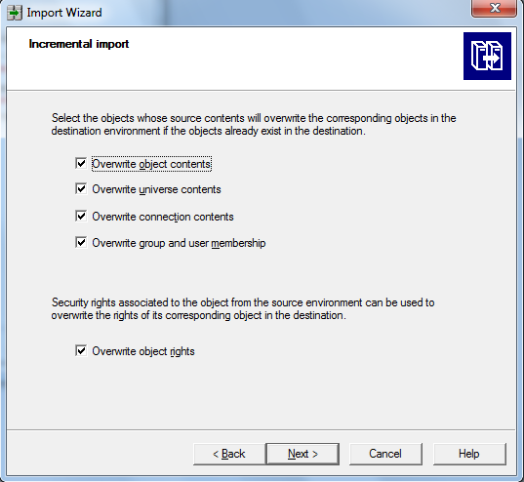

- On Users and groups screen, select the SAM Reports user group. Click Next
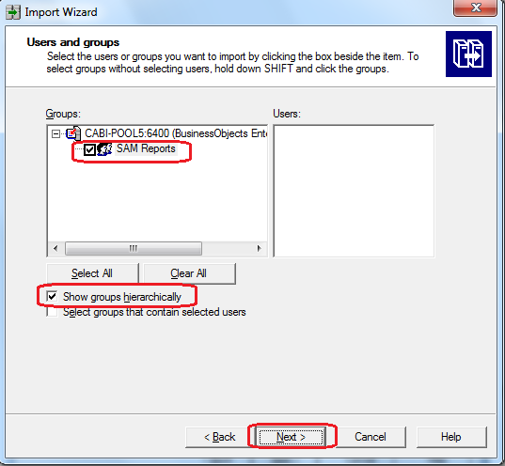

- On Folders and Objects screen, expand the CA Reports folder and select the CA Service Operations Insight folder. This should mark all the reports inside that folder. Click Next
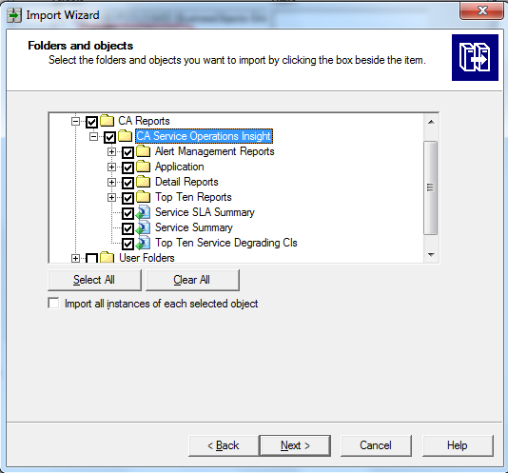

- On Select application folders and objects screen, do not select anything and click Next
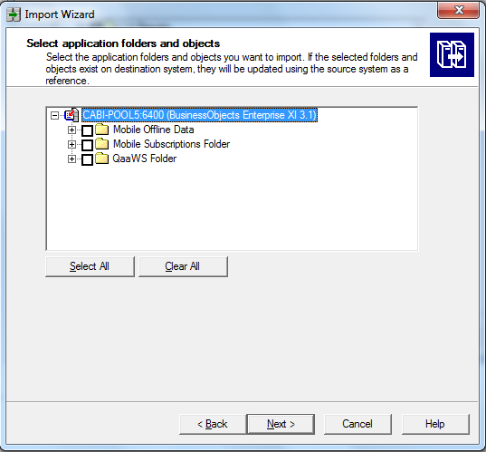

- On Import options for universes and connections screen, select the 3rd option as highlighted below. Also uncheck the “Keep universe overloads for imported users and groups” option
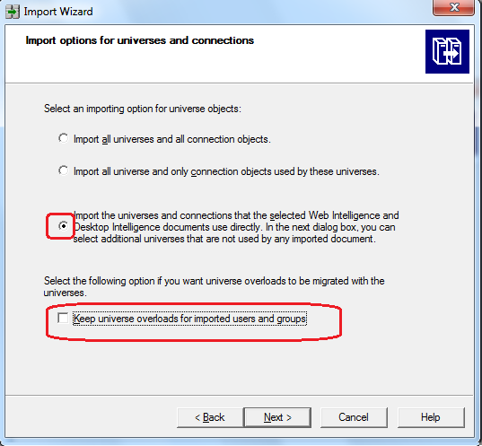

- On the Universe folder and universes screen, expand CA Universes and the expand CA SAM to check whether CA_SAM universe is selected or not. Click Next
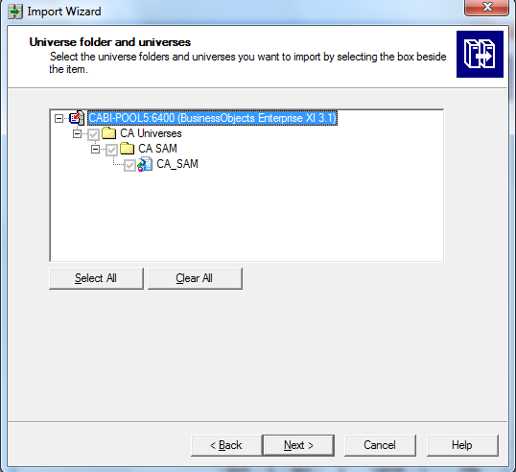

- On Import options for publications screen, select “Do not import recipients” then click Next
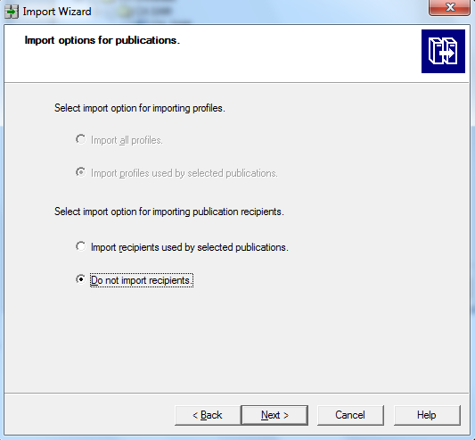

- Click Next on this screen
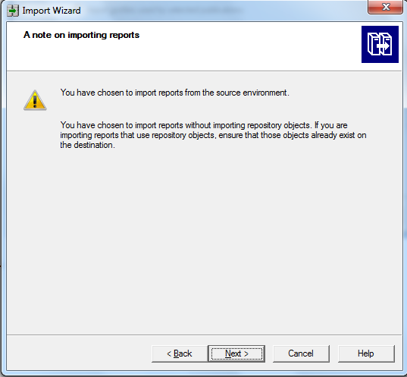

- Click Finish on below screen to complete the process
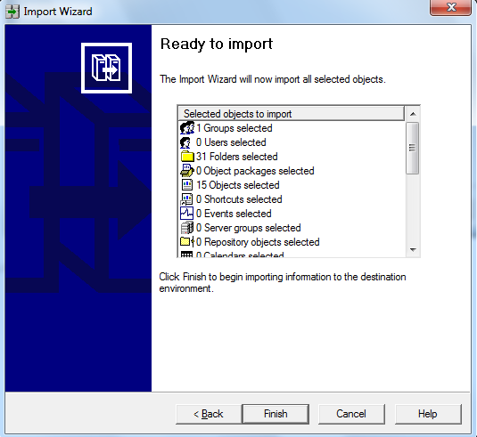

- Once the import process is complete, click Done or check the logs for errors
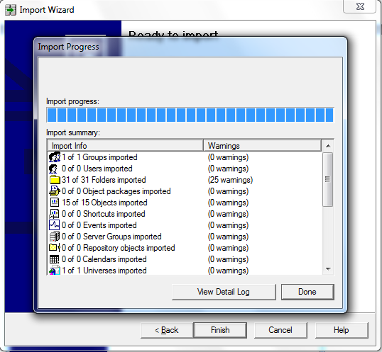

Updating the Connection Details

- Go to Start menu -> All Programs -> Business Objects XI 3.1 -> BusinessObjects Enterprise -> Designer
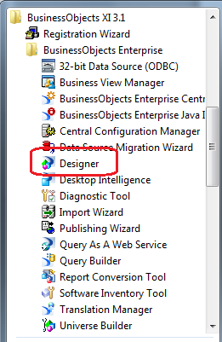

- On the Log In screen, use the CABI administrator to log in
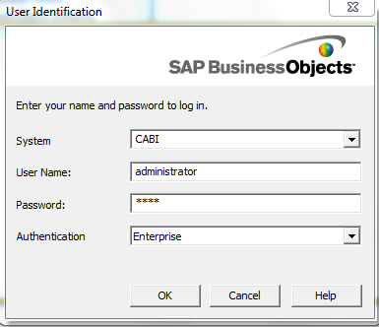

- Click Cancel on the next welcome screen
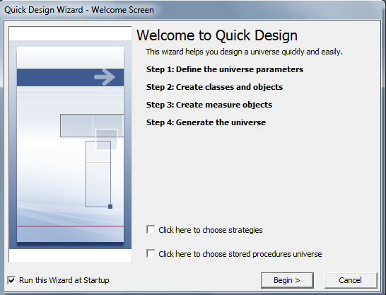

- Go to File -> Import, then on the Import Universe screen click on Browse to select SOI universe under CA Universes->CA SAM. Click Ok.
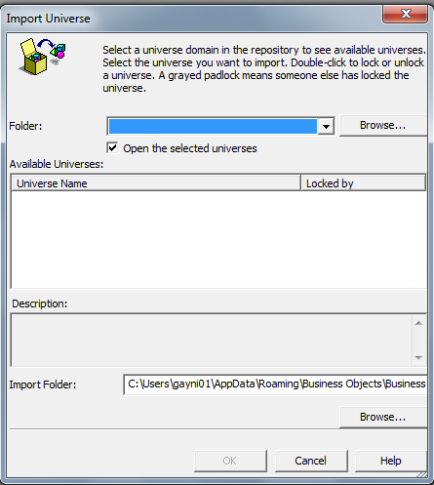
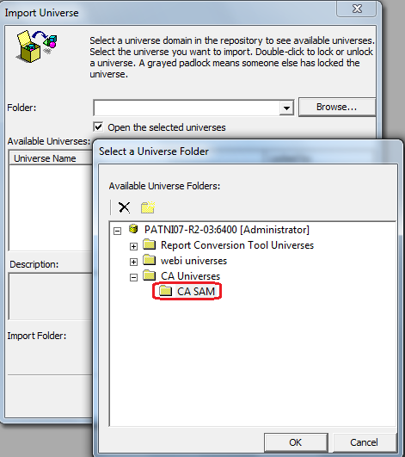
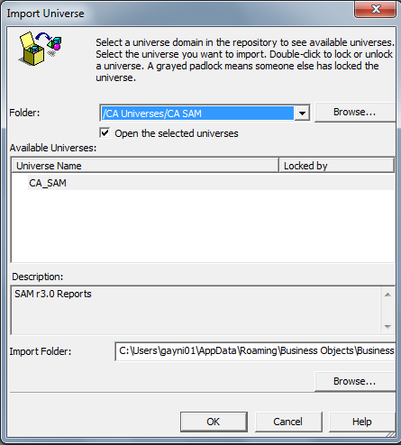
- Once the universe is imported, Go to File -> Parameters, this should open up Universe Parameters window
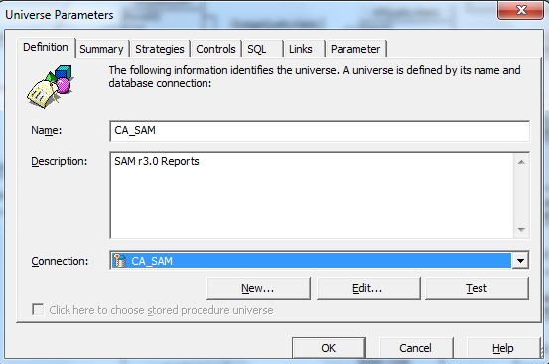

- Click on the Edit button
- If you get Warning like below click on Yes
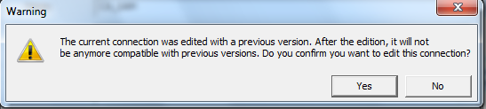

- Now you should get a Edit CA_SAM connection window, Click on Back
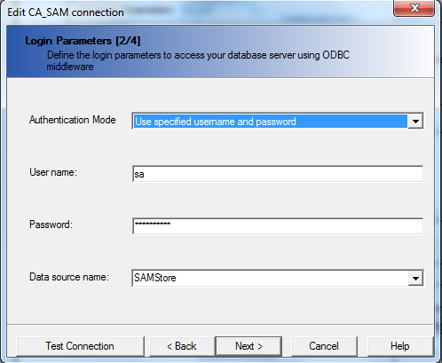

- Select the appropriate drivers for the connection and click Next
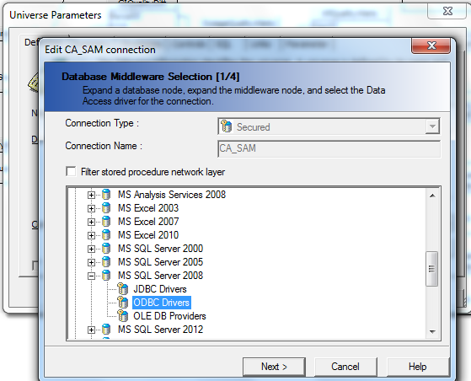

- Provide the Database username and password and also the data source name (in case of ODBC, provide DSN name) Click Next
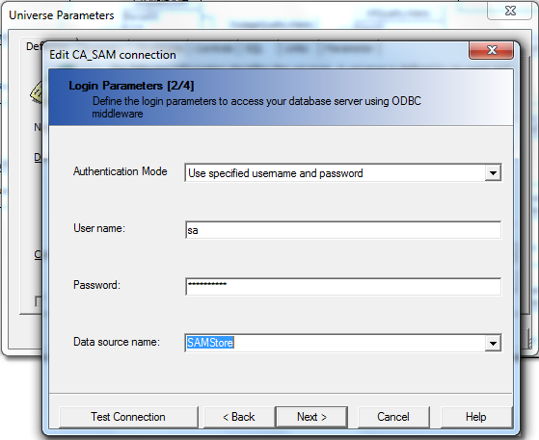

- Make sure that next screen has some appropriate values and then click Next
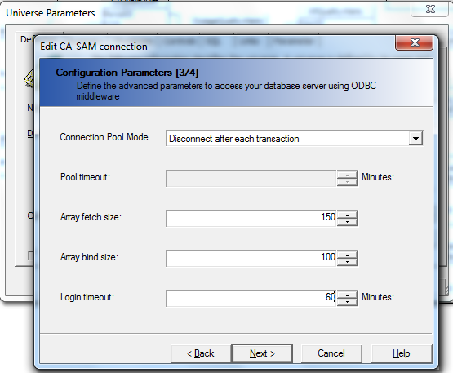

- Now click on Finish on the next screen
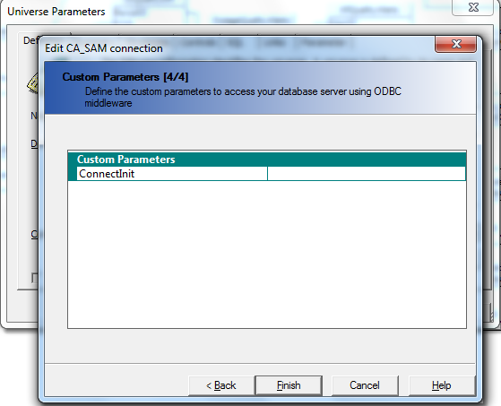

- To verify click on the Test and if connection is responding then click Ok
- Now go to File -> Save
- Now go to File -> Export , this should open up a Export Universe window
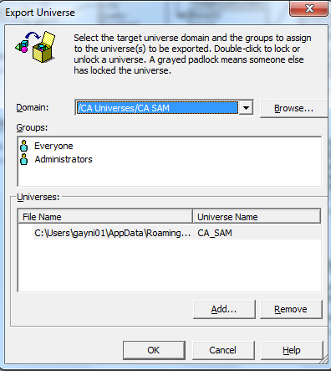

- Click Ok
- Now the universe is exported and connection details are updated, you can close the Designer.

