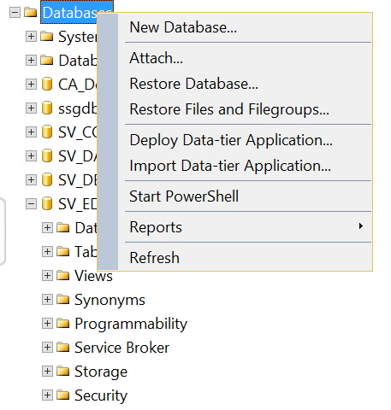
Should I need to use the above option to create 3 DB’s and use the same in the connection string for ED, IAM and Registry for table creation?

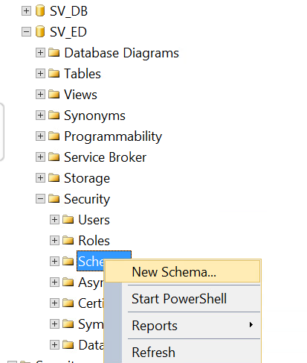

Should I need to create three schema’s under a DB? If so, how can I refer the specific schema under the DB in the connection string so that DevTest can create the tables accordingly?

