Setting up IIS 8.0 with support for ASP.NET 3.5 and ASP.NET 4.5
In Windows Server 2012, both the .NET Framework 3.5 and .NET Framework 4.5 are natively recognized by the operating system. This means both UI-based and command-line driven setup can be used to turn on both versions of the .NET Framework, as well as enabling integration of both versions of ASP.NET with IIS 8.0.
For this walkthrough we will use the new Server Manager UI in Windows Server 2012 Server to demonstrate enabling both ASP.NET 3.5 and ASP.NET 4.5 on IIS 8.0.
- When you first login to a new Windows Server 2012 machine, the new Server Manager UI will display. Click add roles as shown below:
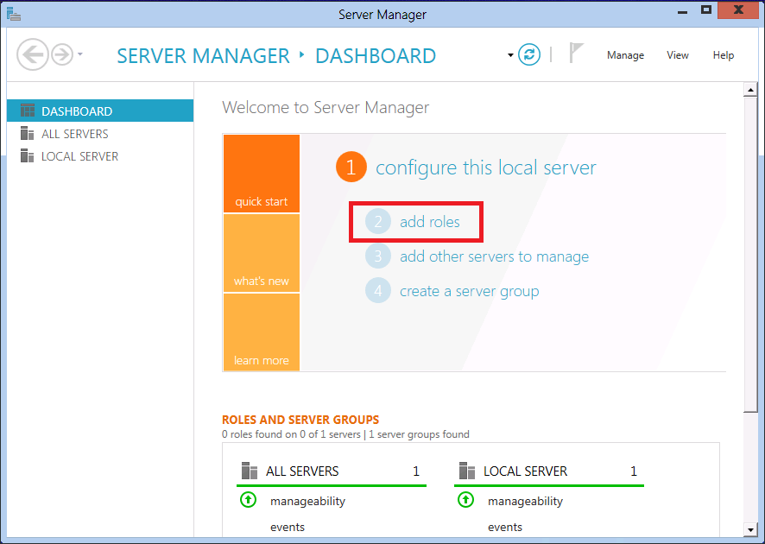
- On the first screen of Add Roles and Features Wizard, click Next. This display a page where you select the desired installation type. Choose either Role-based or Feature-based installation as shown below:
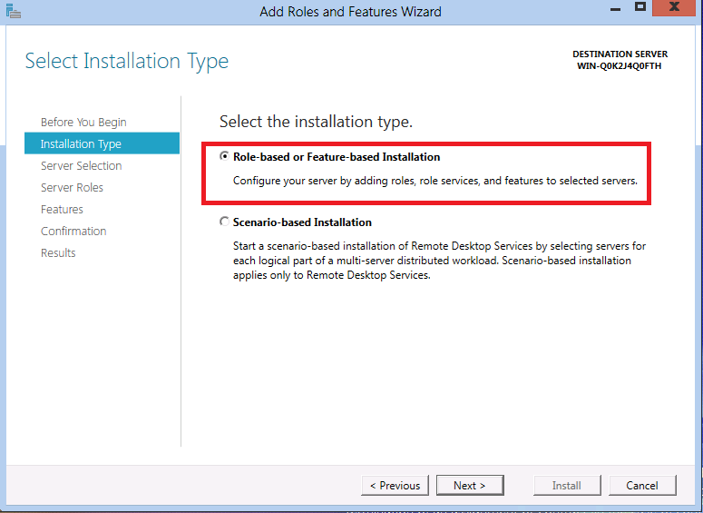
- Click Next. The next screen of the wizard asks you to choose the server that you are configuring.
- On the next wizard step you will be asked to select one or more server roles. Scroll down in the Roles list, and make sure to check the Web Server (IIS) checkbox as shown below:
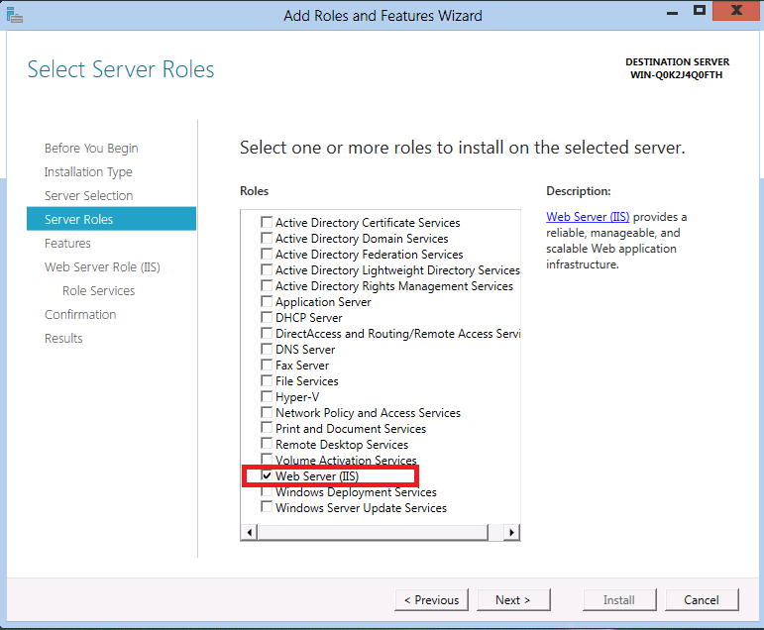
- Click Next to proceed to the next step, which enables you to select additional specific features to install on the server. Click Next again and proceed to the next step.
- The next wizard step displays some introductory information about the Web Server (IIS) role. Click Next again and proceed to the next step. Now you should be at a wizard step that looks like the following:
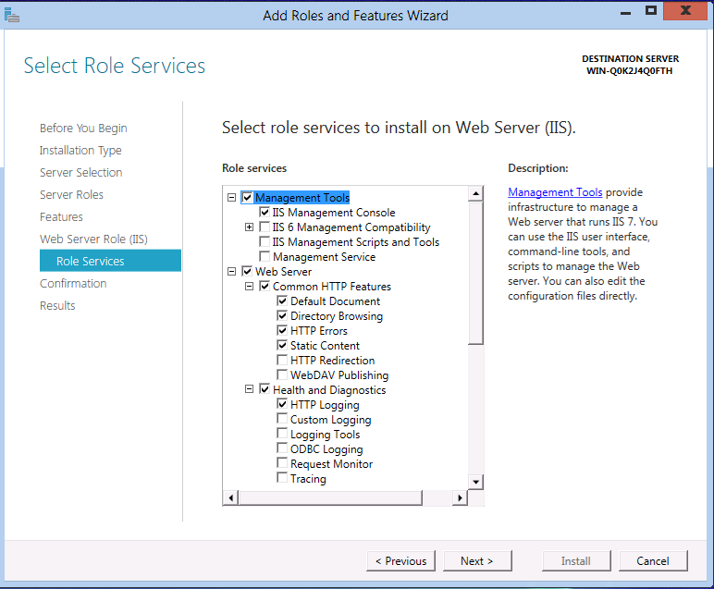
- Note that a number of default sub-features for IIS have already been turned on because you selected the Web Server (IIS) server role earlier. However we want to enable both ASP.NET 3.5 and ASP.NET 4.5 to run on IIS 8.0, so we need to enable some additional IIS related features. Scroll down in the Role services list until the Application Development node is showing. This node is collapsed initially, click on the node and expand it so that its children are showing:
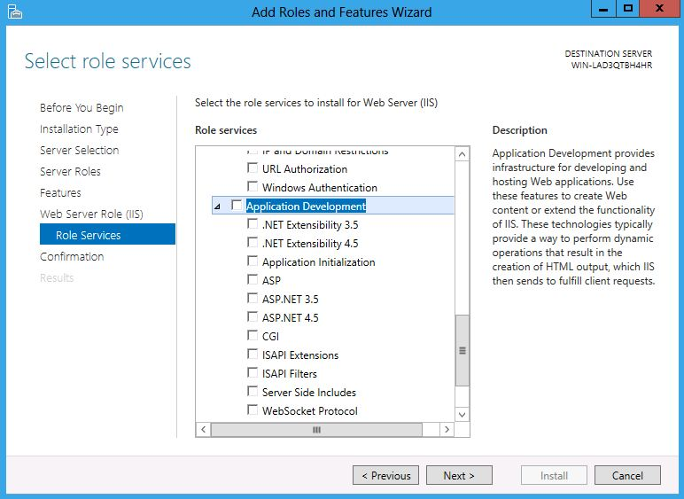
- The Application Development node is where we enable ASP.NET integration with IIS. Note that there are a few checkboxes in the feature list with similar names. The pair of checkboxes that are of interest for this walkthrough are:
  - ASP.NET 3.5 - This option enables ASP.NET 3.5 to run on IIS 8.0. Note that with Windows Server 2012, .NET Framework 3.5 is not available as a part of the base OS image. Instead, the payload is downloaded from the Internet and you need to connect to the Internet.
  - ASP.NET 4.5 - This option enables ASP.NET 4.5 to run on IIS 8.0.
- First click the ASP.NET 3.5 check box. When you do so an additional dialog box will popup as shown below:
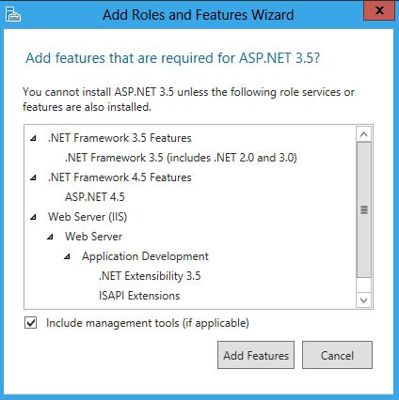
- Since ASP.NET 3.5 is integrated into the Windows Server 2012 setup, Windows Server 2012 knows all of the related dependencies necessary to enable ASP.NET 3.5 on IIS 8.0. This popup dialog is just showing you what will be automatically pulled in and installed. Since we do want ASP.NET 3.5 enabled, click Add Required Features.
- Next, click the ASP.NET 4.5 check box in the Role services feature list. The end result of clicking both ASP.NET related checkboxes is shown below:
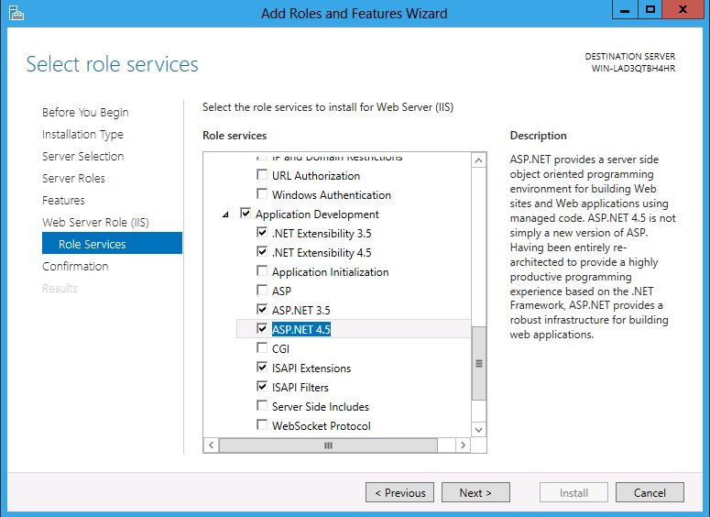
- Even though you only directly selected the ASP.NET 3.5 and ASP.NET 4.5 features, the wizard automatically turned on a number of other items. This is done automatically so that developers do not have to explicitly choose the various component pieces needed to "assembly" of ASP.NET on Windows Server 2012. At this point click Next to accept the changes.
- The Confirm installation selections step displays a list of all of features that are installed if you accept the changes.
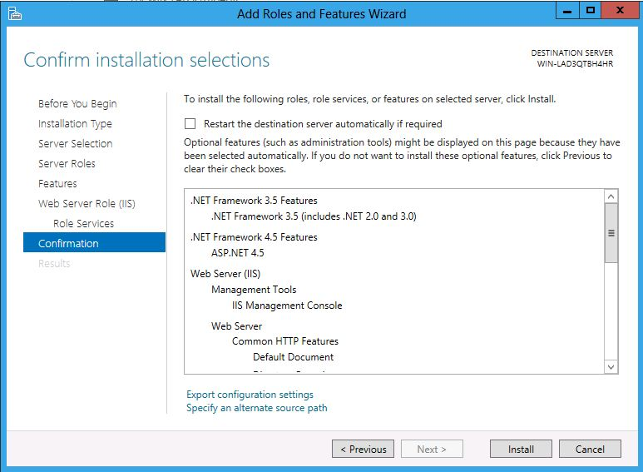
- At this point, click Install to accept the changes and install full ASP.NET support on Windows Server 2012.
- Since the installation will take a small amount of time to complete, the wizard displays a progress dialog while the installation progresses:
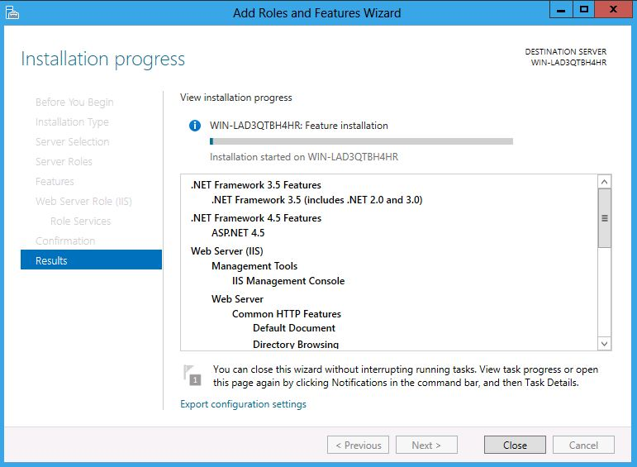
- After a few minutes the wizard shows that the installation has completed:
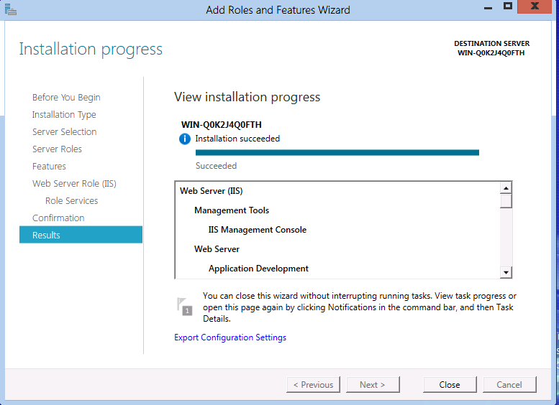
- At this point, you can click Close and exit the wizard.

