I have a FOREACH workflow that consists of two objects and uses a VARA table.

VARA.DPA.HYLAND.FILES.BIWKLY.MED - a list of file names and path statements
JOBS.DPA.OSC.HYLAND.FILES.MED – Sets parameters
Attribute Deactivate on Finish = Always
JOBF.DPA.OSC.HYLAND.MED – Moves files based on parameters
Attrributes Deactivate on Finish = Always

FOREACH
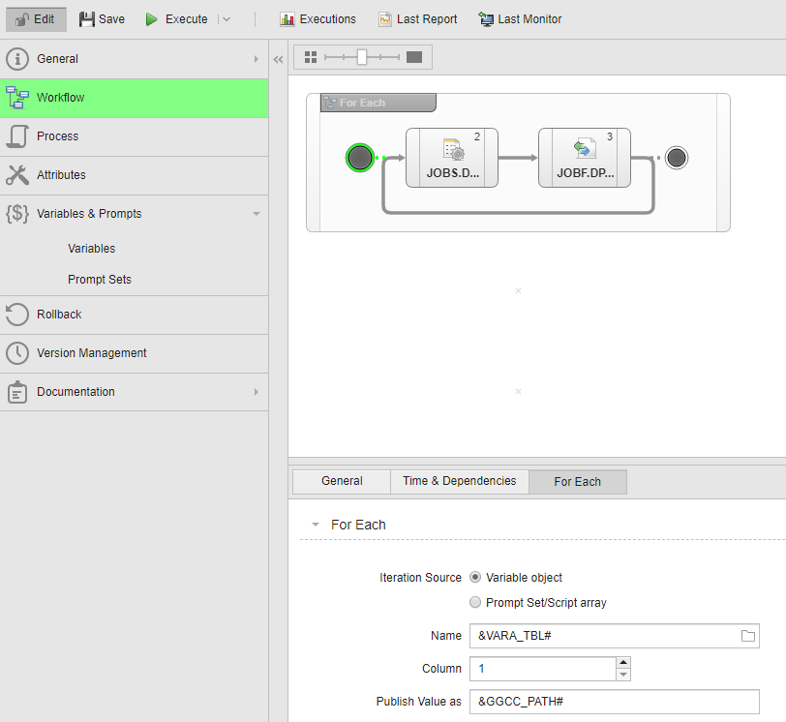
Task properties JOBS.DPA.OSC.HYLAND.FILES.MED
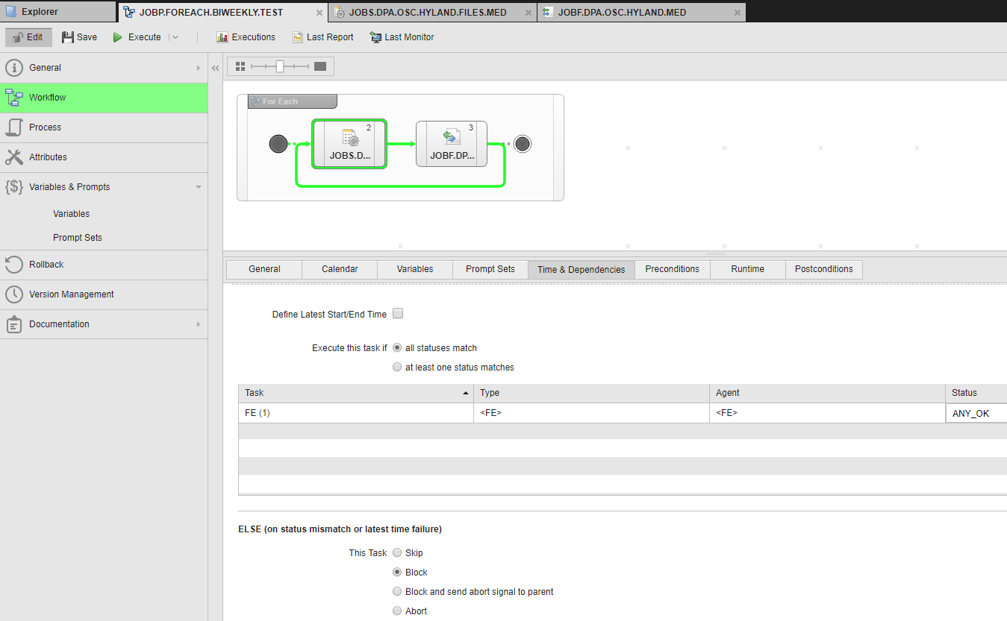

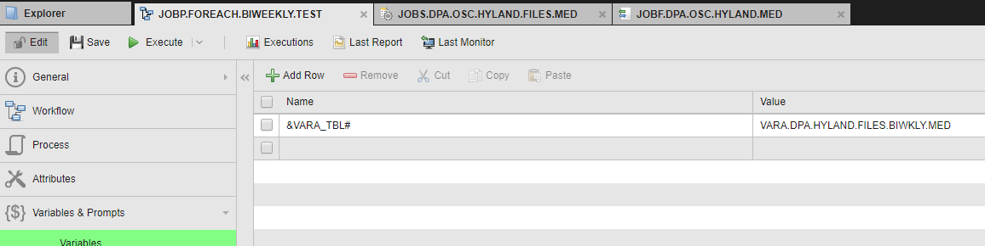
JOBS.DPA.OSC.HYLAND.FILES.MED
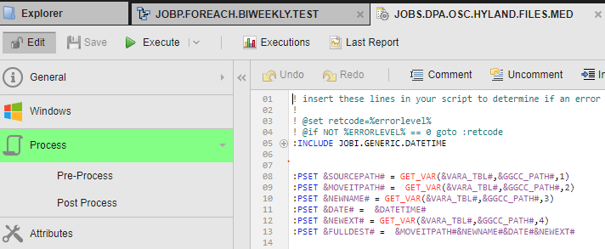

Task properties JOBF.DPA.OSC.HYLAND.MED 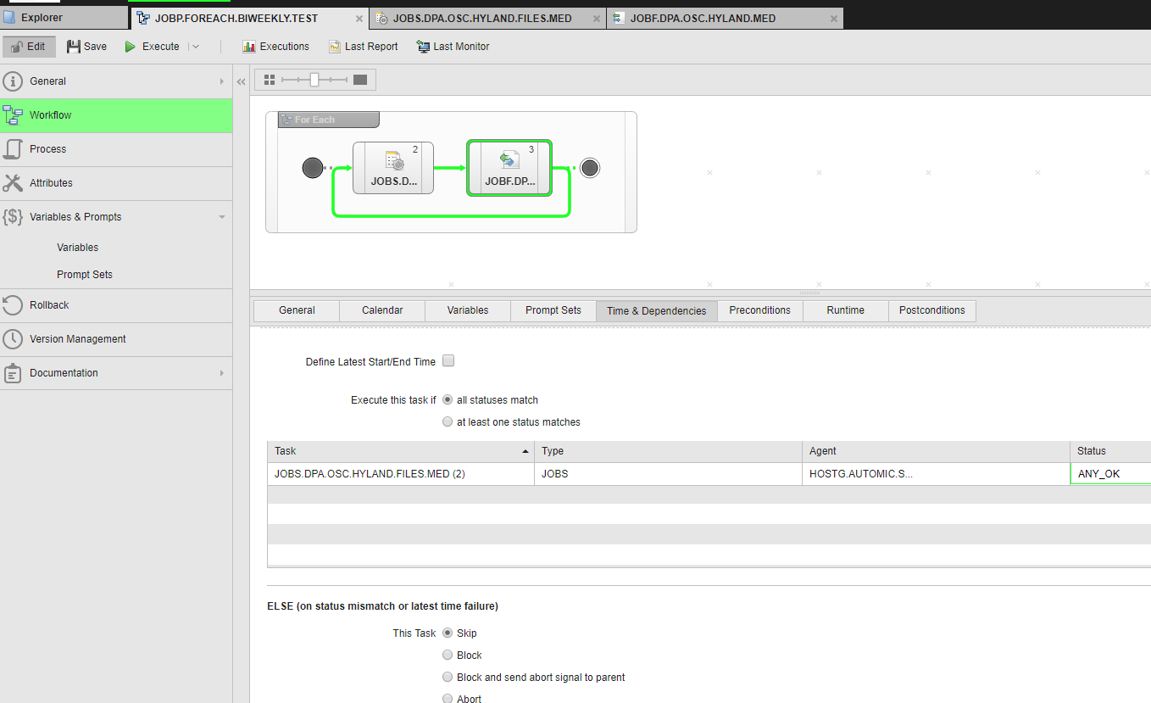

JOBP.FOREACH.BIWEEKLY.TEST | JOBP | 4463969 |  | ENDED_OK - ended normally
JOBF.DPA.OSC.HYLAND.MED | JOBF | 4466003 | 4463969 | ENDED_NOT_OK - aborted
JOBS.DPA.OSC.HYLAND.FILES.MED | JOBS | 4466002 | 4463969 | ENDED_OK - ended normally
JOBF.DPA.OSC.HYLAND.MED | JOBF | 4464000 | 4463969 | ENDED_NOT_OK - aborted
JOBS.DPA.OSC.HYLAND.FILES.MED | JOBS | 4463999 | 4463969 | ENDED_OK - ended normally
JOBS.DPA.OSC.HYLAND.FILES.MED | JOBS | 4463996 | 4463969 | ENDED_OK - ended normally
JOBF.DPA.OSC.HYLAND.MED | JOBF | 4463997 | 4463969 | ENDED_NOT_OK - aborted
JOBF.DPA.OSC.HYLAND.MED | JOBF | 4463994 | 4463969 | ENDED_NOT_OK - aborted
JOBS.DPA.OSC.HYLAND.FILES.MED | JOBS | 4463993 | 4463969 | ENDED_OK - ended normally
JOBF.DPA.OSC.HYLAND.MED | JOBF | 4463991 | 4463969 | ENDED_NOT_OK - aborted
JOBS.DPA.OSC.HYLAND.FILES.MED | JOBS | 4463990 | 4463969 | ENDED_OK - ended normally

In the FOREACH it runs the HYLAND.FILES.MED task and gets a new parameter. The file movement task, HYLAND.MED, does not find a file and the task ends ENDED_NOT_OK – aborted. There will not always be a file so this behavior is OK.

My problem is that the ENDED_NOT_OK – aborted tasks to not deactivate. My operations team says that the messages clog up their activity window and they have to manually deactivate them.

My solution was to add a precondition to the HYLAND.MED task to see if a file exists, if not skip the task else run the task. This works fine for the first variable in the table but gets stuck on the second variable.

JOBP.FOREACH.BIWEEKLY.TEST | JOBP | 4463960 |  | ENDED_CANCEL - manually canceled
JOBS.DPA.OSC.HYLAND.FILES.MED | JOBS | 4463963 | 4463960 | ENDED_OK - ended normally
JOBF.DPA.OSC.HYLAND.MED | JOBF | 4463964 | 4463960 | ENDED_JP_CANCEL - Workflow canceled manually.
JOBS.DPA.OSC.HYLAND.FILES.MED | JOBS | 4463961 | 4463960 | ENDED_OK - ended normally
JOBF.DPA.OSC.HYLAND.MED | JOBF | 4463962 | 4463960 | ENDED_SKIPPED - Skipped because of conditions.

The first run (yellow) gets:
2019-06-25 12:49:18 - IF file 'D.D.RDS.DD001B.ATOM' does not exist (check via GGCCPROD2 and use login LOGIN.GGCC.PROD).
2019-06-25 12:49:18 - True: Found 0 file(s).
2019-06-25 12:49:18 - FINALLY skip task with message 'FILE NOT FOUND'

The second run (blue) gets:
2019-06-25 12:49:19 - IF file 'D.D.RDS.DD40B.ATOM' does not exist (check via GGCCPROD2 and use login LOGIN.GGCC.PROD).
2019-06-25 12:49:19 - True: Found 0 file(s).
2019-06-25 12:49:33 - IF file 'D.D.RDS.DD40B.ATOM' does not exist (check via GGCCPROD2 and use login LOGIN.GGCC.PROD).
2019-06-25 12:49:33 - True: Found 0 file(s).
2019-06-25 12:49:53 - IF file 'D.D.RDS.DD40B.ATOM' does not exist (check via GGCCPROD2 and use login LOGIN.GGCC.PROD).
2019-06-25 12:49:53 - True: Found 0 file(s).
Repeat, repeat, repeat, etc.

