Read-only User to access DE
I have made some mistakes to create a user who can read the applications and follow the application running without modify the applications and change the status of jobs. I pose a question to DE community and get a lot of help, especially Shimaneks. Thanks a lot.
Her solution works well. I simply document her solution with screenshots.

Login under ADMIN and create a Group
I choose OPERGRP_GERAP as group name.

Creation of 5 APPLX rules below for Group OPERGRP_GERAP
You need to create explicitly all 5 APPLX rules. You can find the 5 Command Names by click the red circle below.
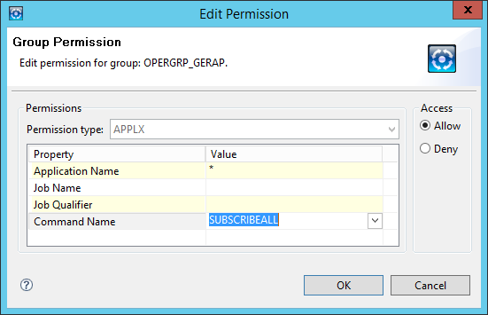
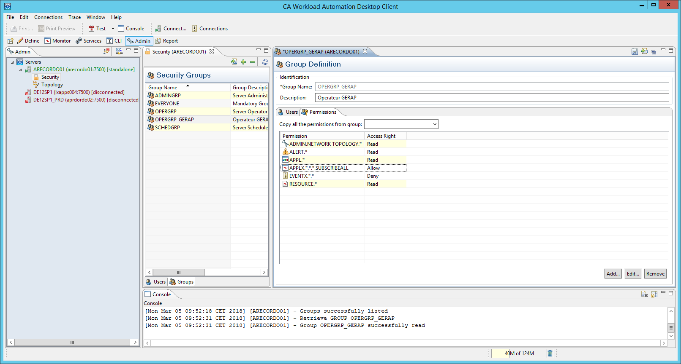
Add
…
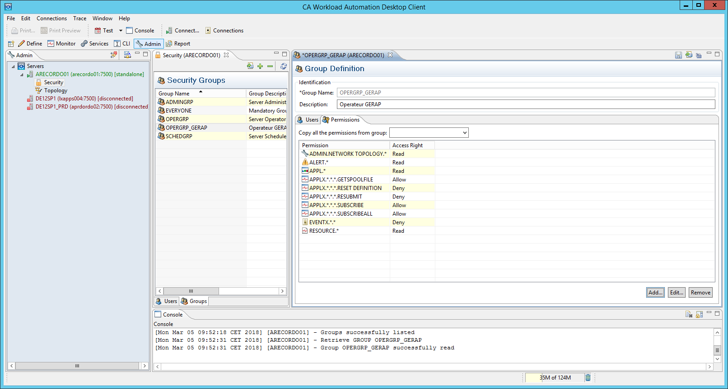
EVENTX is denied
Save

Add User OPERATEUR to the group.
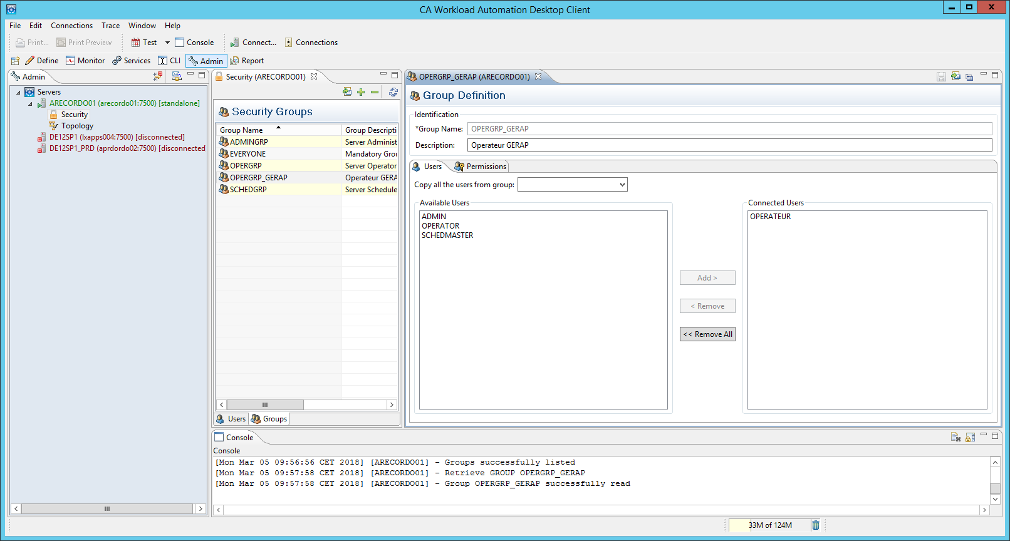
Save

Tests for OPERATEUR
- He gets a permission error when he uploads any application
- The application trigger is greyed out
- He can subscribe all
- Trigger DEMO_SECURITY under SCHEDMASTER
- OPERATEUR gets a permission error when he completes the application.
- OPERATEUR gets a permission error when he cancels an active job of DEMO_SECURITY
- OPERATEUR gets a permission error when he holds a predwait job.
- OPERATEUR can retrieve a job spool

