Tenpc022 – showing as 100% compliant
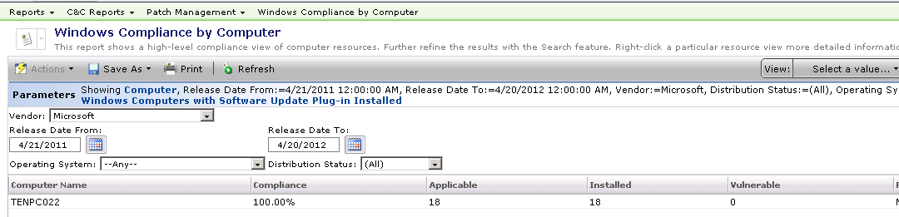

MSBA analysis shows non-compliance below!

