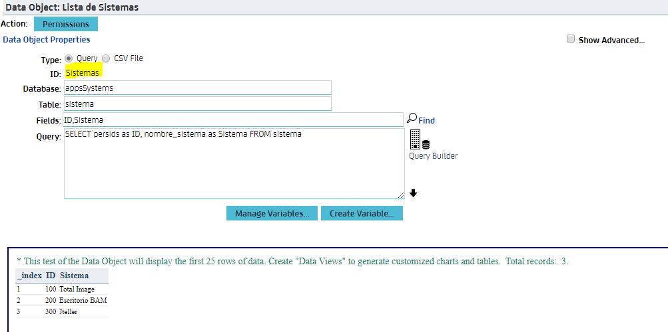

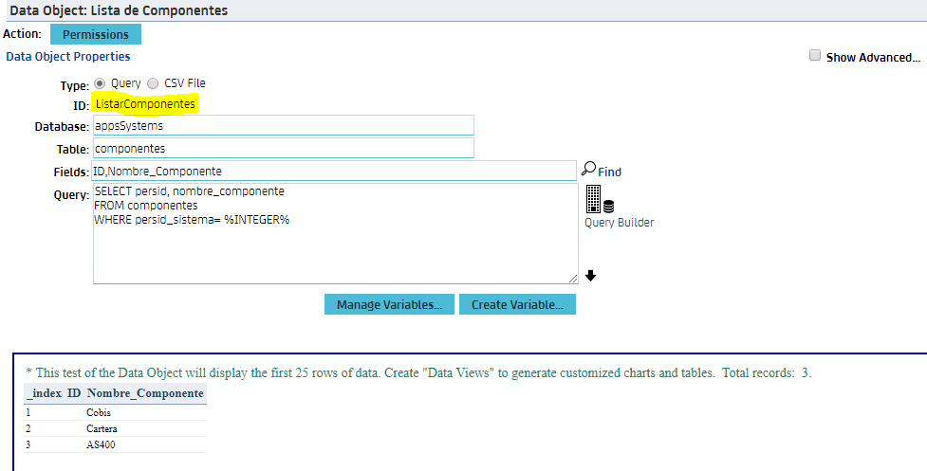
I inserted 200 as INTEGER value
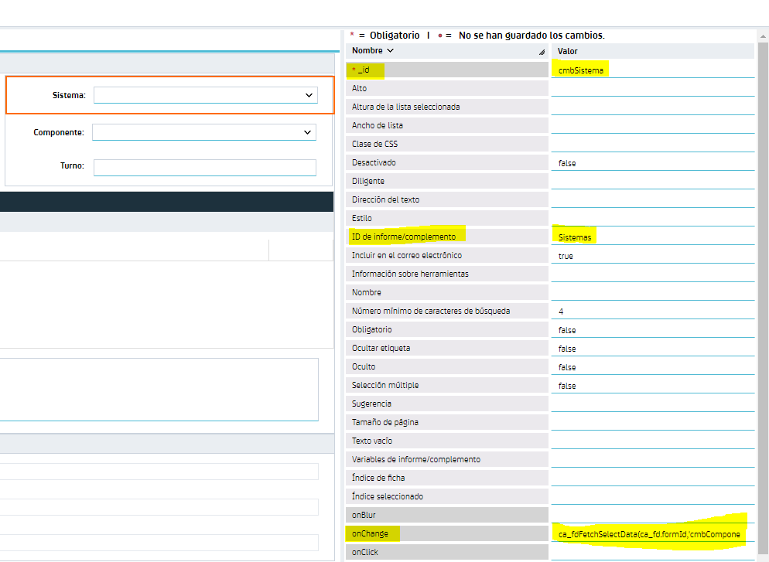

onChange: ca_fdFetchSelectData(ca_fd.formId,'cmbComponente');

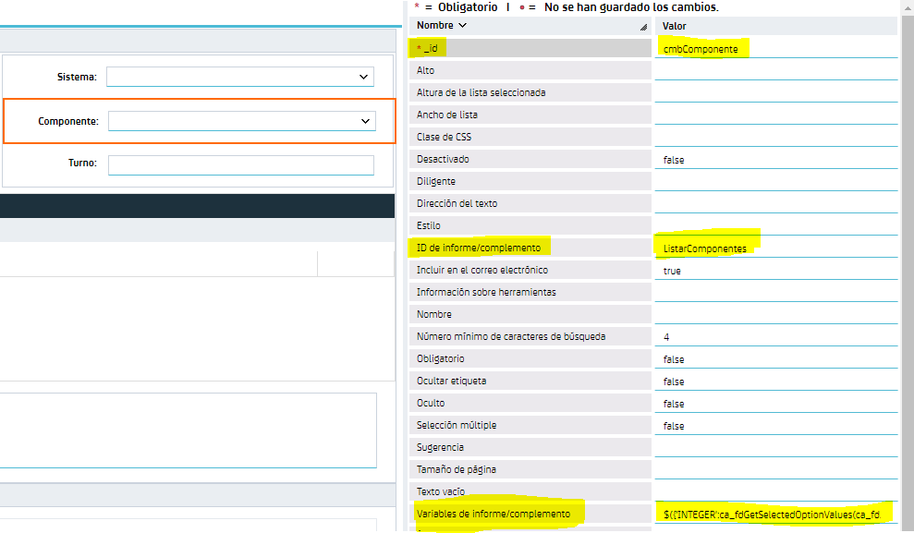

attribute Report variables: $({'INTEGER':ca_fdGetSelectedOptionValues(ca_fd.formId,'cmbSistema')[0]})

