Back story: In normal circumstances, no sender from own domain is expected from external
(Internet)
Emails from own domain should go internally between exchange and not outside
MTA/source.

e.g
Fake sender example.com (Internet) SMG Exchange Mailbox (example.com)
Mailbox (example.com) Exchange Mailbox (example.com)

Objective: Block spoofed sender

Solution: We may use SMG content filtering

- Logon to SMG and then go to Content Dictionaries Add Dictionary

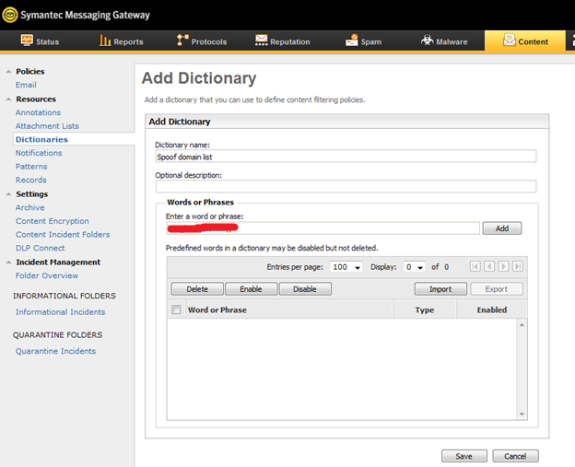

- Create a new dictionary list with name e.g Spoof domain list

Add the potential domain name that can be spoofed by external party then save it

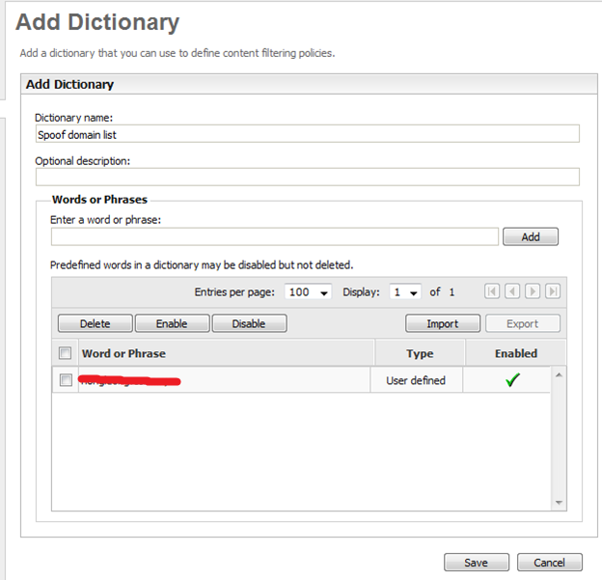

- Go to Content Policies Email
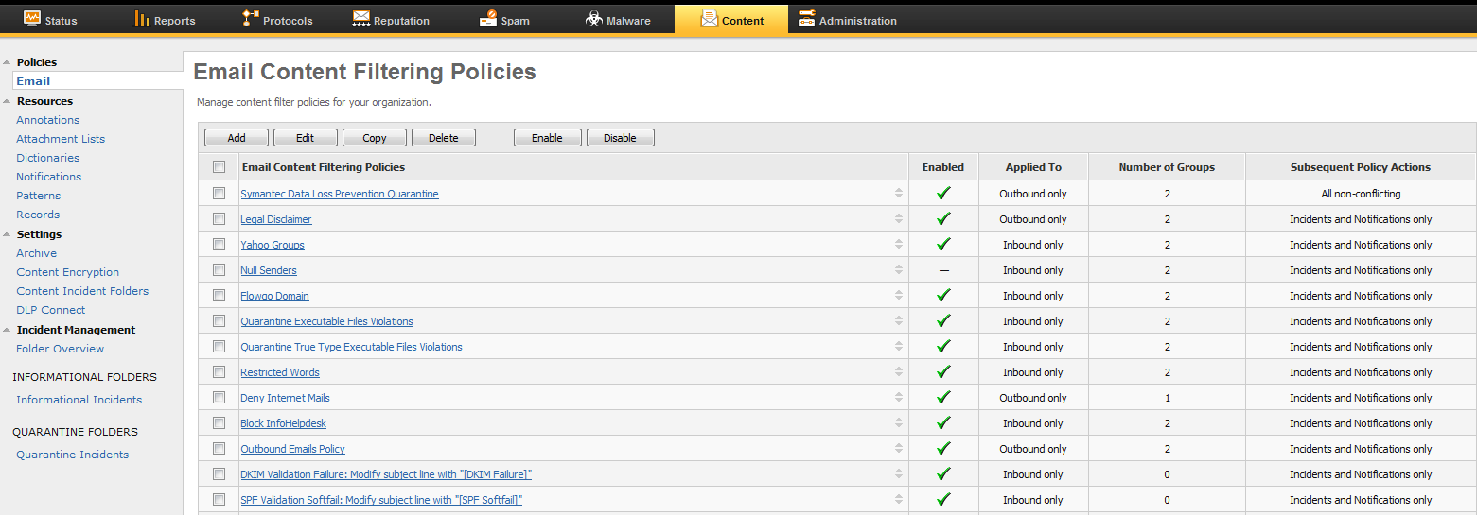

- Click Add and select a new blank policy template

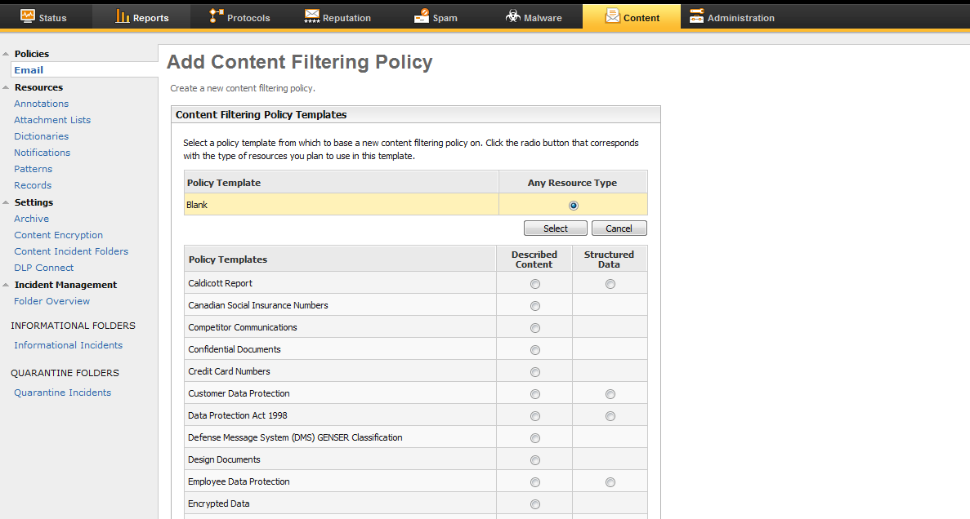

- Name the policy to e.g Block spoof domains

Tick the option Track violations of this policy in the dashboard and reports
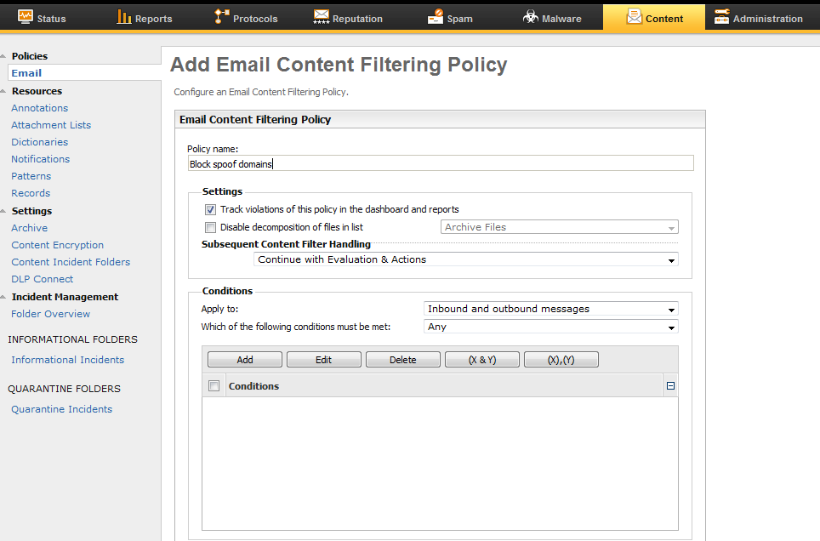

- Edit the conditions and select Apply to Inbound messages

Select Any in Which of the following conditions must be met

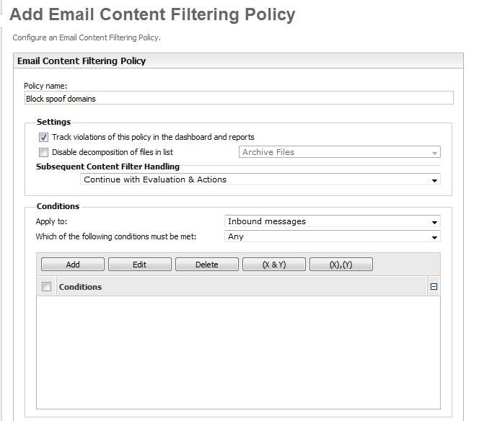

- Click Edit in the conditions tab

Go to “Text in the specific part of the message header” and select Envelope sender
Contains Domain name from dictionary Spoof domain list (custom)

- Go to Action and then click Add

Select Hold message in Spam Quarantine then click Add Action
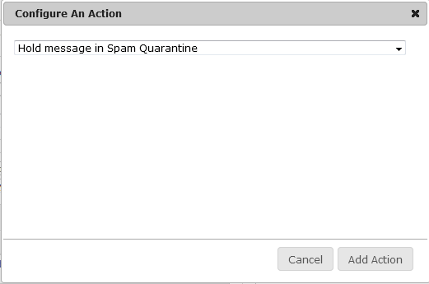

- In the last option, select the Policy Group that you wanted to Apply

(Default in this example)

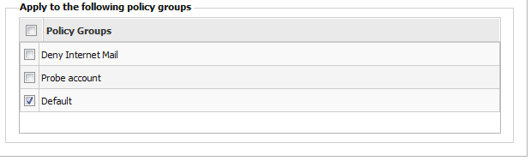

- Then verify everything before clicking save

