Error binary type

1º step:
I created the script on GtSbbset as follow:

@seqlov(0,@sqllist(S,"SELECT * FROM [dbo].z_ciclo_de_vida_cr L0 WHERE ID IN ( ~IdCicloVida~ )")@,~COLUMN_NAME~)@

2º during the validation on Data Maker, the script wasn’t work as is possible to see below.
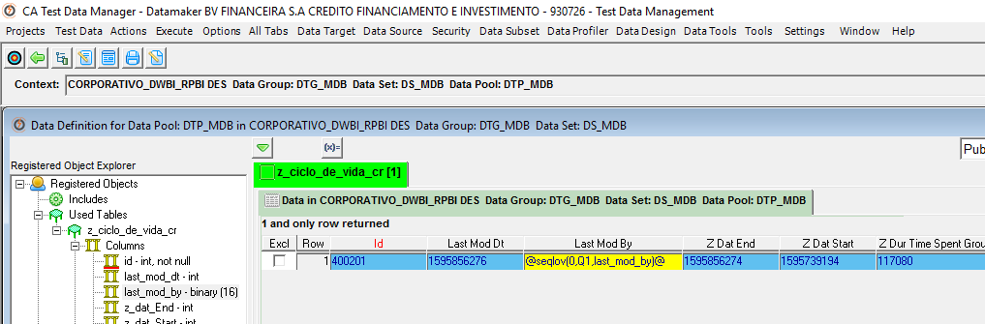
3º When I tried to make a publication, I receive an error. 4 columns doesn’t worked and the similar things about this column is the binary type.
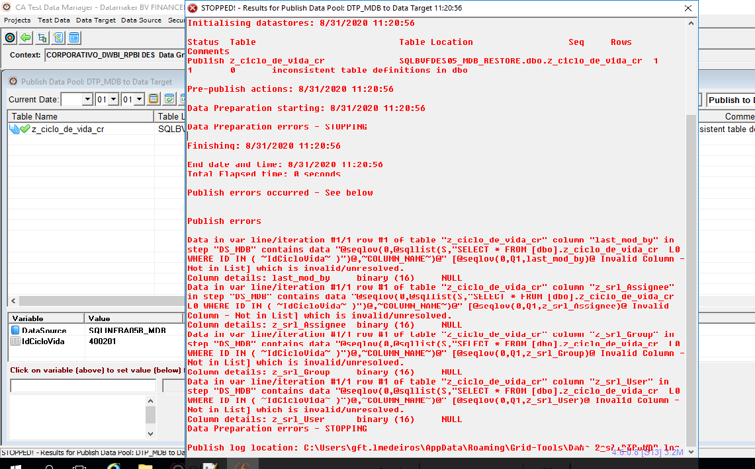
4º I tried to make the publication at TDM Portal but doesn’t worked too. I receive an error and don’t publish the data.
