Rally Sign-In Problem

Signed into Rally AA, I get this:

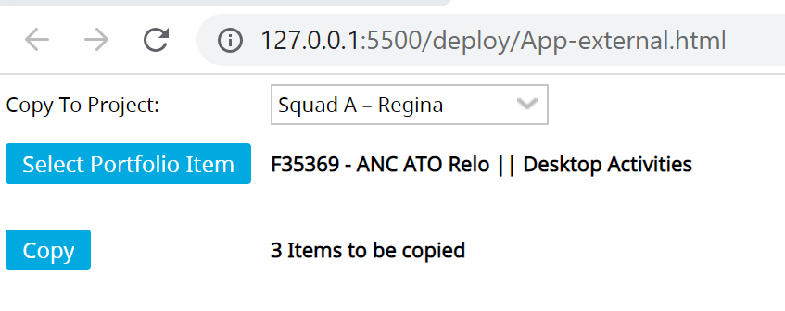

This is one of my AA Portfolio features – so I believe I am in the AA Rally area

If I NOT signed into Rally AA, I only get the Sign In dialogue box

Below is what I get when signed into Rally via the AA credentials

FireFox

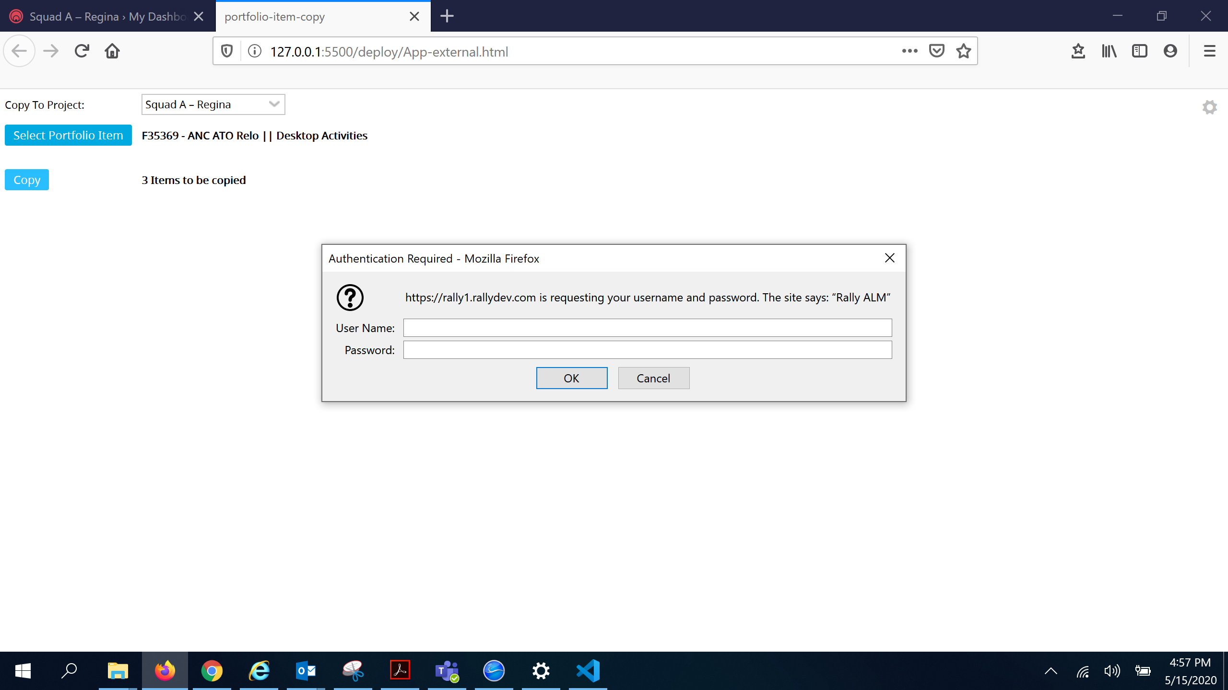

Chrome

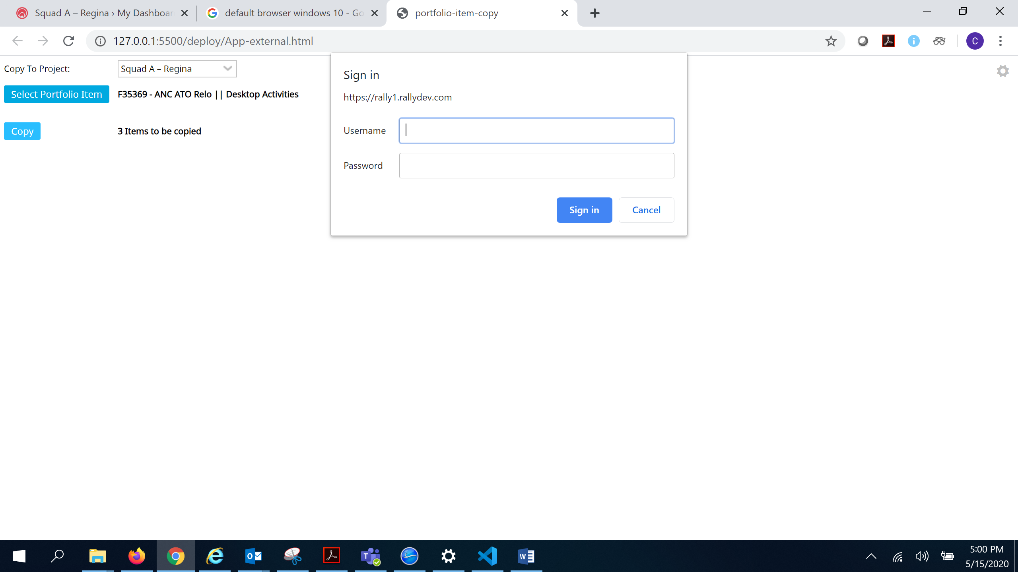

I have tried all combination of Username and password

AA username
Rally username

What is triggering this sine dialogue box
Is it needed as I am signed into AA Rally

