This does not replace the upgrade guide.

E:\Program Files\Symantec\DataLossPrevention\EnforceServer\15.7\Protect\Migrator\URT
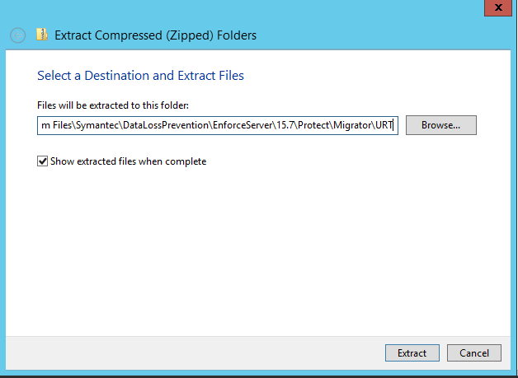

Sqlplus protect/ your protect password@protect

BEGIN
FOR rec IN (SELECT * FROM user_jobs) LOOP
dbms_job.broken( rec.job, true);
dbms_job.remove( rec.job);
END LOOP;
END;
/

Then press Enter.

Select count(*) from user_jobs;

Then press Enter.

Confirm that the count is zero.

Type Exit then press Enter.
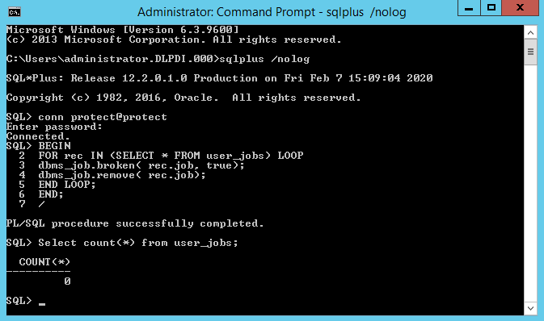

Open a command prompt with administrator and run the following command.
Cd \Program Files\Symantec\DataLossPrevention\EnforceServer\15.7\Protect\Migrator\URT\script
Run sqlplus /nolog
Run @oracle_create_user.sql
Fill in the following information.
Please enter the password for sys user: enter the password for the SYS
Please enter sid: <database_system_id>
Please enter required username to be created : enter a name for the new
upgrade readiness database account. –URT157
Please enter a password for the new username: enter a password for
the new upgrade readiness database account. protect
Press enter after entering the password for the Readiness User and you will see the above.
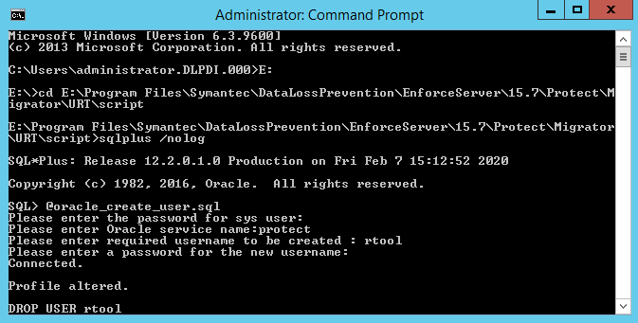
*Note: “Error at line 1: ORA-01918: User ??? does not exist” is expected behavior.
You will then see User created, User altered, Grant
Run the following command if you are running the Oracle database in a RAC environment:
sqlplus sys/[sysdba password]@<RAC node ip>:1521/protect as sysdba
SQL>
GRANT READ,WRITE ON directory DATA_PUMP_DIR TO [schema user name];

Continue:

sqlplus sys/yourpassword as sysdba “for 2 teir”
sqlplus sys/yourpassword@protect as sysdba “for 3 tier”
GRANT READ,WRITE ON directory DATA_PUMP_DIR TO protect; Replace protect with schema user name.
GRANT SELECT ON dba_registry_history TO protect; Replace protect with schema user name.
GRANT SELECT ON dba_temp_free_space TO protect; Replace protect with schema user name.
Type exit then press enter.
Type cd..
Then enter.
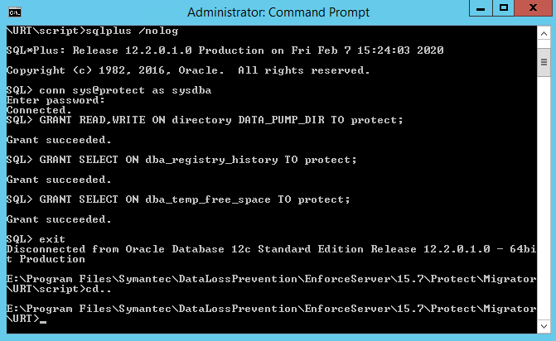
“E:\Program Files\Symantec\DataLossPrevention\ServerJRE\1.8.0_181\bin\java” UpdateReadinessTool

Please enter the database username: <schema user name>
Please enter the database user password: <password>
Please enter the database readiness username: <readiness_username>
Please enter the database readiness user password: <readiness_password>
Please enter the database system identifier (sid): <database_system_id>

Please have Symantec review the ReadinessTool output before upgrading.

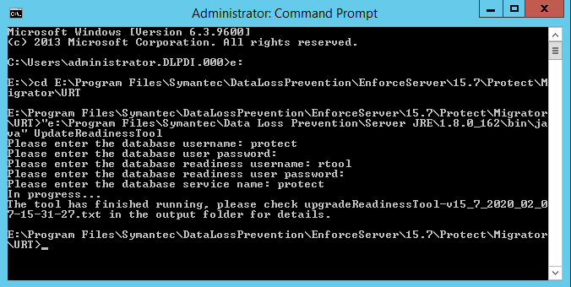

From system where oracle is installed run the below commands
lsnrctl stop
set ORACLE_HOME=c:\oracle\product\12.2.0.1\db_1
set PATH=%ORACLE_HOME%\bin:%PATH%
%ORACLE_HOME%\network\admin\tnsnames.ora
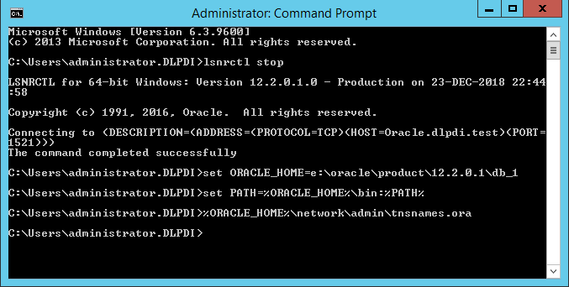

Change SID to SERVICE_NAME for the protect value, where protect is your current SID.
The Protect section should read as follows:
PROTECT =
(DESCRIPTION =
(ADDRESS_LIST =(ADDRESS = (PROTOCOL = TCP)(HOST = 192.168.2.100)(PORT = 1521))
)
(CONNECT_DATA =
(SERVICE_NAME = protect)
)
)

Save tnsname.ora then start the OracleOraDB12Home1TNSListener service.
Copy the tnsnames.ora from c:\oracle\product\12.2.0.1\db_1\network\admin on the oracle server to the enforce server c:\oracle\product\12.2.0.1\client_1\network\admin This location might be different depending on where it was installed.
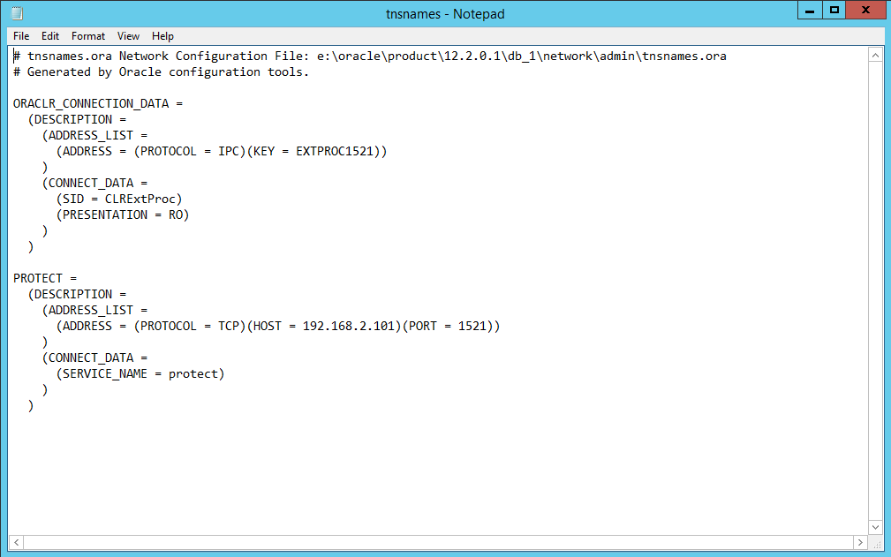

Go to services.msc and start OracleOraDB12HomeTNSListener service.
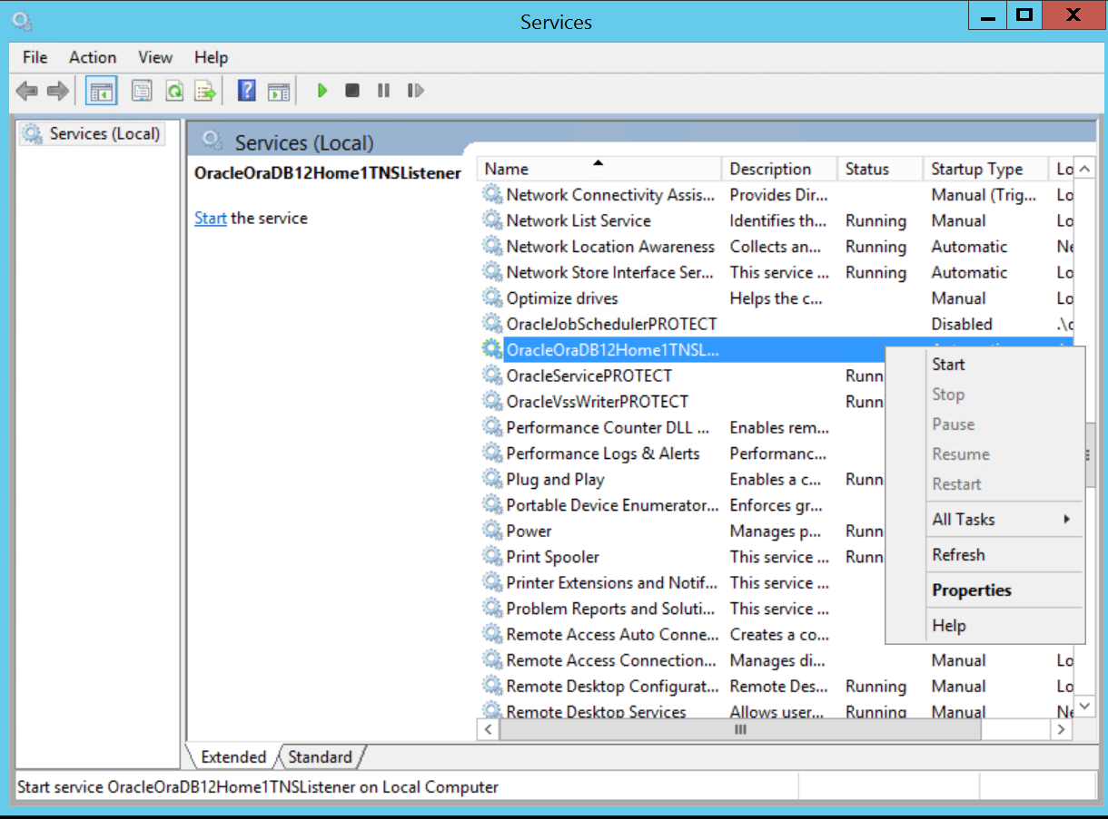
sqlplus /nolog
conn sys/your password@protect as sysdba
alter system set service_names = 'protect' scope=both;
alter system register;
select value from v$parameter where name like '%service_name%';
The SERVICE_NAME value protect displays in the command prompt.
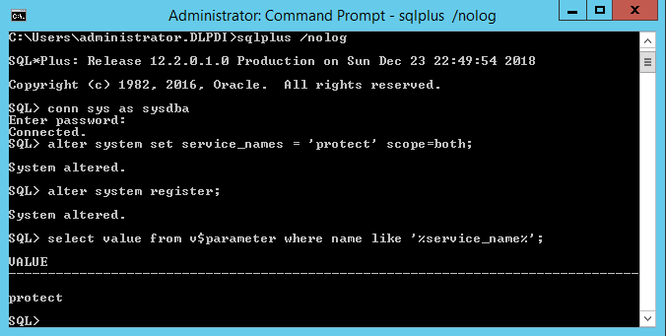

sqlplus /nolog
conn sys/your password@protect as sysdba
GRANT read, write ON directory data_pump_dir TO protect; Replace protect with schema user name.
GRANT SELECT ON dba_registry_history TO protect; Replace protect with schema user name.
GRANT SELECT ON dba_temp_free_space TO protect; Replace protect with schema user name.
GRANT SELECT ON v_$version TO protect; Replace protect with schema user name.
GRANT EXECUTE ON dbms_lob TO protect; Replace protect with schema user name.
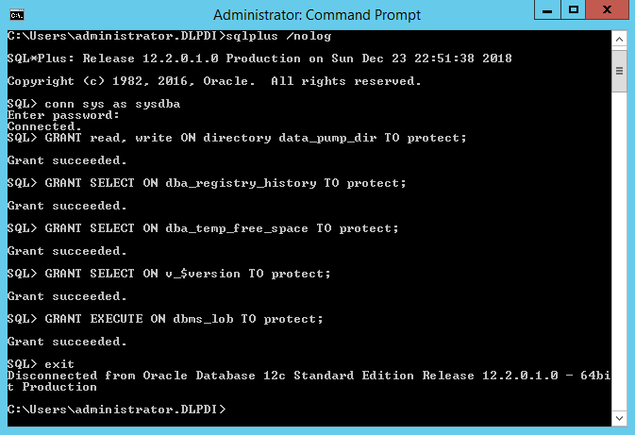
Extract Symantec_DLP_15.7_Platform_Win-IN_15.7.0.18016.zip to c:\temp
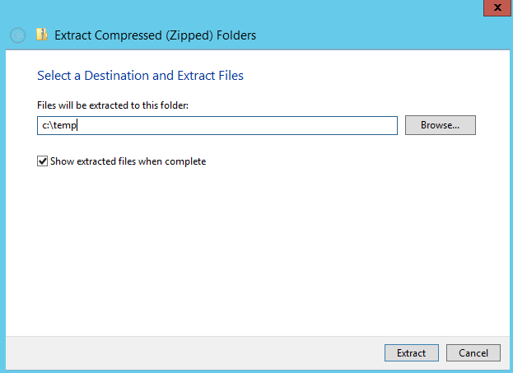

Run ServerJRE from c:\temp
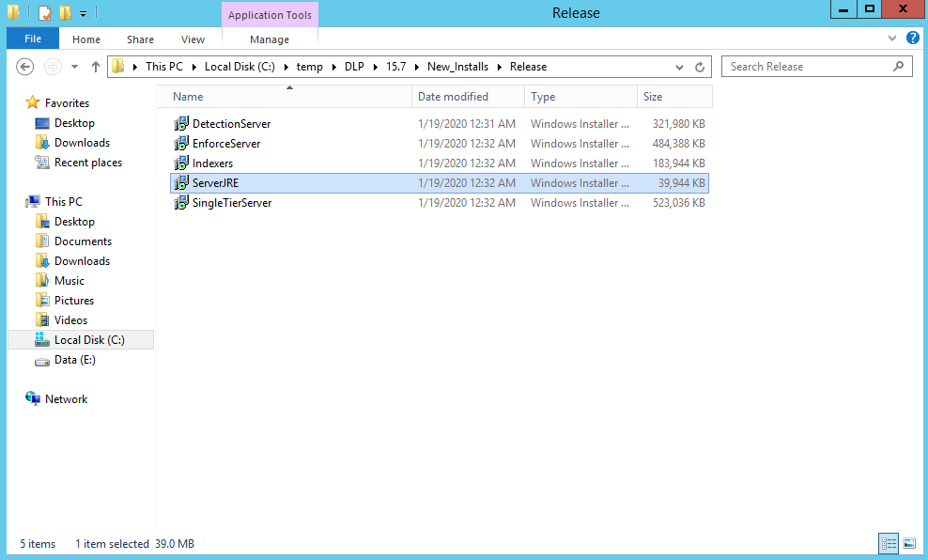
Click Next.
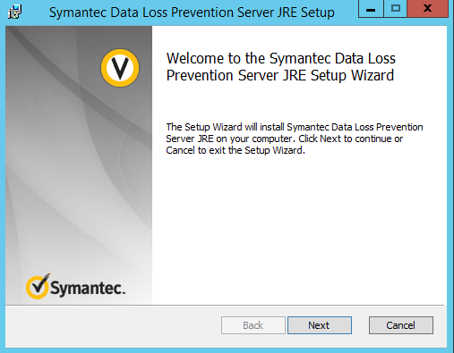

Check I accept then terms in the License Agreement then click Next.
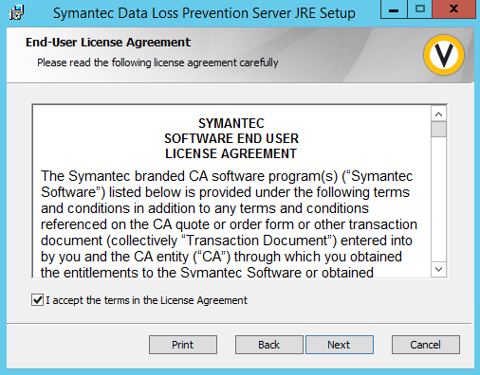
Click Next.
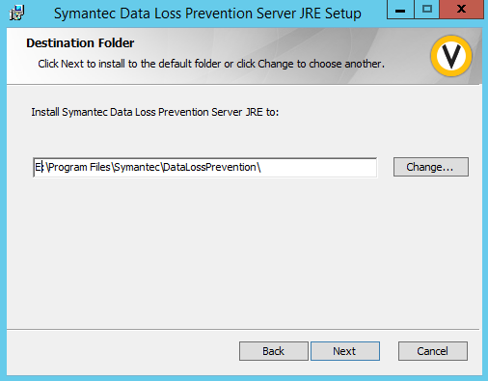

Click Install.
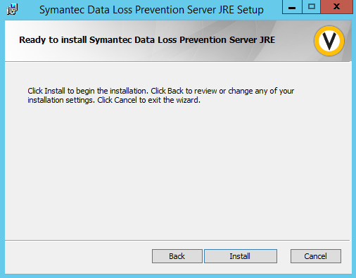

Click Finish.
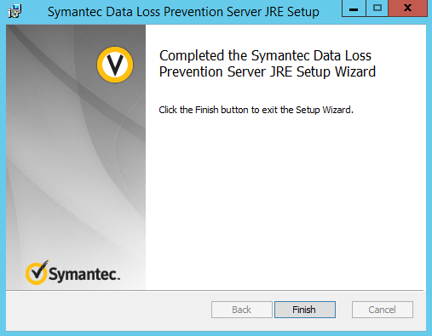

Run EnforceServer from c:\temp
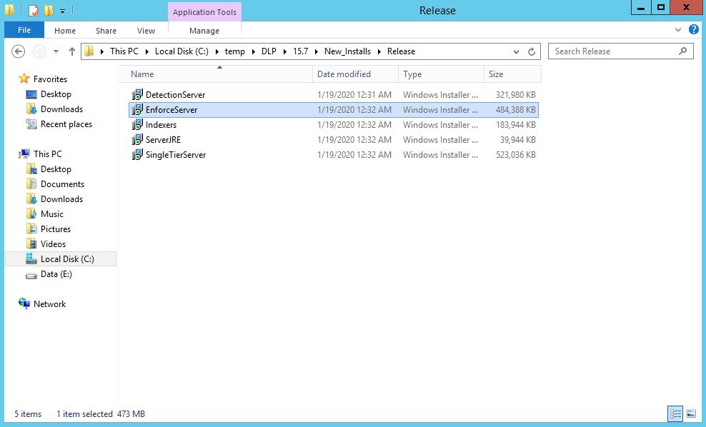

Click Next.
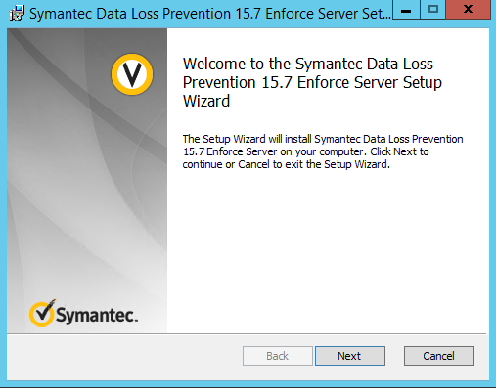

Check I accept terms in the License Agreement then click Next.
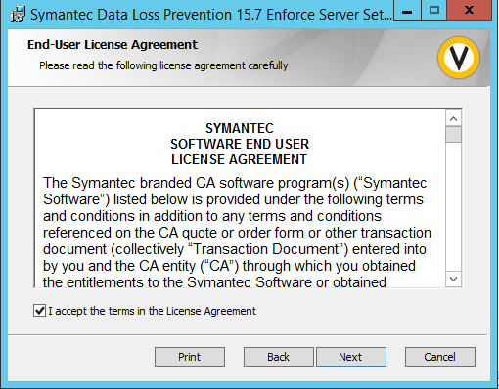
Click Next.
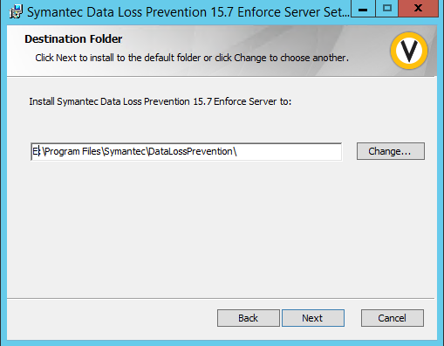

Click Next.
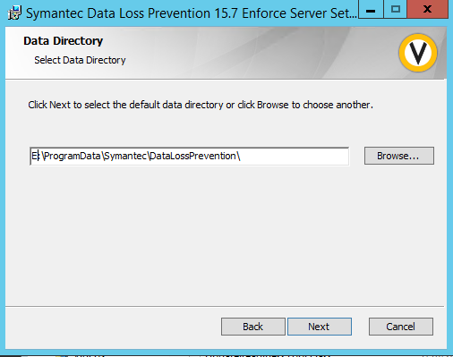
Click Next.
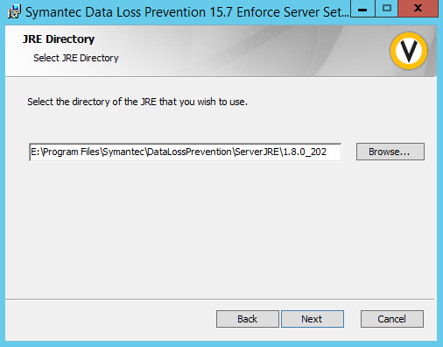

Click Next.
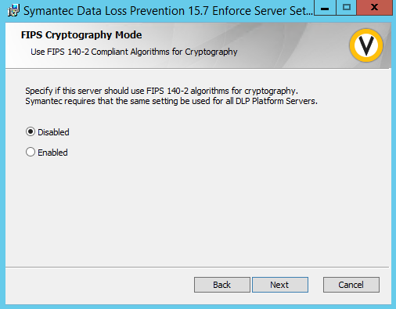
Enter your password and click Next.
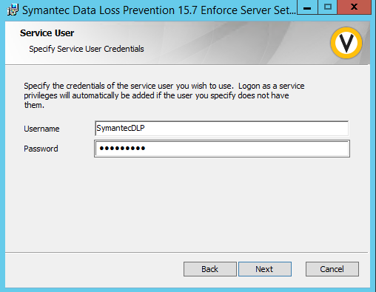

Enters your database host name and the password for the database then click Next.
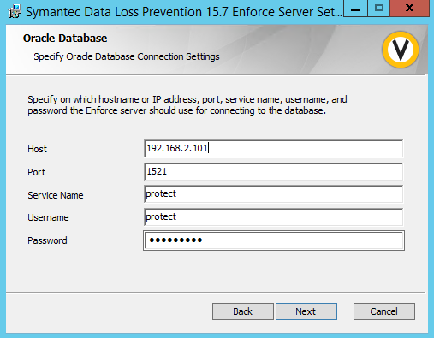

Click Next.
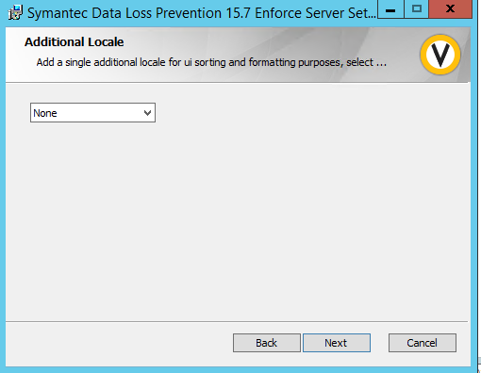

Click Install.
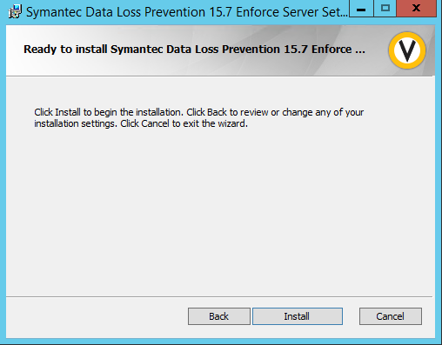
Click Finish.
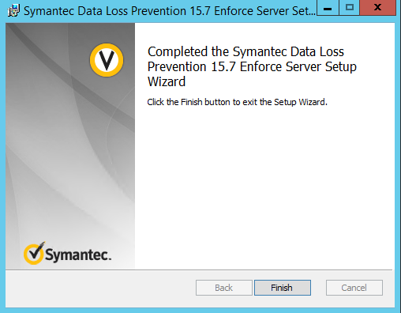

Open a command prompt with administrator. Change directory to \Program Files\Symantec\DataLossPrevention\EnforceServer\15.7\Protect\Migrator\ Run EnforceServerMigrationUtility.exe then enter the number for your newest installation you are migrating from and press enter.
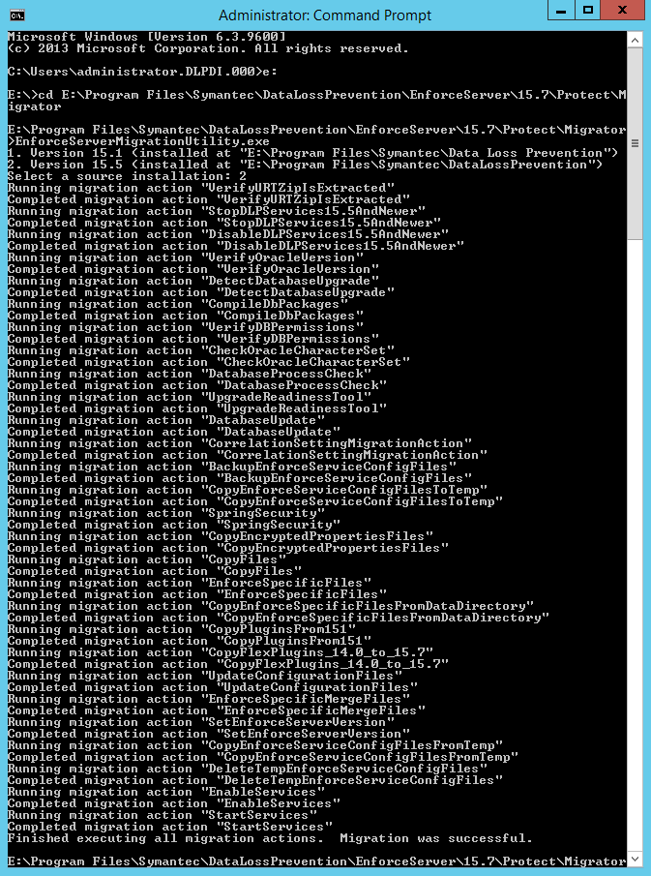
Open the enforce management page and sign in as Administrator.
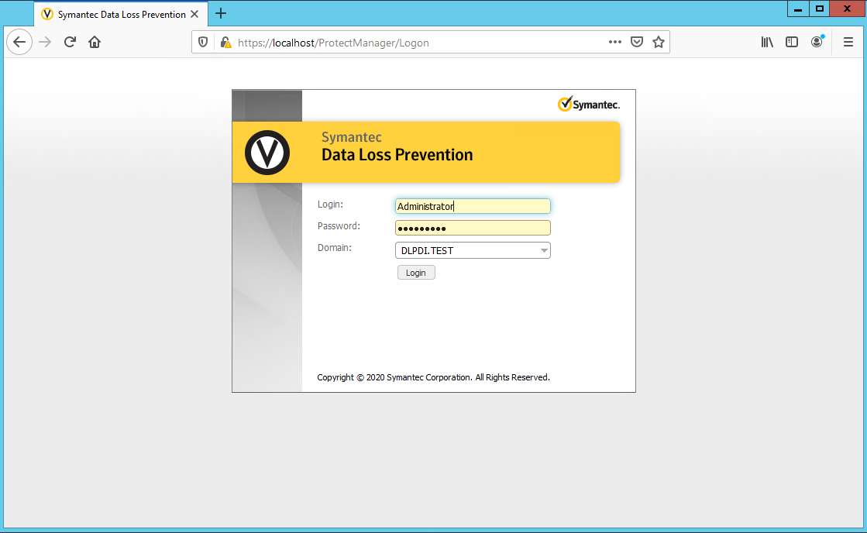

Enter your company information and click I Accept.
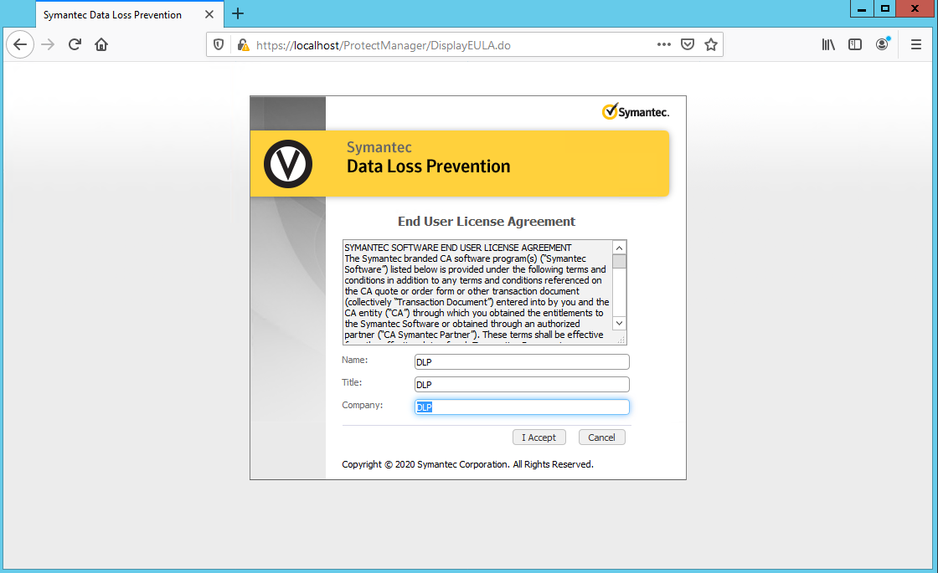

Navigate to System\Servers and Detectors\Overview and make sure your enforce server is upgraded before upgrading your detection servers.
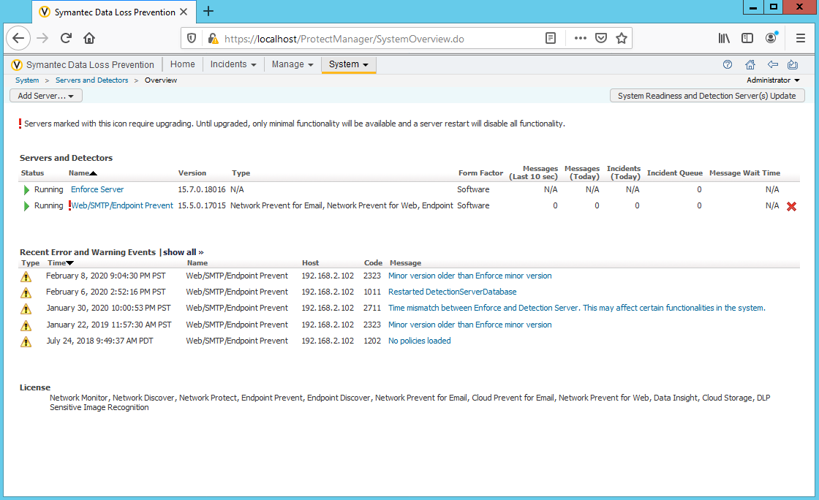

On your detection server extract Symantec_DLP_15.7_Platform_Win-IN_15.7.0.18016.zip to c:\temp
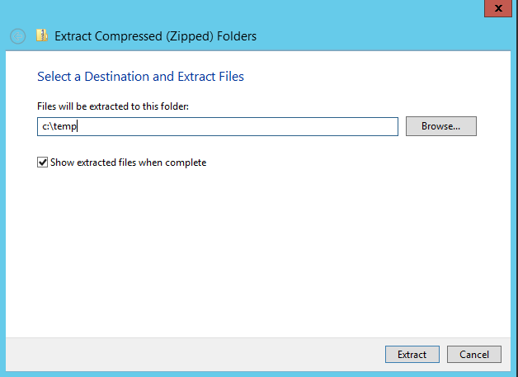
Run DetectionServer from c:\temp
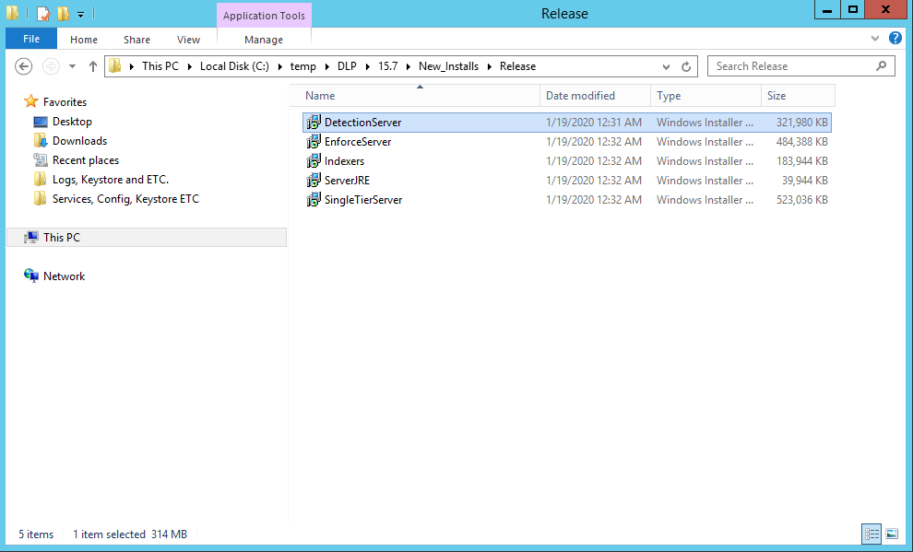

Click OK.
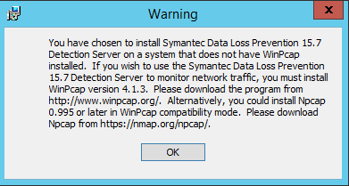

Click Next.
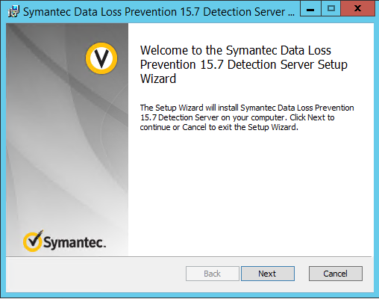

Check I accept the terms in the License Agreement then click Next.
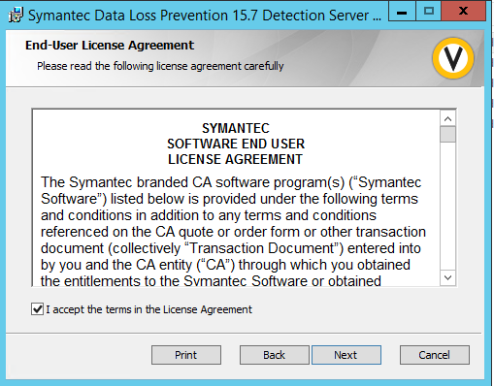
Click Next.
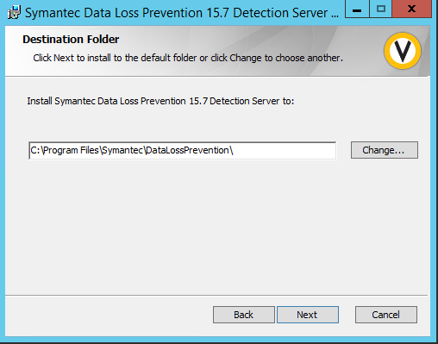

Click Next.
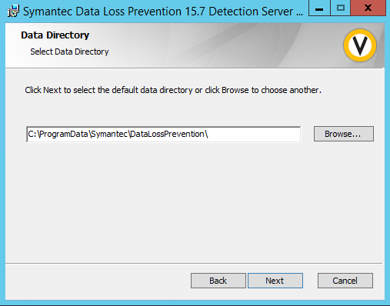
Click Next.
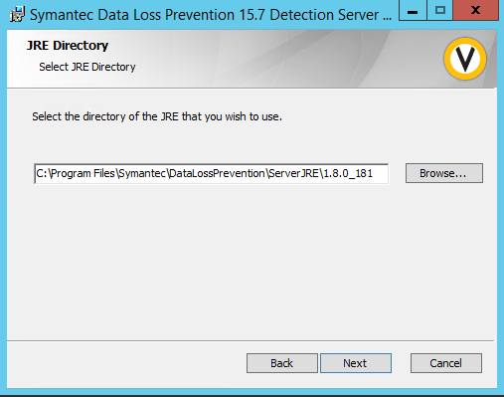

Click Next.
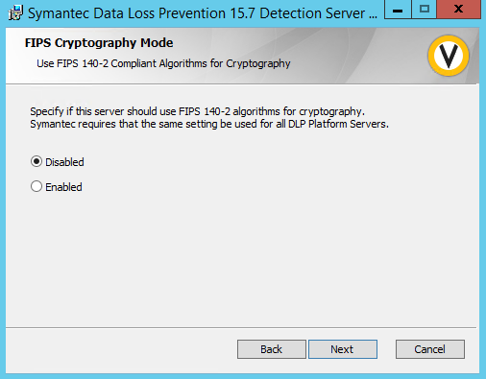
Enter your password then click Next.
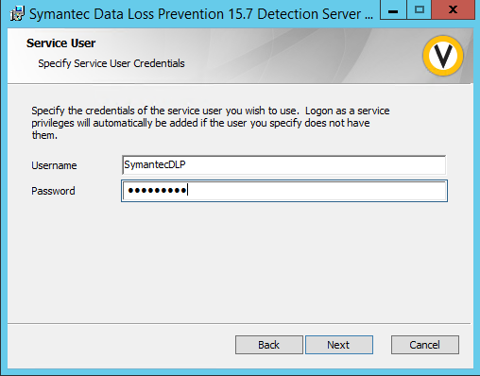

Enter your password then click Next.
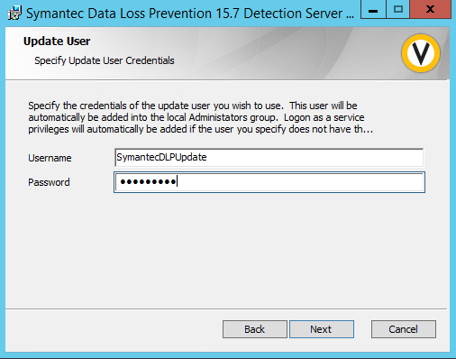
Enter the Host name or IP of your detection server.
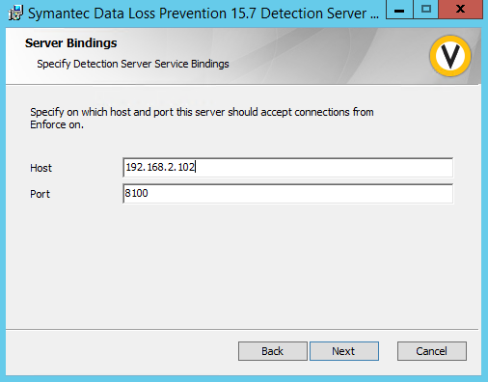

Click Install.
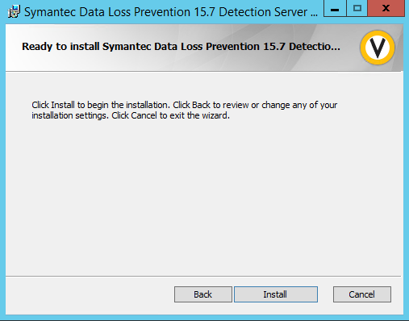
Click Finish.
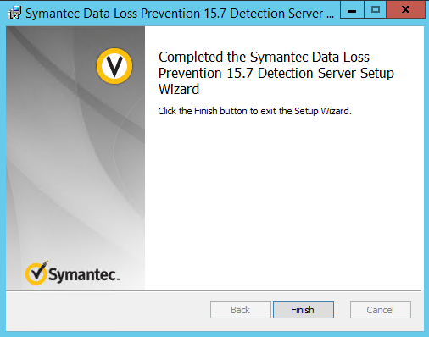

Open a command prompt with administrator. Change directory to \Program Files\Symantec\DataLossPrevention\DetectionServer\15.7\Protect\Migrator Then run DetectionServerMigrationUtility.exe and select the version you are migrating from and press enter.
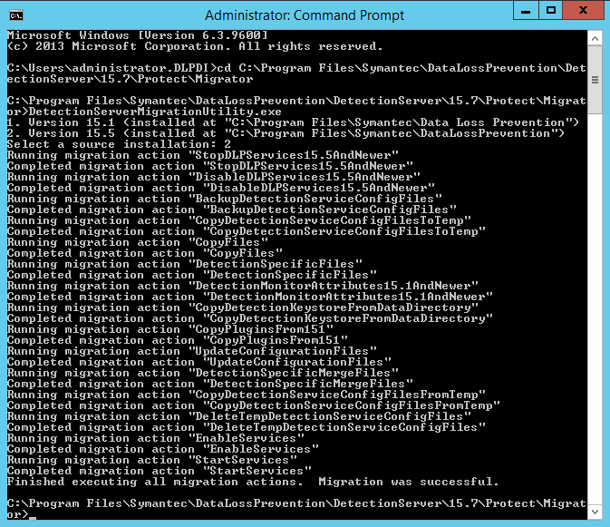
Sign into your enforce management console as Administrator.
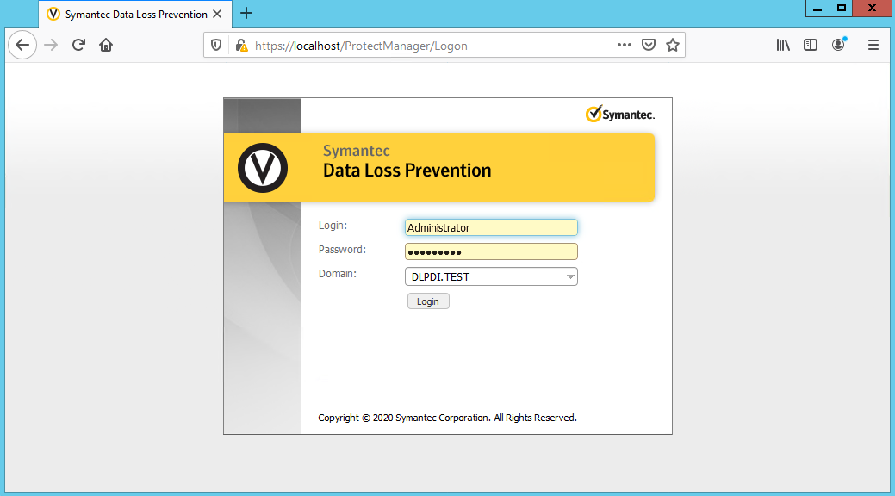

Navigate to System\Servers and Detectors\Overview and make sure your detection server is upgraded.
