How to Create a Reference field
Reference fields are fields that contain a set of discrete set of list values. First you create the extended reference field on a global configuration, then you create the set of list values for this field under Directory -> List Management.

- Edit the global configuration where you want to add the extension field.
Example: Location Global
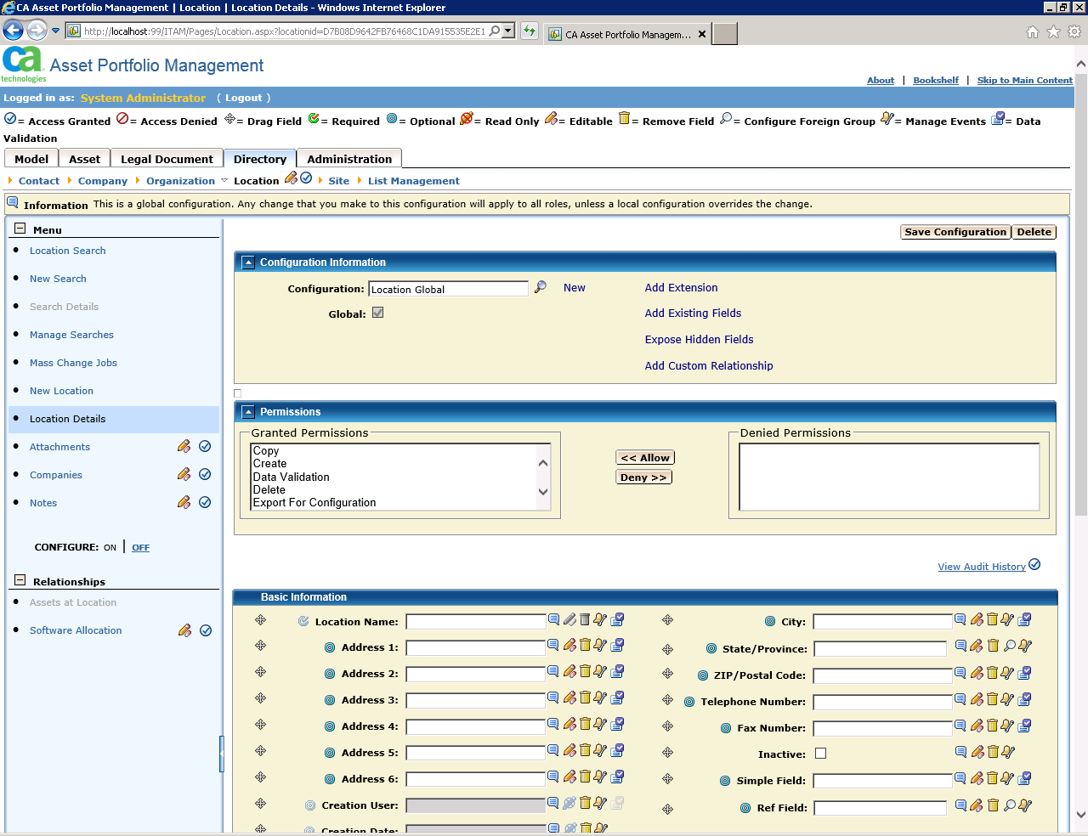

- Click Add Extension, Choose Reference field, and then select which section on the page to add the field.
Example: Basic Information section. Click next.
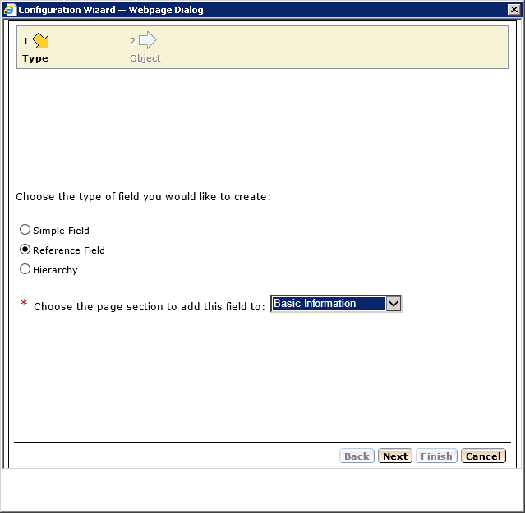

- Fill in the label name, choose ‘new object’, and type in the new object table name.
Typically the label name and the object table name are similar or the same.
Click next.

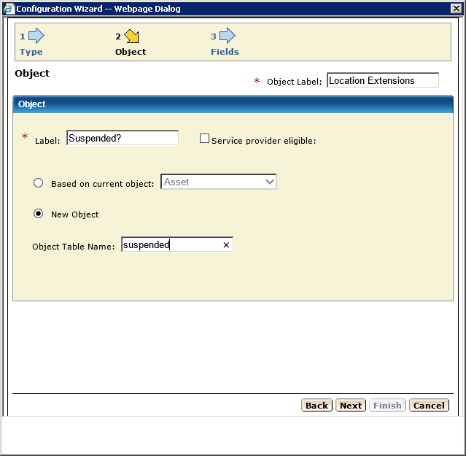

- Click ‘Add field’
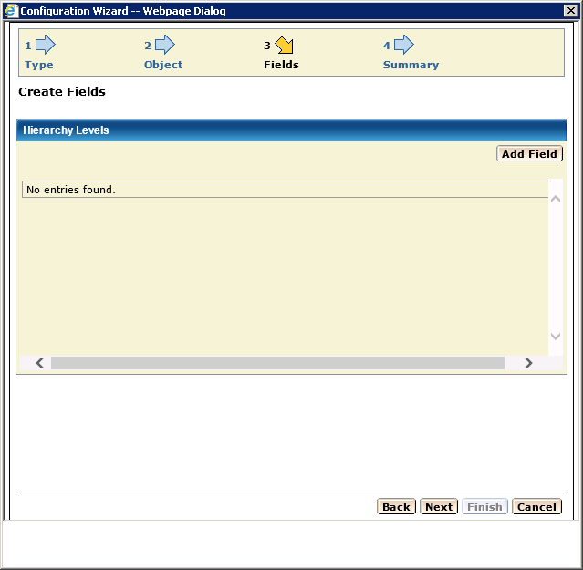

- Fill in the field details. This field will hold the values ‘Yes, No, or Maybe’ so the field size is 5 characters (as ‘Maybe’ is the longest name).
Attribute name and field name are usually the same. Click GREEN checkbox
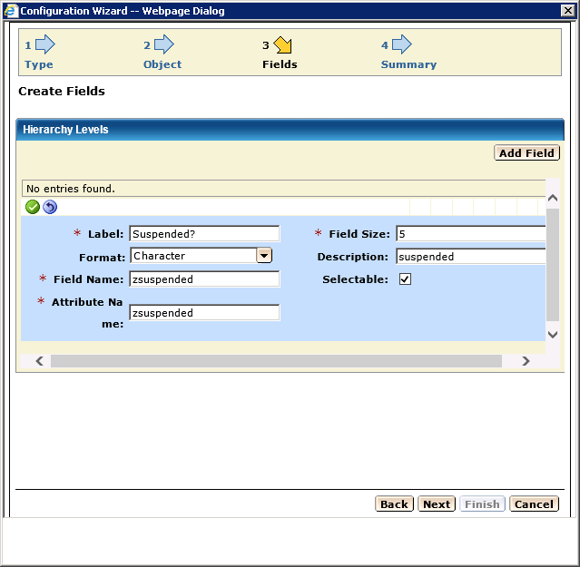

- Review the information and edit again or click Next.
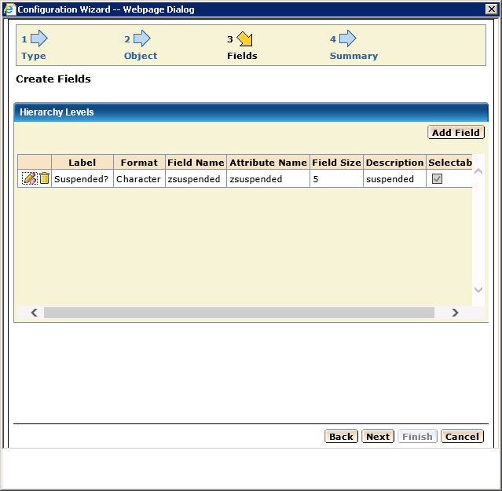

- See this screen and click ‘Save and Exit’
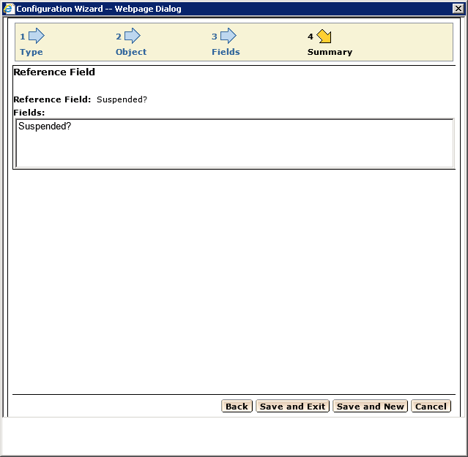

- The configuration page will re-display and then click ‘SAVE CONFIGURATION’
VIP STEP!
Scroll down to the section where you added the field and see that it has been added.

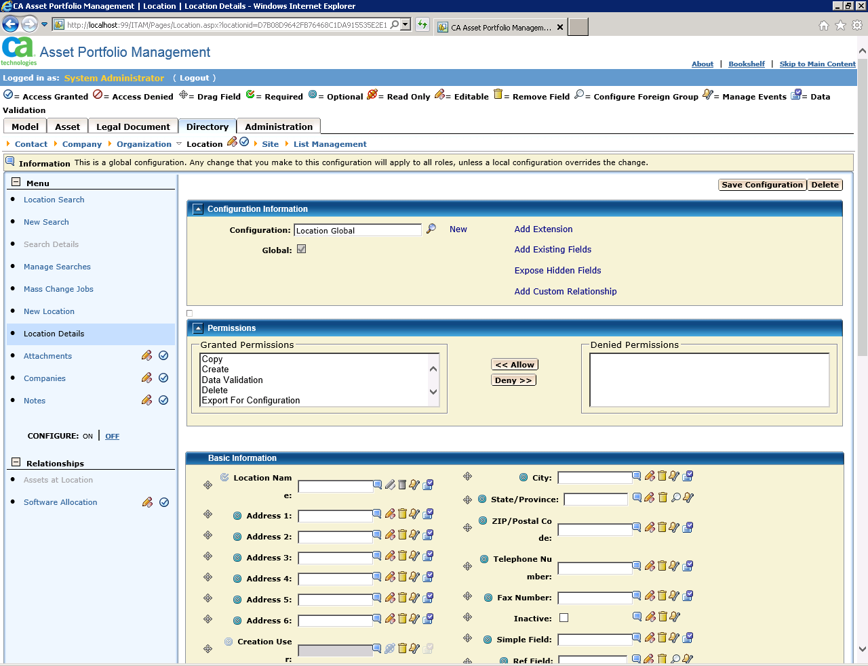

- Next, navigate to Directory -> List Management. Locate your new field under the proper object list.
For this example, the field is under the Location List
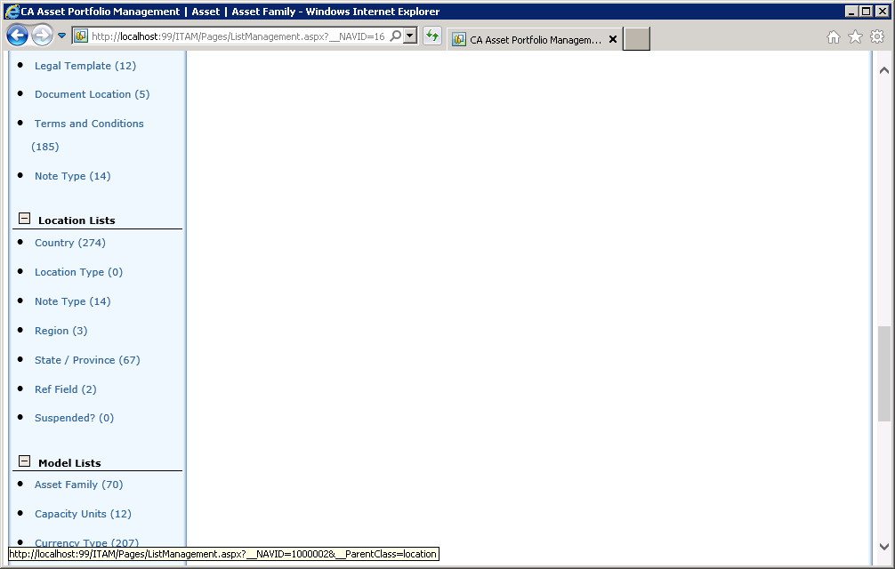

- Click the Suspended field and then click New to add new values for the drop down.

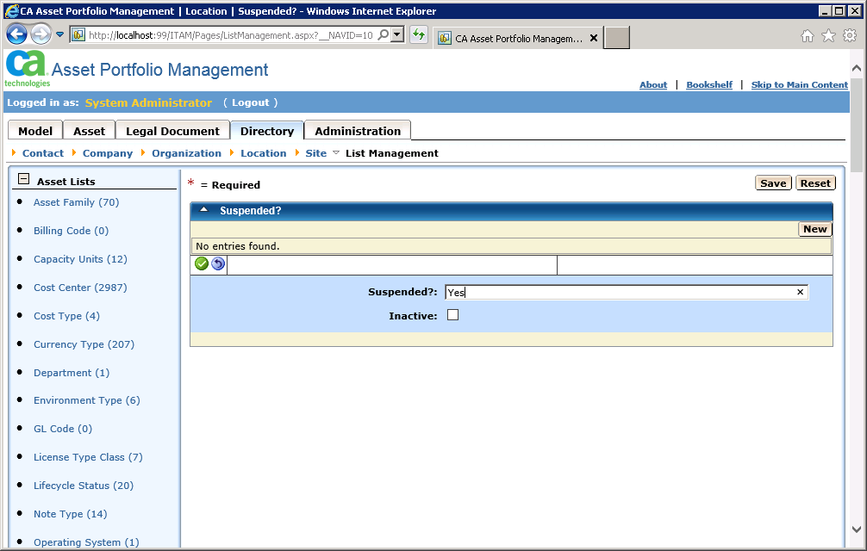

- Click SAVE to save the new values.
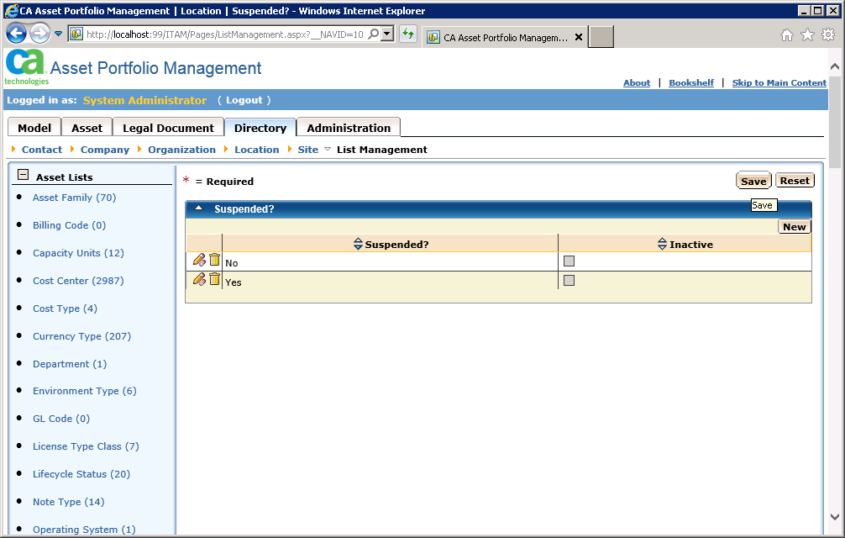

- Perform an IISRESET
- Log back in and test the new field.

