Before Scan: (test.txt)
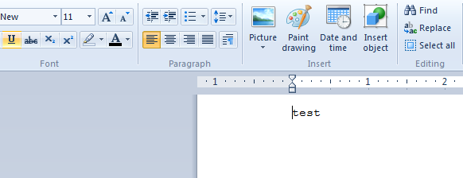

After Scan: (test.txt)
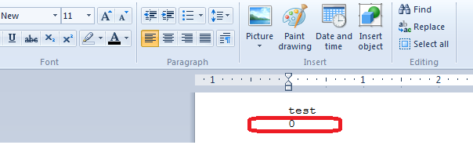

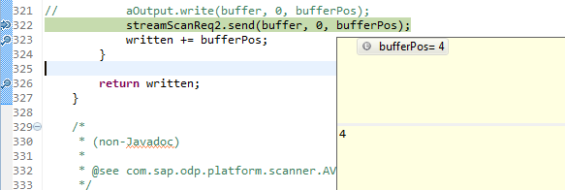

After scanning of word document, when I try to open the file I am getting below popup screen:
Even if I click on OK button, it asks for data recovery if I say yes, file is getting recovered with its actual content.

