Installing (ServiceDesk) Workflow Designer7 on Windows XP or Windows 7

Prerequisites:
Windows XP
- II6
- .Net 3.5
Windows 7
- II6 Compatibility with all sub options
- .Net Framework 3.5.1 with all sub options

Procedure:
- Once you have ServiceDesk 7 Installed, go to the “C:\Program Files (X86)\Altiris\Workflow Designer\Installers” folder
- Copy the following files to a local folder to utilize during the installation:
  - Altiris.Workflow.Server.Setup.exe
  - Logicbase.ServerExtensions.exe
  - Logicbase.Shared.exe
- Also copy the Altiris.ServiceDesk.2009.exe from the (NS or ServiceDesk server) locally as well
- First install Logicbase.Shared.exe application, (using all default prompts are fine)
  - Anytime prompted to restart IIS, then do it
- Then install the Logicbase.ServerExtensions.exe application, (using all default prompts are fine)
  - If prompted to use old server extension settings, select Yes
  - Anytime prompted to restart IIS, then do it
- Then install the Altiris.Workflow.Server.Setup.exe application, (using all default prompts are fine)
  - Anytime prompted to restart IIS, then do it
  - When prompted with the Server Extensions Configuration window, leave all defaults then select “OK” and select “Yes” to save your changes

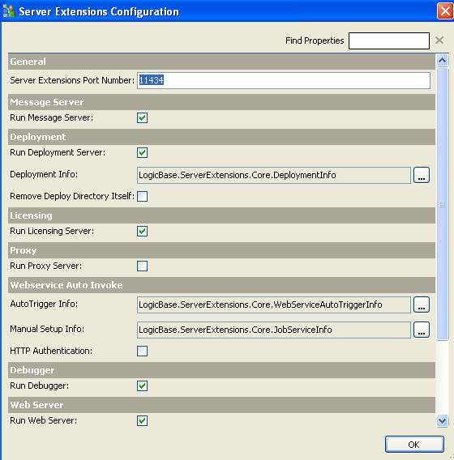

  - Then restart the Server Extension service now
- Then initiate the install of the Altiris.ServiceDesk.2009.exe application
- Select a New Install

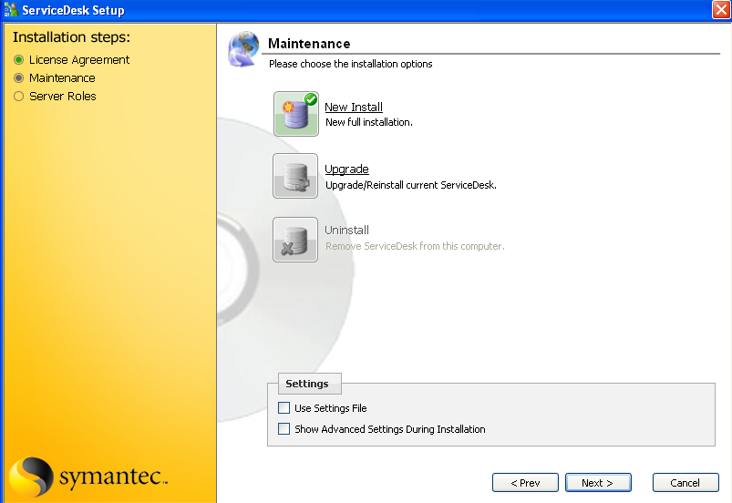

- Uncheck all Server Roles except Workflow Designer, even Workflow Server (it’s already installed) and select Next

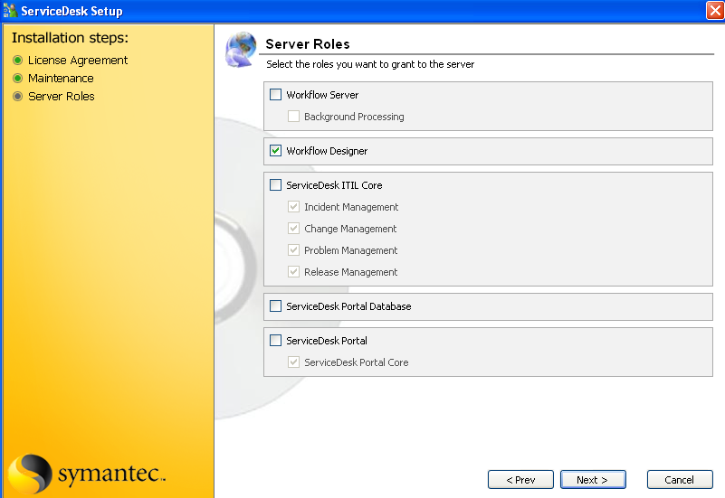

- Enter the correct credentials for your NS, domain, username & password, then select “Test” and “Next”

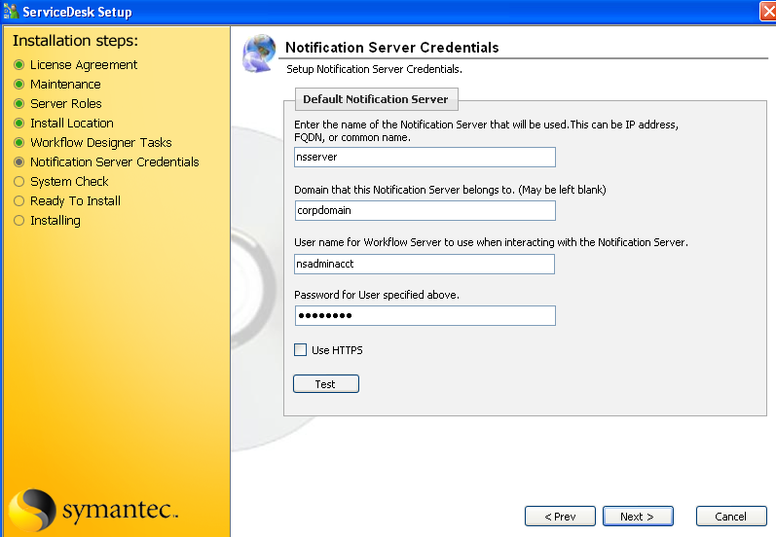

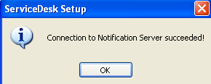

- Review the System Check, I obviously didn’t have 2GB of RAM in my machine but it’s ok, select “Next” and then “Install on the next window if all is acceptable

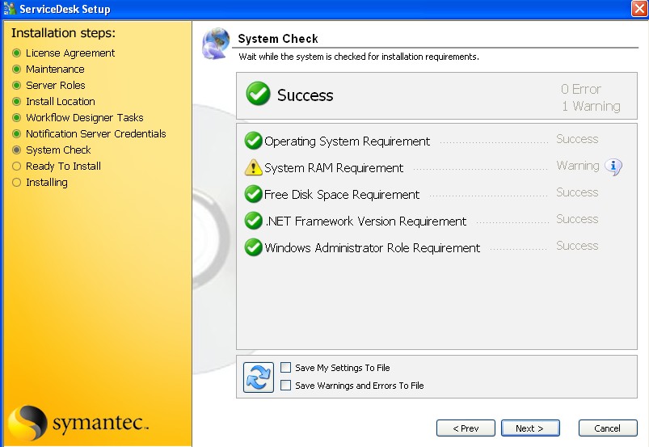

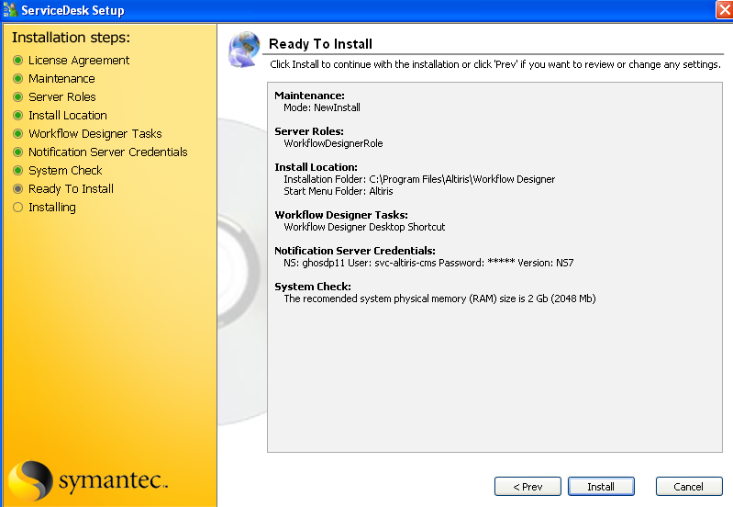

- See the progress … See the Status and click “Finish” if successful!

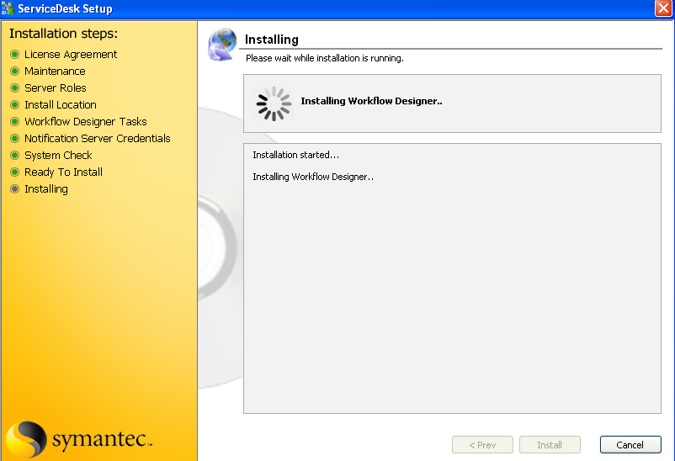

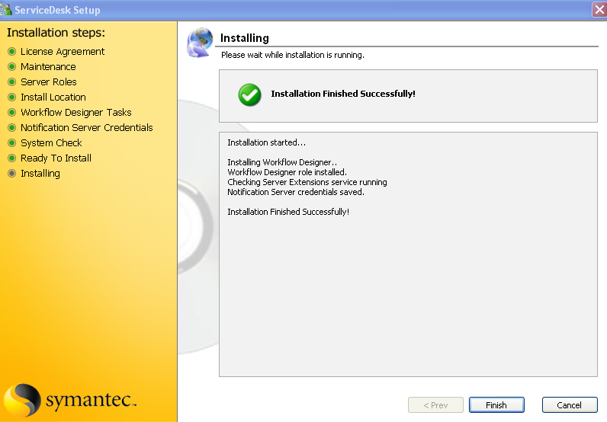

- An Altiris Workflow Designer icon should be your desktop, double-click on it

- See the splash logo and smile

- Add missing projects installed locally if you’d like, “Yes” and away you’ll go

