I registered but can’t log into ca.com
Within 24 hours of registering, you should receive a Confirmation email. Upon receiving it you need to click on link to complete registration link.
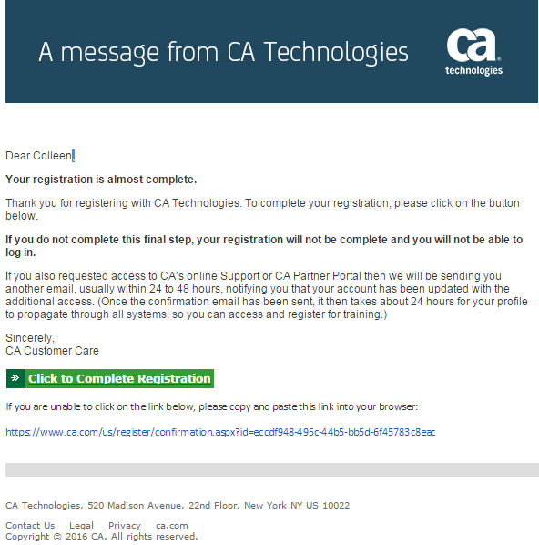
If you did not receive this email, you should first check your Spam or Junk folders and look for email from cainfo@ca.com. If you cannot locate, contact Customer Assistance for assistance

