I want to know how to display the initial budget. The objectif is to follow budget plan approved in idea.
For example, we have a budget plan approved in idea
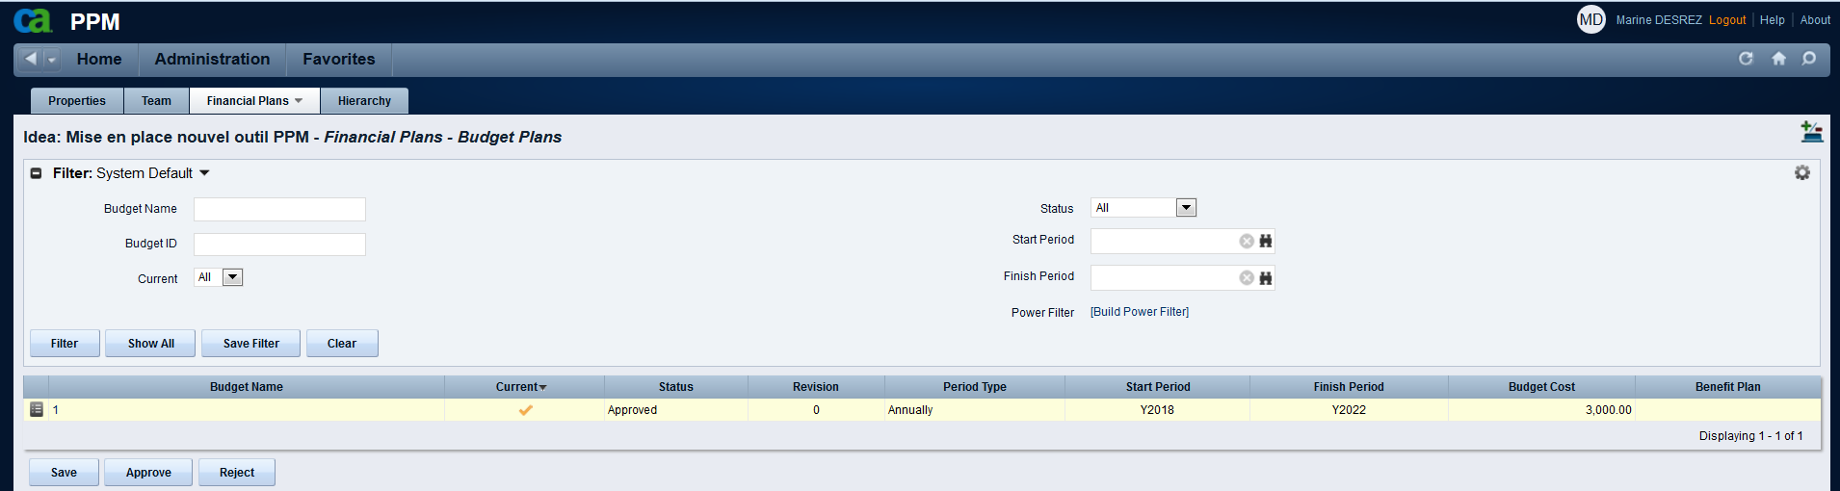

After an idea is converted to a project.
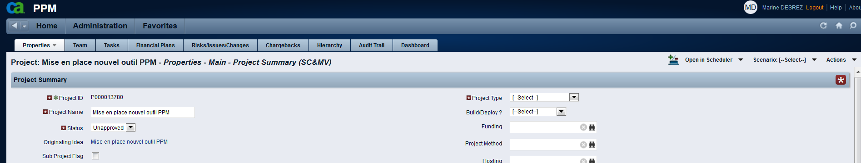

The approved budget from idea was deleted in financial plans. I would like to see the approved budget (in idea) attribute(s) in project view.
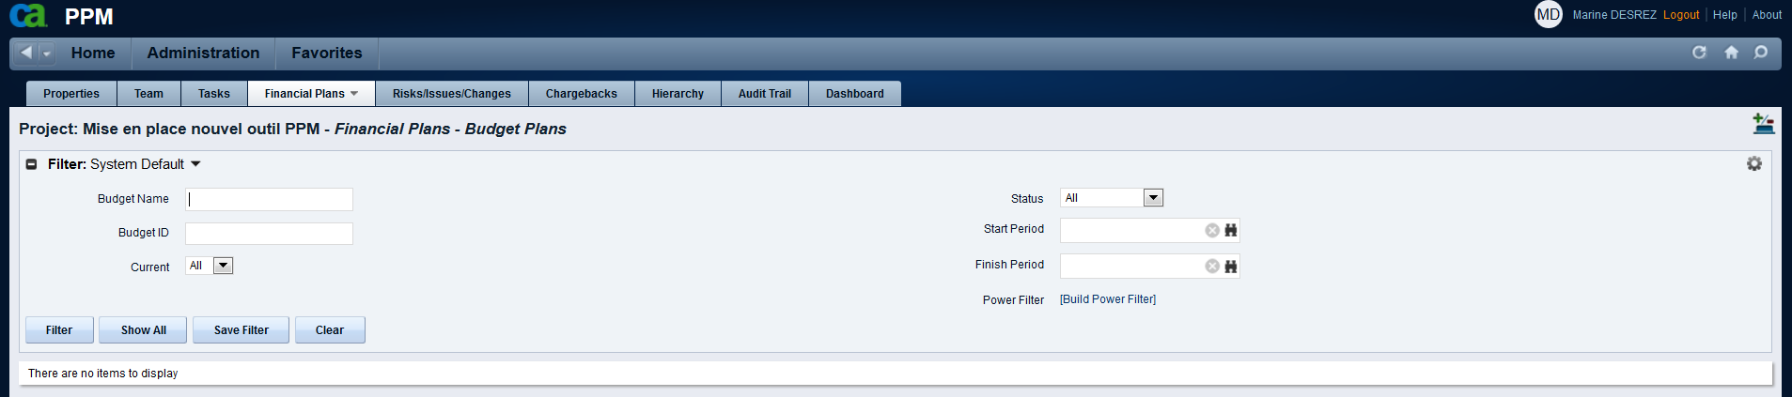
The approved budget (in idea) must be available in attributes Registry in Portfolio Investment Object too.
