Migrating CA Test Data Manager from
On-Premises to Cloud

SWAT TEAM

Table of Contents
Introduction 3
TDM Architecture Diagram 3
Migration Tasks 4
TDM Server system port Requirements 5
TDM Component Ports 5
Source and Target Database Ports 5
TDM Repository Migration 6
Backup and Restore the Repository 6
Create New Repository and move projects 6
TDM OrientDB Migration 7

Introduction
The purpose of this document is to provide steps to migrate TDM from On-Prem to Cloud Platform.
Note:
- This guide deals with database instance being migrated from physical machine or internal virtual machine to the cloud infrastructure.
- Procedure followed here in only with respect to Test Data Management and Cloud Security should be followed as per the cloud recommendation.
- The network between TDM and Database should be stable and available all the time for best performance.
- Please make sure all the ports are enabled

TDM Architecture Diagram
The below diagram shows a basic TDM logical system architecture.

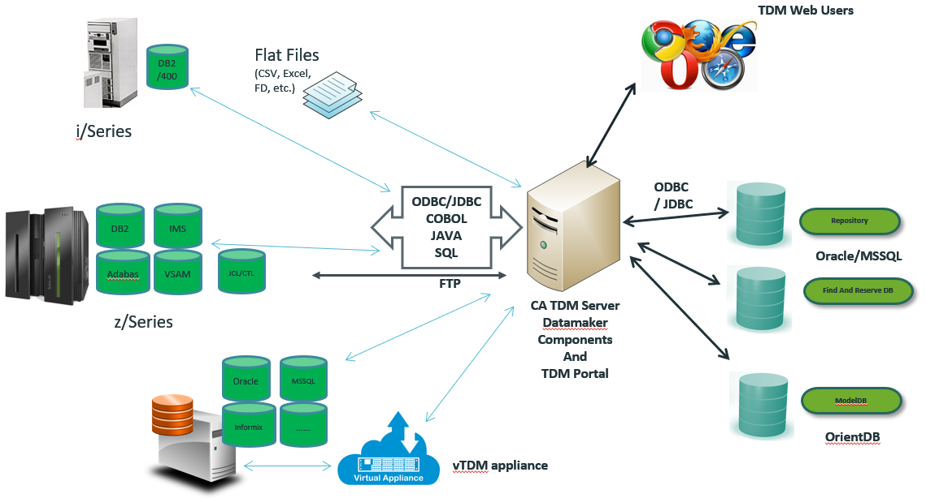

Migration Tasks

This is a high level summary of the tasks required to complete when planning a migration from a TDM on-premise implementation to a cloud platform.

1 Ensure that the cloud TDM environment meets the following requirements -
https://techdocs.broadcom.com/content/broadcom/techdocs/us/en/ca-enterprise-software/devops/test-data-management/4-9/installing/install-test-data-manager/system-requirements.html
1 Ensure that the TDM server in the cloud environment has network connectivity to the cloud based TDM Repository Database server. The ports required are listed in the following section.
2 Shut down the on premise TDM services before backing up the TDM Repository and OrientDB
3 Backup TDM database (Repository) from on-premise location
4 Backup TDM OrientDB from on-premise location
5 Restore TDM database (Repository) to cloud instance
6 Install TDM software on cloud platform
7 Stop TDM Portal Service
8 Restore TDM OrientDB to cloud environment
9 Copy any TDM customisations from on-premise to cloud instance
a Custom Certificates
b Additional Drivers
10 Start TDM Portal Service
11 Ensure that the TDM server in the cloud environment has network connectivity to the cloud based managed Database server. The ports required are listed in the following section

TDM Server system port Requirements
The following table summarizes the default ports used by TDM:

TDM Component Ports
From | To | Port
ARD | TDM | TCP 8090
TDM Portal  Data Maker  Remote Publish Service  Service Layer – TDOD Service | Repository | JDBC MSSQL 1433 /Oracle 1521  ODBC MSSQL 1433 /Oracle 1521  ODBC MSSQL 1433 /Oracle 1521  ODBC MSSQL 1433 /Oracle 1521
TDM Portal  Datamaker | Active Directory | LDAP 389 / LDAPS 636  LDAP 389 / LDAPS 636
TDM Portal  Remote Publish Service | Email Server | SMTP – TCP 25  SMTP – TCP 25
TDM Portal | OrientDB | TCP 2424
TDM Portal | Find and Reserve Database | JDBC MSSQL 1433 /Oracle 1521 (Location - TDM Repository as the default configuration)
Data Maker | Mainframe | FTP – TCP 22
TDM Portal | Masking Messaging Container | TCP 5671
Masking Messaging Container | Masking Container | TCP 5671

Source and Target Database Ports
TDM Portal  DataMaker | Oracle | TCP 1521
TDM Portal  DataMaker | MS SQL | TCP 1433
TDM Portal  DataMaker | IBM DB2 AS400 | TCP 446
TDM Portal  DataMaker | IBM DB2 z/OS | TCP 446
TDM Portal  DataMaker | Teradata | TCP 1025
TDM Portal  DataMaker | PostGres | TCP 5432
TDM Portal  DataMaker | MySQL | TCP 3306

TDM Repository Migration

- Backup and Restore the Repository
- Create New Repository and move projects.
NOTE: Upgrade and Installation procedure would be same as the procedure followed on premises version. You can follow TDM Upgrade Center for relevant upgrade documents.
Reference Link:
TDM Upgrade Center

Backup and Restore the Repository
We recommend that you backup your GTREP TDM REPOSITORY before you upgrade the CA TDM software. This process varies depending on your database. Check with your Database Administrator for more information on how to proceed.

Suggested Process:
- Clean up the Projects in Repository – Remove the unwanted projects
Reference Link:
Deleting the Projects

- Backup the TDM Repository on the Database Server
Reference Link:
Backup the Repository

- Restore the TDM Repository on the new Database Server
- Install the TDM portal server with reference to the new Database Server
- Create new connection profile to the new database server details.
- Install Datamaker and make the necessary connection

Create New Repository and move projects
This procedure can be followed if you don’t want to reuse any projects from old environment or have very few projects.

- Setup new server TDM REPOSITORY on new Database server on Cloud with proper access control.
- Install TDM Portal on the new server using the TDM Repository database server details.
- Create the TDM Portal connection profile
- Install the Data Maker and make the required connection
- If there are any project you need to move from older environment, you can follow moving the Projects from one repository

Reference Link:
Copy Remote Repository

TDM OrientDB Migration

Before Migrating the TDM OrientDB database the OrientDB service should be stopped by running the following command
net stop OrientDB
Once the OrientDB service is stopped the database files can be copied from this default location:
c:\ProgramData\CA\CA Test Data Manager Portal\orientdb\databases
The OrientDB service can now be restarted
net start OrientDB
To restore the OrientDB databases to the cloud environment copy the backed up database files to the cloud TDM Server and reverse the procedure

