Summary of Ports Used In Symantec DLP

- Enforce Server (https) -- port: 443

- Upgrade Wizard (Enforce) -- port: 8300

- Communications from Enforce to Oracle Database -- port: 1521

- Communications from Enforce to Detection Servers -- port: 8100

- Communications from Endpoint Agents to Enforce Server -- port: 8000

DLP Services Troubleshooting

You need to restart manually the Symantec DLP Enforce services.

How to stop the Symantec DLP Enforce Services:

1. Vontu Monitor Controller (if applicable)
2. Vontu Incident Persister
3. Vontu Manager
4. Vontu Notifier
5. Vontu Update (if necessary)

How to start the Symantec DLP Enforce Services:

1. Vontu Notifier
2. Vontu Manager
3. Vontu Incident Persister
4. Vontu Monitor Controller (if applicable)
5. Vontu Update (if necessary)

1. Check the following to ensure that all services are running properly.

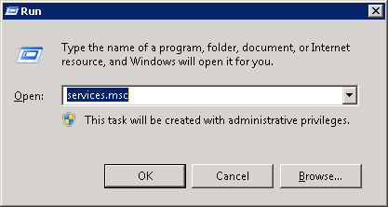

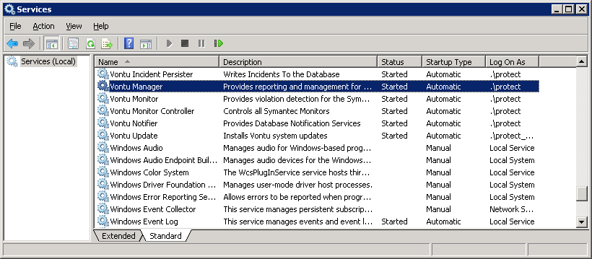

2.Check the Startup Type of all vontu services are set to Automatic.
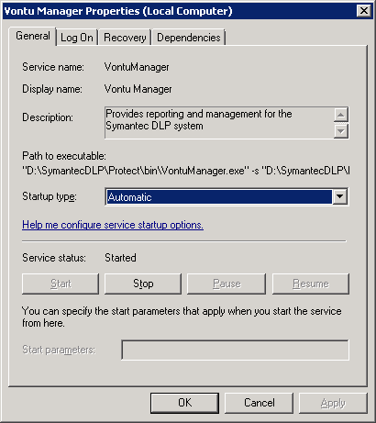
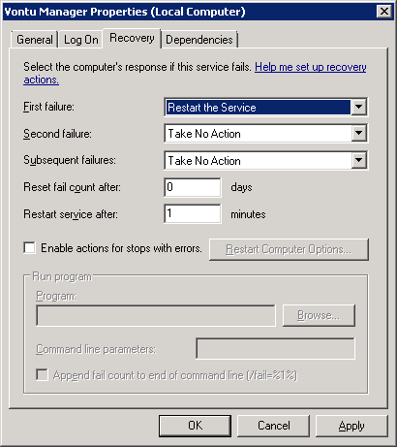
3. Go to System > Servers > Overview
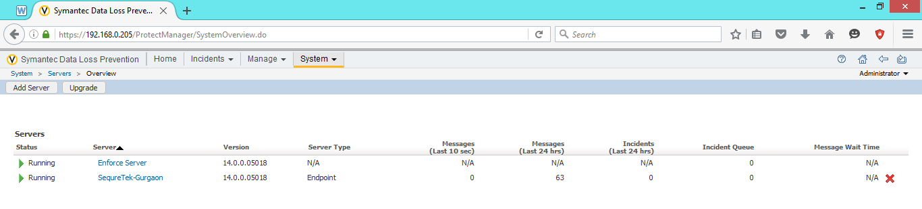
4. Check whether the servers are running properly.
5. Select Detection Server.
6. Check if there any Errors or Warnings.
7. Click Recycle to Restart All Service.

