How to block the access of Application (eg – vlc.exe)

Problem
Require blocking the access of Application (eg – vlc.exe)
Solution
1. Block Access of Application
a. Login into the SEPM console.
b. Click Policies, and then click Application and Device Control under View Policies.
c. Select the Application and Device Control policy which needs to be modified on the right-hand side.
d. Click Edit the Policy under Tasks.
e. In the pop-up window, click Application Control.
f. Click the Add... button.
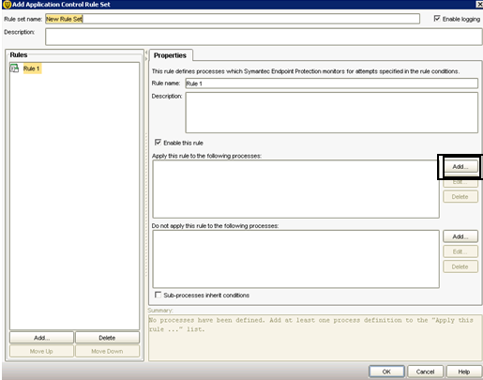
G. In section of “Apply this rule in the following process” click on ADD and enter the Asterisk (*) Sign. Then Select Ok.

H. Now Click on Add from Bottom
I. Click on Add Condition and select the Launch Process Attempts.
J. Under the Launch Process Attempts box click on ADD in the section of “Apply this rule in the following process”
K. Enter the application name (eg- vlc.exe)
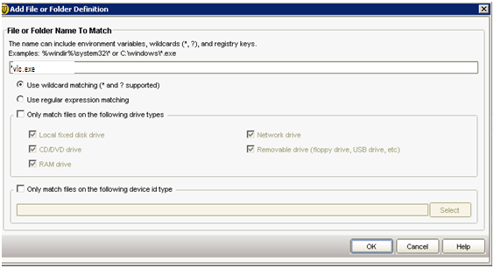

L. Then press ok
M. Go to the Action Tab in “Launch Process Attempts”.
N. Select the Block Access in the “Launch Process Attempts” and check “enable logging”.
O. Select Ok.
Now policy has been created success. Assign the policy to that Group where it Require.

