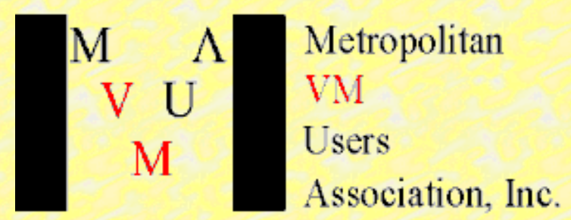 Agenda
2021- Virtual Users Group Meeting

Date: Tuesday, January 19  Time: 9:50am – 2:00pm (Eastern Time Zone) | Meeting coordinators:  Name: Eric Schuler-Dalverny  Bill Munson  Email: FOCUSsys@yahoo.com

Wilhelm Mild from IBM will present:
Title: Plan and get the why to build a Red Hat OpenShift Container Platform on IBM Z and LinuxONE

Abstract:
With Red OpenShift Container Platform on IBM Z and IBM LinuxONE, the journey towards Hybrid Multi Cloud environments and Confidential Computing is easier than ever. This session will outline the best use cases and explain the options, capabilities and advantages running them on IBM Z and IBM LinuxONE. It will cover the integration with existing z/OS environments or Native Cloud implementations.

Vincent Terrone from Vicom Infinity will present:
Title: The Llama Project

Abstract:
Red Hat Ansible module/playbook for automated provisioning of IBM Storage on IBM LinuxONE and Linux on IBM Z.

Bill Bitner from IBM will present:
Title: z/VM 7.2 in 60 Minutes or Less

Abstract:
The z/VM Platform Update: Expanding the Horizon with z/VM 7.2 has been presented several times in the past 6 months at various virtual events. You may also have seen "Leveraging the Newest Capabilities in z/VM" session. This presentation will be a bit of a Frankenstein as we look at parts of these two presentations and some other information and try to give you the most important information for z/VM 7.2. So grab a coffee and join Bill for chat on the newest technology from z/VM.

Yvonne Demeritt from Broadcom will present:
Title: Making VM work for you through the power of automation

Abstract:
When there isn't enough time in the day or hours to execute the demanding schedules we're all presented with, automation in the world of VM becomes a necessity for success and sanity.

