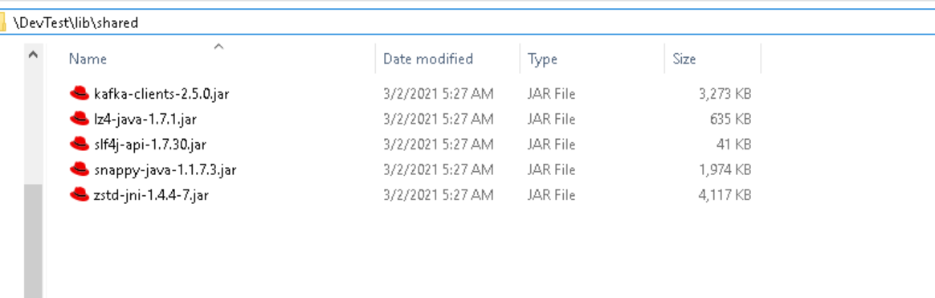

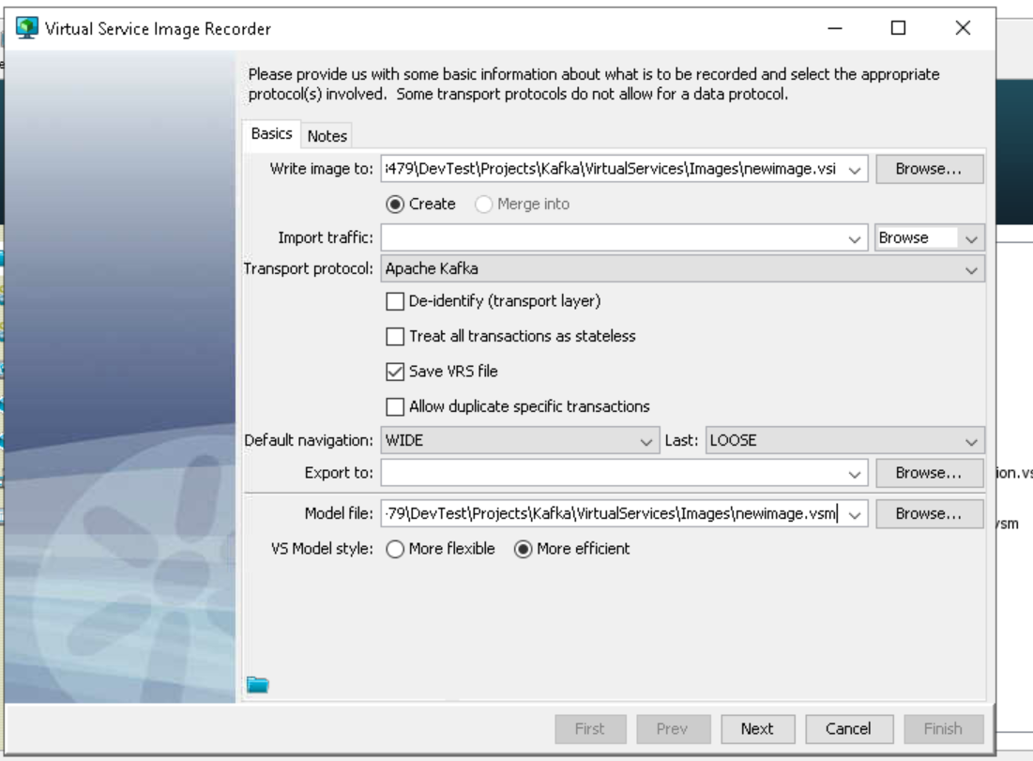

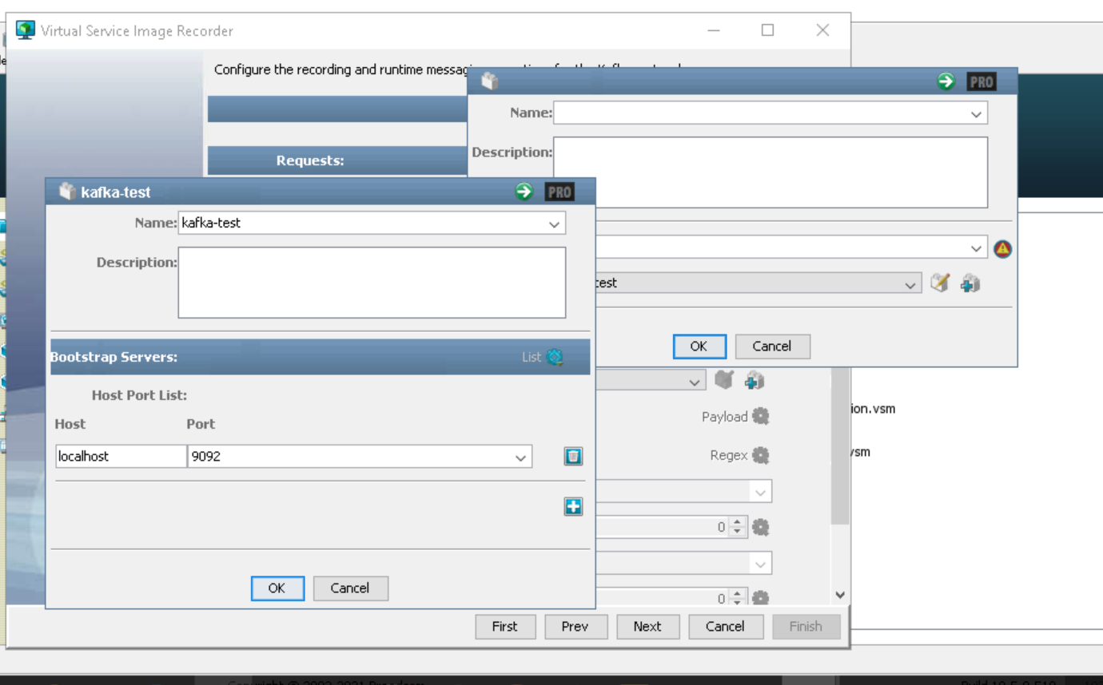

Verifying Asset
Unexpected error: org/apache/kafka/common/errors/InterruptException
java.lang.NoClassDefFoundError: org/apache/kafka/common/errors/InterruptException
at com.itko.lisa.messaging.providers.kafka.asset.KafkaConfigAsset.verifyInstance(KafkaConfigAsset.java:171)
at com.itko.lisa.messaging.providers.kafka.asset.KafkaConfigAsset.verifyInstance(KafkaConfigAsset.java:45)
at com.itko.lisa.asset.AssetUtils.verifyRuntimeAsset(AssetUtils.java:1300)
at com.itko.lisa.asset.ui.AssetEditor$5.run(AssetEditor.java:306)
at com.itko.lisa.asset.ui.ProgressLog$Worker.doInBackground(ProgressLog.java:142)
at com.itko.lisa.asset.ui.ProgressLog$Worker.doInBackground(ProgressLog.java:100)
at javax.swing.SwingWorker$1.call(SwingWorker.java:295)
at java.util.concurrent.FutureTask.run(FutureTask.java:266)
at javax.swing.SwingWorker.run(SwingWorker.java:334)
at java.util.concurrent.ThreadPoolExecutor.runWorker(ThreadPoolExecutor.java:1142)
at java.util.concurrent.ThreadPoolExecutor$Worker.run(ThreadPoolExecutor.java:617)
at java.lang.Thread.run(Thread.java:745)
Caused by: java.lang.ClassNotFoundException: org.apache.kafka.common.errors.InterruptException
at java.net.URLClassLoader.findClass(URLClassLoader.java:381)
at java.lang.ClassLoader.loadClass(ClassLoader.java:424)
at sun.misc.Launcher$AppClassLoader.loadClass(Launcher.java:331)
at java.lang.ClassLoader.loadClass(ClassLoader.java:357)
... 12 more

