- Patch Remediation Center-> All Software Bulletins-> Search for MS12-048

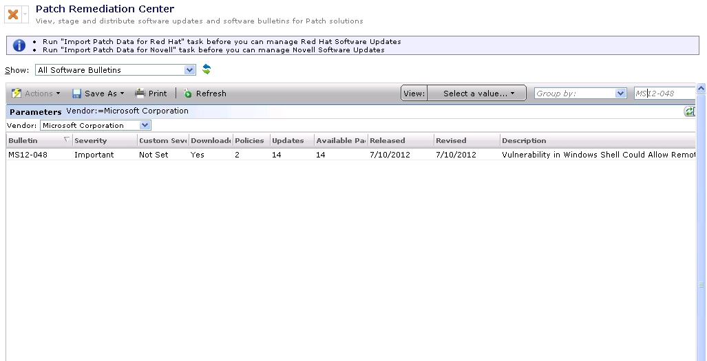

- Right Click on the Bulletin and select “List Software Updates”.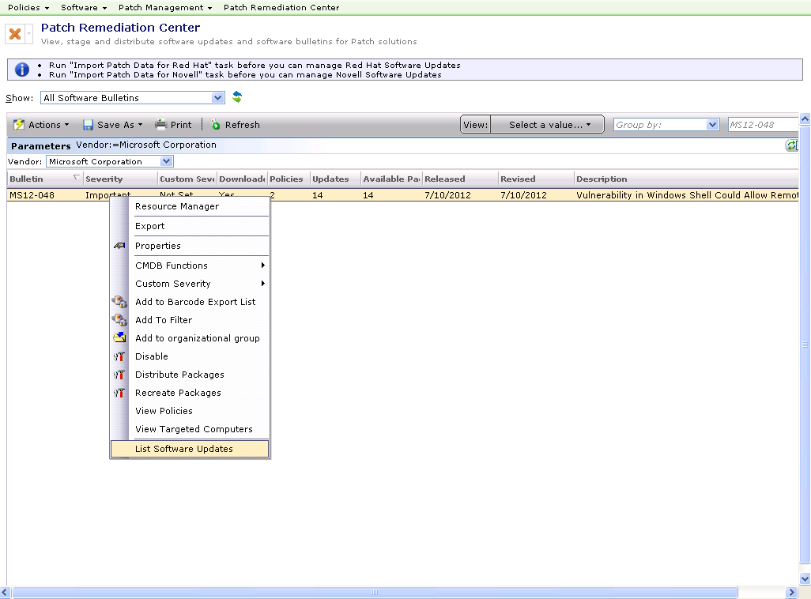

- Now we have all the updates contained in the bulletin.

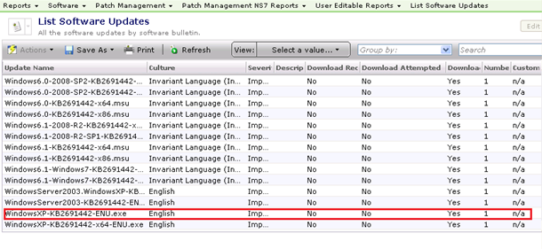
- Patch Remediation Center-> All Software Updates-> Search for KB2691442.
No patch available here for Windows XP X86 machines.

