CIS Microsoft Windows Server 2012 R2 v2.2.0 (v2.2.1)

Check: 1.2.3 Is the 'Reset account lockout counter after' parameter set to '15 or more minute(s)'? 2
Status and evidence as reported by CCS: 2
Issue: Check has wrong expression 2
Fix: Expression should use “>=” instead of “=” 2
Check: 18.4.13.1 (18.4.14.1) Is the 'Hardened UNC Paths' parameter set to 'Enabled, with "Require Mutual Authentication" and "Require Integrity" set for all NETLOGON and SYSVOL shares'? 2
Status and evidence as reported by CCS: 2
Setting on server: 3
Issue: 3
Fix: 3
Check: 18.9.22.3 (18.9.24.3) Is the 'Default Protections for Internet Explorer' parameter set to 'Enabled'? 4
Status and evidence as reported by CCS: 4
Setting on server: 4
Issue: 4
Fix: 4
Check: 18.9.22.4 (18.9.24.4) Is the 'Default Protections for Popular Software' parameter set to 'Enabled'? 4
Status and evidence as reported by CCS: 4
Setting on server: 5
Issue: 5
Fix: 5
Check: 18.9.22.5 (18.9.24.5) Is the 'Default Protections for Recommended Software' parameter set to 'Enabled'? 5
Status and evidence as reported by CCS: 5
Setting on server: 5
Fix: 5
Check: 18.9.24.4.2 (18.9.26.4.2) Is the 'System: Specify the maximum log file size (KB)' parameter set to 'Enabled: 32,768 or greater'? 6
Status and evidence as reported by CCS: 6
Setting on server: 6
Issue: 6
Fix: 6

Check: 1.2.3 Is the 'Reset account lockout counter after' parameter set to '15 or more minute(s)'?

Status and evidence as reported by CCS:
Check Name | Status | Risk Score | Evidence
1.2.3 Is the 'Reset account lockout counter after' parameter set to '15 or more minute(s)'? | Fail... | 3.799999952 | Object Name: WORKGROUP\\GOLDV8W2K12  Object Type: Machines  Expression: Reset account lockout after = '900'  Current Value: 01:00:00
Setting on server: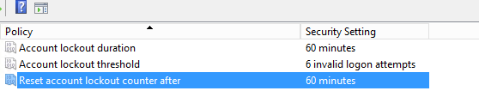
Issue: Check has wrong expression
Fix: Expression should use “Greater or equal to” instead of “Equal to”

Check: 18.4.13.1 (18.4.14.1) Is the 'Hardened UNC Paths' parameter set to 'Enabled, with "Require Mutual Authentication" and "Require Integrity" set for all NETLOGON and SYSVOL shares'?

Status and evidence as reported by CCS:
Check Name | Status | Risk Score | Evidence
18.4.13.1 Is the 'Hardened UNC Paths' parameter set to 'Enabled, with "Require Mutual Authentication" and "Require Integrity" set for all NETLOGON and SYSVOL shares'? | Fail... | 6.900000095 | Object Name: [No data available]  Object Type: Registry  Expression: Wnt.Registry.REGISTRYDATATYPEUSINGWMI = 'reg_sz'  Current Value: [No data available]  Object Name: [No data available]  Object Type: Registry  Expression: Wnt.Registry.REGISTRYVALUEUSINGWMI =~ '[Rr]equire([Mm]utual[Aa]uthentication|[Ii]ntegrity)=1.*[Rr]equire([Mm]utual[Aa]uthentication|[Ii]ntegrity)=1'  Current Value: [No data available]
Setting on server:
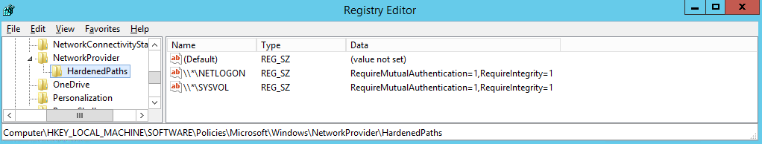
Issue:
Original check logic has trouble reading unusual registry value name like "\\*\SYSVOL".
Fix:
Re-write check to use Key/Value Name Matches Pattern instead of Value Name Equal To inside Data Item Filter:
“Key/Value Name Matches Pattern '/^HKLM\\SOFTWARE\\Policies\\Microsoft\\Windows\\NetworkProvider\\HardenedPaths\\.*SYSVOL$/”

Check: 18.9.22.3 (18.9.24.3) Is the 'Default Protections for Internet Explorer' parameter set to 'Enabled'?
Check Name | Status | Risk Score | Evidence
18.9.22.3 Is the 'Default Protections for Internet Explorer' parameter set to 'Enabled'? | Fail... | 6.800000191 | Object Name: [No data available]  Object Type: Registry  Expression: Wnt.Registry.REGISTRYDATATYPEUSINGWMI = 'reg_sz'  Current Value: [No data available]

Status and evidence as reported by CCS:
Setting on server:
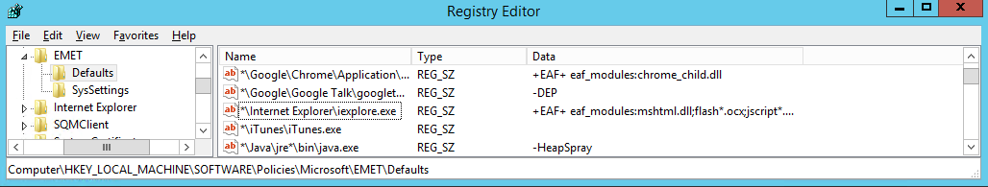
Issue:
Original check logic has trouble reading unusual registry value name like " *\Internet Explorer\iexplore.exe". On top of that, original checks does not verify if registry value data matches.
Fix:
Re-write check to use Key/Value Name Matches Pattern instead of Value Name Equal To inside Data Item Filter: Key/Value Name Matches Pattern '/^HKLM\\Software\\Policies\\Microsoft\\EMET\\Defaults\\.*Internet Explorer.*iexplore.exe$/i'

Check: 18.9.22.4 (18.9.24.4) Is the 'Default Protections for Popular Software' parameter set to 'Enabled'?

Status and evidence as reported by CCS:
Check Name | Status | Risk Score | Evidence
18.9.22.4 Is the 'Default Protections for Popular Software' parameter set to 'Enabled'? | Fail... | 6.800000191 | Object Name: [No data available]  Object Type: Registry  Expression: Wnt.Registry.REGISTRYDATATYPEUSINGWMI = 'reg_sz'  Current Value: [No data available]

Setting on server:
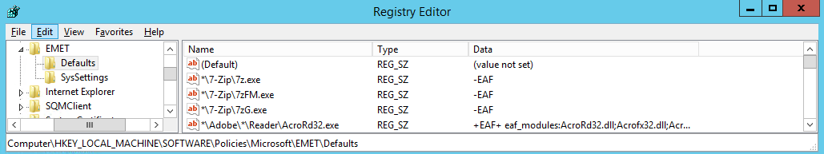
Issue:
Original check logic has trouble reading unusual registry value name like " *\7-Zip\7z.exe". On top of that, original checks does not verify if registry value data matches.
Fix:
Re-write check to use Key/Value Name Matches Pattern instead of Value Name Equal To inside Data Item Filter: Where Key/Value Name Matches Pattern '/^HKLM\\Software\\Policies\\Microsoft\\EMET\\Defaults\\.*7-Zip.*7z.exe$/'
NOTE: not all registry values are covered here, only the first one, but the pattern to fix all is the same.

Check: 18.9.22.5 (18.9.24.5) Is the 'Default Protections for Recommended Software' parameter set to 'Enabled'?

Status and evidence as reported by CCS:
Check Name | Status | Risk Score | Evidence
18.9.22.5 Is the 'Default Protections for Recommended Software' parameter set to 'Enabled'? | Fail... | 6.800000191 | Object Name: [No data available]  Object Type: Registry  Expression: Wnt.Registry.REGISTRYDATATYPEUSINGWMI = 'reg_sz'  Current Value: [No data available]

Setting on server:
Issue:
Original check logic has trouble reading unusual registry value name like " *\Adobe\*\Reader\AcroRd32.exe". On top of that, original checks does not verify if registry value data matches.

Fix:
Re-write check to use Key/Value Name Matches Pattern instead of Value Name Equal To inside Data Item Filter: Where Key/Value Name Matches Pattern ' '/^HKLM\\Software\\Policies\\Microsoft\\EMET\\Defaults\\.*Adobe.*Reader.*AcroRd32.exe$/'
NOTE: not all registry values are covered here, only the first one, but the patters to fix all is the same.

Check: 18.9.24.4.2 (18.9.26.4.2) Is the 'System: Specify the maximum log file size (KB)' parameter set to 'Enabled: 32,768 or greater'?

Status and evidence as reported by CCS:
Check Name | Status | Risk Score | Evidence
18.9.24.4.2 Is the 'System: Specify the maximum log file size (KB)' parameter set to 'Enabled: 32,768 or greater'? | Fail... | 3.799999952 | Object Name: HKLM\Software\Policies\Microsoft\Windows\EventLog\System\MaxSize  Object Type: Registry  Expression: Wnt.Registry.REGISTRYVALUEUSINGWMI >= '32768'  Current Value: 100000

Setting on server:
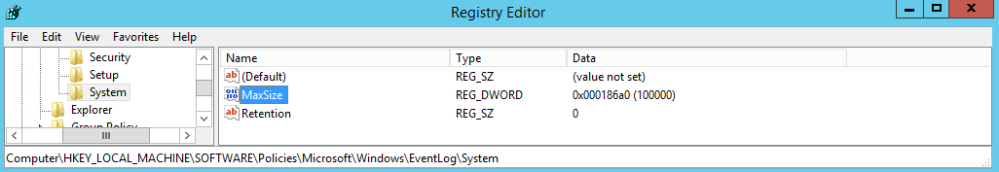
Issue:
Some bug in WMI registry check that caused it not to recognize values properly.
Fix:
Change Value >= '32768' to Value as DWORD Greater or Equal To '32768'

