Here are the data objects I am using to handle the assignment of the manager on the endpoint object.
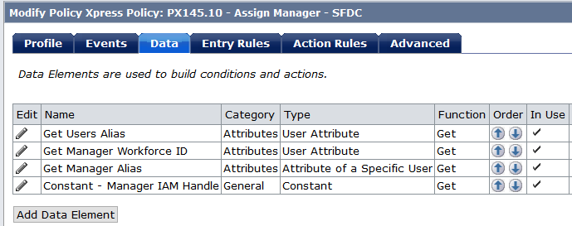

I’m pulling in the users ID. Then using the user’s manager ID to identify the manager account on the Saleforce endpoint.

We created a constant to identify a users account on the SFDC endpoint being that users on that endpoint are identified by their ID.
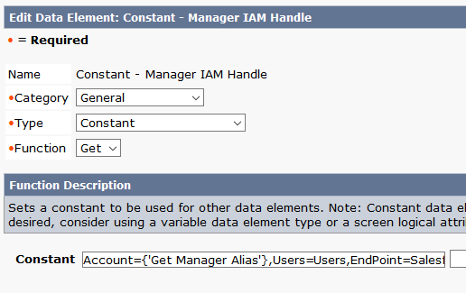
Account={'Get Manager Alias'},Users=Users,EndPoint=Salesforce,Namespace=Salesforce,Domain=idv,Server=Server
Using the constant created above we are assigning the manager to the user object. This is the IAM handle that is used to assign the manager to the users account(See Below).

The Entry rule for development purposes will allow for this Policy to run on every modification. Also I am using the message function to validate the output of my data elements. I have been unsuccessful with retrieveing and manager information that is present on the SFDC endpoint.
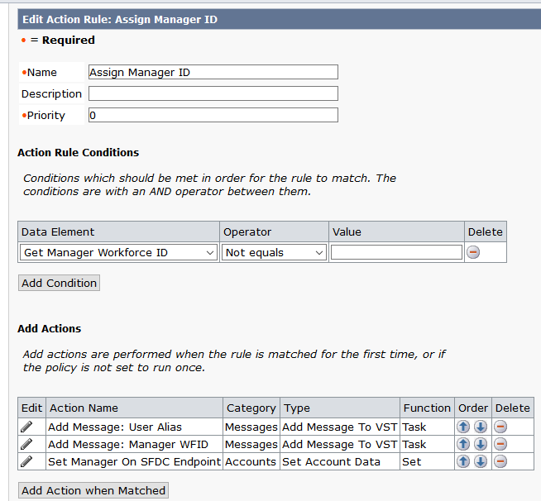
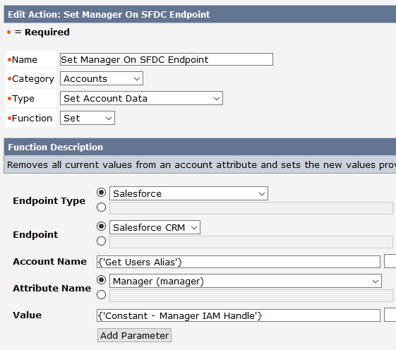

Note: This manager must be present on the SFDC endpoint for this to work. If the manager is not present we then encounter the current issue where the task will hang.

