How to replicate the Asset status of child NS client computers from child NS to parent NS using the stand-alone "Resources" replication rule starting from 8.0 HF1 release?

1. Open Symantec Management Console on Notification Server from where you are going to replicate client computers with their "Asset Status" and export via "Stand-Alone" replication rule.
"Settings" ->"Notification Server" ->"Resource and Data Class Settings" ->"Resource Associations" -> right-click on "Asset's Status" ->"Export"
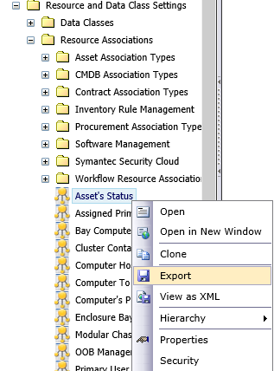
2. Open exported "Asset's Status.xml" file and change the following settings:
FROM Default settings:
<replicationImportMode>Add</replicationImportMode>
<hierarchyReplicationMode>Skip</hierarchyReplicationMode>

TO the following:
<replicationImportMode>Overwrite</replicationImportMode>
<hierarchyReplicationMode>SkipHierarchy</hierarchyReplicationMode>

- Save Changes
3. Now you have to import updated "Asset's Status.xml" using Symantec Management Console. Right-click "Resource Association" folder -> click "Import" -> choose "Asset's Status.xml" and import it.
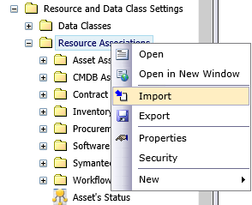

4. Open "Hierarchy Management" page on source Notification Server from where you will replicate client computers with their Asset status. Right-click "Resources" folder and create a new "Resource Replication Rule"

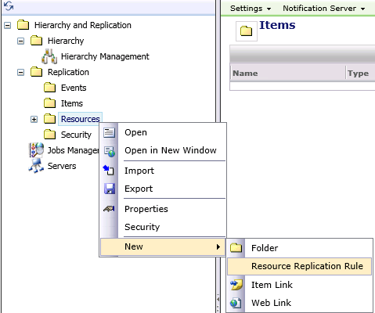

- In "Resource Replication Rule" choose required resources and their Data Classes for further replication (Destination NS address and credentials). When stand-alone replication is configured, you can run it via right-click menu on stand-alone replication rule.

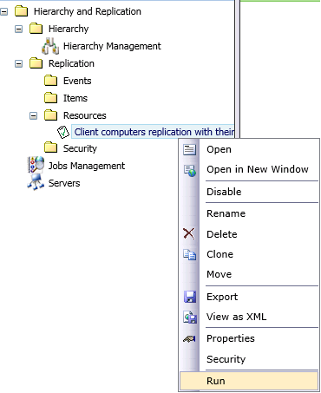
You can check the status of stand-alone replications from "Jobs Management" page on sending NS computer (Source NS).
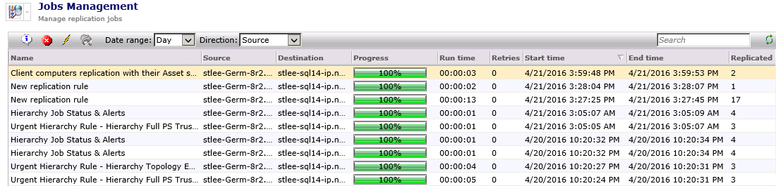
Once stand-alone replication rule is completed, you can open Symantec Management Console on destination Notification Server and check the replicated client computers Asset status in "All Assets" report.
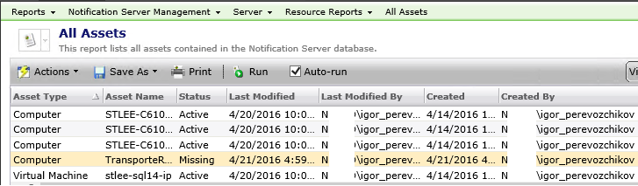
Notes:
1. This functionality works only using stand-alone replication rule when you have custom settings applied, described above in #1 of this Doc.
2. To disable ability of asset status replication via stand-alone replication rule, you need to return back these settings and re-import back "Asset's Status.xml" on Notification Server from Symantec Management Console (Described above in #3 and #4)
<replicationImportMode>Add</replicationImportMode>
<hierarchyReplicationMode>Skip</hierarchyReplicationMode>

3. If you are replicating computers with their "Basic Inventory" data classes and computersaren't available on destination Notification Server, then after 1st stand-alone replication, this replicated client computers will have status "Active" even if they are "Retired" on source Notification Server.

Question: Why computers areActive on destination NS after 1st "stand-alone" replication, if they areRetired on source NS?
Answer: This is because of first registration of this computer on destination NS and computer has updated own "AeX_AC_*" data classes after 1st stand-alone replication.

If you have destination NS which doesn't know about these client computers, then you will need to run "Stand-alone" replication rule 2 times on source NS and after that computers will have up-to-date own Asset status on destination NS.

