IP – Modules
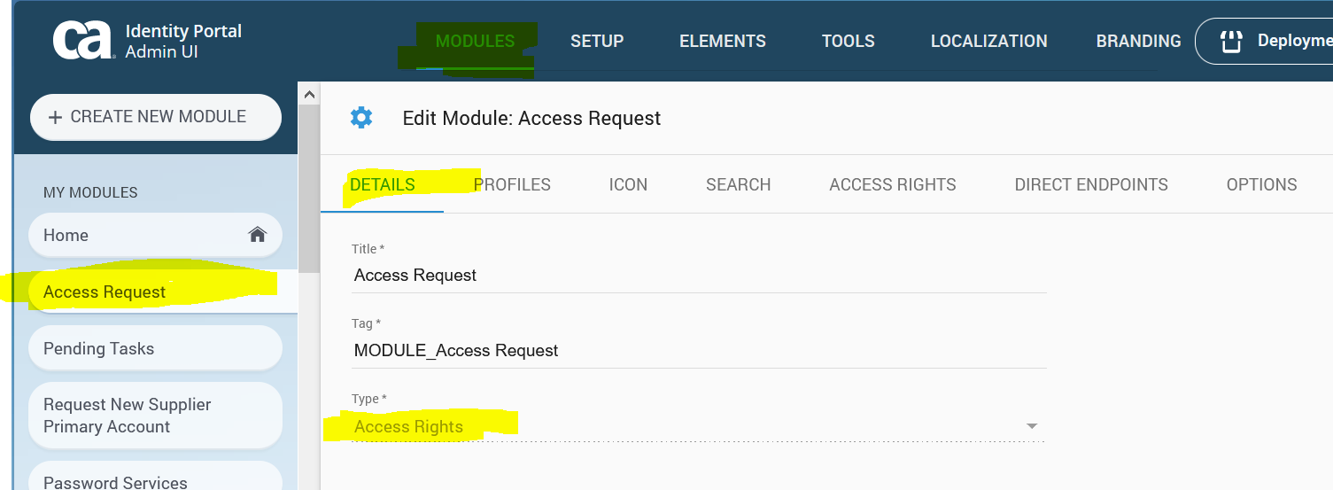
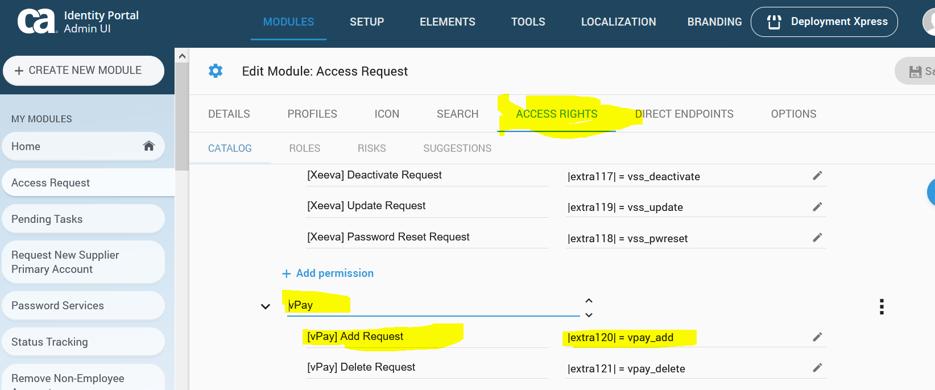
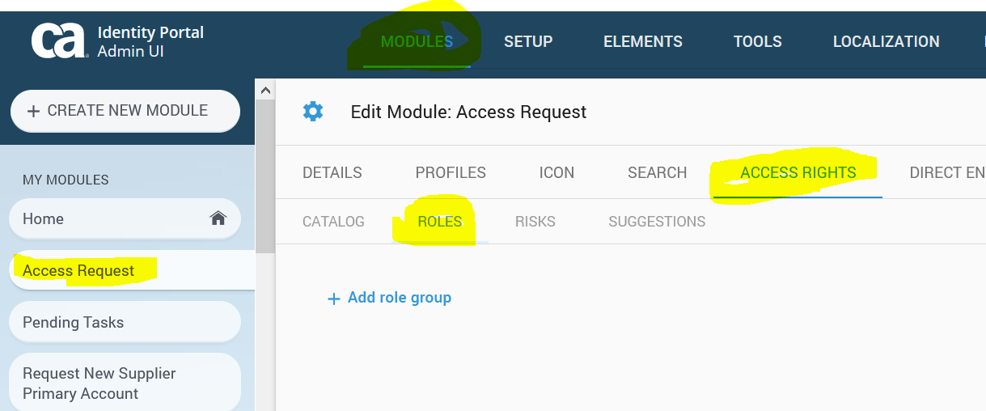
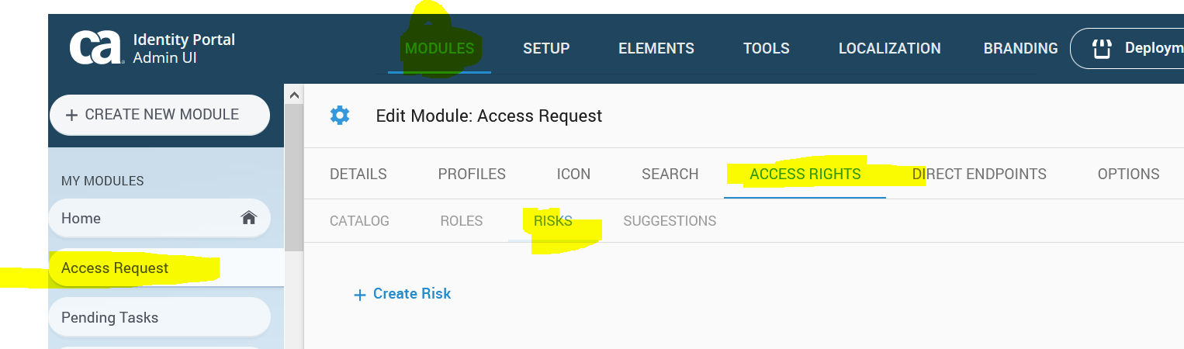
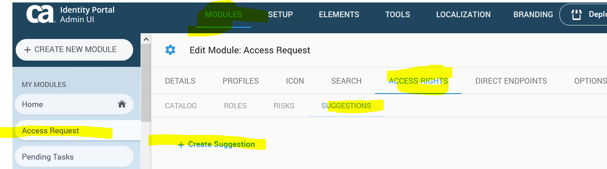

IP - Target Permission
|extra120| is a Logical attribute
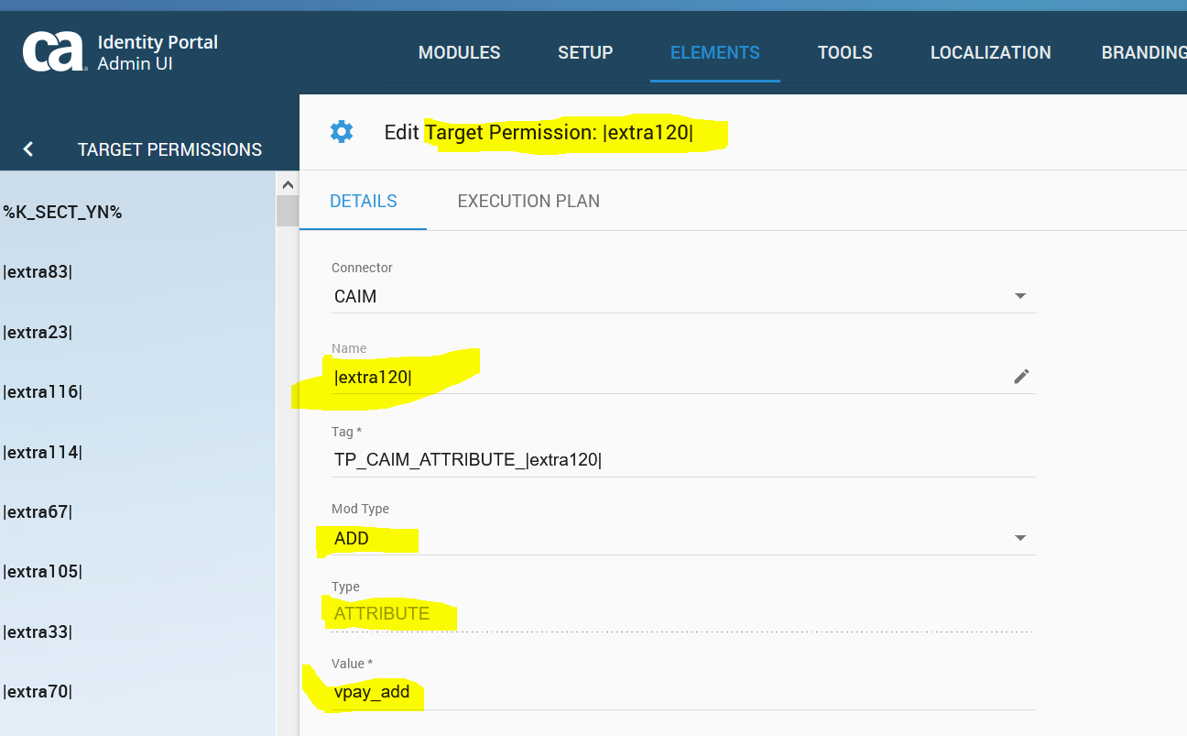

IP - Execution Plan
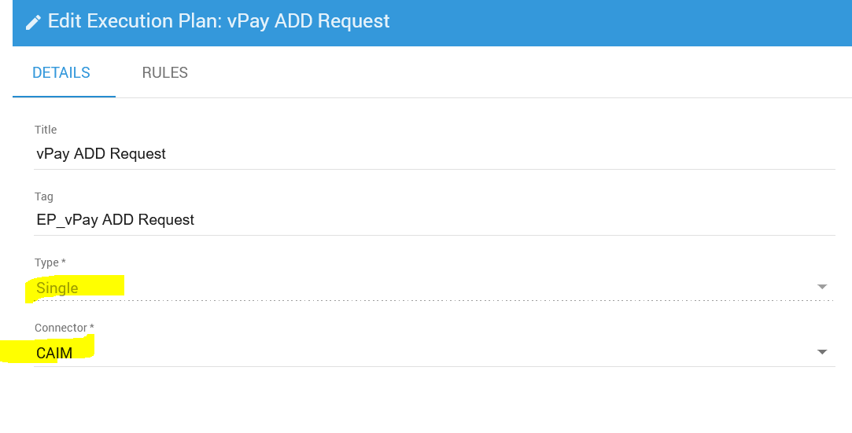
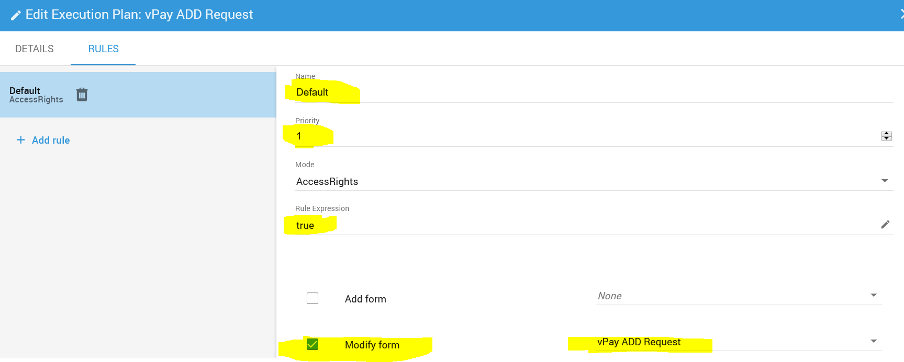

IP – Forms
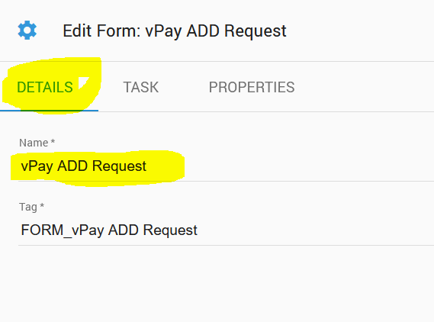
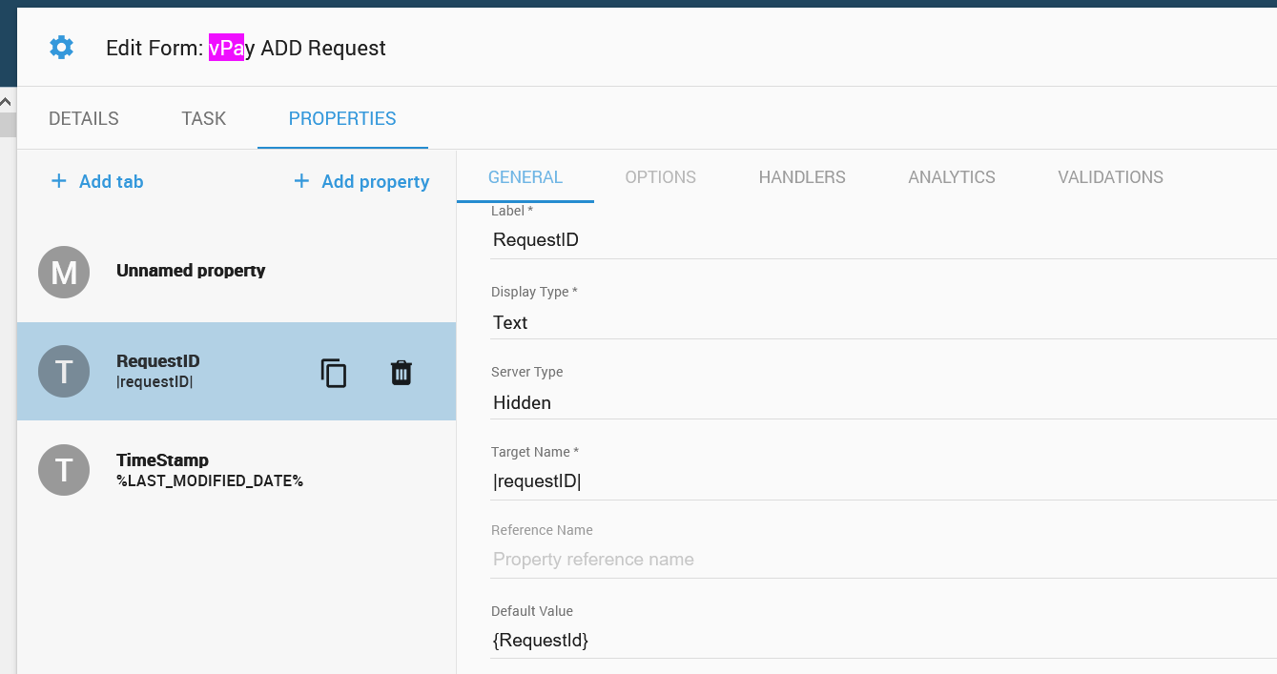
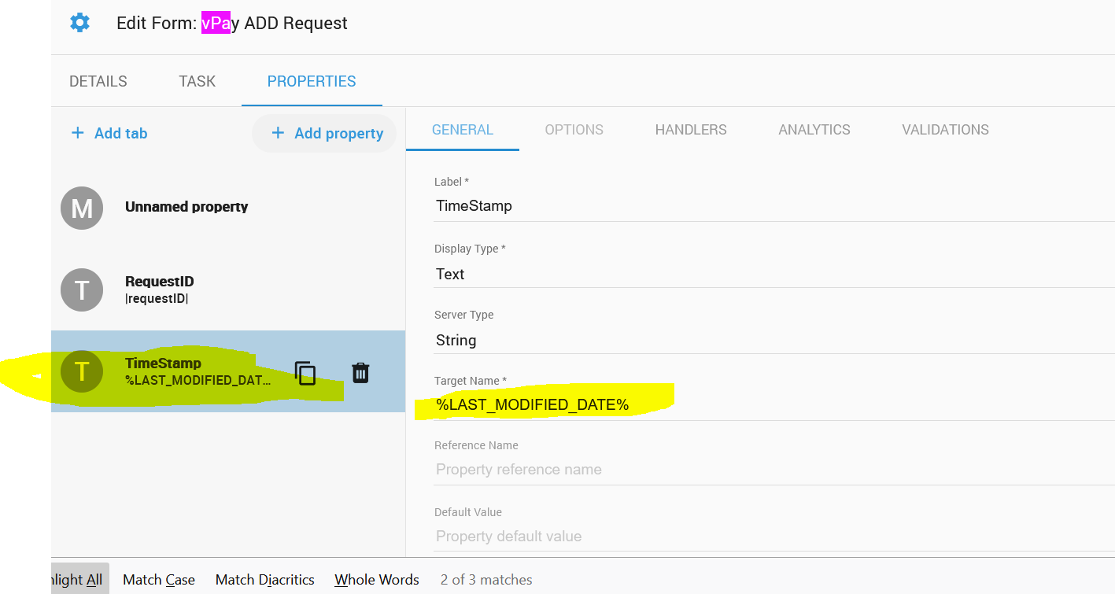
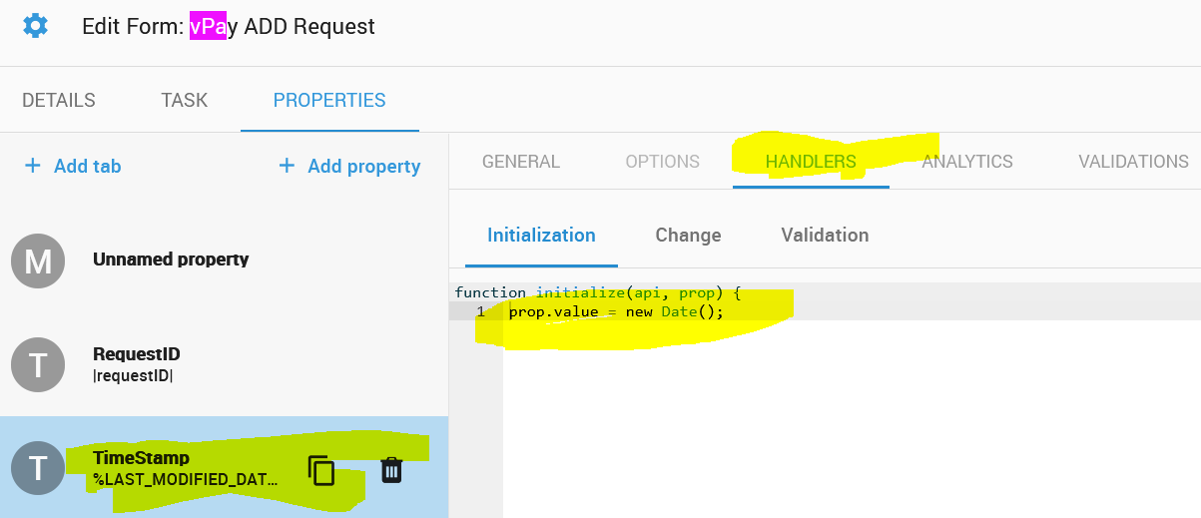

Mapped IP - Task
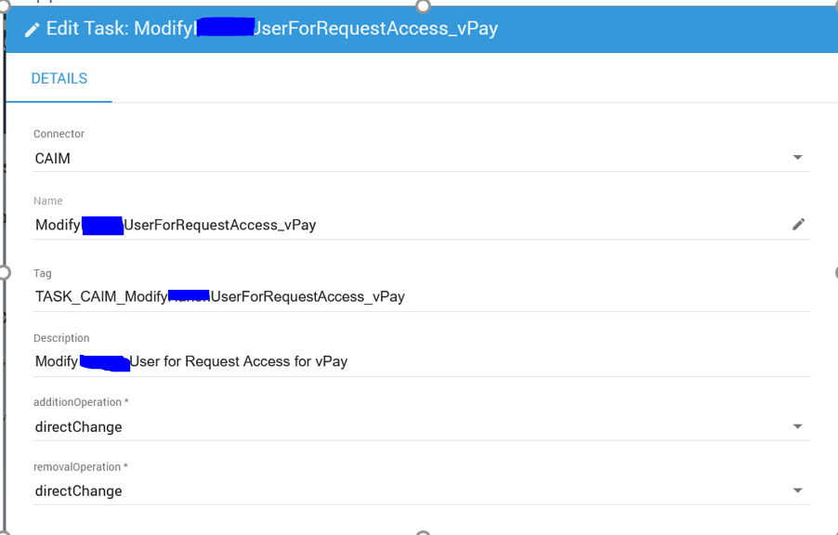

Mapped IM – Admin Task
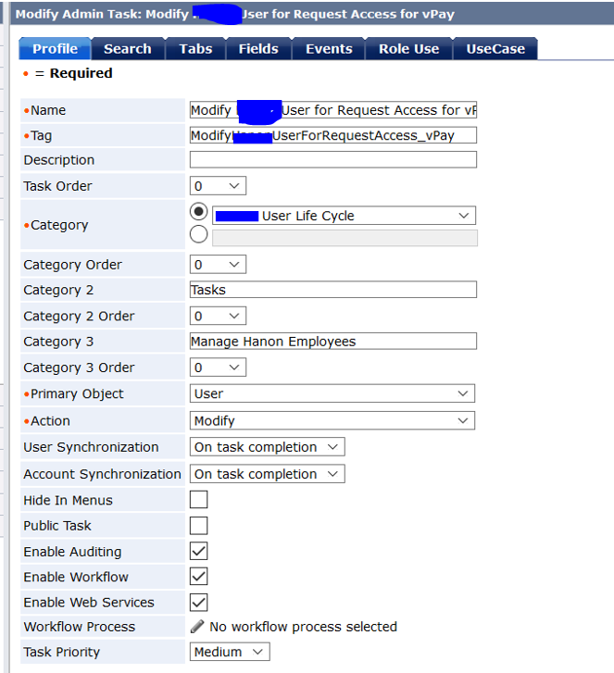

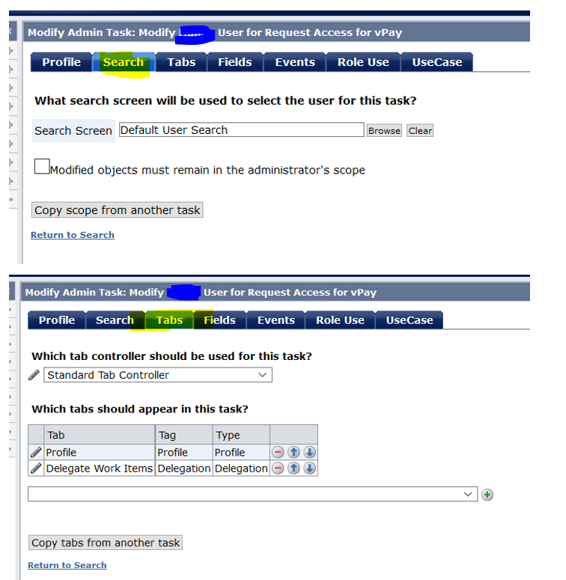

LAH – Logical Attribute Handler
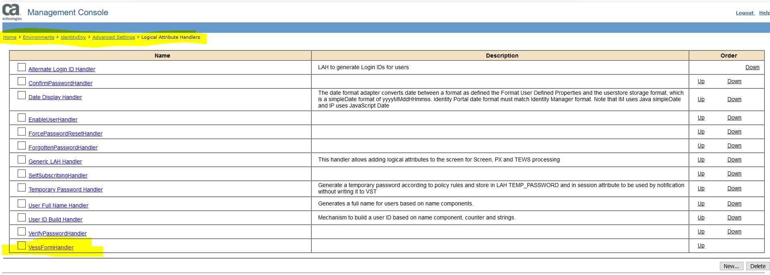

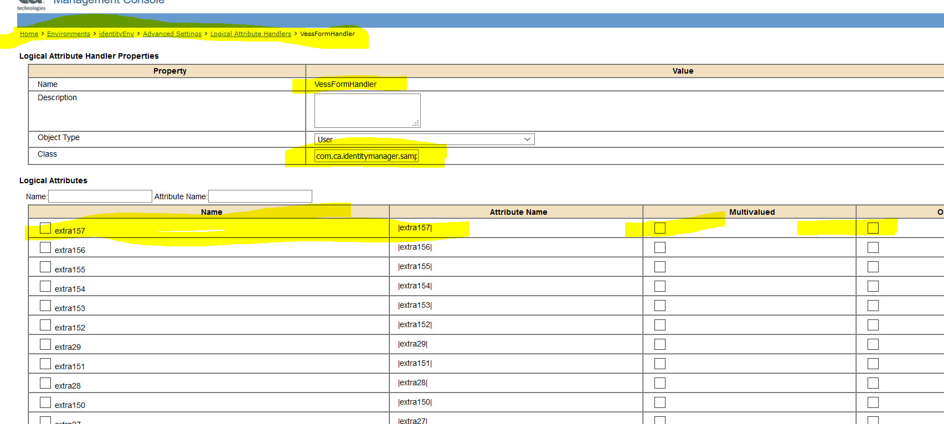

Code of Logical Attribute Handler

package com.ca.identitymanager.samples;

import com.netegrity.imapi.LogicalAttributeContext;
import com.netegrity.imapi.LogicalAttributeAdapter;

public class VessFormHandler extends LogicalAttributeAdapter
{
public void initialize(final LogicalAttributeContext attrContext) throws Exception {
}

public void validate(final LogicalAttributeContext attrContext) throws Exception {
this.logDebugMessage("[Debug]Start VessFormHandler", true);
this.logInfoMessage("[Info]Start VessFormHandler", true);
this.logErrorMessage("[Info]Start VessFormHandler", true);
this.logDebugMessage("[Debug]End VessFormHandler", true);
this.logInfoMessage("[Info]End VessFormHandler", true);
this.logErrorMessage("[Info]End VessFormHandler", true);
}

public void toLogical(final LogicalAttributeContext attrContext) throws Exception {
}

public void toPhysical(final LogicalAttributeContext attrContext) throws Exception {
}
}

Issue

Creating request
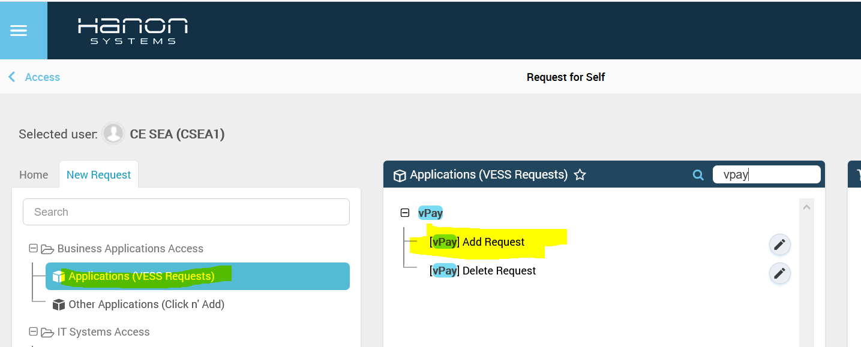
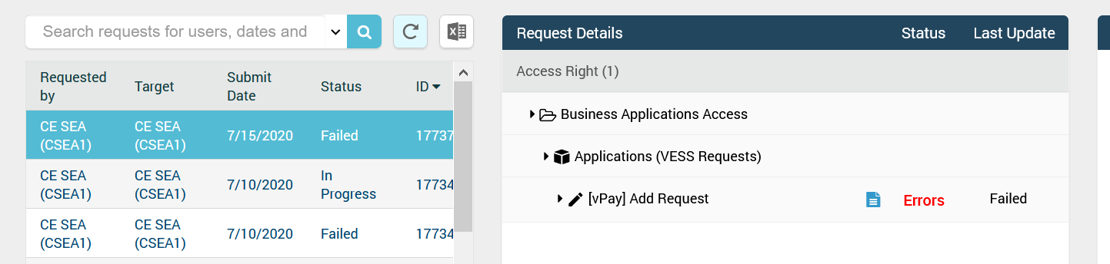
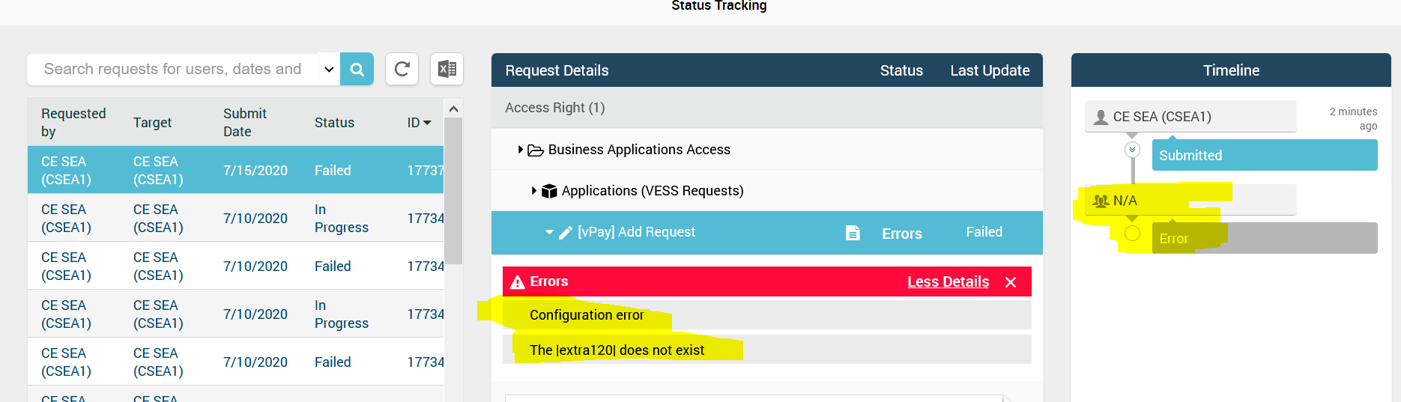

Issue is - Request Status is failed and it shows logical attribute |extra120| does not exist.
It does not go for approval and does not submit any task in VST.

