SD.IncidentManagement model –

Initial Diagnosis – Interaction Setup – Dialog Model

Modified Save Data

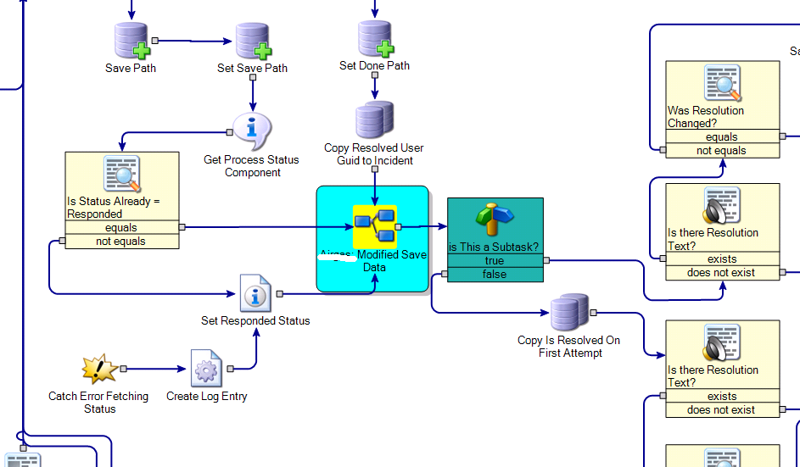

“Send E-Mail to Assignments (Clients if CHD) - Priority Change” Embedded Model
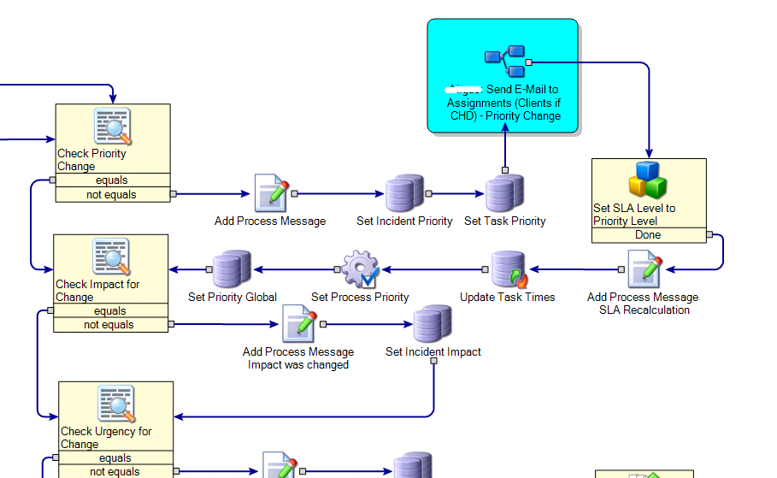

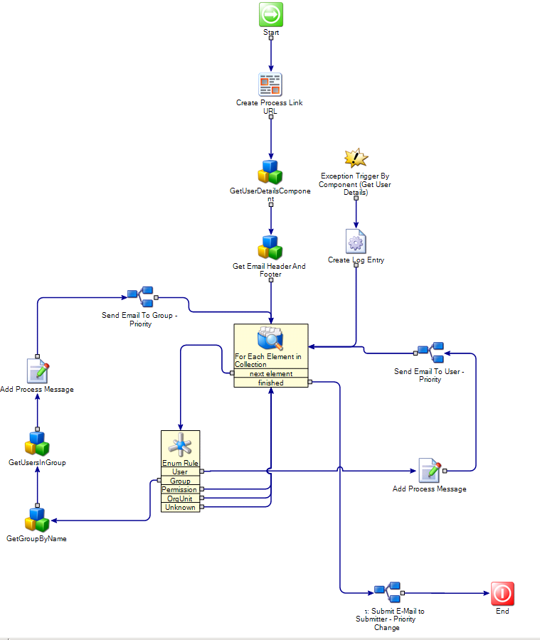
From Start

Create Process Link URL
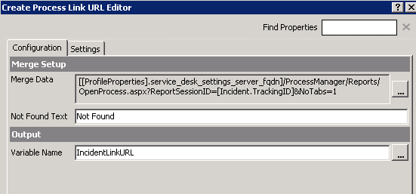
Merge Data:
[[ProfileProperties].service_desk_settings_server_fqdn]/ProcessManager/Reports/OpenProcess.aspx?ReportSessionID=[Incident.TrackingID]&NoTabs=1
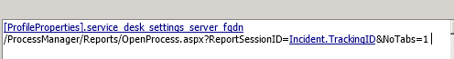

Links to: GetUserDetailsComponent

GetUserDetailsComponent
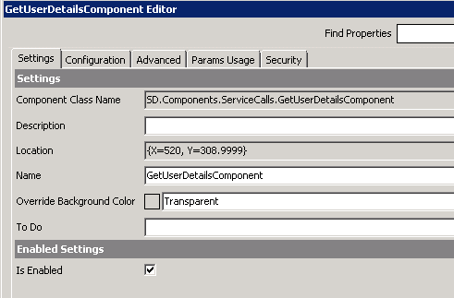
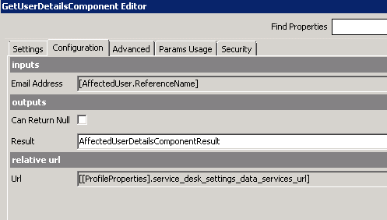

Connects to: Get Email Header And Footer

Get Email Header And Footer
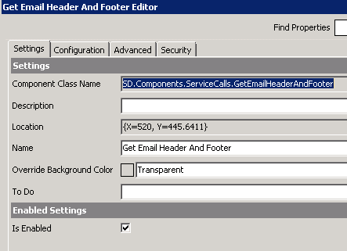
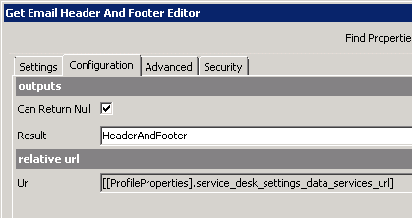

Connects To: For Each Element in Collection

For Each Element in Collection
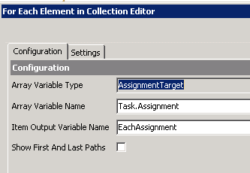
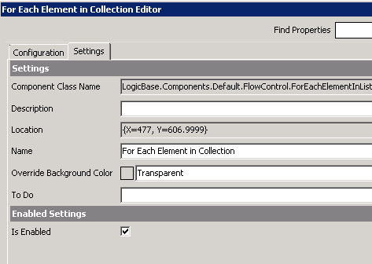

“next element” connects to Enum Rule

“finished” connects to Submit E-Mail to Submitter – Priority Change Embedded Model

ENum Rule

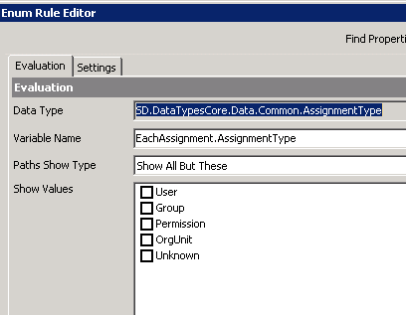
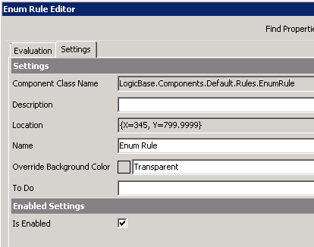

Group connects to “GetGroupByName”

User connects to “Add Process Message”

Permission, OrgUnit, and Unknown connects to For Each Element in Collection

GetGroupByName
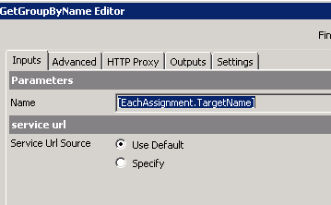
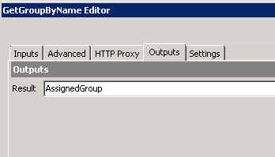
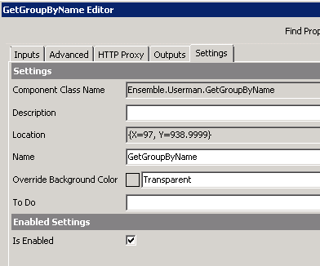

Connects to GetUsersInGroup

GetUsersInGroup
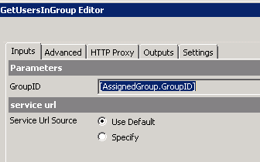
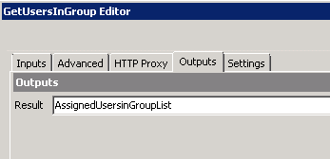
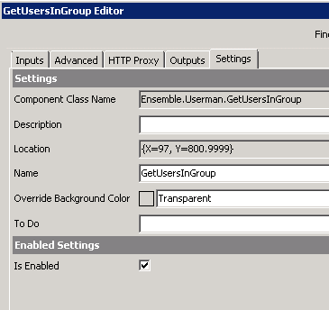

Connects to Add Process Message

AddProcess Message (Group)
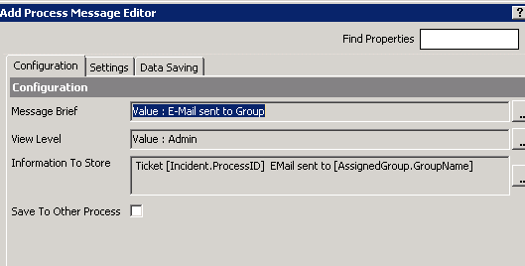
Information to Store: Ticket [Incident.ProcessID] EMail sent to [AssignedGroup.GroupName]
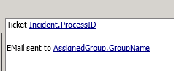
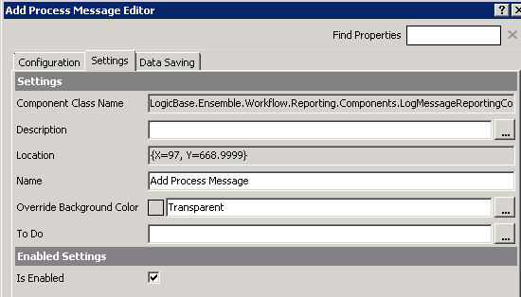

Connects to “Send Email to Group – Priority” embedded model

Add Process Message (User)
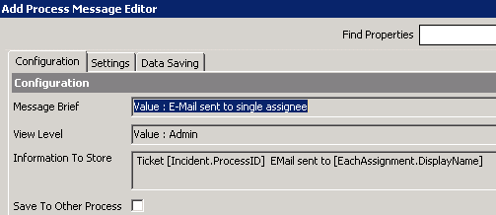
Information to Store: Ticket [Incident.ProcessID] EMail sent to [EachAssignment.DisplayName]
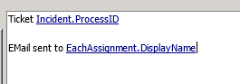
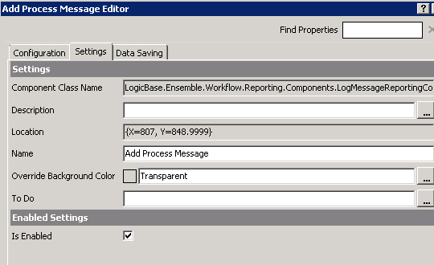

Connects to “Send Email to User – Priority” Embedded Model

Exception Trigger By Component (Get User Details)
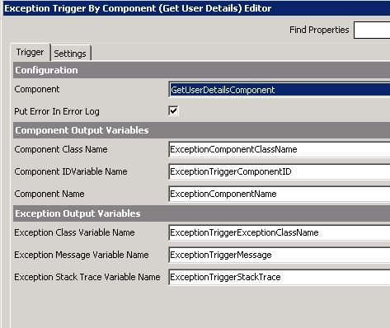
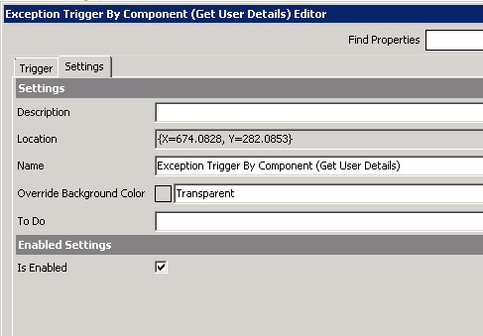

Connects to “Create Log Entry”

Create Log Entry
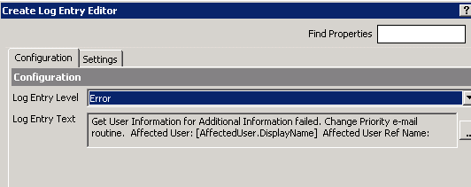
Log Entry Text: Get User Information for Additional Information failed. Change Priority e-mail routine. Affected User: [AffectedUser.DisplayName] Affected User Ref Name: [AffectedUser.ReferenceName] Reference ID: [AffectedUser.ReferenceID]
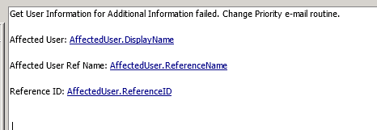
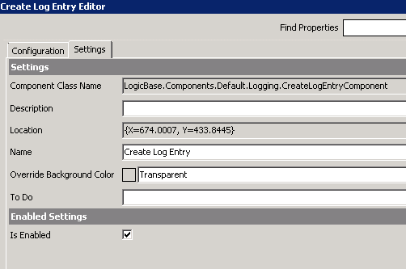

Connects to “For Each Element in Collection”

“Send Email to Group – Priority” embedded model

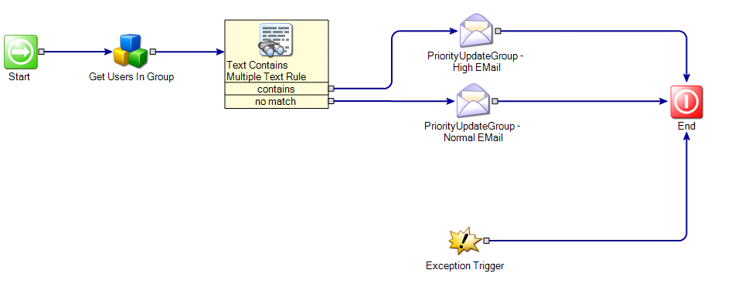

Get Users in Group
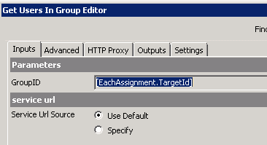
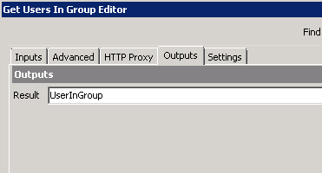
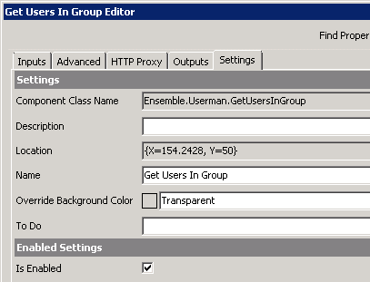

Connects to “Text Contains Multiple Text Rule”

Text Contains Multiple Text Rule
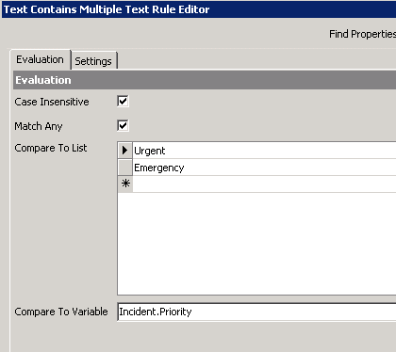
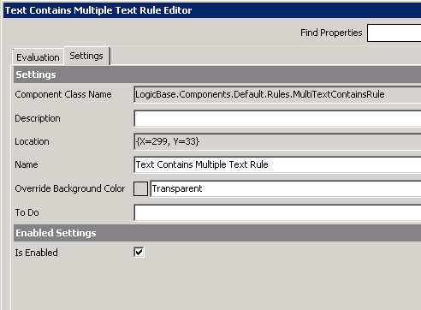

Contains connects to “PriorityUpdateGroup – High Email”
No match connects to PriorityUpdateGroup – Low Email”

PriorityUpdateGroup – High Email

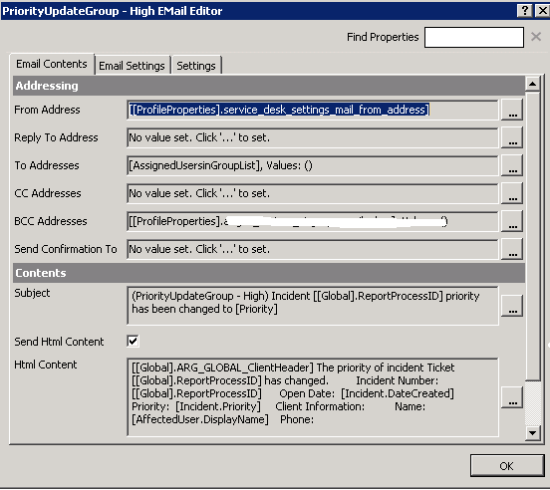

PriorityUpdateGroup - Normal Email
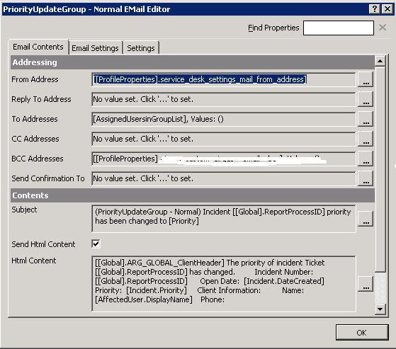
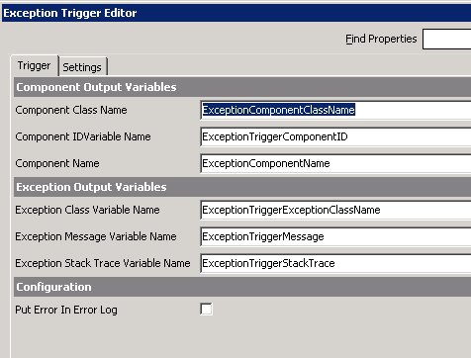

Connects to End

“Send Email To User – Priority” Embedded Model
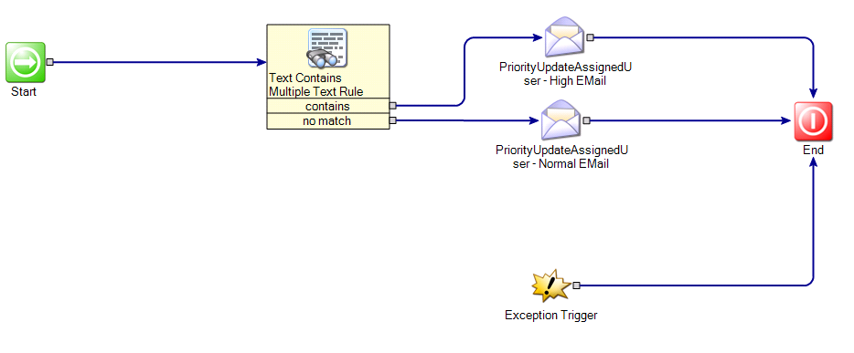

Text Contains Multiple Text Rule

Contains connects to “PriorityUpdateAssignedUser – High Email”
No match connects to PriorityUpdateAssignedUser – Low Email”

PriorityUpdateAssignedUser – High Email

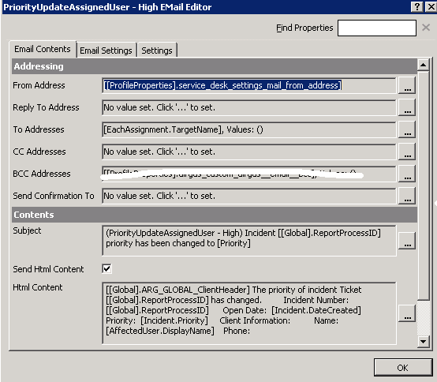

PriorityUpdateAssignedUser - Normal Email
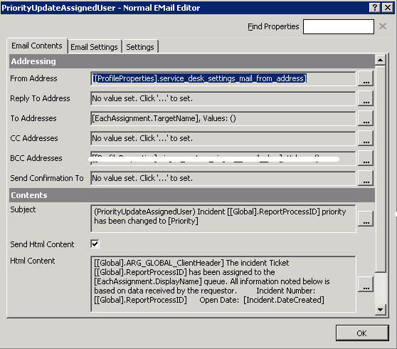

Connects to End

“Submit E-Mail to Submitter - Priority Change” Model
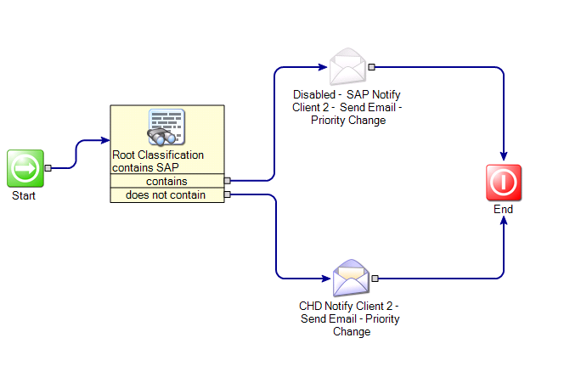

Root Classification contains SAP
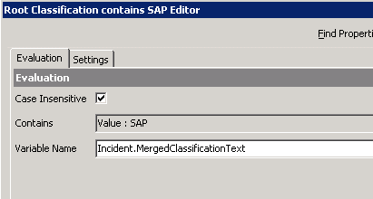

Contains connects to “Disabled - SAP Notify Client 2 - Send Email - Priority Change”
does not contain connects to “CHD Notify Client 2 - Send Email - Priority Change”

Disabled - SAP Notify Client 2 - Send Email - Priority Change
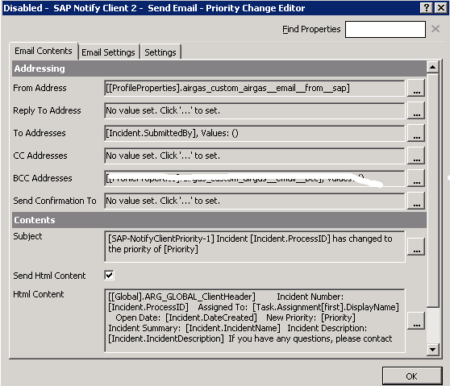

CHD Notify Client 2 - Send Email - Priority Change
