User Administration (also known as Delegated Admin) is an optional function that is available to Broadcom enterprise customers. It provides the ability for User Administrators to manage user access to their site IDs via Broadcom Support Portal. A User Administrator takes on the responsibility of approving, updating and revoking access for users for a specified site ID. When a request is generated from an end-user, the User Administrator will be notified via email of the pending request.
Existing Broadcom Support Online user who wishes to manage their own company's users' access must agree to the Terms of Use upon registering for this additional role. Broadcom will process the first User Administrator based on current business rules. After the first User Administrator has been enrolled to the site ID, Broadcom systems will automatically route all subsequent access requests to the User Administrator for that site ID including additional User Administrator requests. User Administrator takes on the responsibilities of approving, updating and revoking access for the user at specific support site id.
Note: The User Administrators will have 3 business days to accept or reject the request. If the request is not processed by the User Administrator in 3 business days, Broadcom Customer Care will process the request according to current business rules.

Please note that in the event Broadcom receives an inquiry from an enrollee about the status of pending enrollment and there is a User Administrator to a site, we will inform the caller that the site has a UA and provide the details of the User Admin.
User Administrator access request steps:
To get access to the User Administrator, please follow the steps mentioned below:
NOTE: You should have enterprise access for that site to become an admin.
1. Login to the Broadcom Support Portal: https://support.broadcom.com/
2. Once logged in, Click on your name and select Request site access
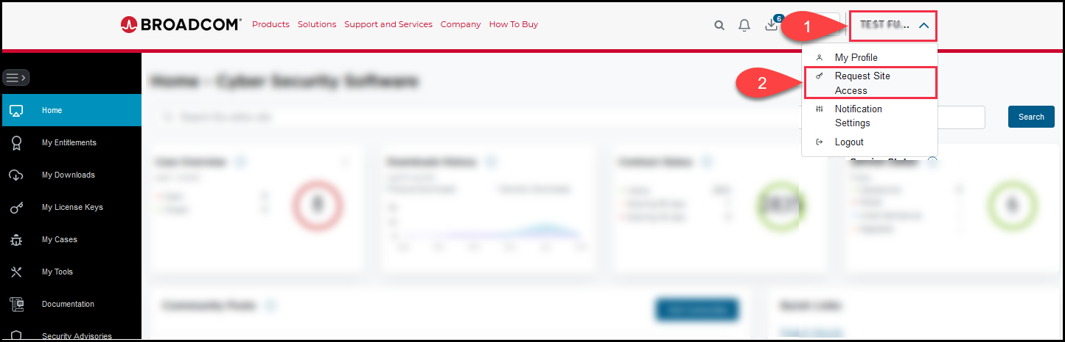

3. Select the Site Administrator access tab next to the Support Site ID access:
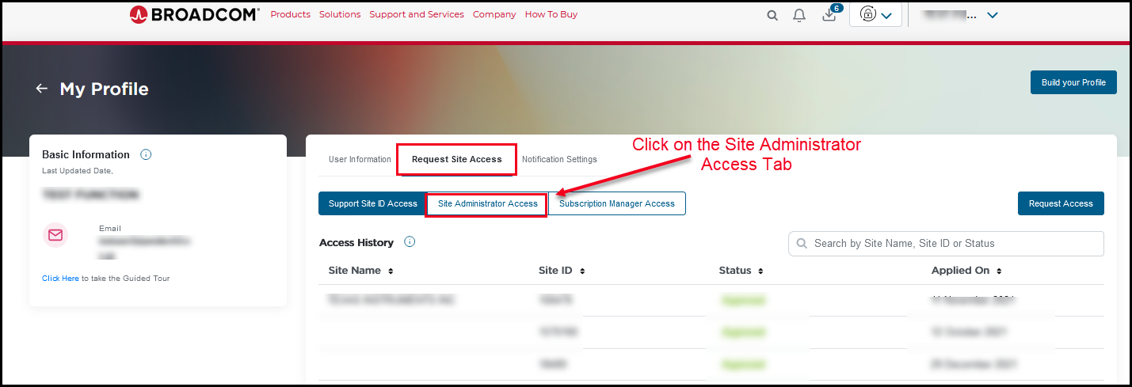

4. Click on Update Access
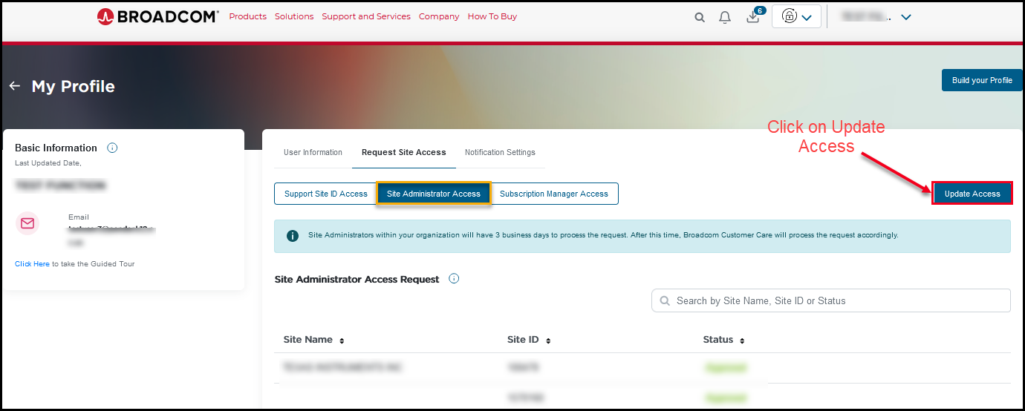

5. Click on the Radio button for selection.
After selecting the site(s) for which you want to become the User Administrator, enter supporting information in the text box. Supporting information example would be something like:
“I need to be able to limit certain users' access to product downloads at this site."
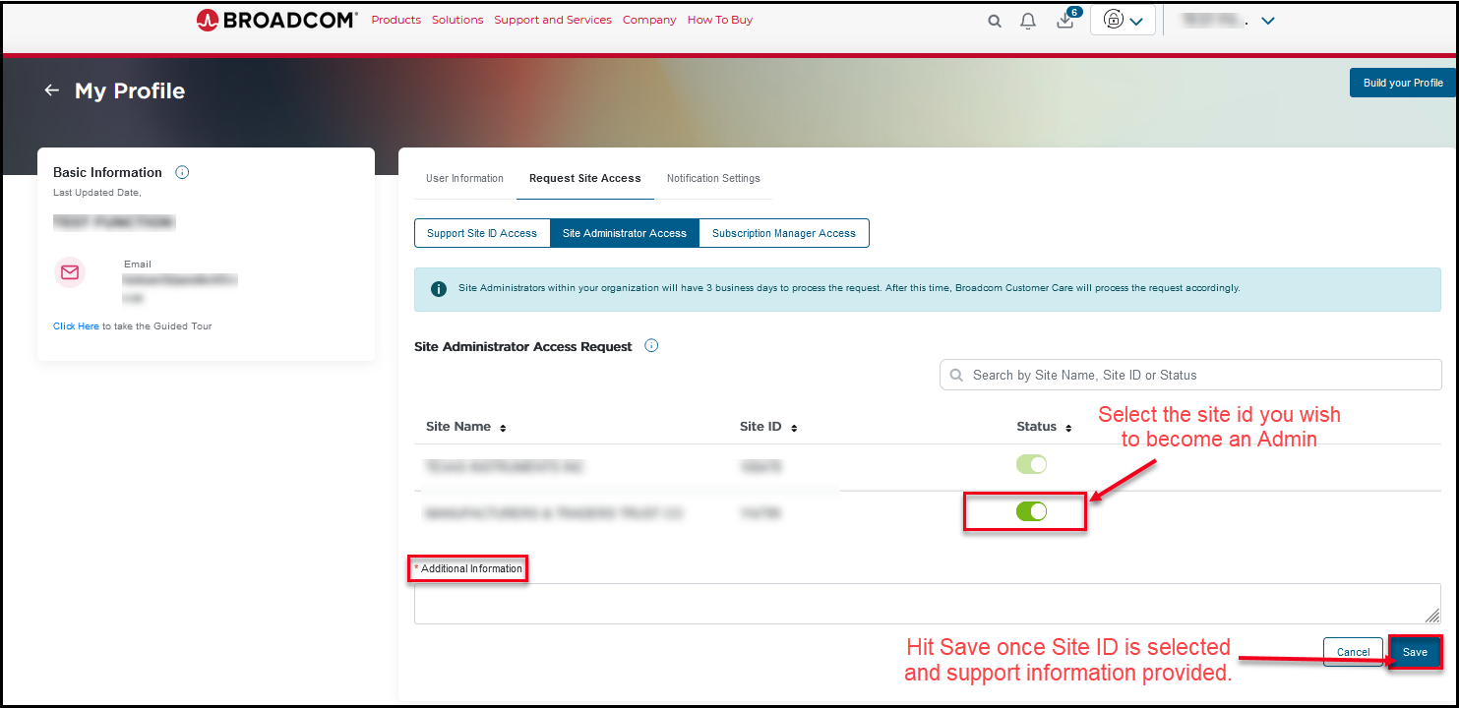
6. Once the request is submitted, Status will be Pending
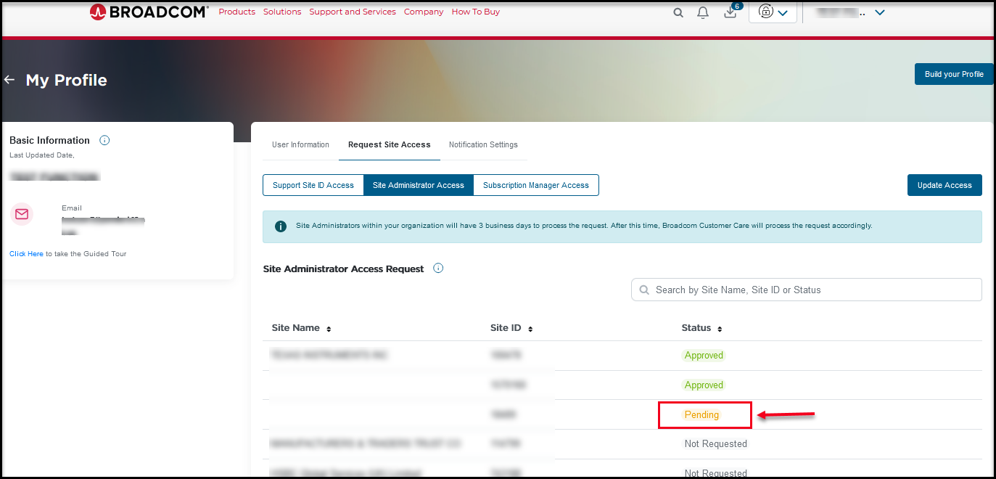
7. For sites that do not have a User Administrator, Broadcom Support enrollments are managed by Broadcom Customer Care. Please be mindful of the following before you take on this responsibility:
- Once you are approved to become the User Administrator, you will be responsible for processing all enrollments for the site
- If you do not process enrollment within 3 business days (Accept or Reject), Broadcom can process enrollment per our standard business rules and will contact you before processing
- If the enrollee does contact Broadcom inquiring about the status of a pending enrollment, we will provide enrollee the User Administrator(s) and contact information and inform enrollee the processing is pending approval from Site User Administrator
Delegated User Admin functions:

User Administrator takes on the responsibilities of approving, updating and revoking access for the user at specific support site id. Requests for access to a site will be routed to the User Administrator instead of to Broadcom Customer Care. Please refer to User Administrator Guide.

If you need any assistance, please contact a Broadcom Customer Care Representative by submitting a request using a Webform.

