I select the job to do the deployment, but it doesn't start and the task in altiris is not logged.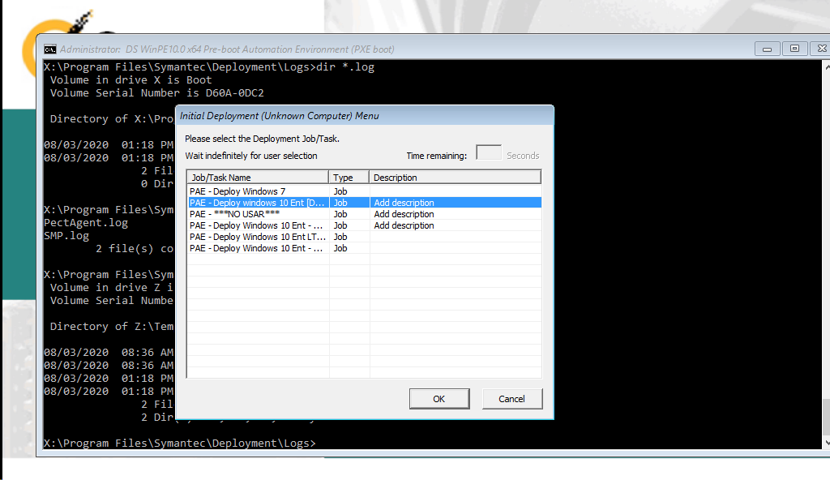
Ghost does not start, and the task is never logged in Altiris
