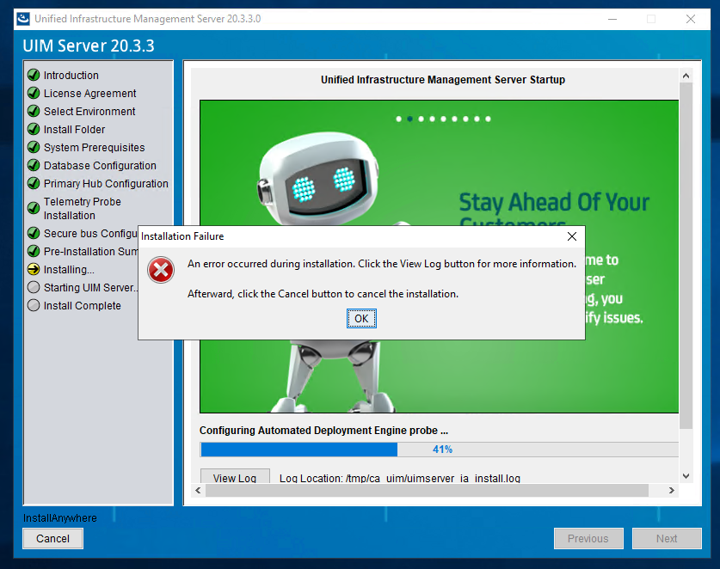
setupUIMCAUIMServer installer

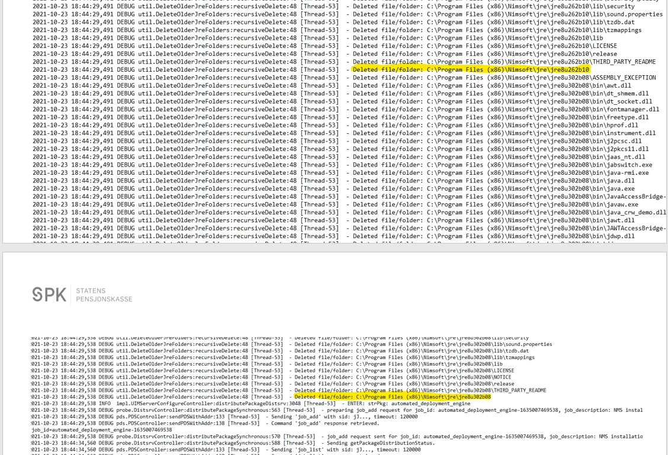
Excerpt from the uimserver_ia_install.log

