CA Release Automation Service Now Integration

AD SWAT

CA Release
6.2

CA Release Automation 6.2
Prepared by: Sachin Srivastava
Date: Jan 2017

Table of Contents

CA RA Service NOW Integration - 6.2 2
Chapter 1: Introduction 2
Purpose 2
Chapter 2: Pre-Requisites 2
Chapter 3: Service Now Plugin Installation 3
STEPS to Install RA Service Now Plugin in the Service Now 3
STEPS for Release Automation Server integration with Service Now: 7
Appendix: 13
STEPS to Install MID Server: 13

CA RA Service NOW Integration - 6.2

Chapter 1: Introduction

Purpose

The purpose of this document is to help CA RA end users to install Service Now Plugin for RA and create new Deployments using the Plugin.

Chapter 2: Pre-Requisites
- MID Server needs to be available to execute the Release Automation Configurations.
- Download the Service Now Plugin for RA. The latest plugin can be downloaded from the Release Automation Server Product page available at support.ca.com.
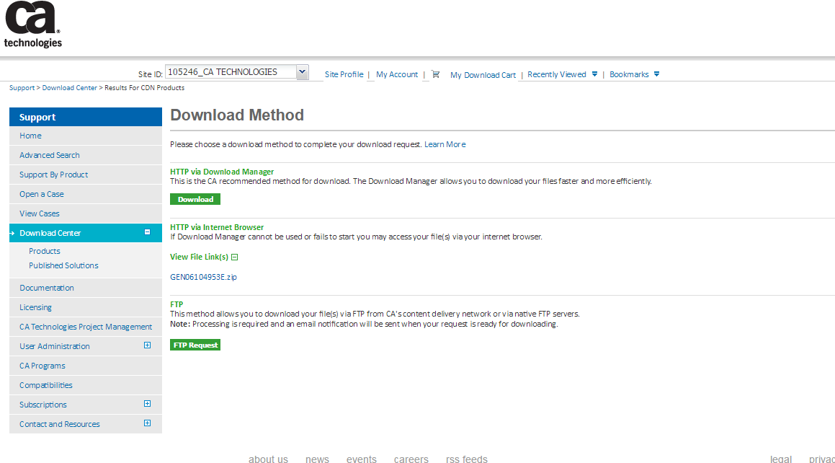
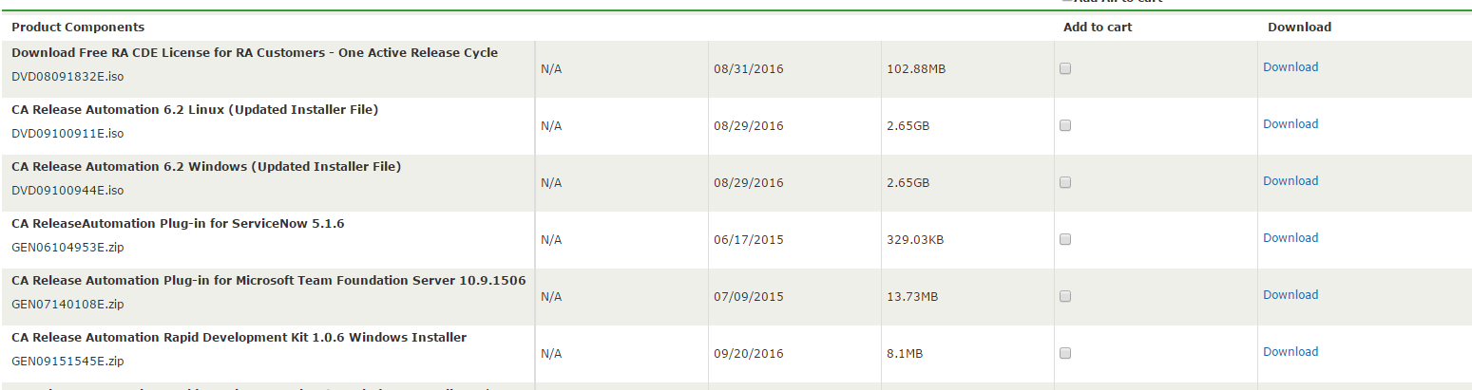
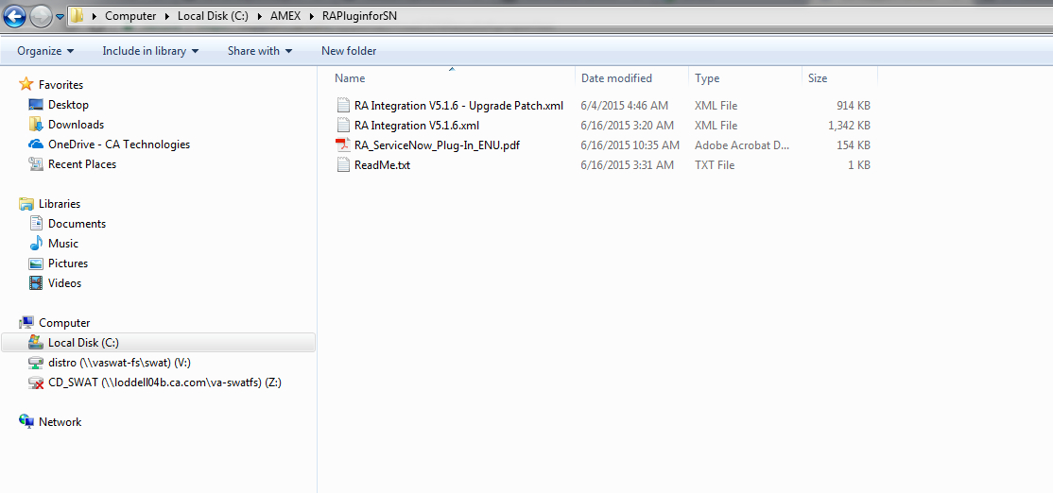

Chapter 3: Service Now Plugin Installation

STEPS to Install RA Service Now Plugin in the Service Now

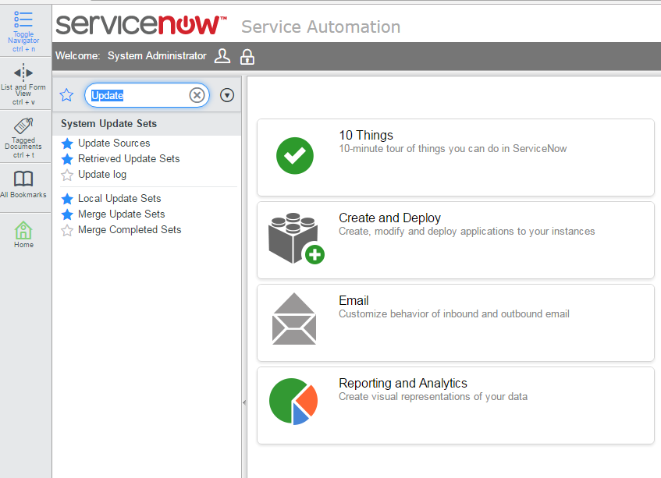 | Click on the Retrieved Update Sets available under System Update Sets
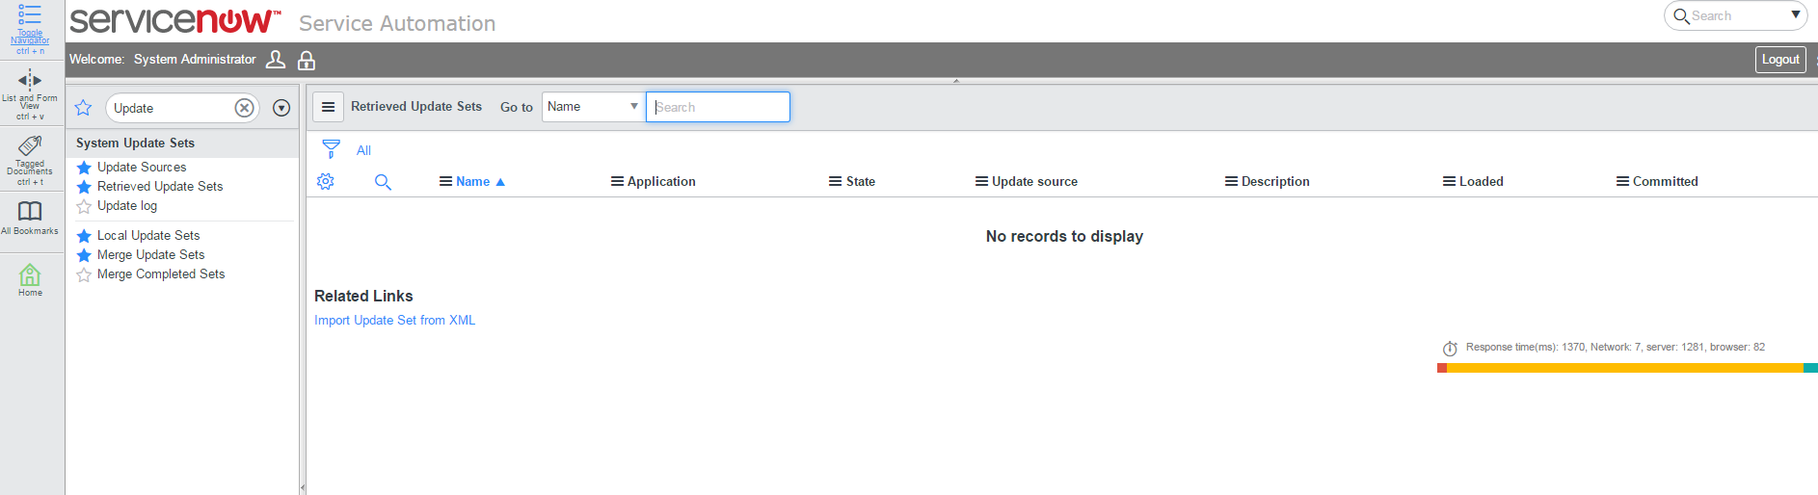  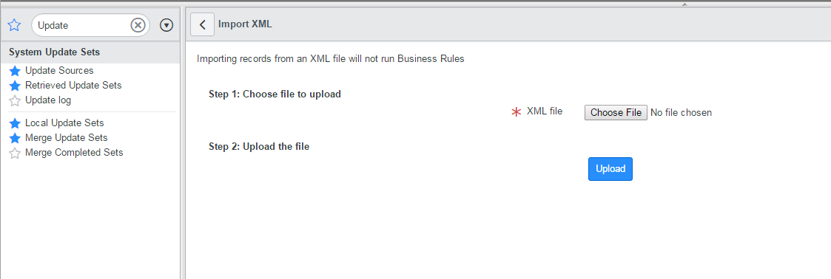  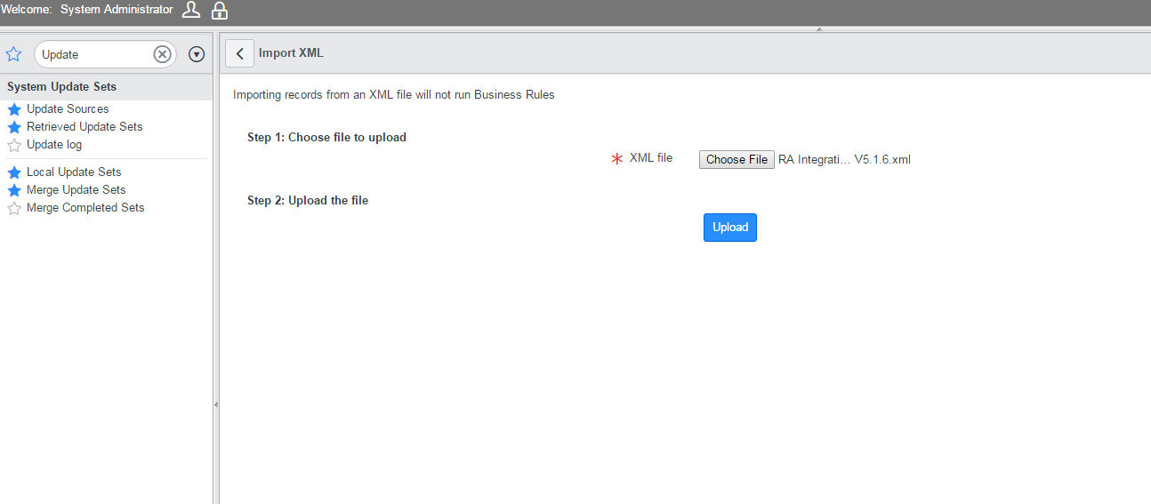  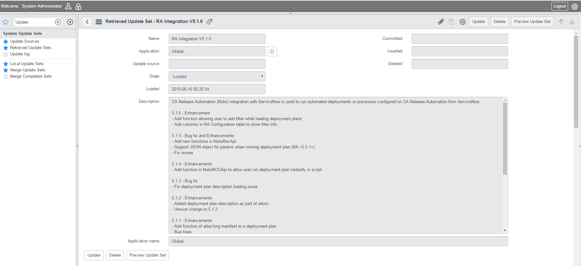  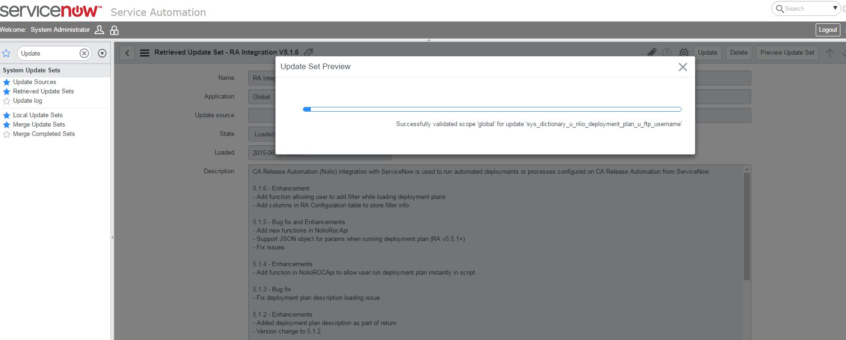  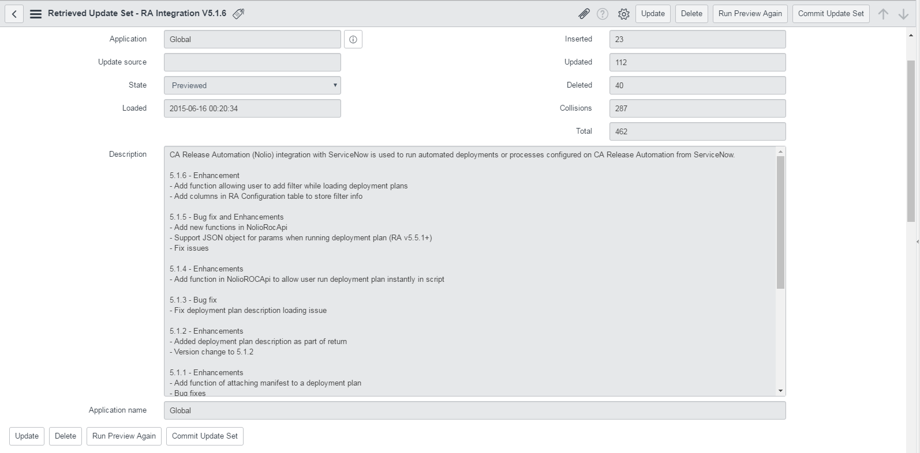  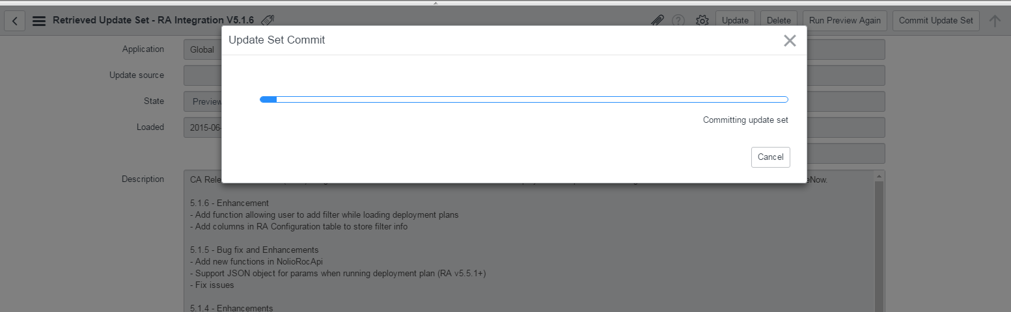  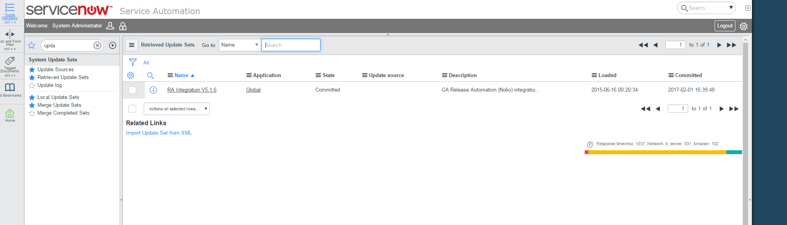 | Click on the Import Update Set from XML hyperlink as shown below and import the Plugin.  Click on the Upload button and it will reflect on the Retrieved Update sets created  Once the Plugin in uploaded Click on the Preview Update Set button.  Commit the Update Set post the completion of Preview.  The committed update set can be seen by clicking on the Retrieve Update sets link again. Follow the same steps to apply the patch for the Plugin if an updated Patch is available.
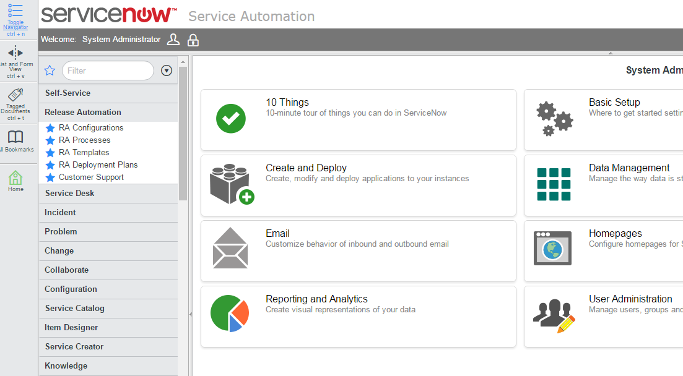 | Once the Commit is complete the Application Menu for Release Automation Server will be created and its subsequent Menus for RA is also created.

STEPS for Release Automation Server integration with Service Now:
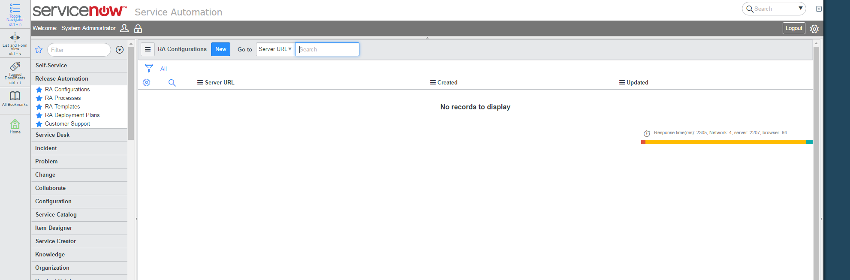 | Click on the RA Configuration Link available in Release Automation Menu.  Click on New button to add the RA server.
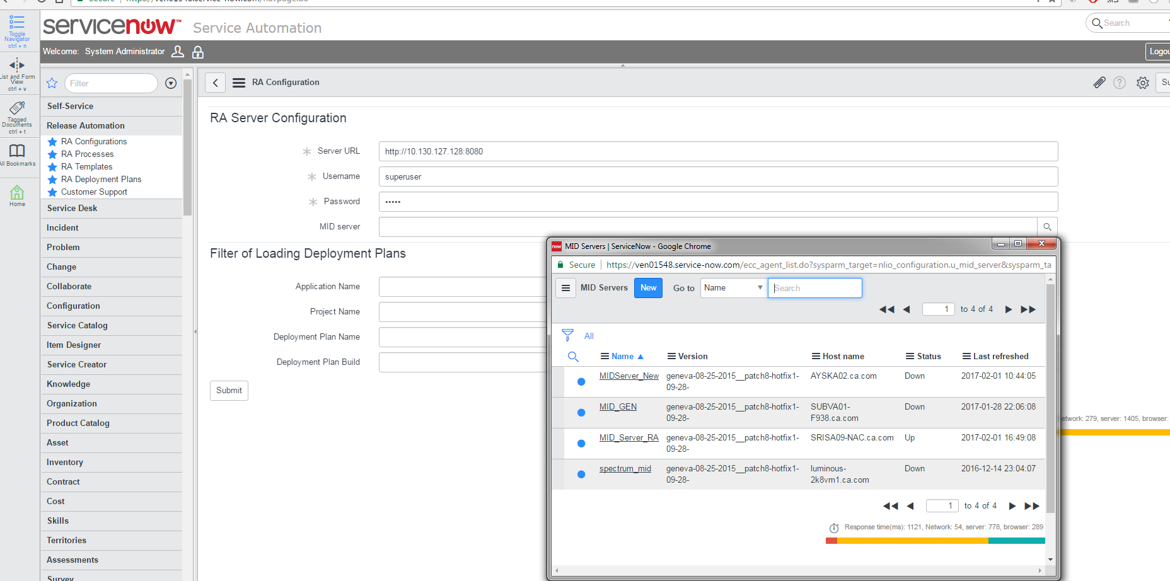 | Provide the server URL, user name, Password and also add the MID Server to the configuration.
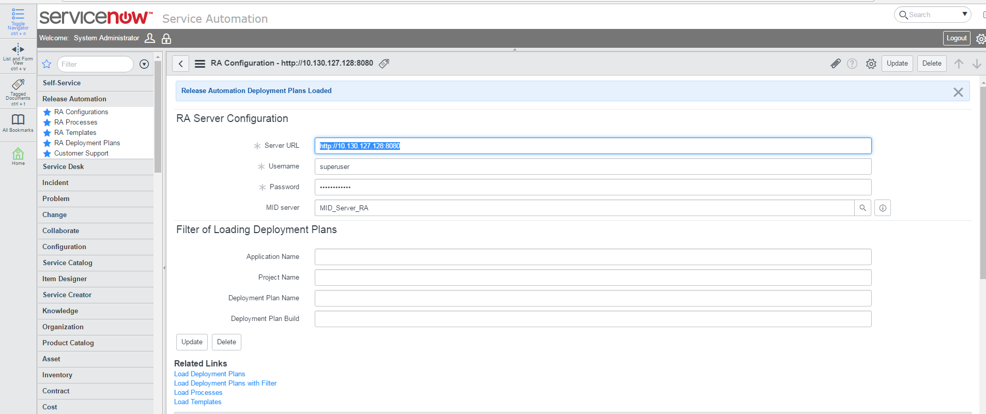  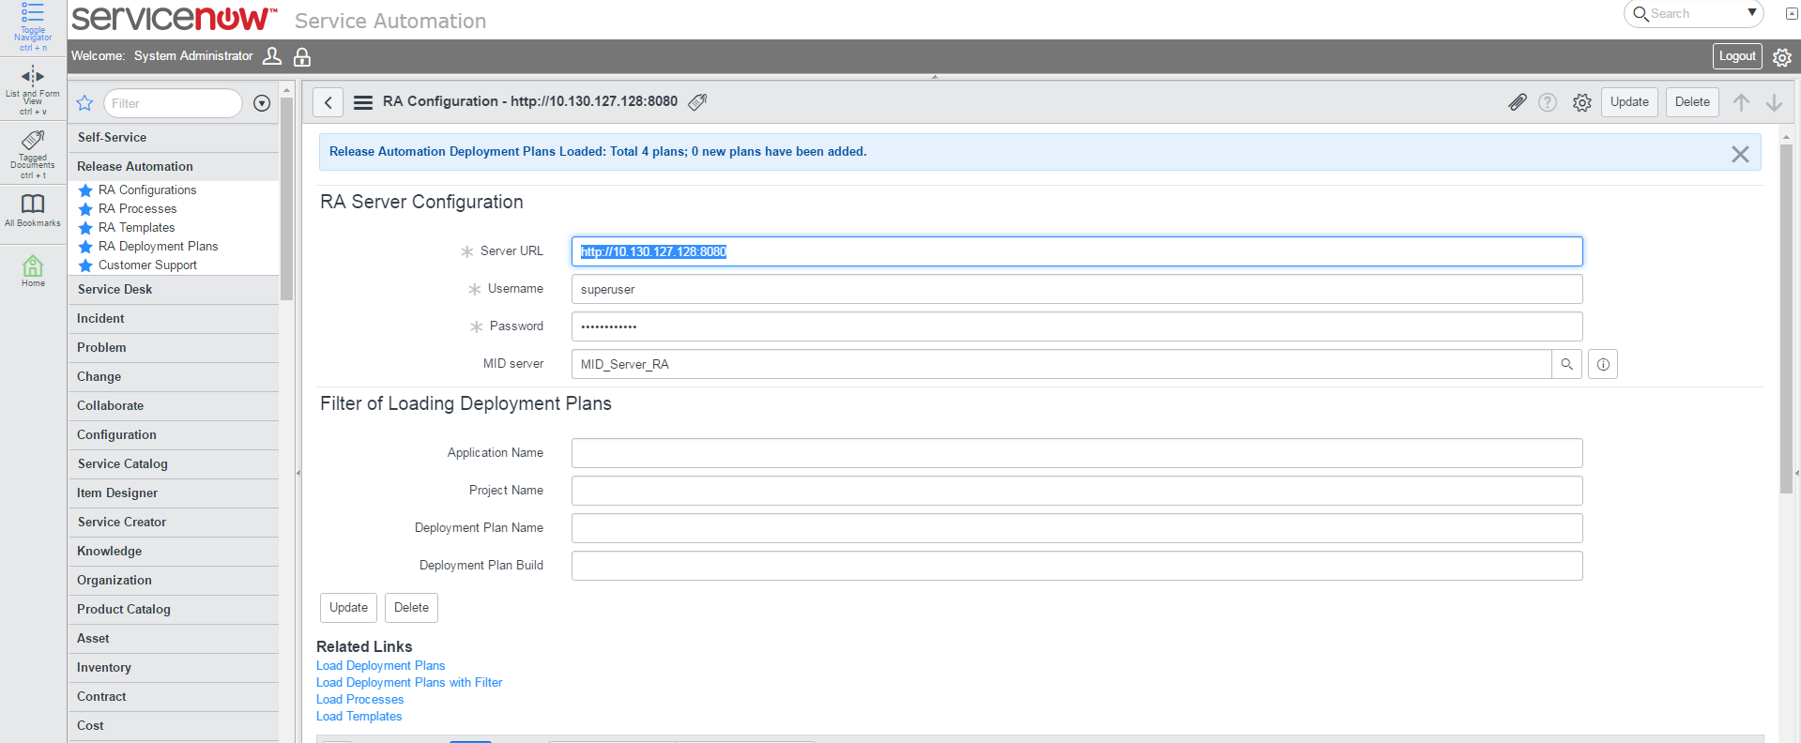  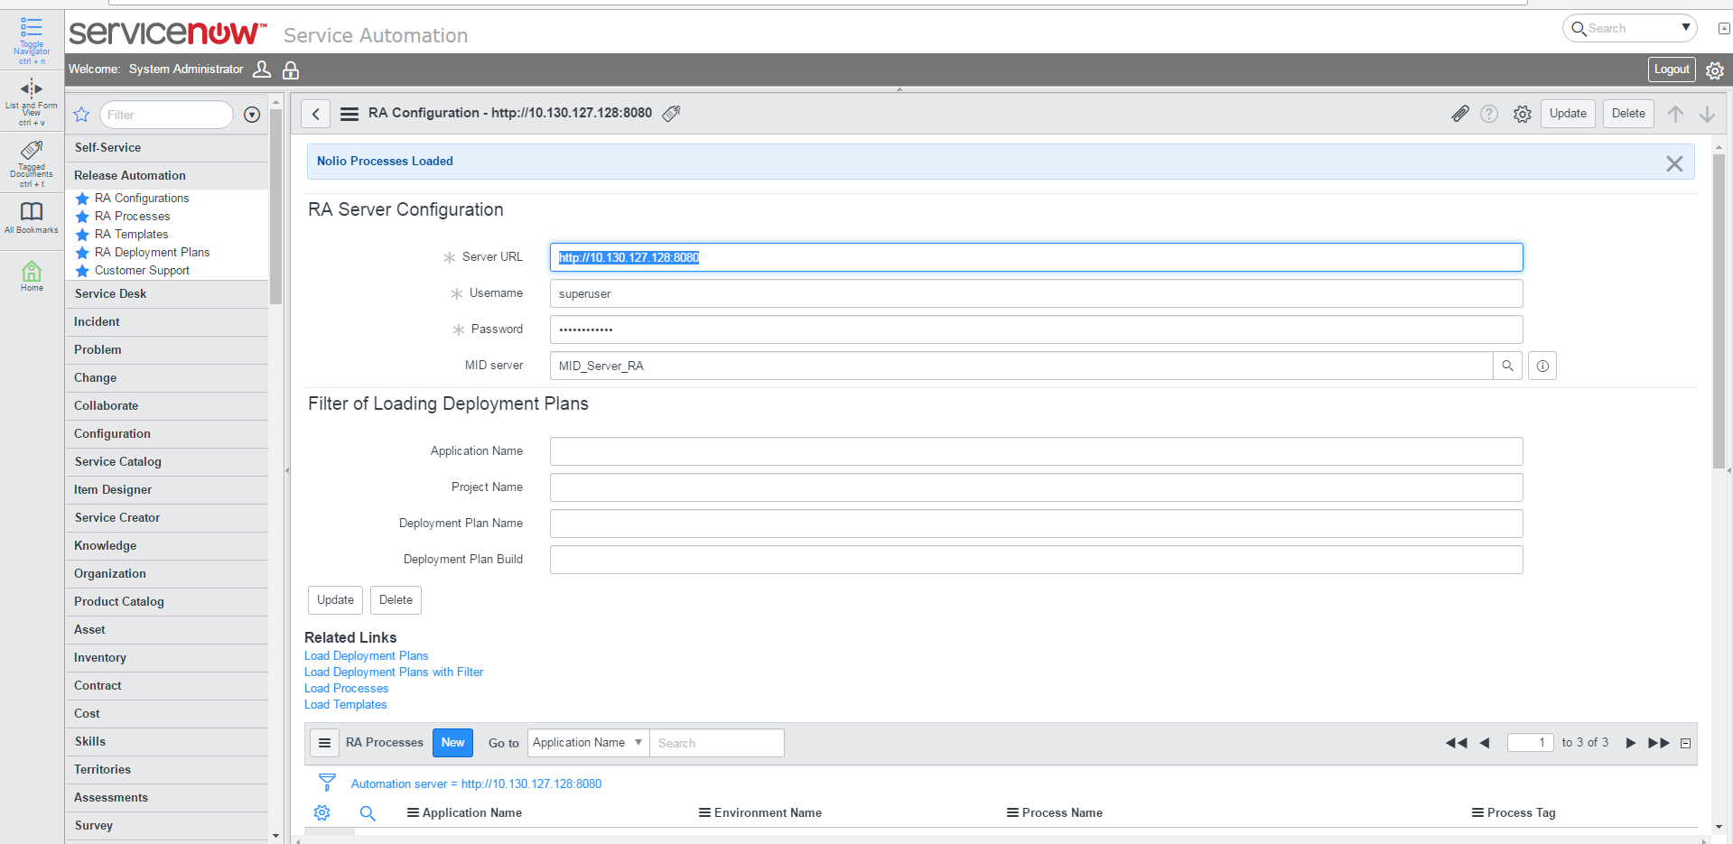  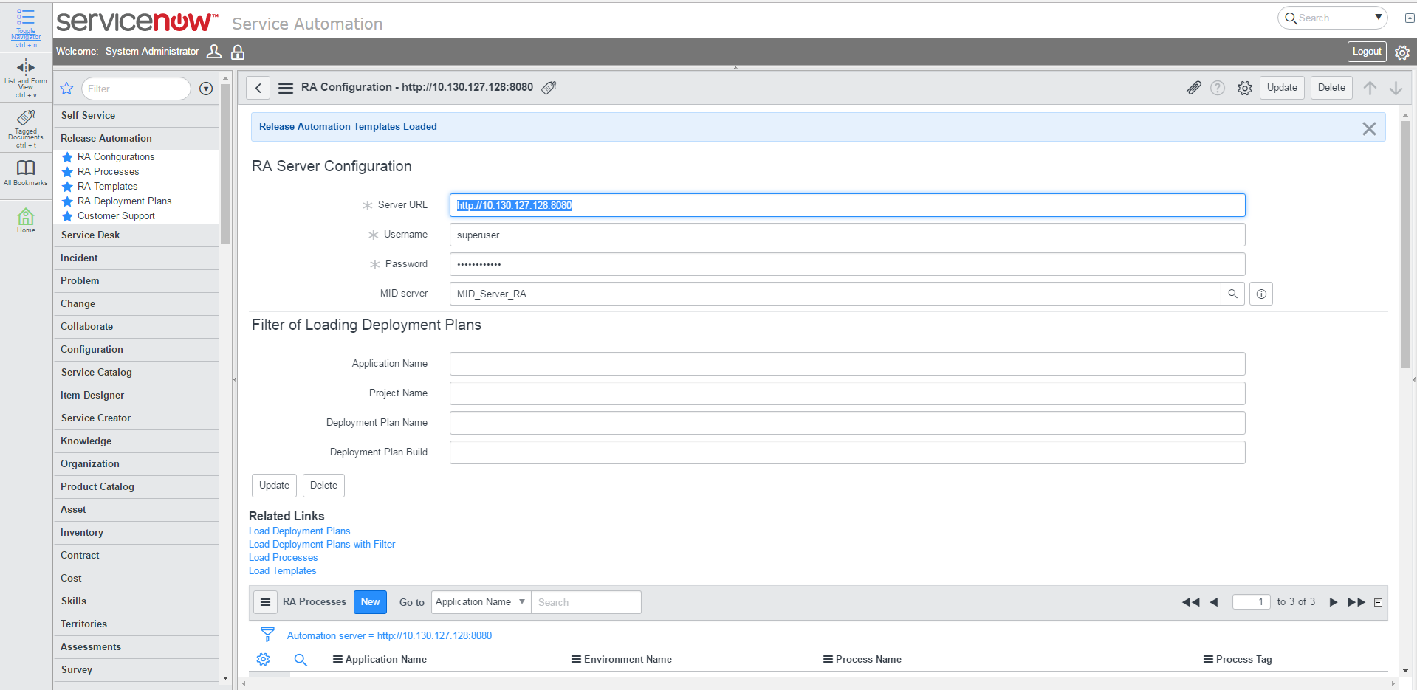 | Once the RA Server is Added Click on All the links available under the Related Links Section to Load Deployment, Process and Templates for RA Server.
 | Once the RA Server is Added Click on All the links available under the Related Links Section to Load Deployment, Process and Templates for RA Server
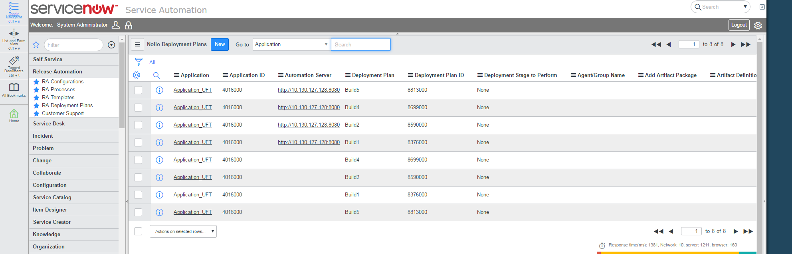  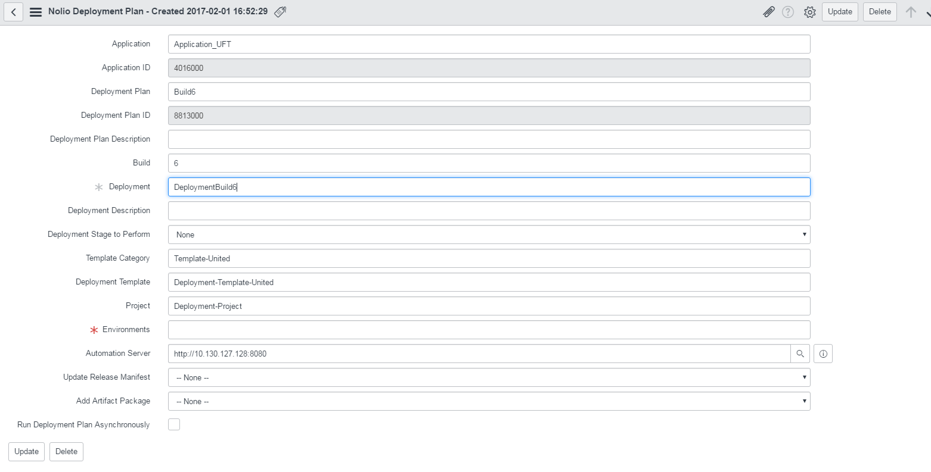 | Create a New Deployment to test the Plugin by clicking on New Button on RA Deployment Plans  Add the details of Application. All the options are similar to the one available at RA Server.
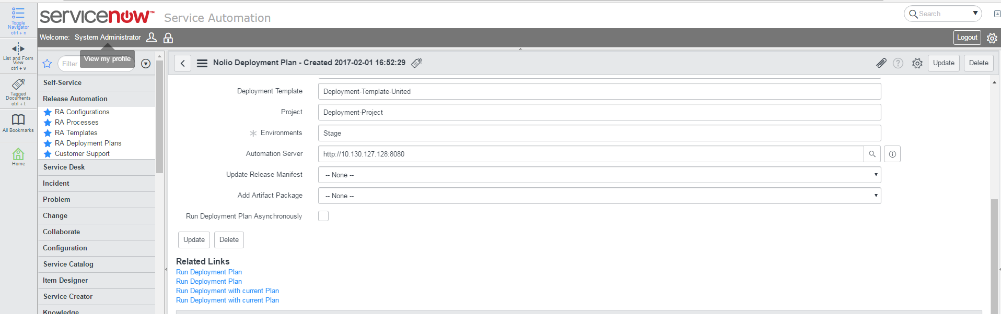  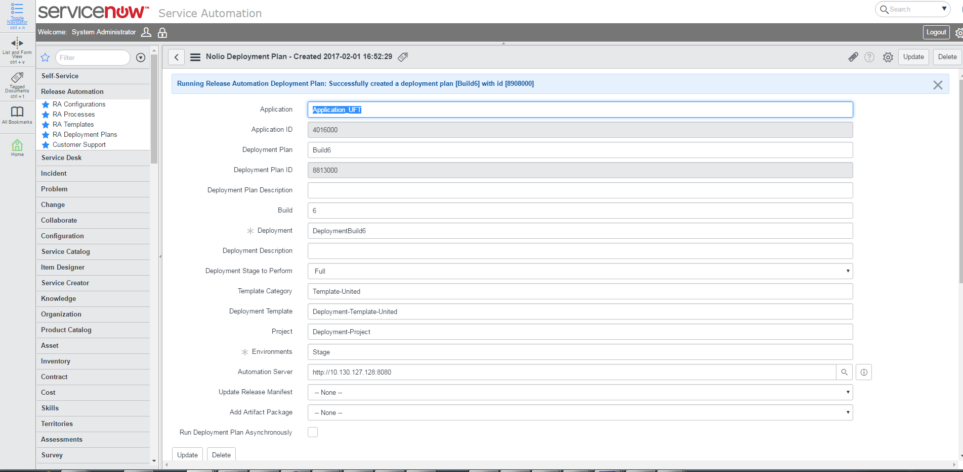 | Once the deployment Plan is created Click on Run Deployment Plan to create a new Deployment in RA.
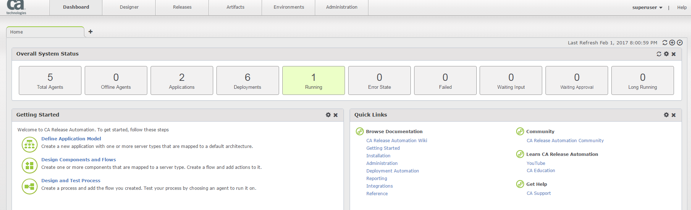  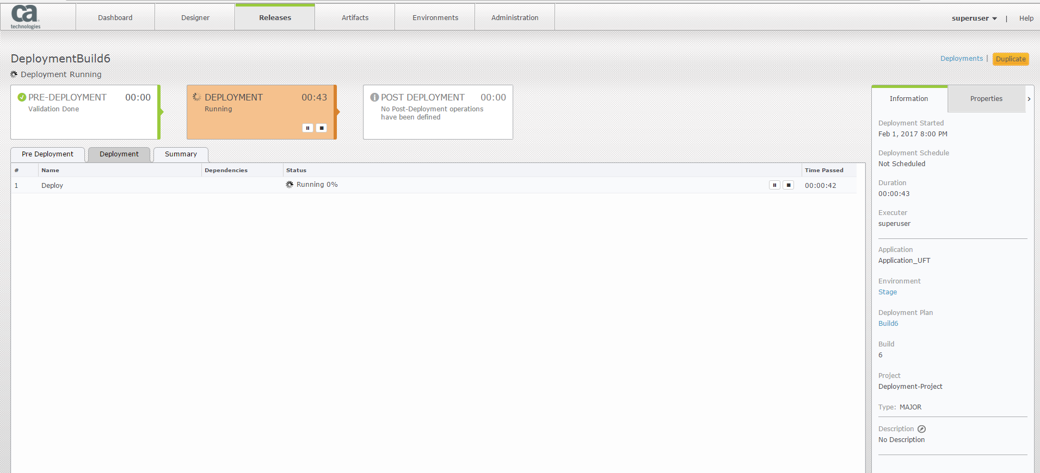 | The same can be seen on Release Automation Server.

Appendix:

STEPS to Install MID Server:
Installing a MID server is not a requirement if a MID Server already exists and is in Up and running state. Below are the required steps to install MID Server in case no MID Server is available.

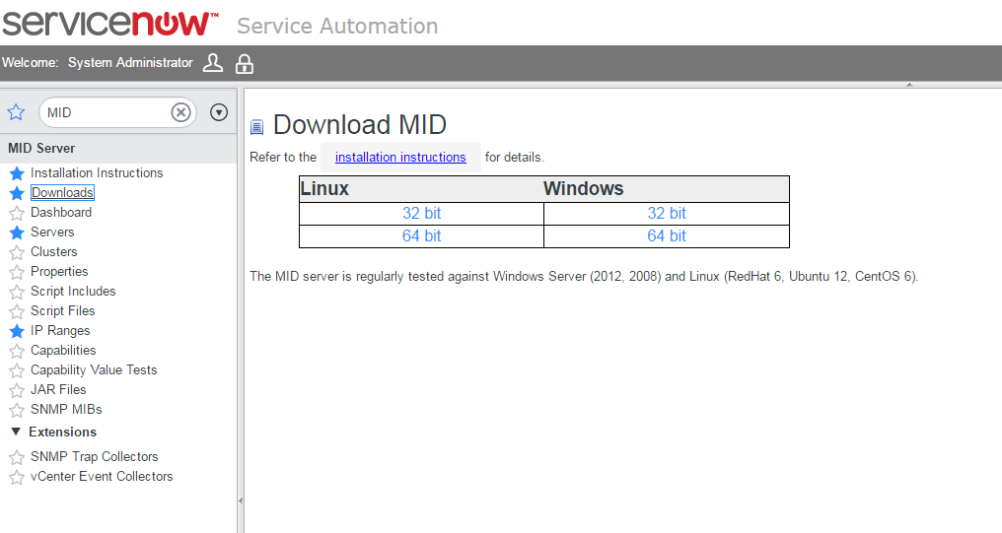 | Download the MID Server installation zip from the Service Now Mid Server downloads page as shown
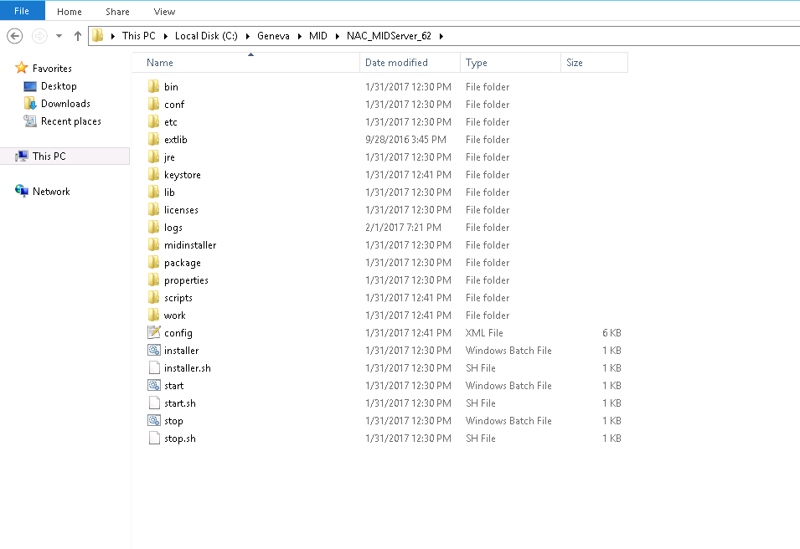 | Unzip the MID Server executables to a Local Server as shown
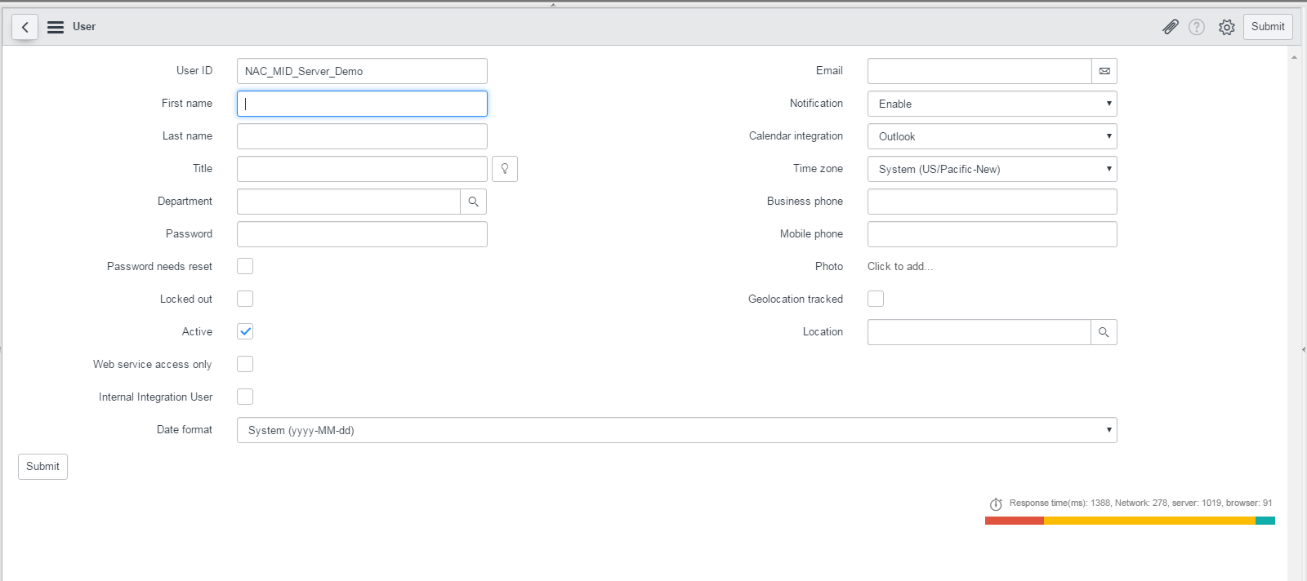 | Create a new user for MID Server in Service Now as shown
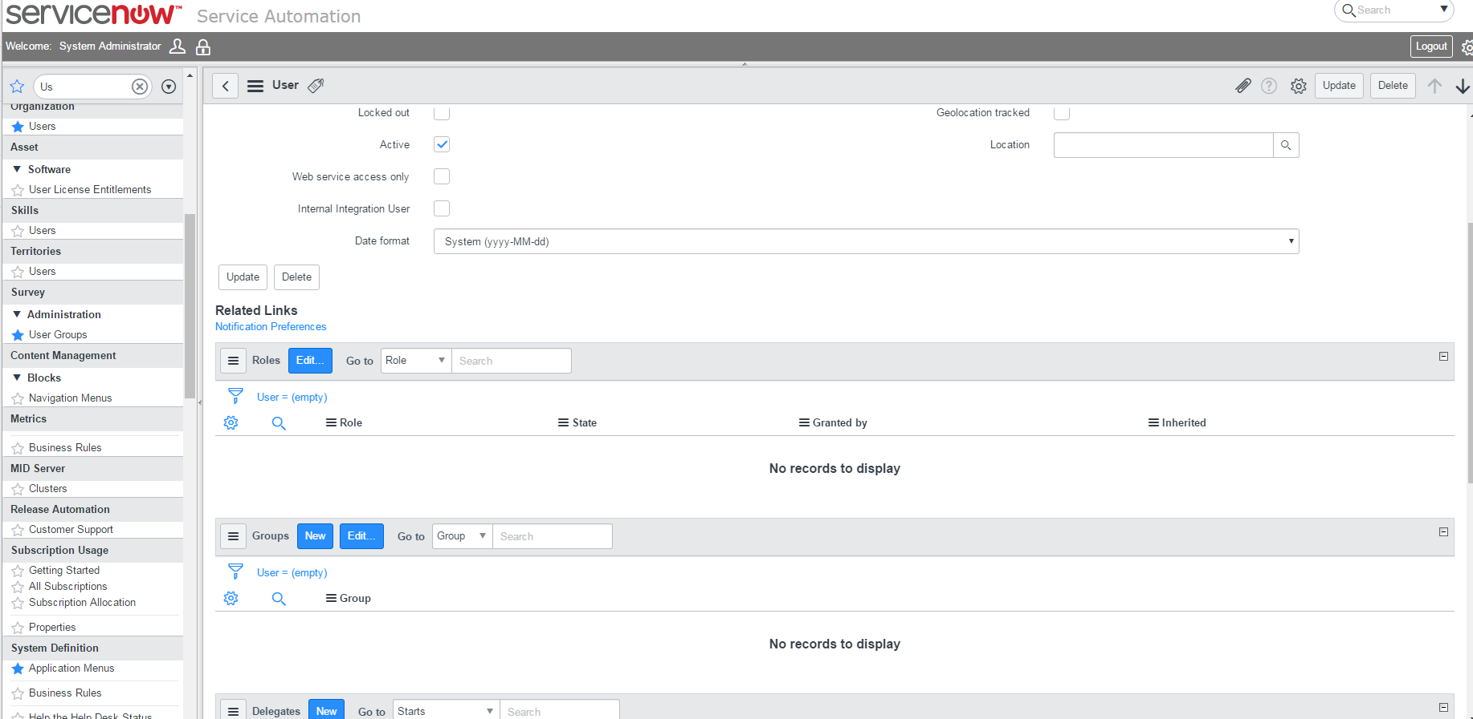  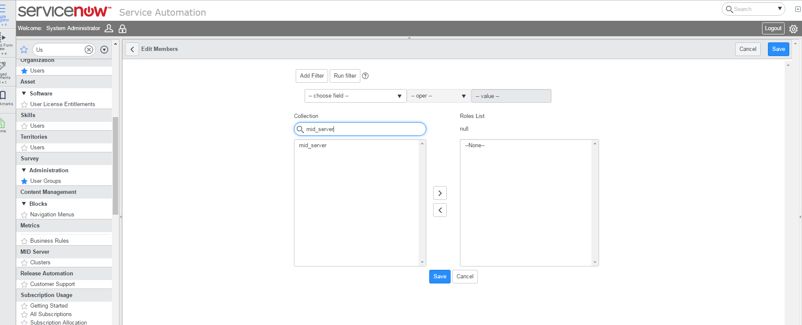  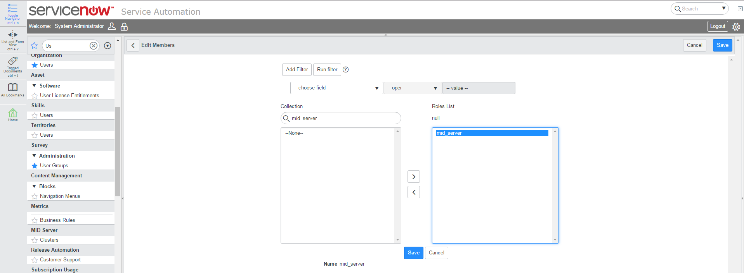  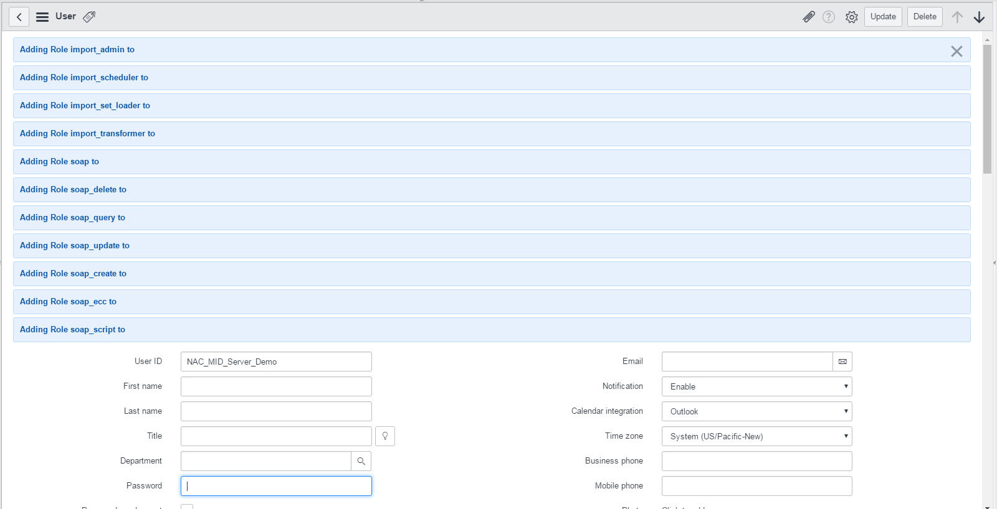  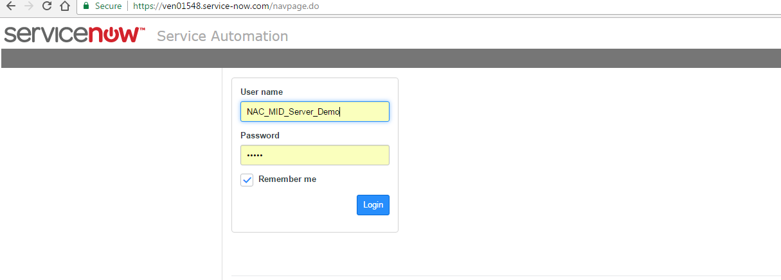  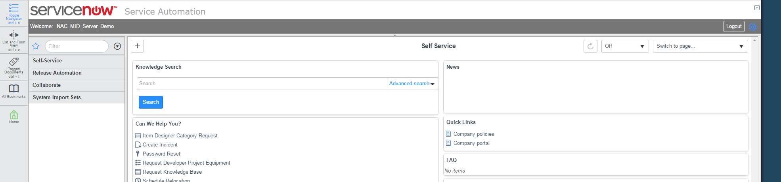 | The new user is required to run the MID Server. Once the User is created a Role is required to be added to the User. The best Practice would be to use the MID Server role available in Service Now.  The roles added will import all the necessary table. Add a password to it as well.  Once the New User is mapped to MID Server role, login to that server and check if login is successful with it
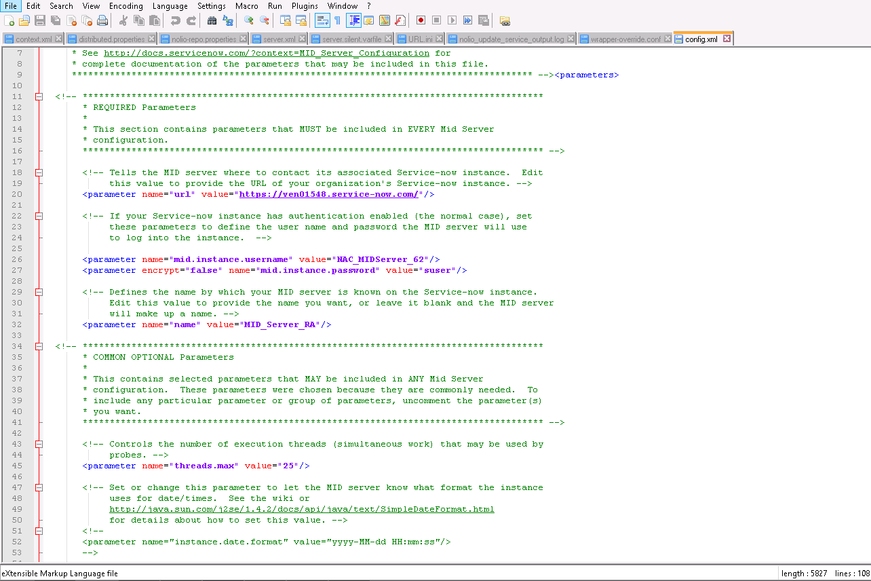  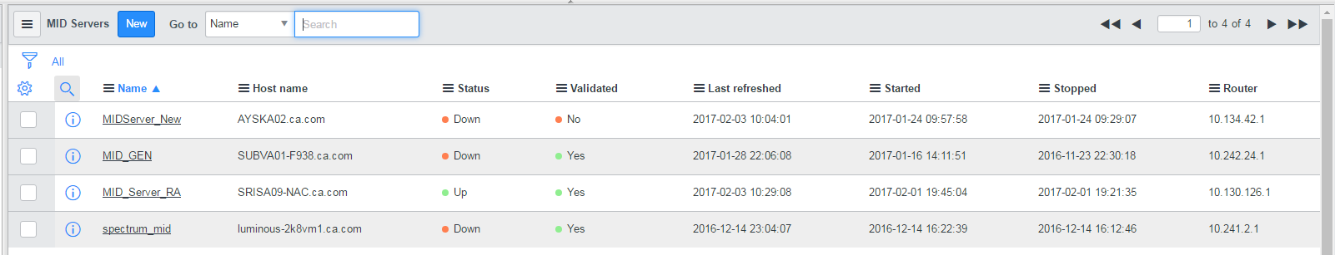 | The MID Server configuration needs to be done for the new User Created.  The values to be added are the parameters URL which is a Service Now URL, then the mid.instance.username this is the new user created and the mid.instance.password with the password created for the MID Server User. Now run the start.bat available at MID_Server_Installation_Directory. Once the server is up and running the same will be reflected on Service Now.

