How to store Package Server repository aside from Symantec Management Agent

Ever wondered how to install the Symantec Management Agent to the system drive but direct all Package Server’s packages to other? How to consolidate all the packages “rotated” by Package Server due to lack of disk free space across multiple drives into one single place? Then this article is for you.

Overview
The ITMS 8.0 has introduced a couple of new features which allow user to specify a custom location where Package Server will store its packages by default. Since this setting can be set up for all Package Servers or/and for some specific Package Server, this feature gives a flexibility to have different file storages on different Package Servers. Just keep in mind that this is an expensive operation and is not intended to be used on daily basis. It is rather for initial infrastructure setup.
By default the PS file storage location is "<SMA install folder>\Package Delivery". This could bring difficulties on some large environments, where system drive is used to be much smaller than drives dedicated to storage purposes. Moving the whole SMA installation to the storage drives is also not usable in some cases. For that purposes it is now possible to have SMA installation and Package Server packages storage on different drives.
Note that in ITMS 8.0 the Package Server (PS) settings were redesigned and split into two categories: the settings common to all Site Servers (Task Server, PS) and pure PS settings. As a result we have two policies under Settings->Site Server Settings: “Package Server Settings” and “Global Site Server Settings”.
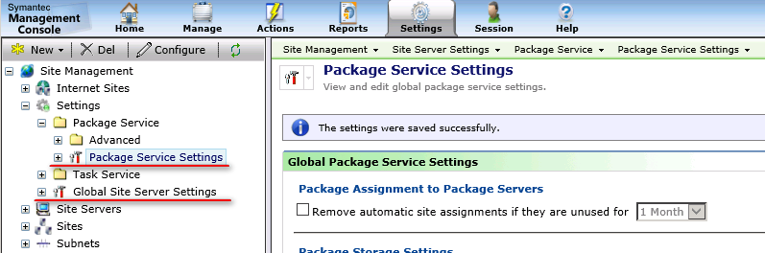
This article will not deep dive into all the details of this redesign but touch only those related to the topic. All we need to know that both of them are “Global” settings which affect all the Site Servers / Package Servers set up on this NS and any change will be spread across. There is also a possibility to override global settings by changing specified Site Server settings which affect only this particular machine.

How it works?
When the custom location is specified on NS side, the PS receives the policy with the new custom path. This triggers the "relocation" of currently downloaded packages by Package Server. While the relocation process, also happen the "consolidation" of packages spread to the "rotated" drives. This means all packages which were stored to the different drives (if "Allow usage of all fixed drives..." setting was turned on) will be moved to the newly specified location as well to the single new drive.
Since file moving is expensive operation, especially when amount of files is big enough, this feature is considered not to be used on daily basis or by any schedule at all. This is rather a one-time action for example while initial infrastructure setup. Nevertheless this could be done on a live environment as well, just need to keep in mind that while packages relocation the Package Server will not share any codebases, so in situation when a lot of files need to be moved, the PS could be inaccessible to clients for a while.

Prerequisites
For relocation process to start, next prerequisites should be met:
- The new drive has fixed media; for example, hard disks drive or flash drive.
- Due to specifics of relocation process implementation the drives should be NTFS drives. FAT32 is not supported.
- The new drive has enough space for all packages from current location + packages stored on different drives due to "Allow usage of all fixed drives..." feature.
- The new location is not a "Windows Known" folder or sub-path of a "Known" folder. Package Server will not relocate files to Windows Known Folders like: FOLDERID_Windows, FOLDERID_ProgramFiles (x86 including), FOLDERID_ProgramData, FOLDERID_UserProfiles.
- Windows has own limitations for path length which could be contained inside the Junction Point structure. The overall Unicode path to end files with filenames should not be longer than 8184 characters.
If any of the conditions above are not fulfilled, the Package Server will not start the packages relocation process.

So, how we do it?
We are interested in the “Package Server Settings” policy. This one has new sections now: “Primary file storage location …” for two types of Agents: Windows and ULM. Each of them has the default and custom location options. The default location is the location where PS will store downloaded packages and related metadata like in previous releases: <Agent installation directory>\Package Delivery. The custom option allows specifying the custom location which PS will use, instead of the default one. If custom location is defined, the PS will relocate own packages to this new location and future downloads will also be stored there by default. Please note that “Custom location packages” (which has the custom package location specified inside the package itself) are not affected by this setting and work as before.
This is example for Windows Agent:
- Navigate to “Settings -> Notification Server -> Site Server Settings”
- Expand “Site Management -> Settings -> Package Service”
- Click on “Package Server Settings”
- On the page choose “Custom” option and enter the desired path. In this example it is “E:\Symantec_store\PS-packages”
- Click “Save changes”.
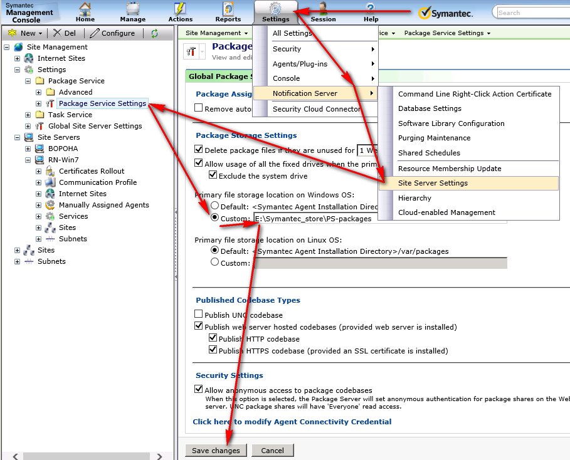
This is it for NS side. Package Servers will receive the policy and perform relocation of the packages. If need to speed that up, or in order to check the status it is possible to go to the PS machine, go to the Package Server and update the policies manually like on the picture below:
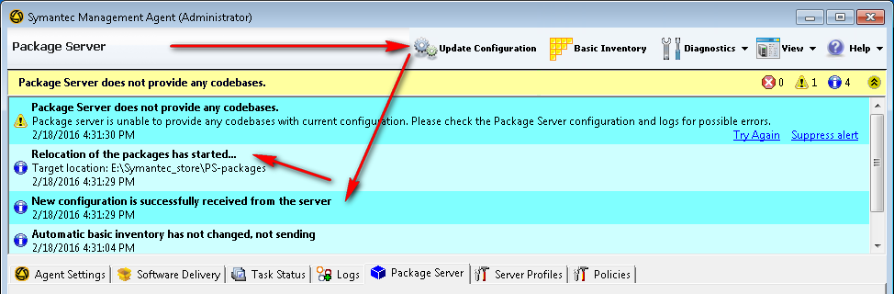

How it really works?
Looks simple enough, but the sweets don’t come without the price, and things not always go smooth as we wish. Below are covered advanced client side settings, troubleshooting and more detailed technical description.
Since we are dealing with the file moving operations, which are quite expensive and potentially vulnerable for different kind of failures, especially on live environments, this relocation process is done using several concepts:
- While the whole relocation process the Package Server is stopping all downloads, delete virtual directories block HTTP/HTTPs requests for packages, removes UNC shares for own packages blocking the UNC downloads. The PS will not be accessible for clients while the relocation process.

- Could happen that relocation process will not be able to move some files, since we can’t guarantee that any other 3rd party process (like some system processes or anti-virus software) is not reading our files exclusively at the moment. At the same time we need the packages to be accessible after relocation finishes. To resolve that, the file moving process is done per package and with retries. By default there are 3 retries with 15 minute interval. Those could be configured by next registry entries:
HKLM\SOFTWARE\Altiris\Altiris Agent\Package Server\Package Storage Relocation Maximum Attempts
(REG_DWORD) The maximum retries number allowed to perform automatically.
HKLM\SOFTWARE\Altiris\Altiris Agent\Package Server\Package Storage Relocation Interval (min)
(REG_DWORD)The interval between relocation retries.
The relocation retries are done only to packages which are failed to move.

- The relocation process uses the Junction Points Windows functionality (remember NTFS, not FAT32 requirement? This is the reason).
The packages failed to relocate are left on legacy location. In order client to be able to download them from PS, the new location will actually be a “link” to folder in old location, thus such packages “pretend” to be in new location although they are not. The relocation process itself in that case will finish with a warning “Some of the files have not been moved to the new location.” and be retried (see parameters from point 2)

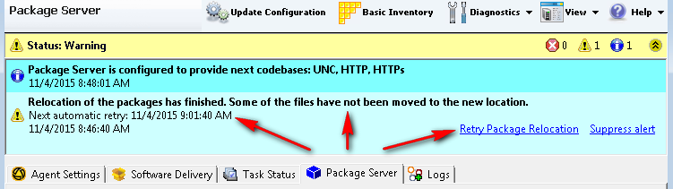

It is possible to manually trigger the relocation attempt retry with the link on the picture above, or by using a server task link from Package Server UI:
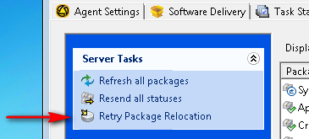
Manually triggered relocations retries do not affect the maximum relocation number. The "maximum number" and "attempts done" are affected only by automatic retries.

Because of the links used, when relocation is finished with a warning and links are created, the PS remains fully functional and for clients those “temporary PS problems” are transparent. PS will restore the virtual directories and shares and start to work as before until next relocation attempt. It will also show the new path as Package Servers default storage path:
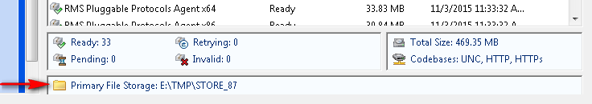

When all files are moved to new location the status will be a success and informational alert will pop-up:
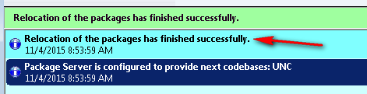

On each relocation attempt (automatic and manual) the "AeX AC Package Location Status" inventory event is sent to NS server.
This event contains next fields:
Description | Value
Storage path | String path where relocation attempt was targeted to.
Total size of the volume | Size in Mbytes
Free size of the volume | Size in Mbytes
Size used by PS on this volume | Size in Mbytes
Last relocation attempt | Date & Time of last attempt
Last relocation status | Set of bites describing the status of last relocation attempt
Volume Size Required By PS | Size in Mbytes

Those values could be seen in Basic Inventory fields from within the Resource Manager.

