How to block the access of Extension (.mp3, .mp4, .mpg, .mpeg, .flv)

Problem
Require blocking the access of Extension (.mp3, .mp4, .mpg, .mpeg, .flv)?
Solution
1. Block Access of Extension
a. Login into the SEPM console.
b. Click Policies, and then click Application and Device Control under View Policies.
c. Select the Application and Device Control policy which needs to be modified on the right-hand side.
d. Click Edit the Policy under Tasks.
e. In the pop-up window, click Application Control.
f. Click the Add... button.
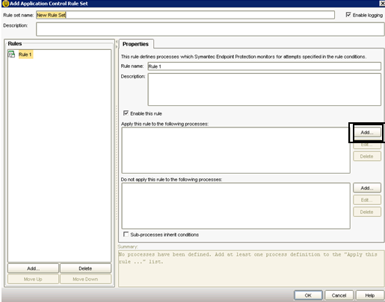
G. In section of “Apply this rule in the following process” click on ADD and enter the Asterisk (*) Sign. Then Select Ok.

H. Now Click on Add from Bottom
I. Click on Add Condition and select the file and folder Access attempts.
J. Under the File and Folder Access Attempts box click on ADD in the section of “Apply this rule in the following process”
K. Enter the Extension with Asterisk Sign (eg- *.mp3, *.mp4, *.mpg, *.mpeg, *.flv)

L. Then press ok
M. Go to the Action Tab in “File and Folder Access Attempts”.
N. Select the Block Access in the “Read Attempt” and “Create, Delete or Write Attempt”.
O. Select Ok.
Now policy has been created success. Assign the policy to that Group where it Require.

