Contents

1 – UIM HA 3
1.1 UIM Secondary core hub 4
1.1.1 UIM Secondary (HA) hub installation 5
1.1.2 HA probe 9
2 - UMP HA 12
2.1 UMP failover solution 1 12
2.1.1 UMP/Wasp settings 14
2.1.2 CABI/Wasp settings 17
2.1.3 NAS settings 18
2.1.4 Create failover scripts/commands 19
2.1.5 NAS failover profiles 21
2.1.6 Check failover 23
2.2 UMP failover solution 2 24
2.3 UMP failover solution 3 24

Version: 0.19 (review version)
Date: 09/12/2019
Author: Luc Christiaens (luc.christiaens10@telenet.be)

Updates:
18/08/17: reviewed/commented by Rowan Collis
24/08/17: rewritten doc based on fresh 8.5.1 CentOS HA setup
09/09/17: remove “delete db” option in install Secondary core hub
: added more explicit stop/start Primary/Secondary after install
04/10/17: added extra comments/edits suggested by Steve Danseglio
21/10/17: updated after Windows implementation with external cabi
27/12/17: minor updates
09/05/19: added ems ha parameter added in 9.1
26/07/19: added link to solution 3 script in Broadcom environment
12/10/19: added new HA parameter: NAS_AO_first_if_failover
23/10/19: added remote wasp (adminconsoleapp) to be stopped
: certificate.pem
: tested with 9.2.0 on W2016/SQL2016 and bundled CABI
09/12/19: added possible CABI keys

1 – UIM HA

An important step in the implementation of UIM is the installation and customization of a Secondary core hub with as only goal to provide HA support in case the Primary core hub becomes unavailable.
There are 2 possible problems when trying to build a Secondary core hub:
- The steps to create a Secondary core hub are not always up to date (especially in the latest UIM versions where certain probes must contain other, not always documented, packages.
- The steps to make your UMP and CABI servers HA ready are not documented.

This document will try to explain:
- A simple way to install a Secondary core hub for HA usage (chapter 1)
- How to create a custom archive package to modify UMP, CABI and NAS settings during a failover (chapter 2)
- Create 2 NAS AO profiles that will trigger/launch PU commands to deploy this archive packages (chapter 2)
Note: the normal installation of your UMP(s) and CABI environment is done like documented in the UIM documentation.

1.1 UIM Secondary core hub

The used environment to perform the initial tests: (you will see some server names in the screen shot or examples)
OS: CentOS 7 (but under Windows it will be exactly the same logic)
Installation in directory: /opt/nimsoft
Domain: bgbulab76_domain
Primary core hub: bgbulab76_hub
Primary core hub robot: bgbulab76
Primary core hub IP: 192.168.0.176
Secondary core hub: bgbulab77_hub
Secondary core hub robot: bgbulab77
Secondary core hubIP: 192.168.0.177
MySQL server: bgbulab75 (in fact MariaDB)
UMP1: bgbulab78
UMP2: bgbulab79
CABI: bgbulab80 (bundled) (on a Windows setup tested with external CABI)
In case you want a Secondary core hub that can take over the Primary core hub you can install/setup the Secondary core hub in 2 ways:
Solution 1:
The CA documented way:
- Install robot
- Copy hub package + a list of other packages. The instructions of the list & order of packages that we need on the HA hub are not always up-to-date. Each UIM version changes the list of needed packages, and some probes need several, undocumented, packages.
- Setup/Customize HA probe on Secondary core hub (= standby hub). Note that this step is the same as in solution 2.
- Install UMP and CABI server. This is done in the officially documented way.
- Note that UMP/CABI failover is not (yet) officially supported/documented you can use the UMP failover steps explained in chapter 2.

Solution 2:

1.1.1 UIM Secondary (HA) hub installation

To avoid the problem that we need for each version to decide/hesitate what packages and probes we need on the Secondary core hub, we will install a second Primary core hub, with the same domain name, but with another hub name.
- Take a copy of /hub/security.cfg on your Primary core hub (for safekeeping)
- Stop the Primary core hub
- select: setupCAUIMServer (or setupCAUIMServer_linux) like on the Primary core server. (check that you have the file: uimserverpackages.zip in the same directory)
- During the Secondary/HA hub installation select the “use existing database” option.
- Follow the installation instructions of Primary core hub, give same domain, but another (different) hub name and use the same userid/password combinations.
- Before shutdown, “deactivate” all core probes on this Secondary core hub (HA hub) that are only needed on Primary/running core hub
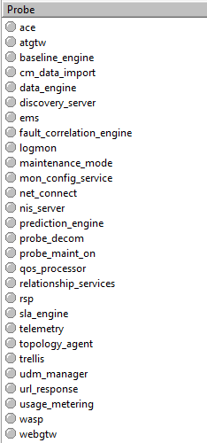
- Copy /nimsoft/security/certificate.pem from the primary hub to your secondary hub (**
failure in executing this step will be the reason why cabi wasp and ump wasp will NOT start during failover ***)
- Shut down the Secondary core (HA) hub (stop the robot service)
- Start the Primary core hub and login via Infrastructure Manager or the Adminconsoleapp
- Restart the Secondary core hub (once the Primary is active). (if you have IM open and you don’t see your Secondary core hub appear, open the Primary core hub configuration, select “name services” and add a new static hub and select the IM login icon)

Note: At this point during startup of the Primary hub, UIM may prompt you to re-initialize the security on your Primary core hub, if you leave the Secondary core hub running. Do not re-initialize security.

- Copy the queues defined in /hub/hub.cfg from your Primary core hub to your Secondary core hub, but set most of the queues inactive:
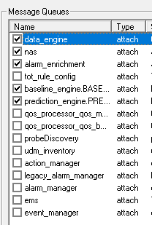
Note: keep only the queues: data_engine, nas, alarm_enrichment, baseline_engine.BASELINE_CONFIG, prediction_engine.PREDICTION_CONFIG active
- Define a QoS GET queue on the Primary to get the data_engine queue of the Secondary core hub. (so that you have the QoS entries of the active probes on your Secondary core hub)
- If you activated the LDAP interface on your Primary hub you can install/customize this interface also on your Secondary core hub
- If you defined tunnels on your Primary core hub you will need to define them also on your Secondary core hub. The GET queues can stay INACTIVE because you can activate them in the HA probe configuration/setup.
- If you installed and customized some extra probes on the Primary hub, like "emailgtw" to send out emails or "snmptd" to receive SNMP traps AND you want these features to be available during failover you need to install and customize these probes also on your Secondary core hub.
IMPORTANT: If you implement HA according to this document you will have all basic functions running during failover, but it's difficult to document all the additional probes / rules you might add after the basic HA setup.
- Check that you activated the hub and probe licenses on both Primary and Secondary hubs
- Create a distsrv forwarding rule for “all” packages, on the Primary core hub, to your Secondary core hub to ensure that your Primary and Secondary archives are in sync.
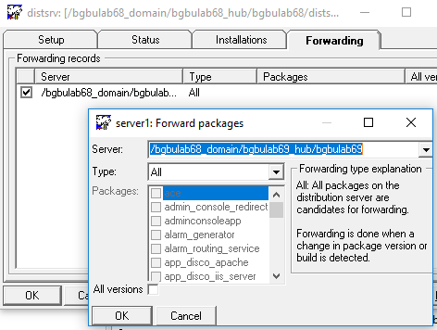
Version 9.1 (and later) had a problem with EMS not starting correctly in an HA environment. Therefor you need to add in raw config of your primary hub EMS:
- An additional property (ha_address) is now available in the ems probe to configure the secondary hub address where HA is deployed. Format: /domain/hub/robot

- On the Secondary core hub, Nas probe configuration, disable the NIS Bridge. (nis_bridge = no) Only 1 NAS can/may update the database tables with the alarms.
- On the Primary core hub, Nas probe configuration, tab: “forwarding & replication”- create forwarding bi-directional (all alarms in both directions), rule to Secondary core hub
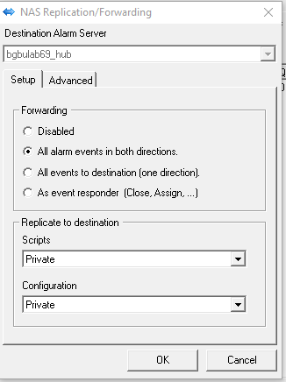
Activate:
- Forwarding – All alarm events in both directions
- Replicate scripts and configuration in Private mode.
Since the NAS scripts and nas.cfg are replicated in a nas replication folder you will need to perform a MANUAL task to copy the scripts to your normal location (/nimsoft/probes/services/nas/scripts) and to update the nas.cfg with the needed AO and pre-processing rules.
Warning: do NOT copy the replicated nas.cfg to the real Secondary core nas.cfg because this version contains the wrong NAS forwarding rules for the Secondary core NAS
Note1: the nas.cfg file will be available on the Secondary core server in directory:
/nimsoft/probes/services/nas/replication/config/bgbulab76_hub/
Note2: the replicated "scripts" will be available on the Secondary core server in directory:
/nimsoft/probes/services/nas/replication/scripts/bgbulab76_hub/
Note3: verify on your Secondary core hub if you have the correct licenses, else you could encounter the problem that after a failover, most of the important probes are not started because of license errors/expiration. (this is not needed anymore in version 9.20)

1.1.2 HA probe

- Deploy the HA probe on the Secondary core hub (a.k.a. HA hub/Standby hub). After the deployment the HA probe stays deactivated.
- Double-click to open the HA probe

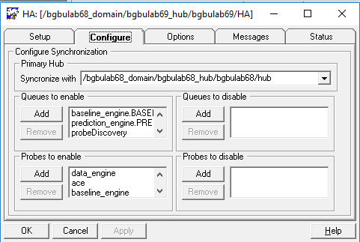
- Queues to enable:
Note: These queues are only the queues from a "test" environment, in a real production environment you will see in the HA GUI also all possible GET queues you created on your Primary core hub to GET all QOS and Alarm Attach queues from you Secondary/remote hubs (tunneled and not tunneled)
<queue_up>
queue_0 = action_manager
queue_1 = alarm_manager
queue_2 = ems
queue_3 = ems_uim_db_sync
queue_4 = event_manager
queue_5 = legacy_alarm_manager
queue_6 = policy_management
queue_7 = probeDiscovery
queue_8 = udm_inventory
</queue_up>

Note: you will need to add also all GET queues from your secondary/proxy hubs

- Probes to enable (and in they must be in the correct order):
Note: if you don’t respect this order you will have some probes that will not start for example because a pre-requisite probe that must start before is not available/started (yet).
<probes_up>
probe_0 = data_engine
probe_1 = ace
probe_2 = discovery_server
probe_3 = maintenance_mode
probe_4 = mon_config_service
probe_5 = nis_server
probe_6 = qos_processor
probe_7 = sla_engine
probe_8 = udm_manager
probe_9 = trellis
probe_10 = ems
probe_11 = wasp
probe_12 = logmon
probe_13 = baseline_engine
probe_14 = prediction_engine
probes_up>

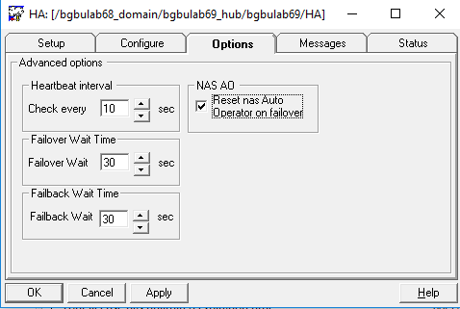
On the Secondary core/HA hub, verify that you activated “NAS AO”, so that the Auto Operator becomes active after a failover. BUT keep in mind that it’s a manual task that you copy/create/update the nas AO Profiles to the Secondary hub.
Note1: that is one of the reasons why your AO profile to start the failover has a wait of 1 minute. This gives the NAS AO enough time to start.
Note2: on your production server you will probably want a "failover wait time" longer than 30 sec. Set here a time like 3 or 5 minutes, so that a restart of the primary hub or a reboot will not trigger a failover.

- Select Raw Configure for the HA probe and add a new key:

NAS_AO_first_if_failover

And set the value: 1.
When set to: 1, when the failover starts, the HA probe performs the actions in the following sequence:
  - Activates nas Auto Operator.
  - Issues "Initiating failover from remote Hub XXXXXX" alarm.
  - Activates queues configured in [Queues to enable].
  - Activates probes configured in [Probes to enable].
When set to: 0, the default.:
  - Issues the "Initiating failover from remote Hub XXXXXX" alarm.
  - Activates the queues configured in [Queues to enable].
  - Activates nas Auto Operator.
  - Activates probes configured in [Probes to enable].

Now you can (re)start the AO probe and the basic failover is ready (failover without UMP and Cabi up to this point)
At this point you can try a first failover test by stopping the Primary hub (stop the robot) and verify if all probes and all queues on the Secondary core hub are activating.
Note: up to now you can follow the alarm flow via the alarmsubconsole.exe fat client (located in C:\ Nimsoft\bin). This client doesn’t need UMP and can serve later also as a backup console.

2 - UMP HA

You can install your primary and optionally your other UMP's like documented in the official UIM documentation.
All installed UMP servers will always be active and point to the primary hub. The official documentation does not offer a solution for failover situations (yet).
The next section will try to explain a possible solution so that your UMP/CABI server(s) will continue to work after your primary core hub failed over to your secondary core hub.

2.1 UMP failover solution 1

To help you to failover the UMP and change the NAS NIS Bridge setting there are several solutions available.
In this section, we will use a method that will be easy to adapt if UIM requirements change with new Service Packs or versions.
Note1: if your UMP server(s) and/or your Cabi server are managed by your Primary Core hub, it’s important to define the Secondary Core hub as Secondary hub in the controller configuration of each robot. In case you would have multiple hubs that could be discovered, these UMP/Cabi servers could connect to a wrong hub in failover mode and the following commands/customizations could have an invalid hub name in the UIM address. (and fail)
Example messages that you can receive during failover:
- Lost contact with remote Hub /bgbulab68_domain/bgbulab68_hub/bgbulab68/hub
- Initiating failover from remote Hub /bgbulab68_domain/bgbulab68_hub/bgbulab68/hub
- Start failover to Secondary UIM server
- Distribution to /bgbulab68_domain/bgbulab69_hub/bgbulab69 of nas_config_nis_yes (): Finished (0) job=job23 ()
- Distribution to /bgbulab68_domain/bgbulab69_hub/bgbulab70 of wasp_config_Secondary (): Finished (0) job=job22 ()

Note: the package distribution alarms are only generated if you customized your distsrv probe “alarm on finished installations”.
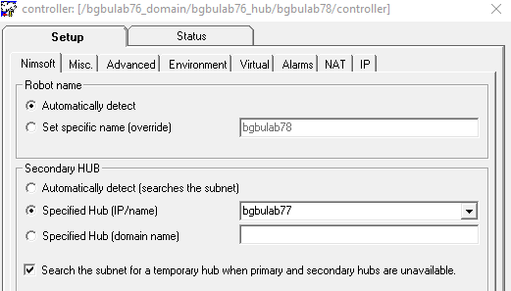
The setting: “Secondary hub” must be set to your Secondary core hub.

2.1.1 UMP/Wasp settings

The basic underlying concept/idea is that when you look in wasp Raw configure you can see the settings UMP needs to point to for the correct UIM server:
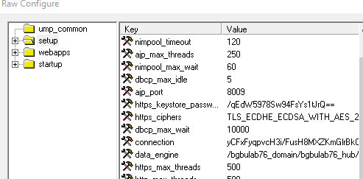
Under “setup” you can find the reference to the probe: data_engine and perhaps also the reference to CABI.
Note: in some cases the CABI url in UMP stays blank. In that case you can try to add in the UMP wasp probe under setup a new key: cabi that points to the address of the cabi probe:
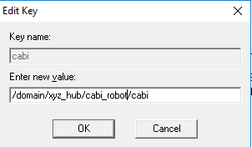
If you added this key, you will need to include this key in the failover package.
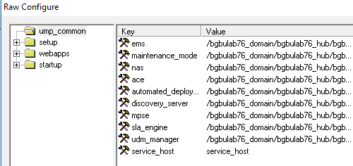
Under the “ump_common” section you can find all other main UIM hub probe references.
Now we need to create an archive package that will contain only the Wasp probe settings needed after failover and after fallback to point UMP to the correct UIM server.
Note that after failover the ump_common keys should be pointing to the Secondary hub.
- Via Infrastructure Manager: Copy the wasp probe from the UMP hub to the archive and rename it to:
  - wasp_config_ump_Primary
- Edit this new archive package: (the names are pointing to your Primary hub, this will be used in case a failover is finished, to set the original pointers back to the Primary hub)
Note: if your CABI server runs on an external server running only CABI you will probably have a wasp – setup reference to CABI. If your CABI server is located under your primary hub it will probably switch to another hub (your secondary hub) during failover. If this is true you must include the CABI entry in the wasp setting.

<ump_common> overwrite
ems = /bgbulab76_domain/bgbulab76_hub/bgbulab76/ems
maintenance_mode = /bgbulab76_domain/bgbulab76_hub/bgbulab76/maintenance_mode
nas = /bgbulab76_domain/bgbulab76_hub/bgbulab76/nas
ace = /bgbulab76_domain/bgbulab76_hub/bgbulab76/ace
automated_deployment_engine = /bgbulab76_domain/bgbulab76_hub/bgbulab76/automated_deployment_engine
discovery_server = /bgbulab76_domain/bgbulab76_hub/bgbulab76/discovery_server
mpse = /bgbulab76_domain/bgbulab76_hub/bgbulab76/mpse
sla_engine = /bgbulab76_domain/bgbulab76_hub/bgbulab76/sla_engine
udm_manager = /bgbulab76_domain/bgbulab76_hub/bgbulab76/udm_manager
service_host = service_host
</ump_common>
<setup> overwrite
data_engine = /bgbulab76_domain/bgbulab76_hub/bgbulab76/data_engine
cabi = /bgbulab76_domain/bgbulab76_hub/bgbulab80/cabi
</setup>

- Copy the wasp probe again to archive and rename it to:
  - wasp_config_ump_Secondary.
- Keep the above entries and change them to the Secondary hub (in this example change all "bgbulab76_hub/bgbulab76" to "bgbulab77_hub/bgbulab77")
Note: in above example:
- domain: bgbulab76_domain
- primary core hub: bgbulab76_hub
- secondary core hub (HA): bgbulab77_hub

2.1.2 CABI/Wasp settings

The CABI Wasp probe has only 1 setting that refers to the Primary core hub; under setup you can find a reference to the data_engine probe:
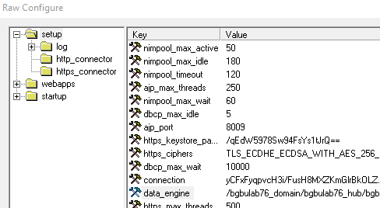

To create a package that we can deploy during failover:
- Copy the wasp probe from the Cabi server to the archive of your Primary core hub and give it a name like:
  - wasp_config_cabi_Primary
- Edit this archive package and keep only the lines: (point to your Primary core hub)
<setup> overwrite
data_engine = /bgbulab76_domain/bgbulab76_hub/bgbulab76/data_engine
</setup>
- Copy the cabi wasp probe package again to the Primary core server archive and name it:
  - wasp_config_cabi_Secondary
- Edit this archive package and keep the lines: (point to your Secondary core hub)
<setup> overwrite
data_engine = /bgbulab76_domain/bgbulab77_hub/bgbulab77/data_engine
</setup>

2.1.3 NAS settings

Create a package that contains the setting “nis_bridge”.
- Copy the nas probe to your archive on your Primary hub and give it the name: “nas_config_nis_yes”
- Edit the package and nas.cfx file must only contain:

<setup> overwrite
nis_bridge = yes
</setup>

- Copy the nas probe a second time and give it the name: “nas_config_nis_no”
- Edit the package and nas.cfx must only contain:

<setup> overwrite
nis_bridge = no
</setup>
This NAS package will only be distributed to the Secondary HA hub NAS.
When failover start we will distribute: nas_config_nis_yes to the Secondary core hub server. This will activate the NIS bridge on the Secondary core hub so that NAS alarms are updated in the database and so the USM console can display all messages.
Note: alarmsubconsole.exe users are not dependent of this nis_bridge setting because their alarms come from the SQLite db.

2.1.4 Create failover scripts/commands

The UMP server is: bgbulab78
The CABI server is: bgbulab80
- Create a user directory on the Primary and Secondary core server, example /opt/temp/luc and copy the following 2 files in this directory:
File: ump_failover_start.sh (executed on Secondary core hub) Linux example
/opt/nimsoft/bin/pu -u administrator -p xxx /bgbulab76_domain/bgbulab77_hub/bgbulab77/distsrvjob_add "" "" "wasp_config_ump_Secondary" "" "/bgbulab76_domain/bgbulab77_hub/bgbulab78" "" ""
/opt/nimsoft/bin/pu -u administrator -p xxx /bgbulab76_domain/bgbulab77_hub/bgbulab77/distsrvjob_add "" "" "wasp_config_cabi_Secondary" "" "/bgbulab76_domain/bgbulab77_hub/bgbulab80" "" ""
/opt/nimsoft/bin/pu -u administrator -p xxx /bgbulab76_domain/bgbulab77_hub/bgbulab77/distsrvjob_add "" "" "nas_config_nis_yes" "" "/bgbulab76_domain/bgbulab77_hub/bgbulab77" "" ""
/opt/nimsoft/bin/nimalarm -l 2 "Start failover to Secondary UIM server"
File: ump_failover_start.bat (executed on Secondary core hub) Windows example (with 2 UMP servers)
rem --- deploy packages to set ump and cabi server to Secondary UIM server
d:/ca/uim/bin/pu -u administrator -p xx /DOMAIN/SECONDARY_HUB/Secondary_robot/distsrv job_add "" "" "wasp_config_ump_Secondary" "" "/DOMAIN/SECONDARY_HUB/ump01_robot" "" ""
d:/ca/uim/bin/pu -u administrator -p xx /DOMAIN/SECONDARY_HUB/Secondary_robot/distsrv job_add "" "" "wasp_config_ump_Secondary" "" "/DOMAIN/SECONDARY_HUB/ump02_robot" "" ""
d:/ca/uim/bin/pu -u administrator -p xx /DOMAIN/SECONDARY_HUB/Secondary_robot/distsrv job_add "" "" "wasp_config_cabi_Secondary" "" "/DOMAIN/SECONDARY_HUB/cabi_robot" "" ""
d:/ca/uim/bin/pu -u administrator -p xx /DOMAIN/SECONDARY_HUB/Secondary_robot/distsrv job_add "" "" "nas_config_nis_yes" "" "/DOMAIN/SECONDARY_HUB/Secondary_robot" "" ""
d:/ca/uim/bin/nimalarm -l 2 "Start failover to Secondary UIM server"
Note: after a failover we need to change the UMP and CABI settings to point to your secondary core hub, running the HA probe.
File: ump_failover_end.sh (executed on Primary core hub) Linux example
/opt/nimsoft/bin/pu -u administrator –p xxx /bgbulab76_domain/bgbulab76_hub/bgbulab76/distsrvjob_add "" "" "wasp_config_ump_Primary" "" "/bgbulab76_domain/bgbulab76_hub/bgbulab78" ""“”
/opt/nimsoft/bin/pu -u administrator –p xxx /bgbulab76_domain/bgbulab76_hub/bgbulab76/distsrvjob_add "" "" "wasp_config_cabi_Primary" "" "/bgbulab76_domain/bgbulab76_hub/bgbulab80" "" “”
/opt/nimsoft/bin/pu -u administrator -p xxx /bgbulab76_domain/bgbulab76_hub/bgbulab76/distsrvjob_add "" "" "nas_config_nis_no" "" "/bgbulab76_domain/bgbulab77_hub/bgbulab77" "" ""
/opt/nimsoft/bin/nimalarm -l 2 "Stopping failover, coming back to Primary UIM server"
Note: at the end of the failover we need to reset the UMP and CABI settings to point to your primary core hub + on the secondary core hub NAS we need to set NIS_BRIDGE = NO, because only 1 NAS can update the alarms into the database.
File: ump_failover_end.bat (executed on Primary core hub) Windows example
rem --- deploy packages to set ump and cabi back to Primary uim server
d:/ca/uim/bin/pu -u administrator -p xx /DOMAIN/PRIMARY_HUB_HUB/Secondary_hub/distsrv job_add "" "" "wasp_config_ump_Primary" "" "/DOMAIN/PRIMARY_HUB_HUB/ump01_robot" "" ""
d:/ca/uim/bin/pu -u administrator -p xx /DOMAIN/PRIMARY_HUB_HUB/Primary_robot/distsrv job_add "" "" "wasp_config_ump_Primary" "" "/DOMAIN/PRIMARY_HUB_HUB/ump02_robot" "" ""
d:/ca/uim/bin/pu -u administrator -p xx /DOMAIN/PRIMARY_HUB_HUB/Primary_robot/distsrv job_add "" "" "wasp_config_cabi_Primary" "" "/DOMAIN/PRIMARY_HUB_HUB/cabi_robot" "" ""
d:/ca/uim/bin/pu -u administrator -p xx /DOMAIN/PRIMARY_HUB_HUB/Primary_robot/distsrv job_add "" "" "nas_config_nis_no" "" "/DOMAIN/SECONDARY_HUB/Secondary_robot" "" ""
d:/ca/uim/bin/nimalarm -l 2 "Stopping failover, coming back to Primary UIM server"
- Verify that these files can be executed (chmod +x ….)
Note1: if you have multiple UMP servers you only need to repeat the first command that will add the wasp_config_ package to your extra UMP server (and change the target UMP server name, in our case bgbulab70 into the extra name)

2.1.5 NAS failover profiles

- Create a Nas rule on the Primary core hub:
Note1: the packages wasp_config_ump_Primary and wasp_config_ump_Secondary will point the wasp to the correct active UIM hub core server.
Note2: the packages: wasp_config_cabi_Primary and wasp_config_cabi_Secondary will point the cabi wasp to the correct active UIM data_engine on the hub core server.
Note3: The packages: nas_config_nis_yes and nas_config_nis_no will activate the NAS Nis bridge on the Secondary core server (so that the UMP USM console will see/receive the latest alarms) and will set it back to no on the Secondary core server when the Primary becomes back active.
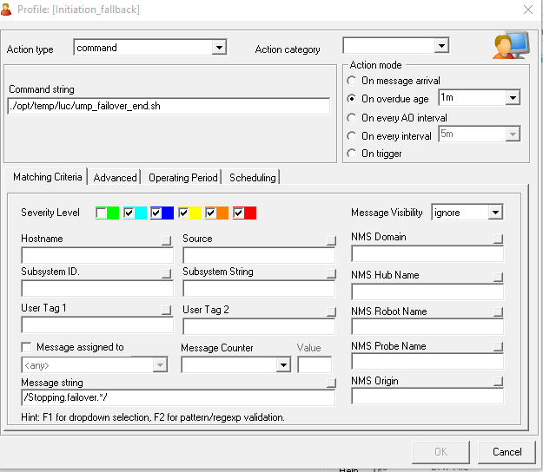
- Message string: /Stopping.failover.*/
- Command string: /opt/temp/luc/ump_failover_end.sh
- On overdue age: 1m (or 3m)
- Action type: command
Note1: depending on your environment setup you could need an "overdue" longer than 1 minute. Example: if your UMP and CABI servers are located under the Primary hub they will move to the Secondary hub during failover. Sometimes this can take more than 1 minute before they are moved. The problem is that you cannot execute the packages too soon else the probe addresses in the packages are not correct.
Note2: if you will deploy more HA probes in your environment you will need to use the “NMS Robot Name” field in the NAS AO rules in the format: /primary_hub_robot|secondary_hub_robot/
- Create a Nas rule on the Secondary core hub:
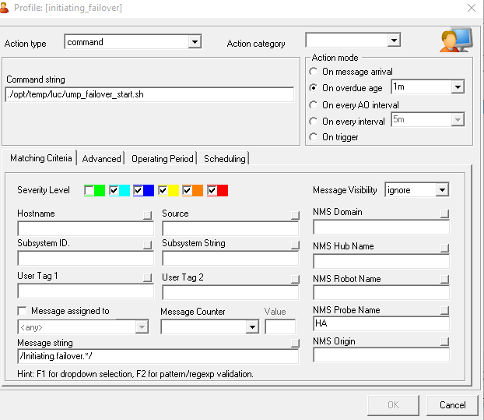
- Action type: command
- Command string: /opt/temp/luc/ump_failover_start.sh
- Action mode: on overdue 1m (or 3m)
- Message string: /Initiating.failover.*/

- Verify that your 5 packages are in the archive of the Secondary core hub
- If yes, you can perform a first test by stopping the Primary core hub (service stop nimbus or stop robot service)
- Verify specially the UMP USM and Console alarms
- overdue time must be long enough to give the UMP and CABI robots the time to move to your new hub, else the settings in the archive packages will not correspond.
Note1: command string is WITHOUT the starting “.”

2.1.6 Check failover

Once a failover occurs you need to check:
- Are the UMP and CABI servers switching to the Secondary Core Hub quick enough, else you must define the Secondary core hub in the controller probe.
- On the Secondary core NAS, Is the Nis Bridge activated?
- If you take your UMP wasp probe in raw configure, do all settings under common point to the Secondary core hub?
- If you open the UMP USM console, do you see the new messages arrive?
- If you connect to the Cabi server can you view the UIM Overview dashboard with populated data

If the Primary hub takes control again, check:
- On the Secondary core NAS, is the Nis Bridge de-activated?
- If you take raw configure of the UMP wasp probe, do all common settings point to the Primary hub?
- If you take raw configure of the CABI wasp probe, is the data_engine key pointing to your Primary core hub?

- It’s a good idea to reboot the Secondary core hub after a failover, when the Primary core hub is back up again.

2.2 UMP failover solution 2

CA France has written a probe: UMP_HA that you install on your UMP server and that will constantly monitor if the current UMP server is still pointing to his active hub.
If the probe remarks that the UMP controller is switched to his Secondary hub the UMP settings are modified.
For the moment this probe is not yet published on the communities website.

2.3 UMP failover solution 3

In CA Communities (https://communities.ca.com/thread/241724130) you can find a LUA script that will modify the UMP, CABI and the NAS nis_bridge settings once a NAS AO profile is triggered
New Broadcom link: https://community.broadcom.com/enterprisesoftware/communities/community-home/digestviewer/viewthread?MessageKey=5ede5751-d9ab-4068-a0b6-e9a2147c05f8

