To create a new custom client installation configuration
- Open the Symantec Endpoint Protection Manager console.
- On the Admin Tab, under Tasks, click Install Packages.
The current default client installation packages appear on the right.
- Under Install Packages, click Client Install Settings.
- Under Tasks, click Add Client Install Settings.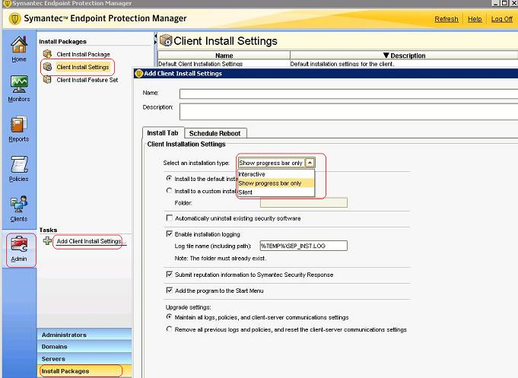
- Specify the name you would like the custom Client Install Settings to have.
- Give the custom Client Install Settings a description.
- Select an installation type from the following:
  - Show progress bar only (Displays notification, but requires no user input)
  - Interactive (User input required)
  - Silent (No user input or display)
- Select the installation location (default or custom folder).
- Enable or disable installation logging.
- Submit reputation information to Symantec Security Response.
- Select whether or not to add the program to the Start Menu.
- Select whether or not to maintain all previous logs, policies, and client-server communication settings
- Viewing the 'Schedule Reboot' tab, consider whether to force or schedule a reboot.
- Click OK.

To know more about :
Restarting client computers : http://www.symantec.com/docs/HOWTO55111

