Configuring APM 12.9 for SSL, using IIS 7.x
See the following URL for an explanation of SSL certificates:
http://www.techrepublic.com/blog/how-do-i/how-do-i-request-and-install-ssl-certificates-in-iis-70/

- Configure IIS for SSL
- On APM Web Server, launch Internet Information Services Manager, highlight the machine name, and double click ‘Server Certificates’
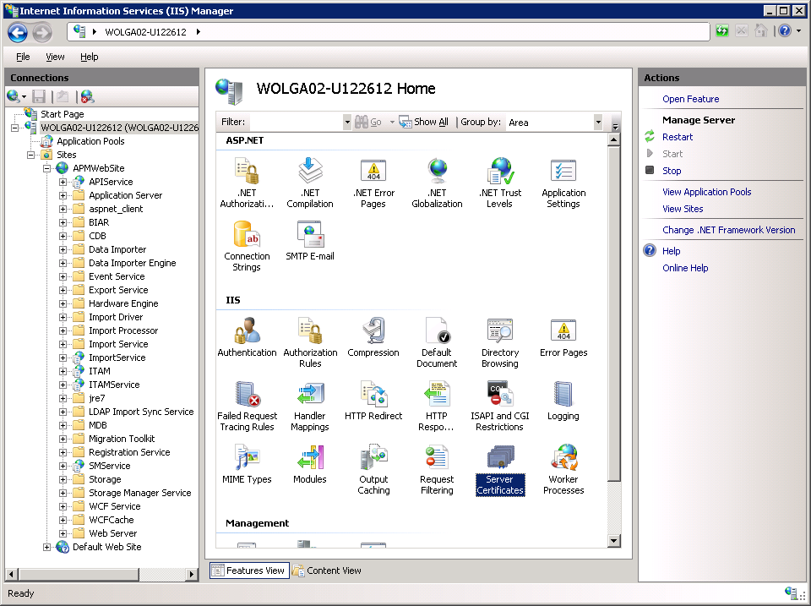

- Click ‘Create self-signed Certificate’
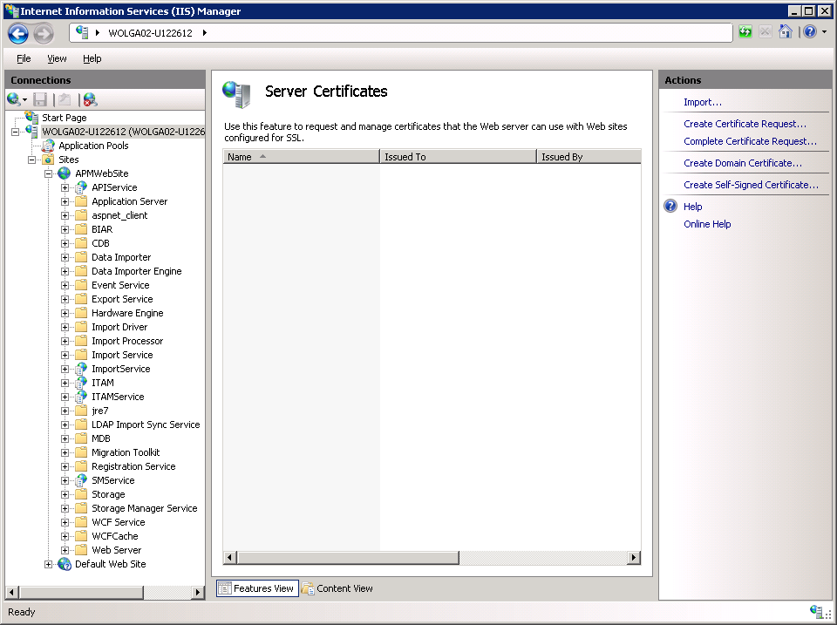

- Provide a certificate name and click OK.
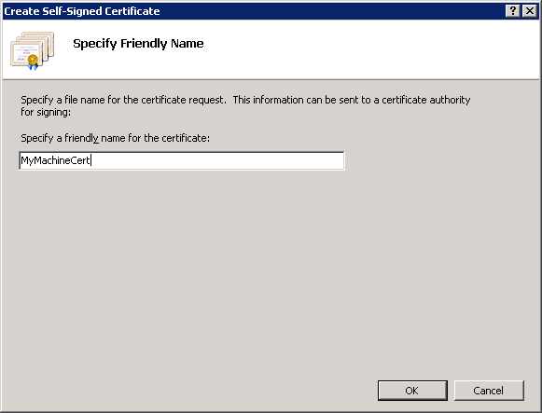

- This creates the certificate below
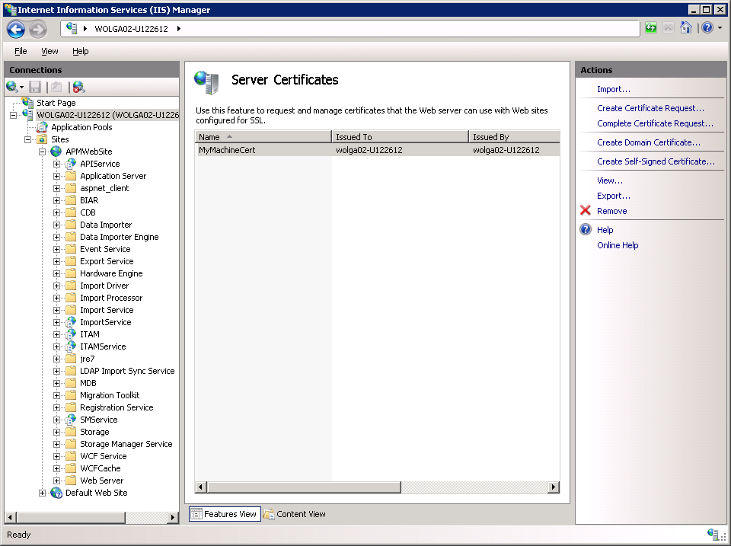

- Click on ‘APM Web Site’ and select ‘Bindings’
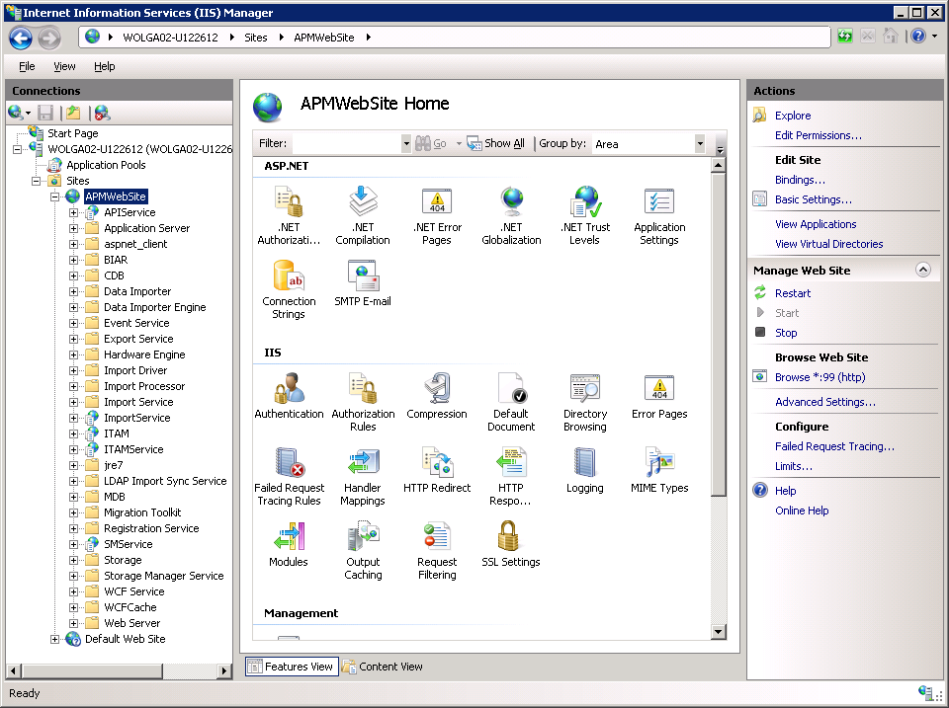

- Click Add and choose https, and specify the port and the SSL certificate name:
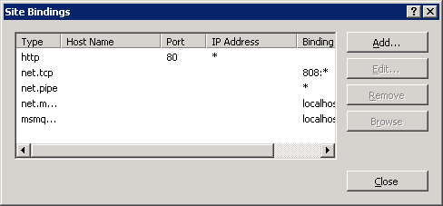
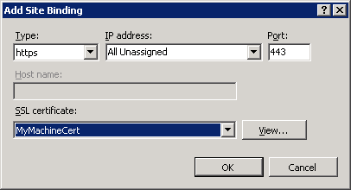

IIS is now configured for SSL.
Proceed to configure APM for SSL

- Configure APM for SSL
  - Login to APM and navigate to Administration – system configuration
  - Click on Web Server and change the protocol to ‘https’ and SAVE.
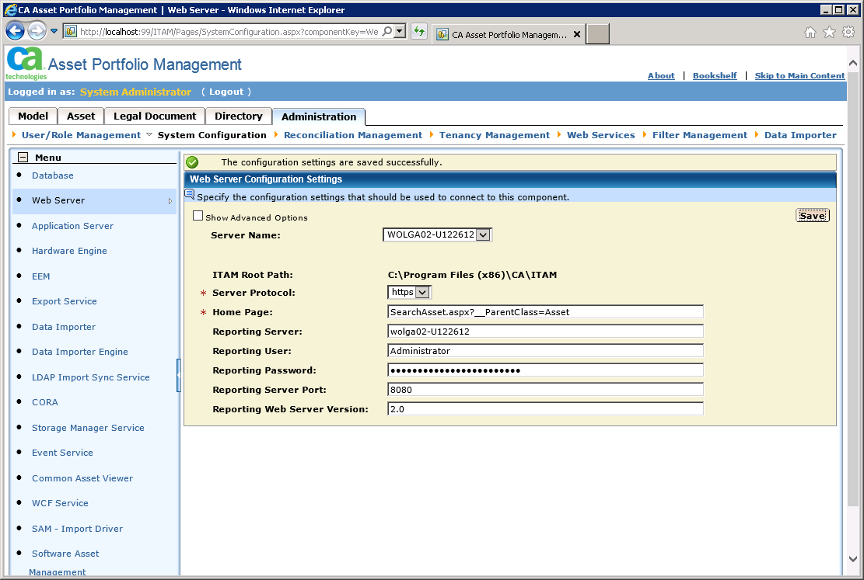

  - Click on the Application Server link and change the protocol to https and the port to the
SSL port number
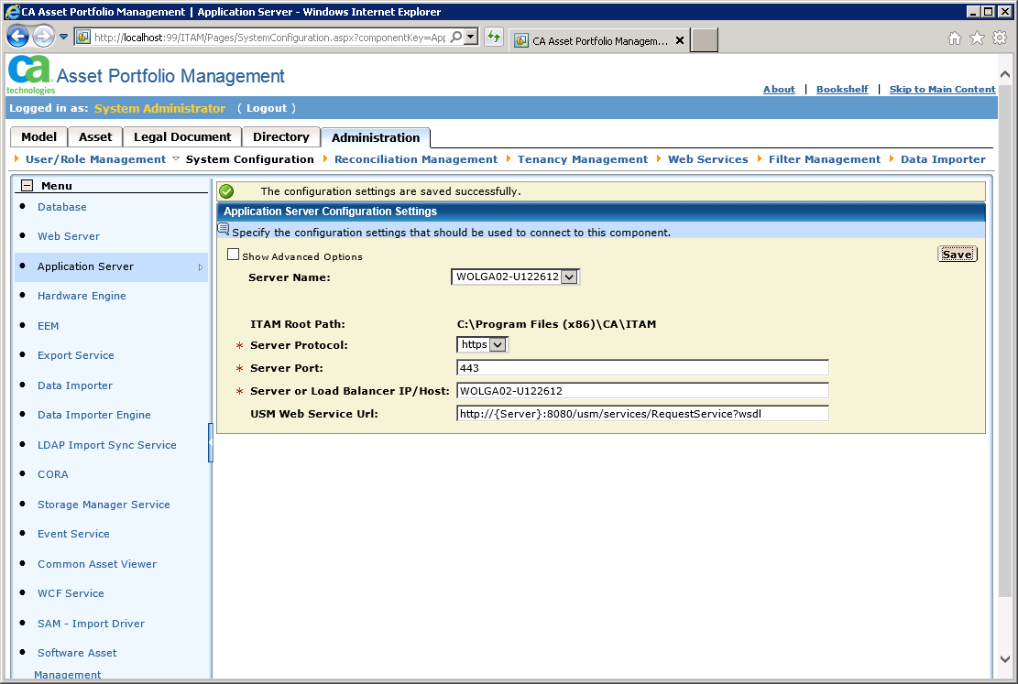

  - Click on the WCF Service link and change the protocol to https://
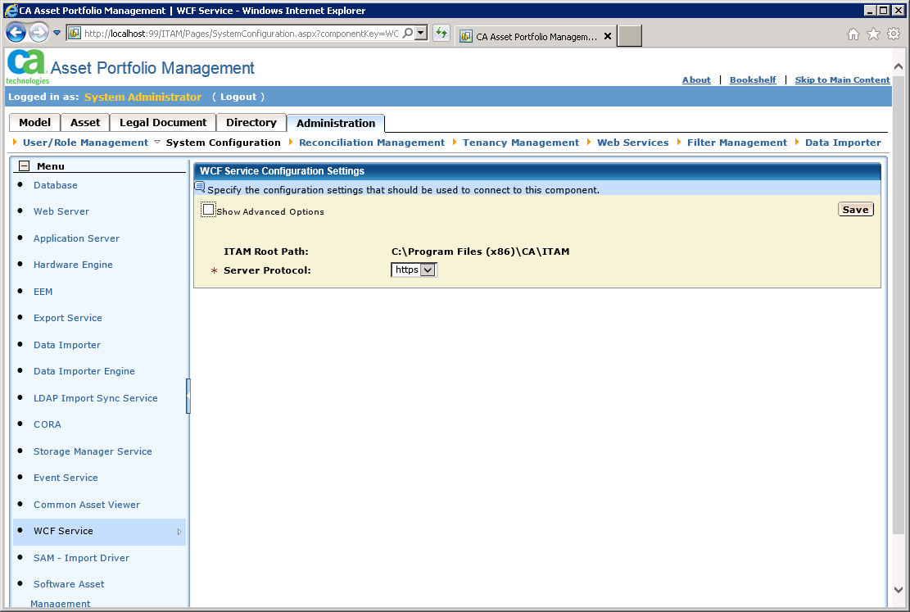

  - Launch SQL Server management studio and run this query:
Select * from al_cdb_configurationparameters where configkey = ‘ServerPort’:
Update the port number using this query:
Update al_cdb_configurationparameters set configvalue = ‘443’ where configkey = ‘ServerPort’

  - If your machine name is using the fully qualified domain name (FQDN), and the server certificate is using the FQDN, then also run these queries:

Select * from al_cdb_configurationparameters where configkey = ‘LoadBalancerName’
The configvalue from this query likely contains the short server name.

To update to the FQDN:
Update al_cdb_configurationparameters set configvalue = ‘<MyFQDNServerName>”
where configkey = ‘LoadBalancerName’

  - Perform an IISRESET; close all browsers and then launch the URL to access ITAM under SSL.
Example: https://<MyServerName>/ITAM or https://<MyServerFQDNName>/ITAM

