User setup in IDM. They have “Master Customer User Manager” assigned.
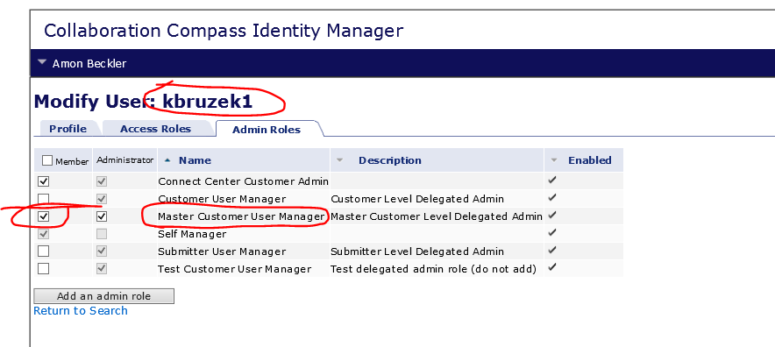

View User Task definition – Users with “Master Customer User Manager” should have access
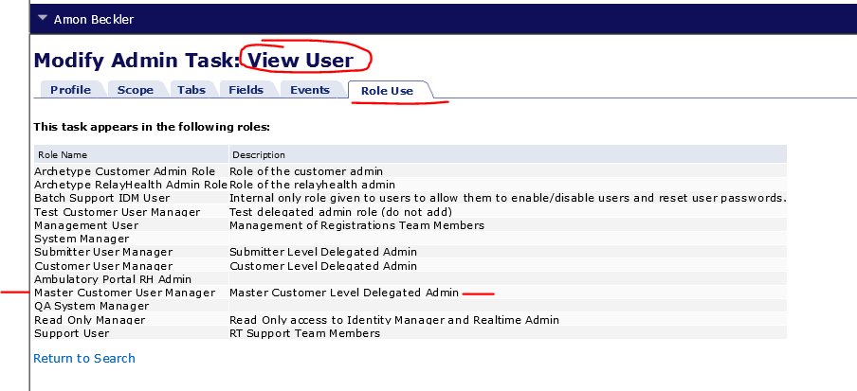

TEWS call as kbruzek1 – incorrectly getting not authorized for task
Showing logged in as kbruzek1 and going into IDM GUI, only has self mgmt. functions.