Connect APMSQL using CA Business Intelligence
Connect the CA Business Intelligence infrastructure to CA APMSQL for reporting.
IMPORTANT NOTE: APMSQL Server requires JVM 1.8 and above.
Follow these steps:
- Copy the teiid-9.0.1-jdbc.jar driver file from the APMSQL\client directory of APM EM (10.100.0.116) to the apache-tomcat/lib (10.100.0.222) destination folder in the CA Business Intelligence installation directory.
Examples: APM SQL driver and CA Business Intelligence installation paths
  - Example of an APM SQL driver installation path:
/opt/apm/apmmom/APMSqlServer/client/teiid-9.0.1-jdbc.jar
  - Example of a CA Business Intelligence installation path:
C:\Program Files\CA\SC\CA Business Intelligence\apache-tomcat\lib
- Log in to CA Business Intelligence with the following address: http://10.100.0.222:8080/jasperserver-pro/login.html. The default power user login for CA Business Intelligence for JasperReports Server is superuser/superuser as the username and password credentials.
- Click Create and New Data Source to add APM SQL as a data source:
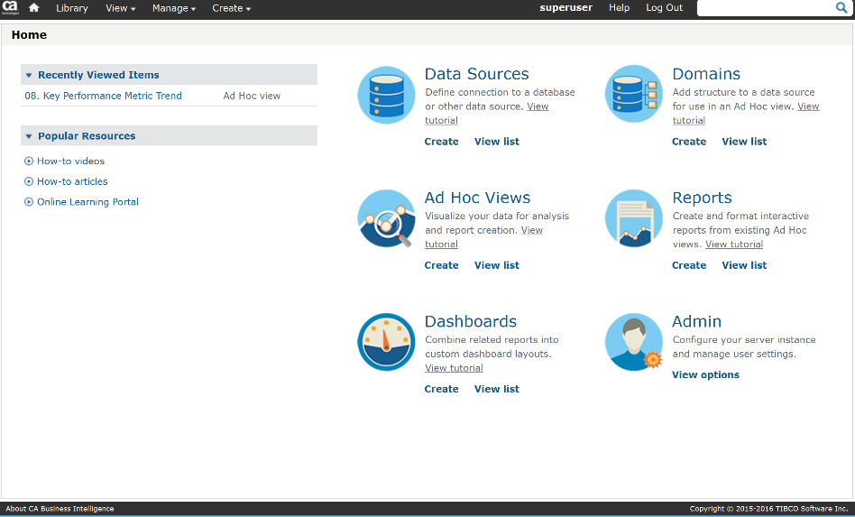
- Select JDBC Data Source from the drop-down list and select Other from the JDCB driver drop-down list.

- Type in the following details:
  - JDBC driver: org.teiid.jdbc.TeiidDriver
  - URL: jdbc:teiid:apm_base@mm://<APMSQL server host name or IP address>:<port number>
  - Username and password: enter a valid CA APM username and password. The default CA APM admin login is Admin/<blank> as the username and password credentials.
- Click Test Connection to validate the settings:
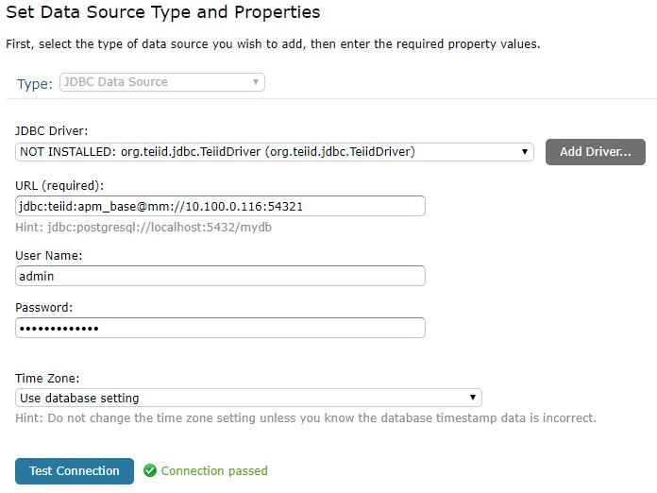

It is possible that you will need to add the defaultReadOnly property to the applicationContext.xml file. Set the property to false under the jdbcDataSourceServiceFactory setting as shown below:

<bean id="jdbcDataSourceServiceFactory" class="com.jaspersoft.jasperserver.api.engine.jasperreports.service.impl.JdbcReportDataSourceServiceFactory">
<property name="pooledJdbcDataSourceFactory">
<ref bean="dbcpJdbcDataSourceFactory"/>
</property>
<property name="autoCommitUnsupportedDrivers">
<set>
<value>com.simba.cassandra.jdbc4.Driver</value>
<value>com.simba.impala.jdbc4.Driver</value>
</set>
</property>
<property name="driverAuthMethMap">
<map>
<entry key="com.simba.cassandra.jdbc4.Driver" value="1"/>
<entry key="com.simba.impala.jdbc4.Driver" value="3"/>
</map>
</property>
<property name="poolTimeout" value="900"/>
<property name="defaultReadOnly" value="false"/>
</bean>

NOTES
- Password of admin user in this example is blank. The encrypted characters were set automatically by JASPER.
- If you have set APM to run in secure port by using em-jetty-config.xml file but you want the communication between JASPER and APMSQL to be using the default port (which is 8081) you should comment out the part of http configuration in em-jetty-config.xml.
- If you need to set up secure communication between JASPER and APMSQL after turning APM to secure port then you need to change value of property com.ca.apm.sqlserver.em.webserver.port from 8081 to 8444 (if you used the default port in em-jetty-config.xml) and also add the below line in APMSqlServer.properties file
com.ca.apm.sqlserver.em.webserver.connection.protocol=https
Then you will also have to add the certificate used in the EM which should be created by a global certification authority.
It would be the same sort of issue as Team Center not being able to display data so if Team Center is already working you shouldn't face any certificate issues.

How to make APM run in secure channel

Configure APM Data Adapter in Jaspersoft Studio
Open Jaspersoft Studio (we assume that you have already downloaded it from here).
Keep in mind that you must download a Jaspersoft Studio version which is at least 6.4.3 when you have installed JasperReports server 6.4.3

Go to Repository Explorer and then right click on Data Adapters and select Create Data Adapter.

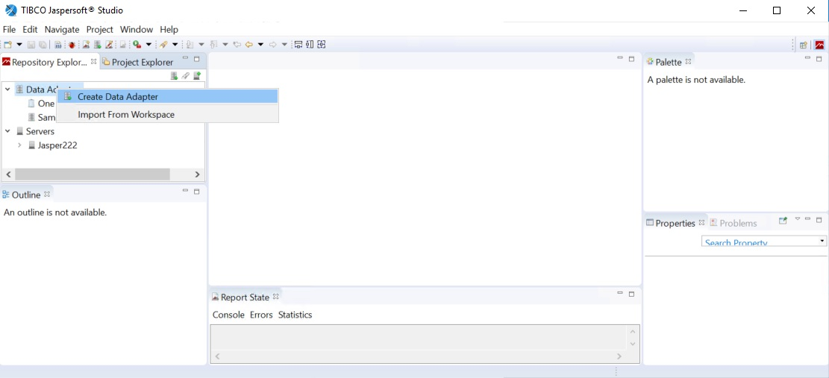

Then select Database JDBC Connection option and press Next.

Provide an appropriate name for the adapter and set the below fields as shown in the next picture.
This is the same settings we used to create the APM data source according to the documentation provided by CA here.

In this example we used APM EM Standalone in 10.100.0.116 (CentOS 7) in Syntax lab while the Jaspersoft Studio application is installed in 10.100.0.222 (Windows Server 2016) which is the same server where we have installed the JasperReports instance.

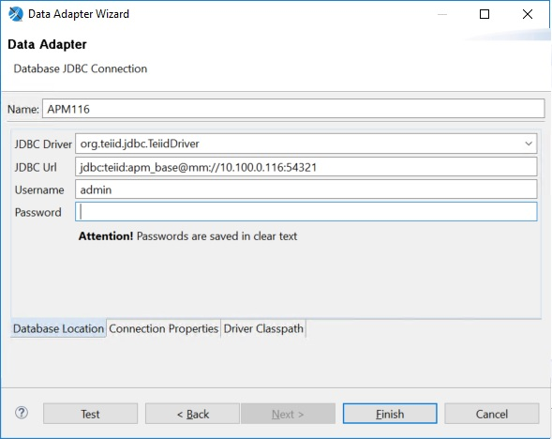

Since there is no such a driver available as an option in the field JDBC Driver above the most important step is to go to Driver Classpath tab and browse for the already imported teiid-9.0.1-jdbc.jar file from the initial steps. After you import it click on Test button to make sure the configuration is right.

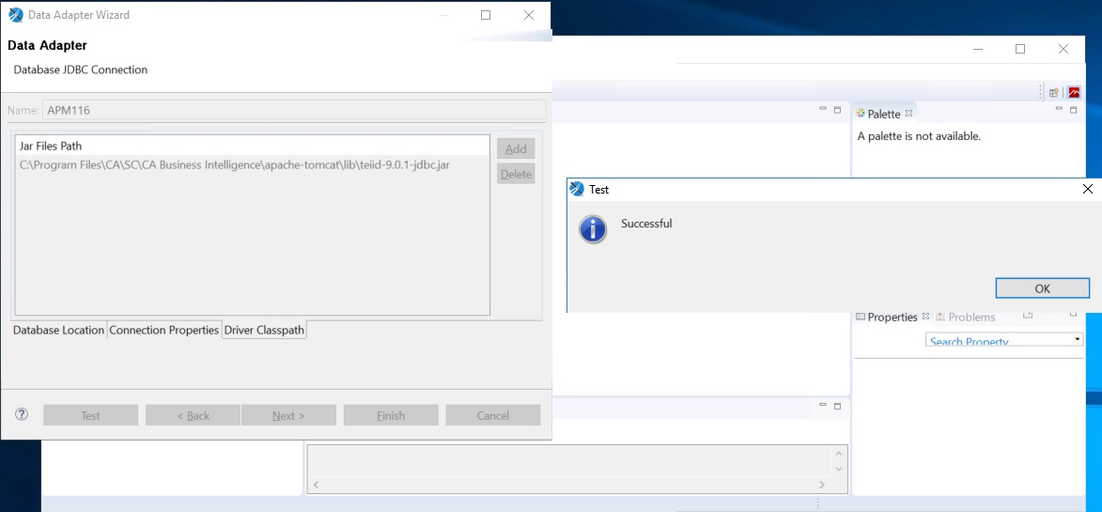

Create APM Reports in Jaspersoft Studio
Make sure that Jasper server has network access to port 8081 of APM server.
Open Jaspersoft Studio and go to File New Jasper Report

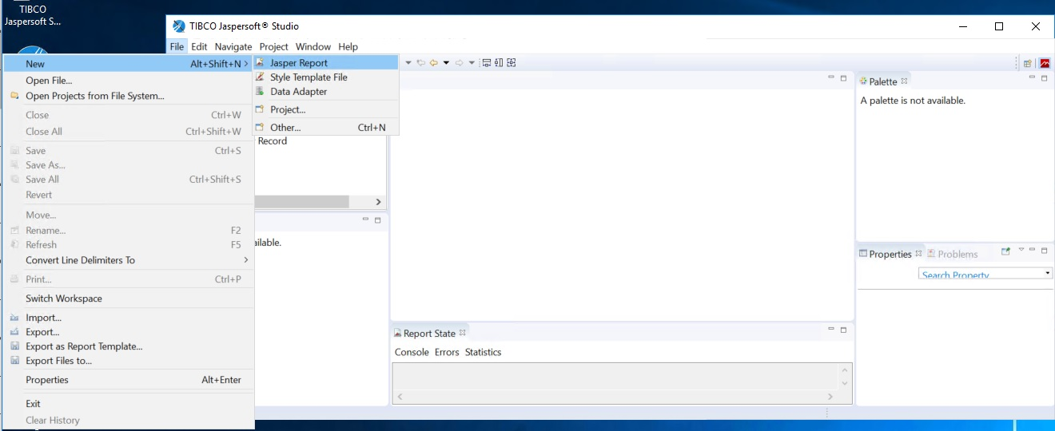

https://www.youtube.com/watch?v=yRLvJgz9Dxk

