TDM Upgrade Guide

Team – SWAT

Table of Contents
Purpose 3
Introductions 3
Upgrade Pre-Requisites 3
Upgrade Path for 4.9.x 3
Download Media 4
Backup 5
Repository Backup 5
Upgrade Process 6
Upgrade TDM Portal 6
TDM Portal Upgrade on Windows 6
TDM Portal License 11
PLA LICENSE AGREEMENT – YES 11
PLA LICENSE AGREEMENT – NO 12
TDM Portal Upgrade on Docker 13
Download the TDM Docker Images 13
Import new Docker images: 14
Backup the Docker containers 16
Upgrading the DataMaker and Components 23
Post Upgrade Process 43
Upgrade Validation 43
Reference Documents: 44

Purpose
The purpose of this document is to provide steps to upgrade TDM environment from older version to TDM 4.9.X and above.

Introductions
TDM Upgrade procedure has changed from upgrading the repository from DataMaker to TDM Portal.

Upgrade Pre-Requisites

Upgrade Path for 4.9.x
- 4.0 and 4.1 to 4.2
- 4.1 and 4.2 to 4.3
- 4.2 and 4.3 to 4.4
- 4.3 and 4.4 to 4.5
- 4.4 and 4.5 to 4.6
- 4.5 and 4.6 to 4.7
- 4.6 and 4.7 to 4.8
- 4.7 and 4.8.1 to 4.9

Download Media
You can download the media from Broadcom Support
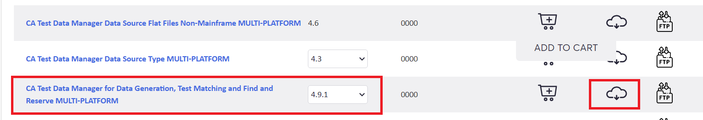

Download the required files as per your environment requirement.
CA Test Data Manager Full Package – For both DataMaker and TDM portal upgrade on Windows.
CA Test Data Manager Portal for Docker – TDM portal on Docker

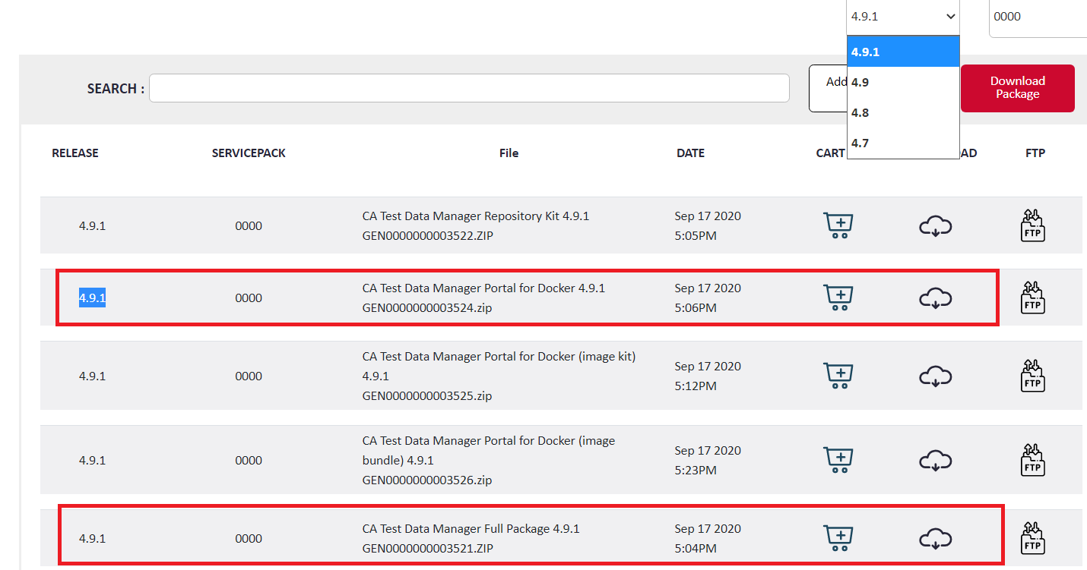

Backup

Repository Backup
We recommend that you backup your gtrep repository before you upgrade the CA TDM software.
This process varies depending on your database. Check with your Database Administrator for more information on how to proceed.

TDM Portal
NOTE: Stop the TDM Portal and OrientDB services before performing the below steps.
Folders | Note | Comments
C:\Program Files\CA\CA Test Data Manager Portal | Copy the Entire folder and Store it in the Backup Folder | Recommended
C:\Program Data\CA\CA Test Data Manager Portal | Copy the Entire folder and Store it in the Backup Folder | Recommended
C:/ProgramData/CA/CA Test Data Manager Portal/orientdb/databases/ | Copy the OrientDB folder and store it in Backup Folder | Mandatory
C:/ProgramData/CA/CA Test Data Manager Portal/ | Copy the Entire folder and Store it in the Backup Folder | Recommended
C:/ProgramData/CA/CA Test Data Manager Portal/logs | Delete all the files from the logs folder | Mandatory

DataMaker
NOTE: Stop the CA TDoD Service and CA Remote Publish services before performing the below steps.
Folders | Note | Comments
C:\Grid-Tools\ | Copy the Entire folder and Store it in the Backup Folder | Recommended
C:\Program Files (x86)\Grid-Tools\ | Copy the Entire folder and Store it in the Backup Folder | Recommended

Upgrade Process

Upgrade TDM Portal

TDM Portal Upgrade on Windows
Step by Step process guides you the upgrade process.
- Stop the TDM Portal and OrientDB services before performing the below steps.
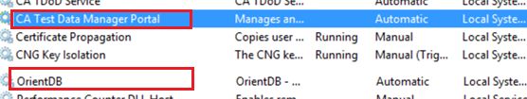

- Right click on the installation file and choose Run as Administrator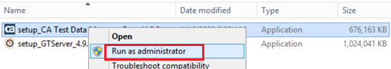

- Choose Next
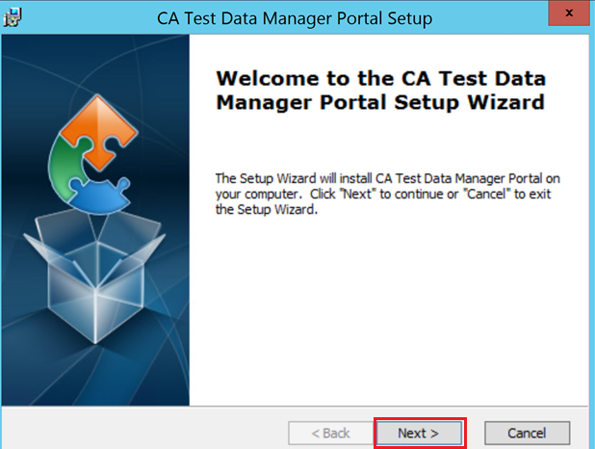

- Accept the License Agreement and select Next
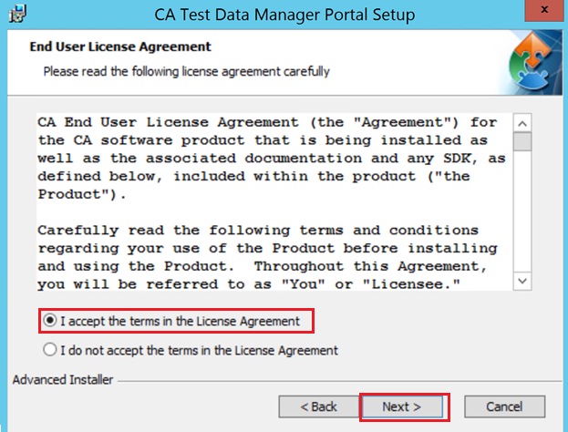

- Note the upgrade version FROM and TO, Select Next to proceed with the upgrade.
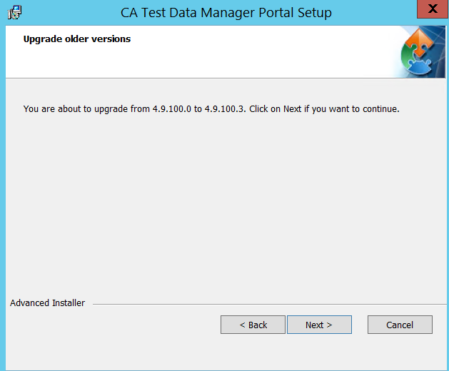

- Select Upgrade to proceed with the upgrade.
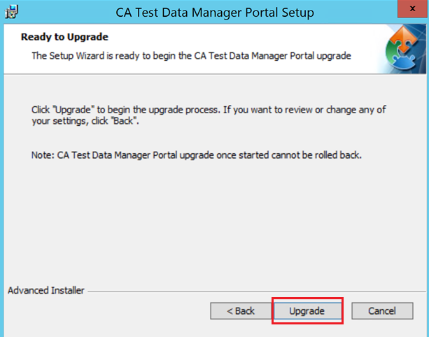

- Select “Start CA Test Data Manager Portal” Service to start the Service automatically and “Finish” to complete the TDM Upgrade.
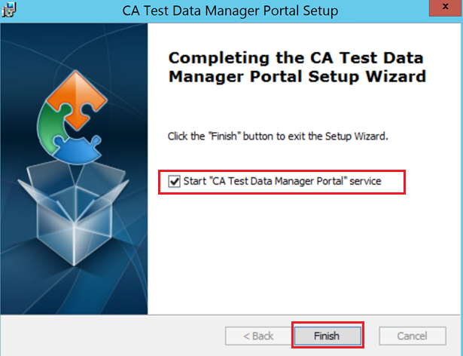

- Check the TDM Portal and OrientDB services, It should be started and running.
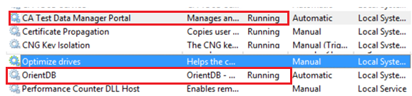

- Optionally clear Browsing Data for the Chrome or Internet Explorer Browser.
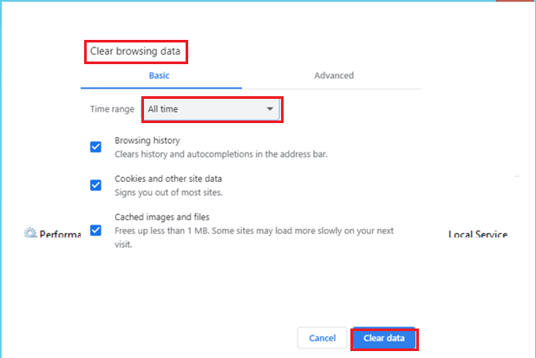

- Check the TDM Portal logs
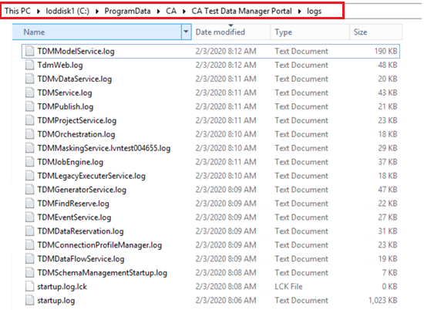

- After all the logs are created, TDM portal should be UP and Running
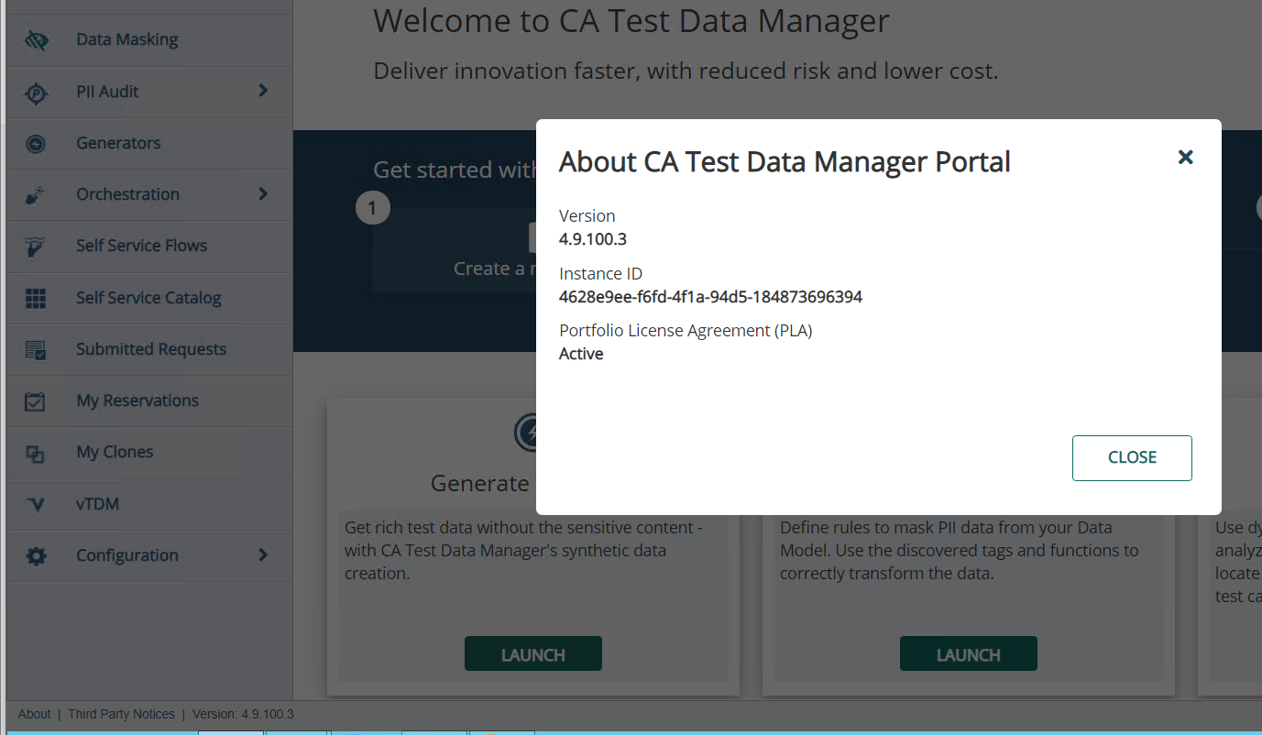

TDM Portal License
Once the upgrade is complete, when you open the TDM Portal, You will be asked to activate the Product. Please follow below steps to Activate.

PLA LICENSE AGREEMENT – YES
If you have Test Data Manager under PLA agreement, you can choose “YES” and select “NEXT”
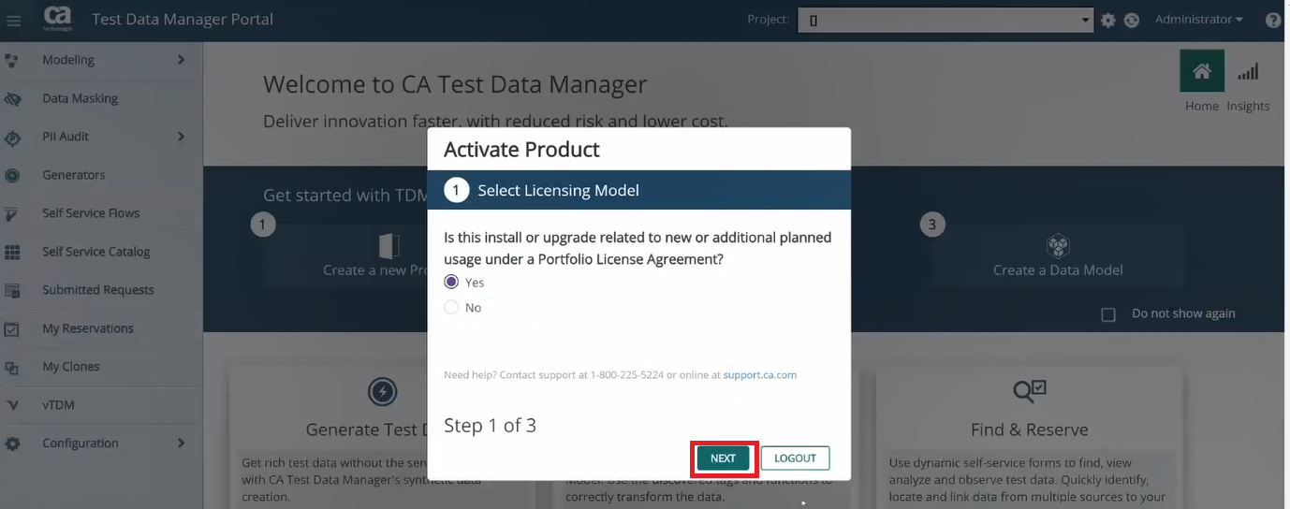
Enter the Company Domain and Enterprise Site ID and Select Activate.
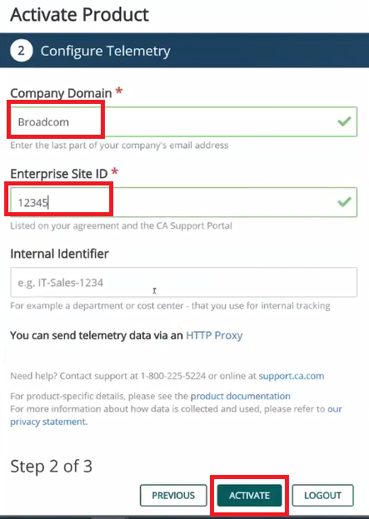

You get the below screen when, Select DONE to complete the ACTIVATION.
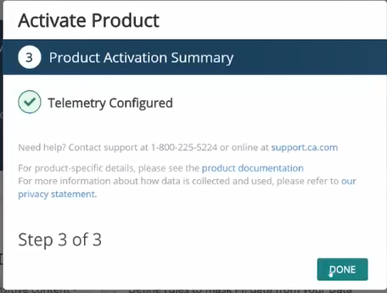

PLA LICENSE AGREEMENT – NO
If the PLAB License Agreement is No, You can go to the NEXT SCREEN, and ENTER your TDM License KEY and Select ACTIVATE.

TDM Portal Upgrade on Docker
Note: In the document, we have used the screen shots for upgrading Oracle Docker container, if you are using Oracle server, you can skip the Oracle container upgrade steps.

Download the TDM Docker Images
Using the “CA Test Data Manager Portal for Docker 4.9” from CA downloads

Extract the file using below command
tar –xvf TDM_Portal_docker-4.9.1.100.tgz
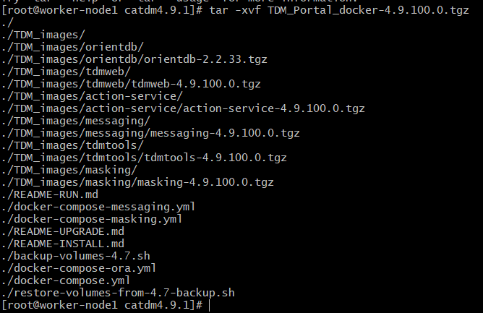
NOTE:
- You can view README-RUN.md to read more information
- README-Install.md for new TDM installation and
- README-Upgrade.md for TDM upgrade.

Import new Docker images:
gunzip -c ./TDM_images/orientdb/orientdb-2.2.33.tgz | docker load
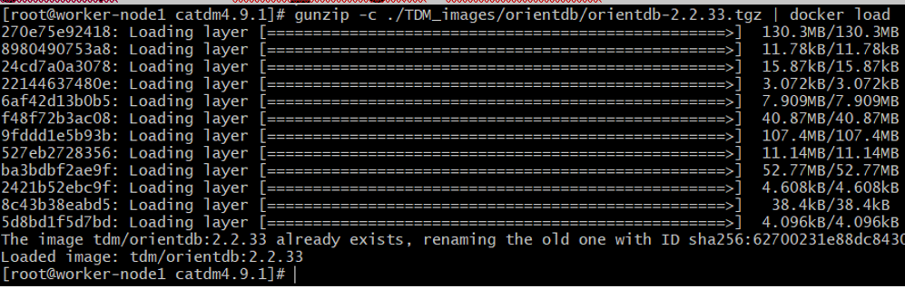

gunzip -c ./TDM_images/tdmtools/tdmtools-4.9.100.0.tgz | docker load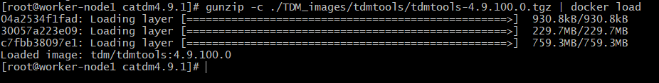

gunzip -c ./TDM_images/tdmtools/tdmtools-4.9.100.0.tgz | docker load

gunzip -c ./TDM_images/tdmweb/tdmweb-4.9.100.0.tgz | docker load
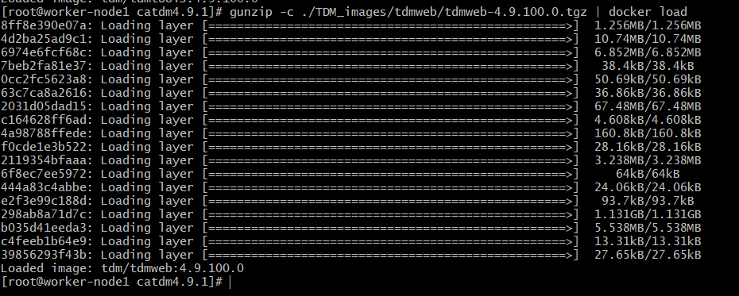

gunzip -c ./TDM_images/action-service/action-service-4.9.100.0.tgz | docker load

gunzip -c ./TDM_images/messaging/messaging-4.9.100.0.tgz | docker load
gunzip -c ./TDM_images/masking/masking-4.9.100.0.tgz | docker load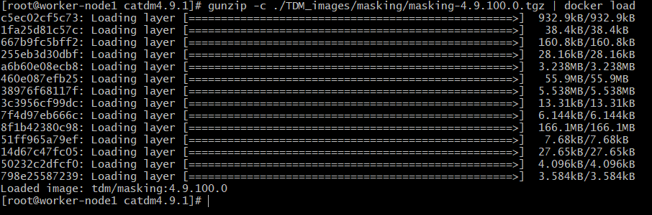

Backup the Docker containers
IMPORTANT NOTE: Make sure you stop all the container before the backup.
Stop all the containers
docker container ls –a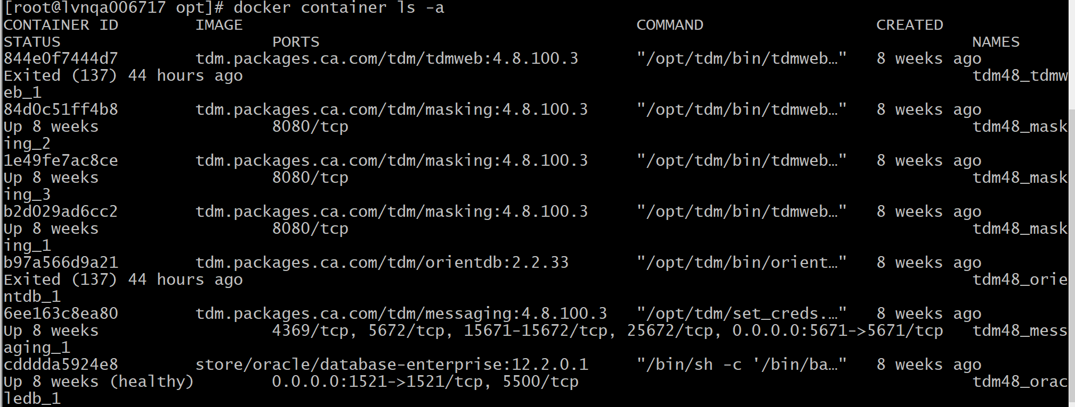
docker stop <<Container ID>>
[root@lvnqa006717 TDM4.9]# docker ps
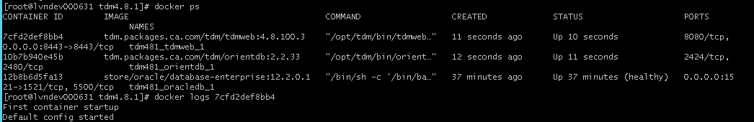

[root@lvnqa006717 TDM4.9]# docker-compose stop
Stopping tdm49_orientdb_1 ... done
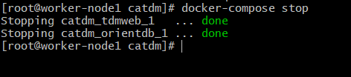

[root@lvnqa006717 TDM4.9]# docker ps

[root@lvnqa006717 TDM4.9]# docker stop 7cfd 10b7 12b8
7cfd
10b7
12b8

[root@lvnqa006717 TDM4.9]# docker ps
CONTAINER ID IMAGE COMMAND CREATED STATUS PORTS

- Create a Backup folder For Example: /opt/Backup
- Make sure you execute backup commands from Backup folder
- Backup of Oracle OrientDB and TDMWeb containers
- Optionally - Backup of Oracle or SQL database containers if running on docker
docker ps
tdm481_tdmweb_1 is the 4.8 TDMWeb container name
tdm481_orientdb_1 is the 4.8 Orient DB container name
tdm481_oracledb_1 Oracle DB container name

TDBWeb Backup
docker run --rm --volumes-from tdm481_tdmweb_1 -v $(pwd):/backup alpine sh -c "tar -cvzf /backup/portal-volumes.tar.gz /mnt/logs /mnt/storage /mnt/fdmconfig"
OrientDB Backup
docker run --rm --volumes-from tdm481_orientdb_1 -v $(pwd):/backup alpine sh -c "tar -cvzf /backup/orientdb-volumes.tar.gz /orientdb/backup /orientdb/config /orientdb/databases"
Oracle Backup
docker run --rm --volumes-from tdm481_oracledb_1 -v $(pwd):/backup alpine sh -c "tar -cvzf /backup/oracle-volumes.tar.gz /ORCL"
Note: To get the Volume of Oracle
docker container inspect tdm48_oracledb_1 | less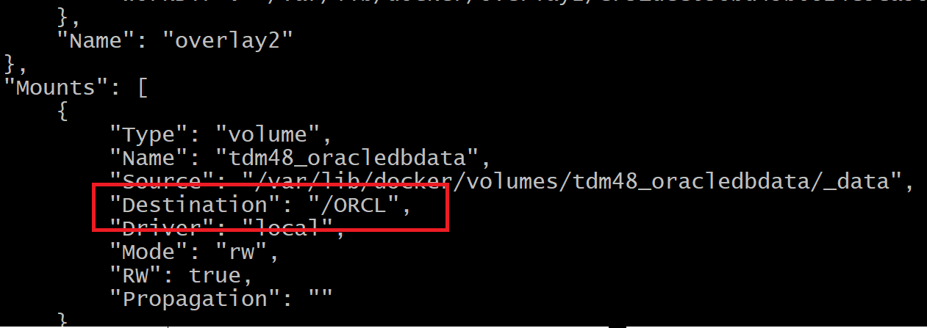
Modify the compose files
docker-compose.yml File
Make sure the 4.9 image is correct and Oracle GTREP data details are entered.
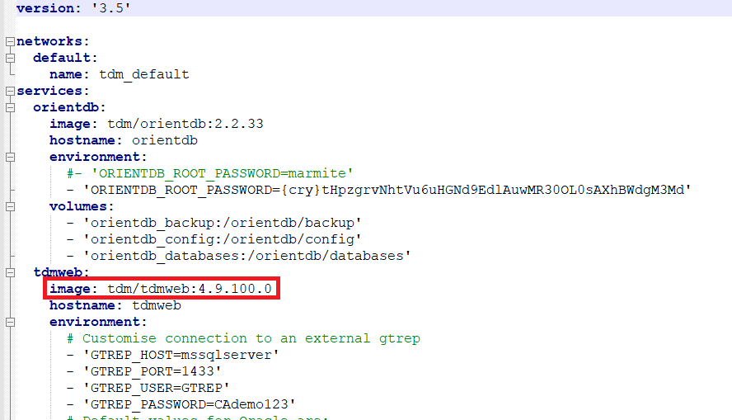

docker-compose-ora.yml file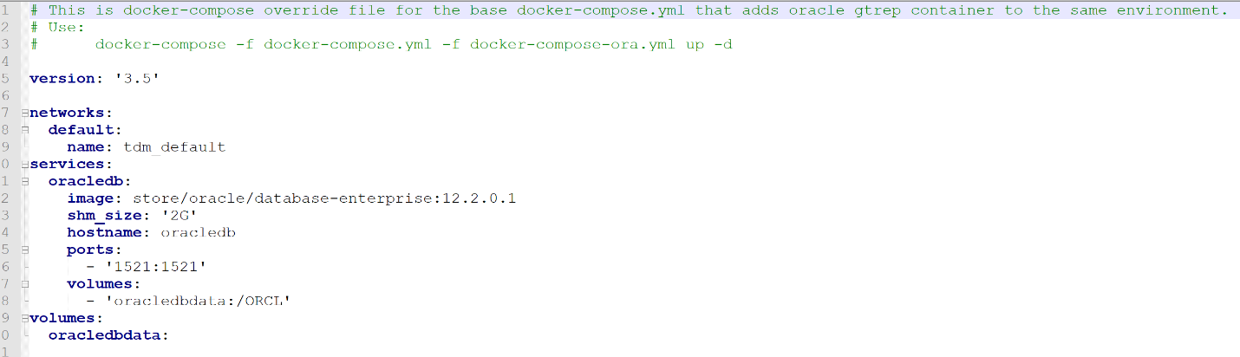

docker-compose-masking.yml file
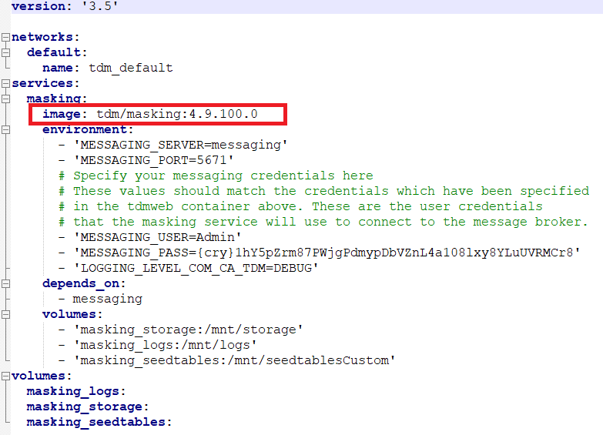
docker-compose-messaging.yml File
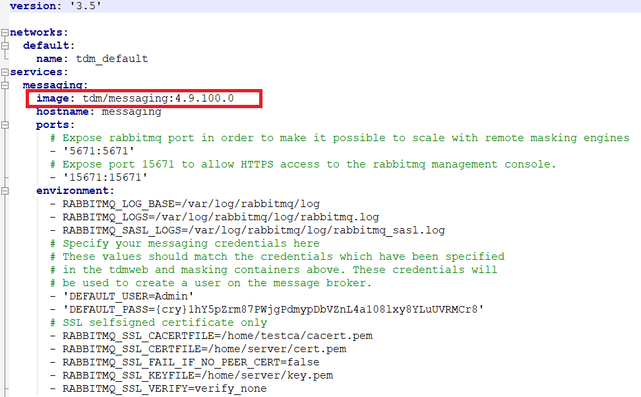
Restore the TDM containers
TDMWeb Restore
Make sure you run the restore commands from backup directory (Example opt/Backup
docker run --rm --volumes-from tdm49_tdmweb_1 -v $(pwd):/backup alpine sh -c "tar -xvzf /backup/portal-volumes.tar.gz"
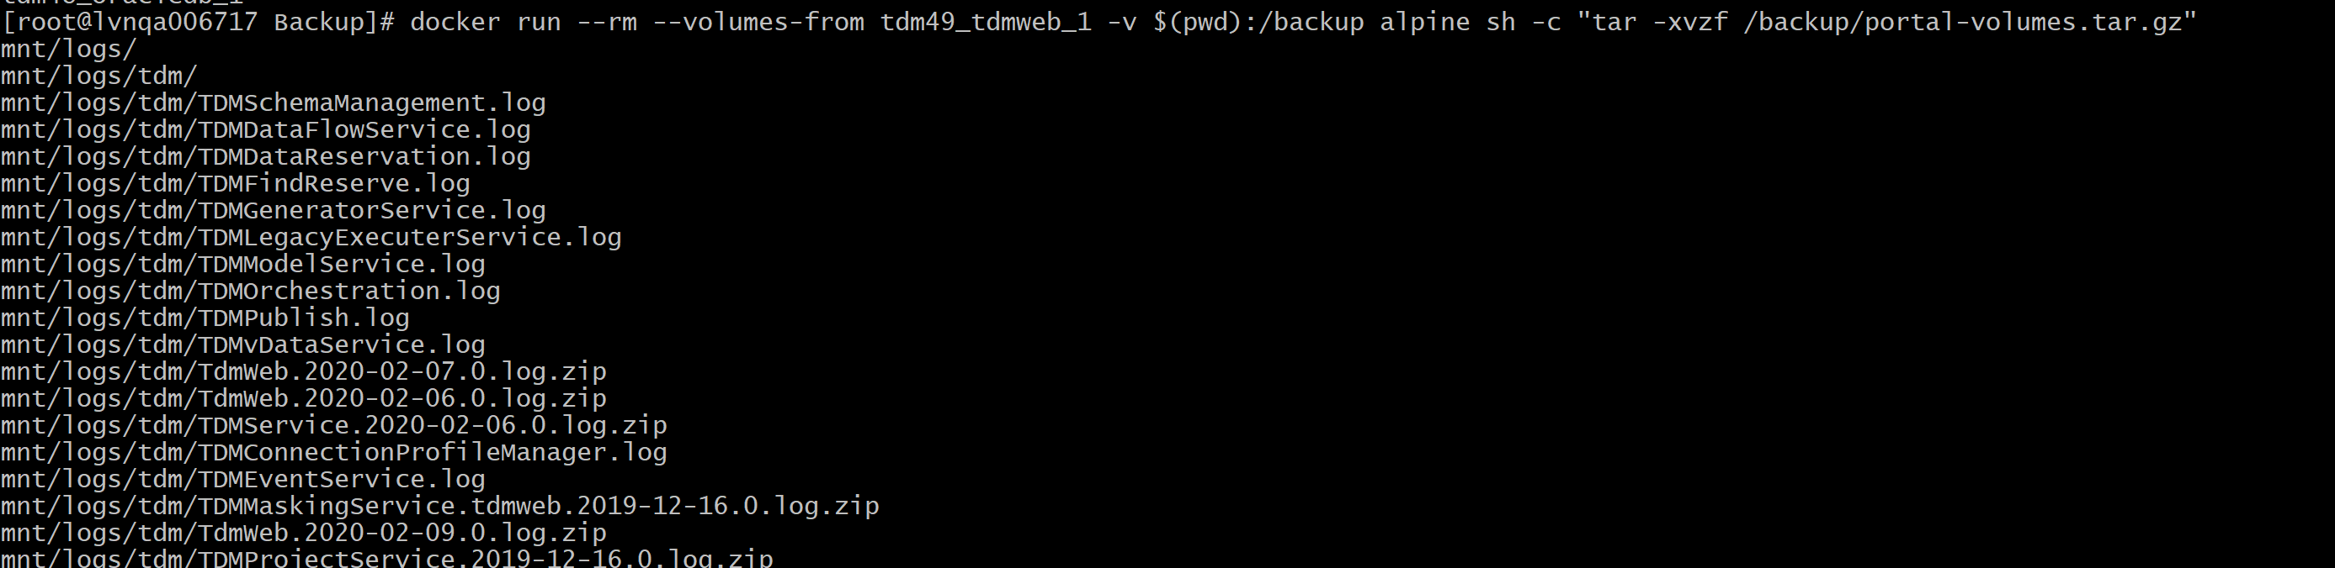
OrientDB Restore
docker run --rm --volumes-from tdm49_orientdb_1 -v $(pwd):/backup alpine sh -c "tar -xvzf /backup/orientdb-volumes.tar.gz"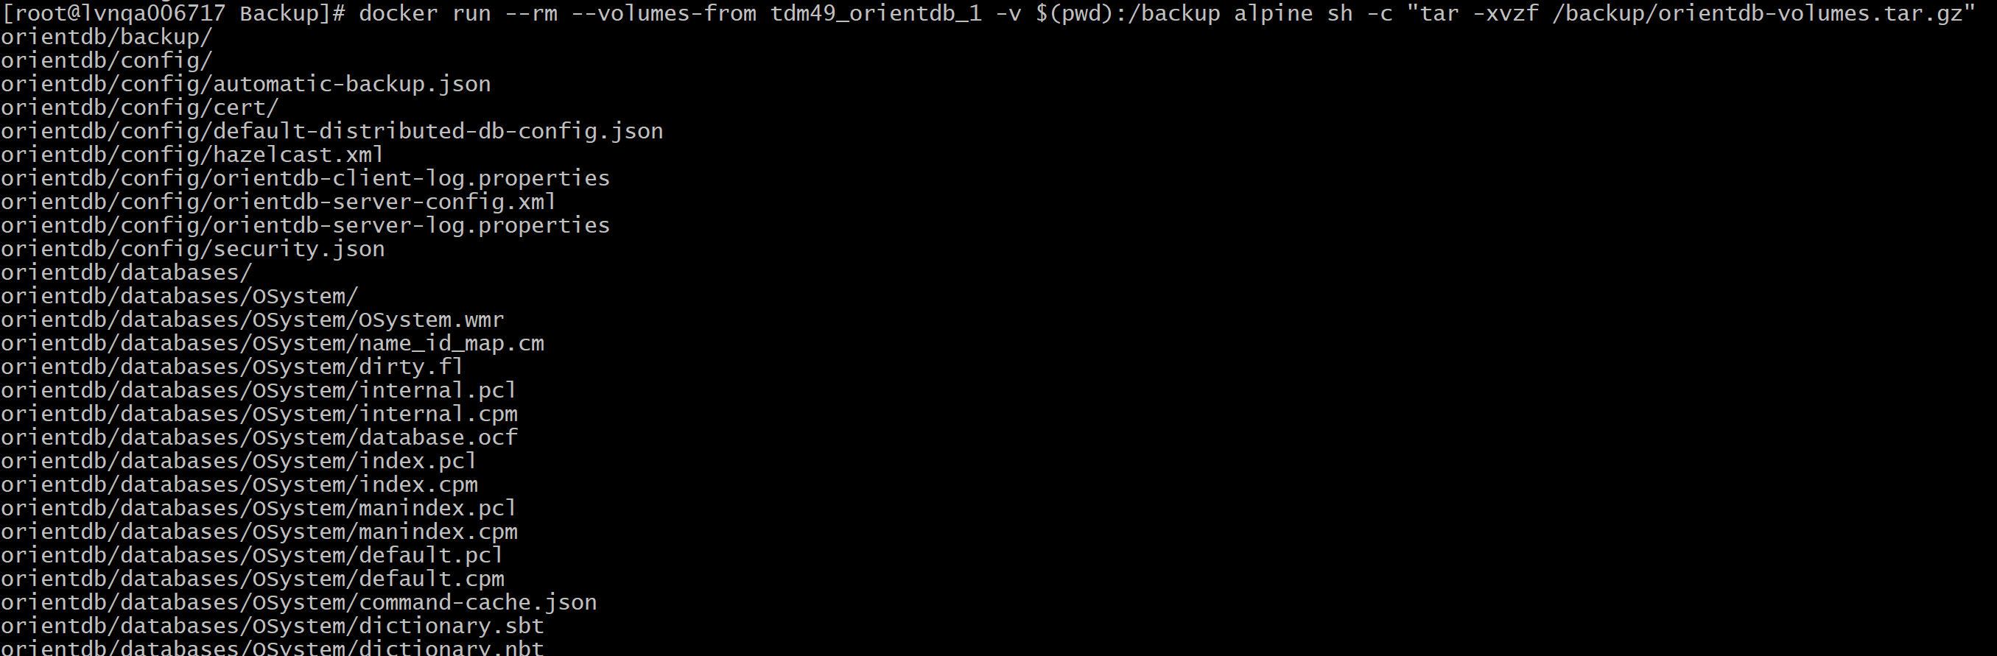
Note: Oracle Restore --- Optional Step
docker run --rm --volumes-from tdm49_oracledb_1 -v $(pwd):/backup alpine sh -c "tar -xvzf /backup/oracle-volumes.tar.gz

Start the TDM Upgrade
Run the below command
Cd to the TDM4.9 directory
docker-compose -f docker-compose.yml -f docker-compose-masking.yml -f docker-compose-messaging.yml up -d
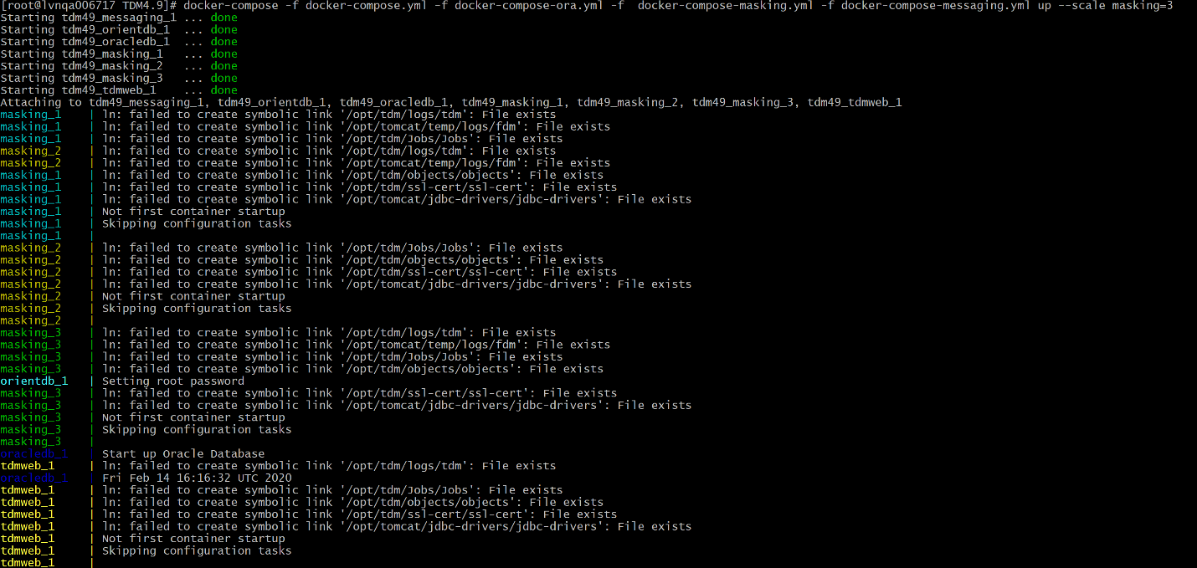
Post Upgrade
docker ps 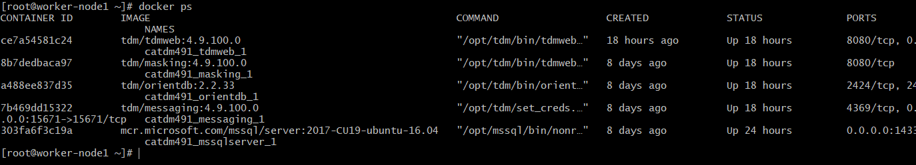

docker logs <<TDM WEB Container ID >>
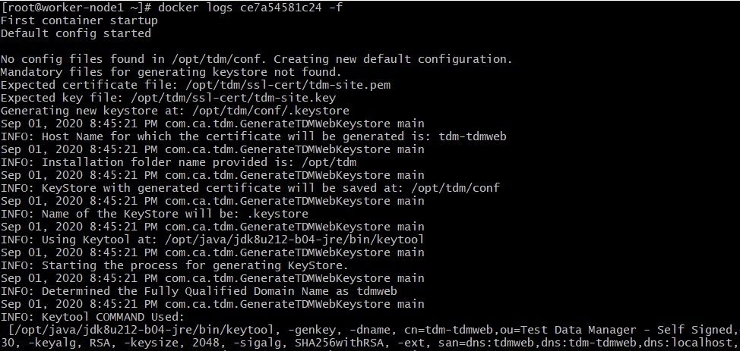
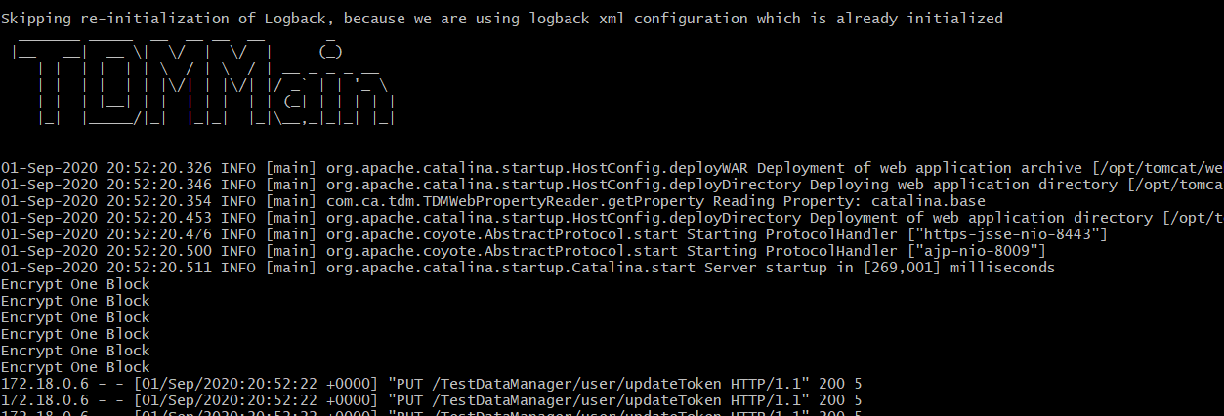
login to the TDM Portal
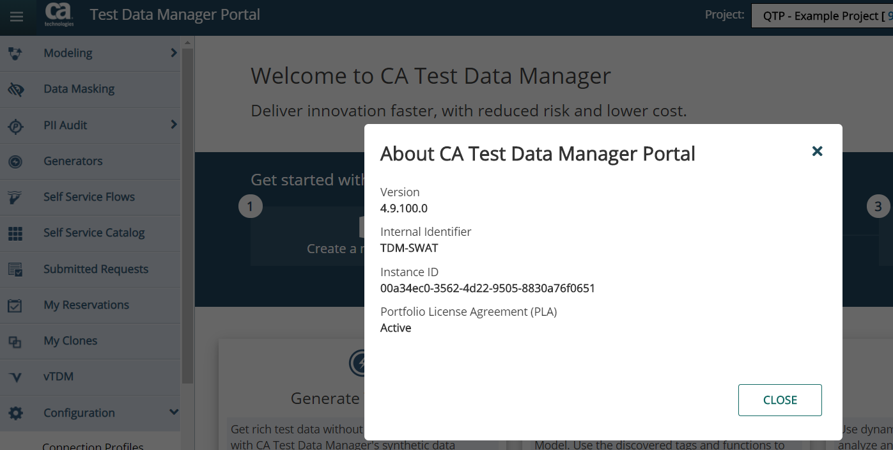

Upgrading the DataMaker and Components
To Upgrade the DataMaker, Javelin, Fast Data Maker, TDoD and other components, you can follow below steps.
Note: Same process is followed to install the DataMaker and other components on the client.
- Right Click on the GTServer.exe and choose Run as administrator
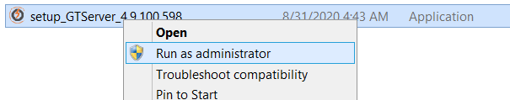

- Select “Next” to continue
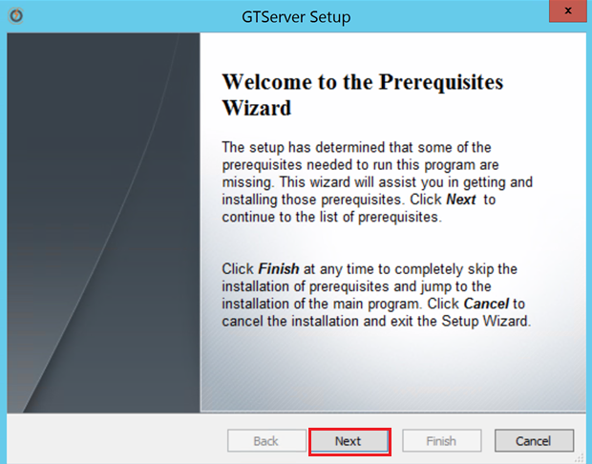

- Accept the License Agreement and select “Next”
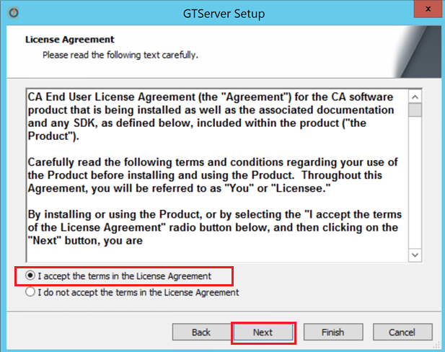

- Choose the components to be installed or upgraded.
Note: Choose the Default
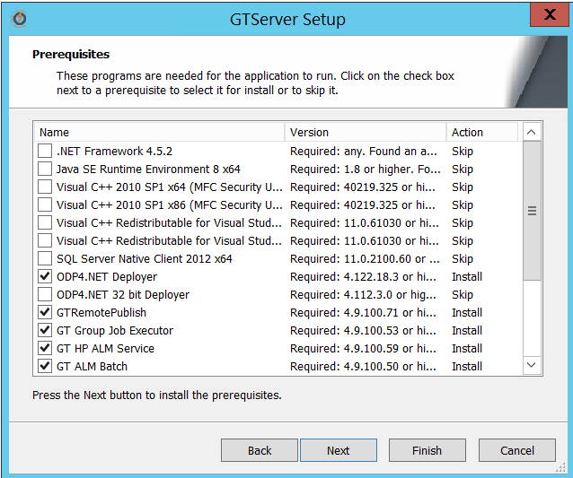

- From TDM 4.8 onwards, OpenJDK is installed, So choose “Next” to install
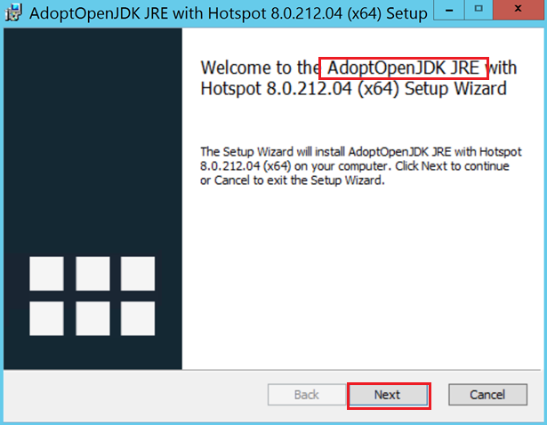

- Accept License Agreement and select “Next” to proceed. 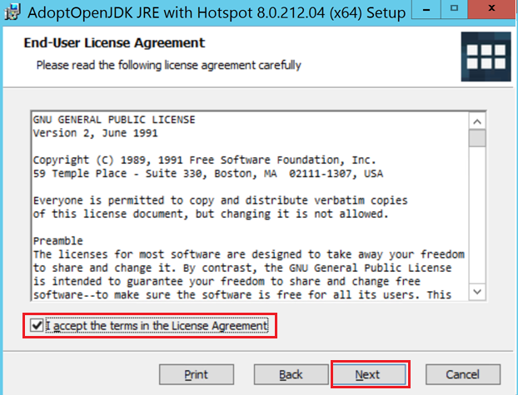

- Choose “Next”
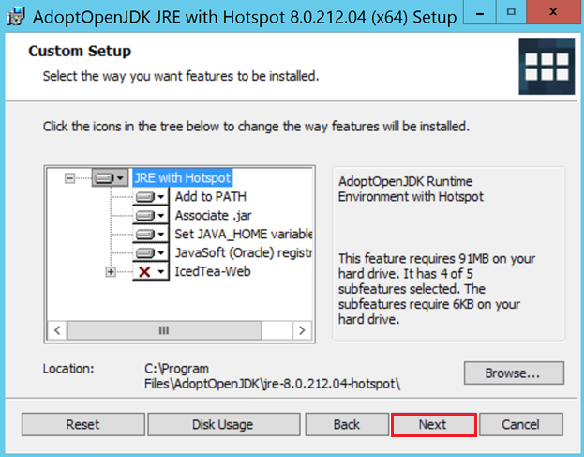

- Choose “Install”
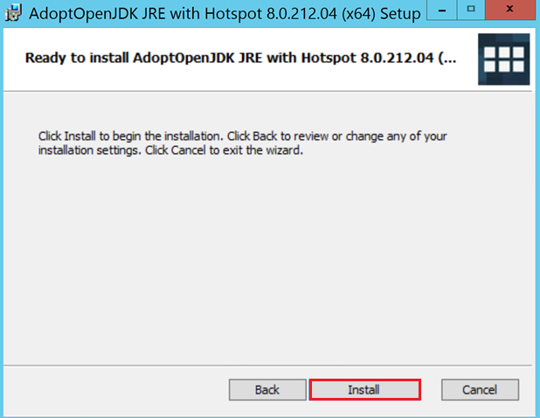

- Choose Finish to complete the OpenJDK installation.
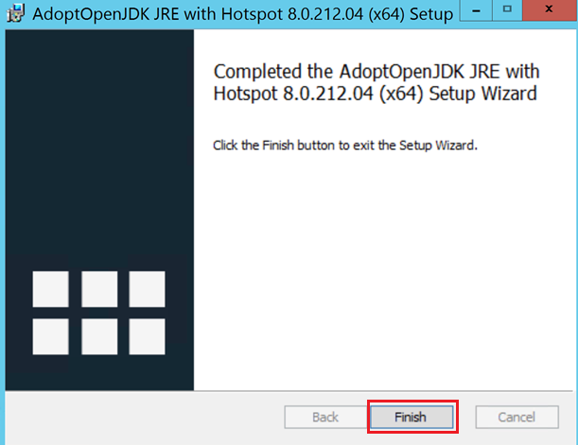

Installing Remote Publish
- Select “Next”
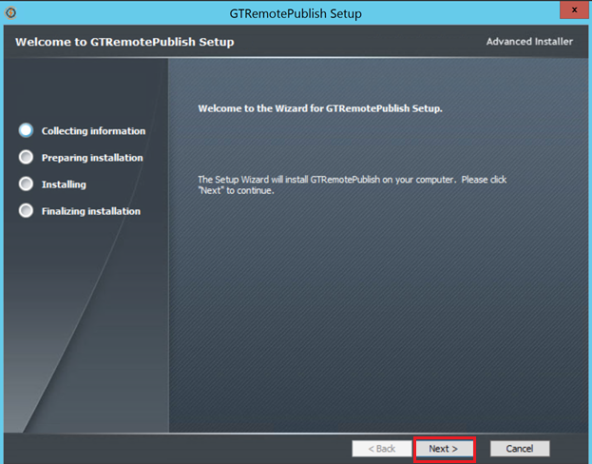
- Select “Next” to continue the installation
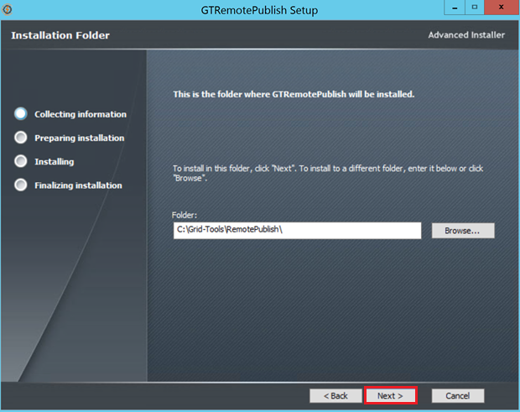

- Select “Install” to continue the installation
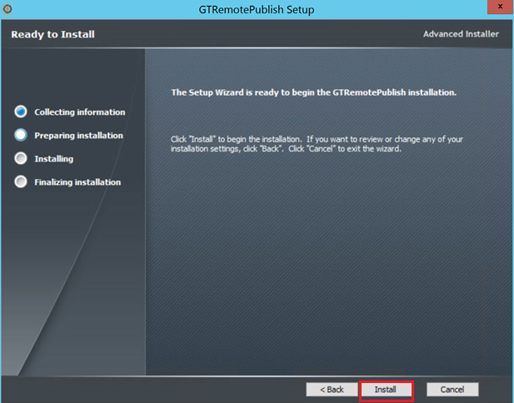

- Select “Complete” to complete the installation 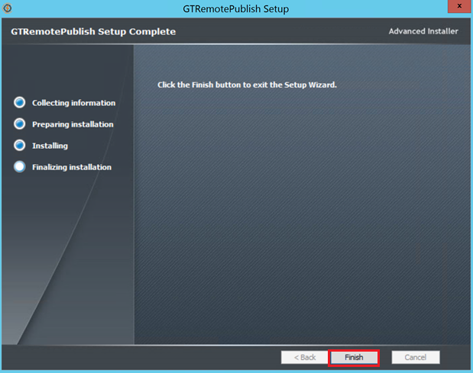

GT DataMaker Installation
- Select “Next” to continue the installation
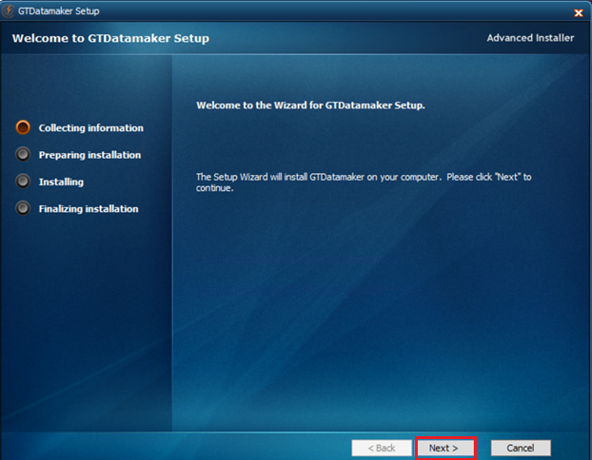
- Select “Next” to continue the installation
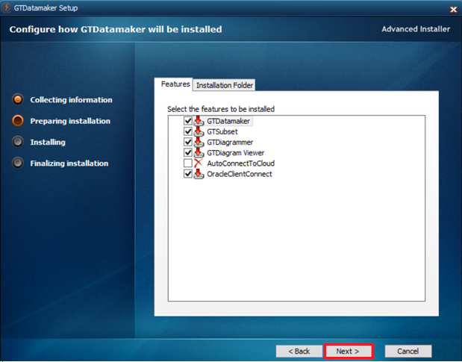

- Select “Install” to continue the installation
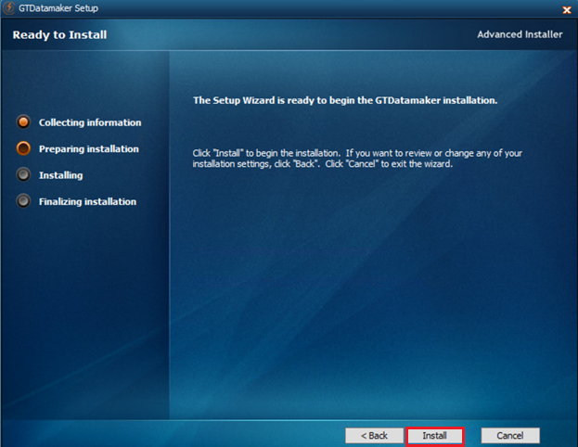
- Select “Finish” to complete the installation
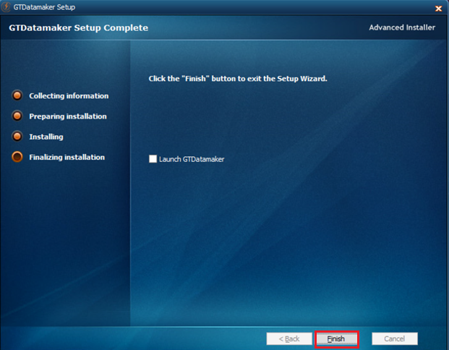

Test Data on Demand Installation
- Select “Next” to continue the installation 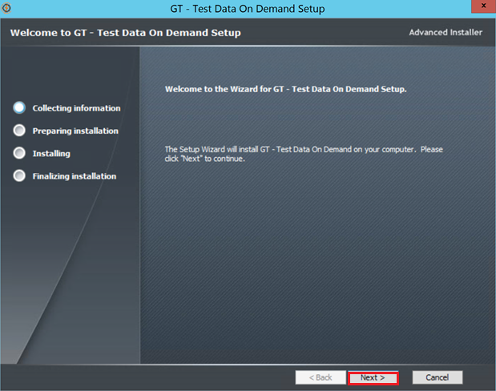
- Select “Next” to continue the installation
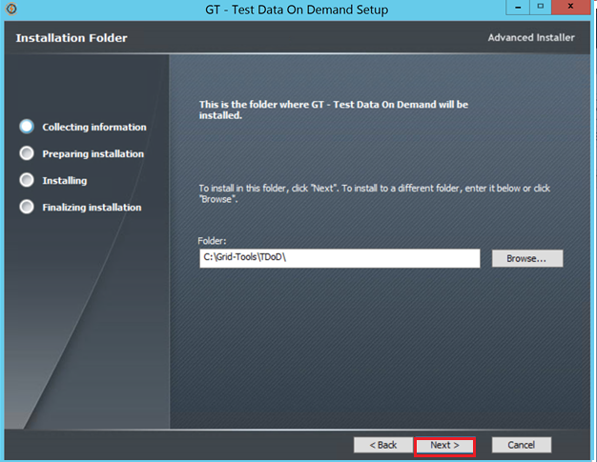

- Select “Install” to continue the installation
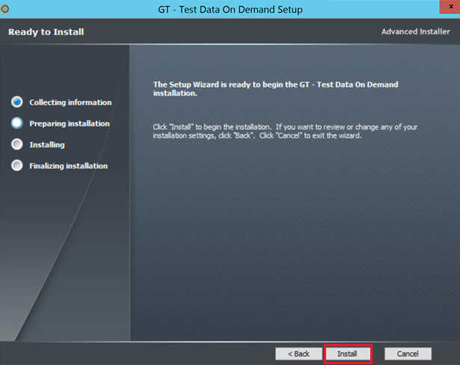
- Select “Finish” to complete the installation
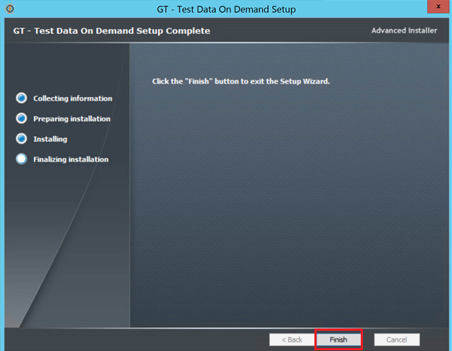

Fast Data Masker Install
- Select “Install” to continue the installation
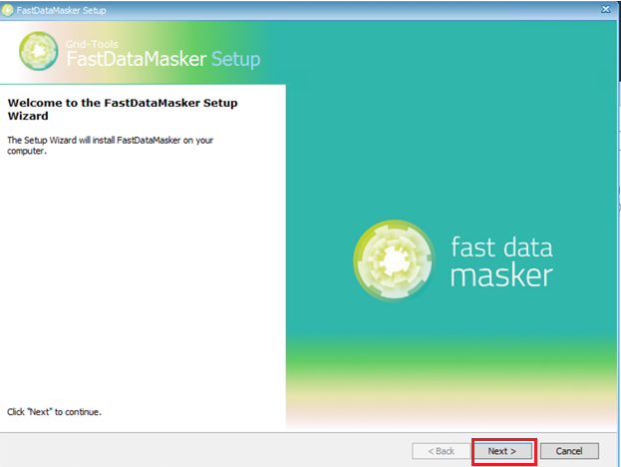

- Select “Accept the License Agreement ” and select “Next” to continue the installation
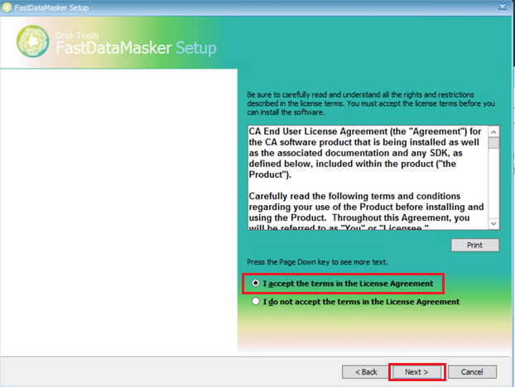
- Select “Install ” to continue the installation
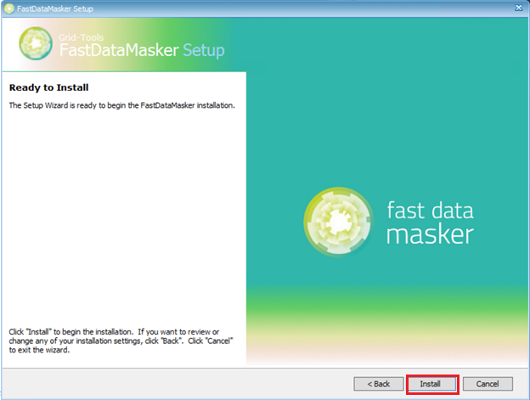

- Select “Finish” to complete the installation
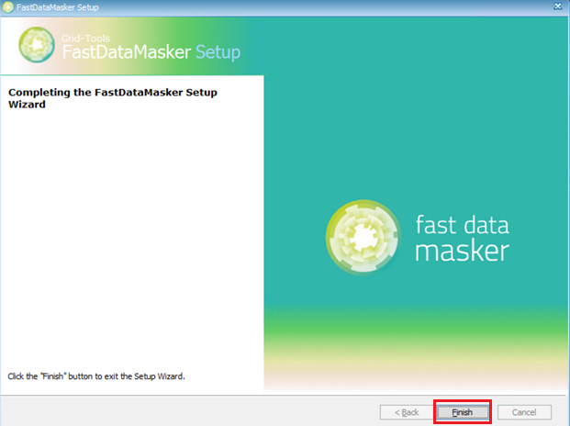
Javelin Install
- Select “Next” to continue the installation
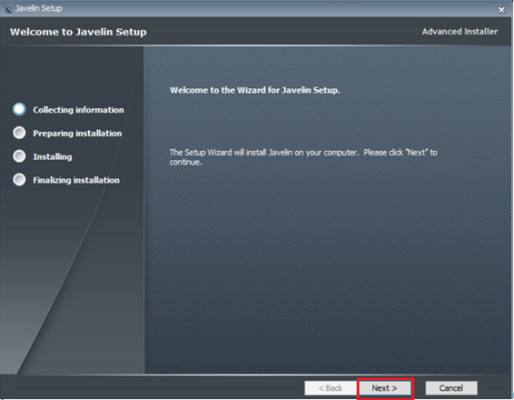

- Select “Next ” to continue the installation
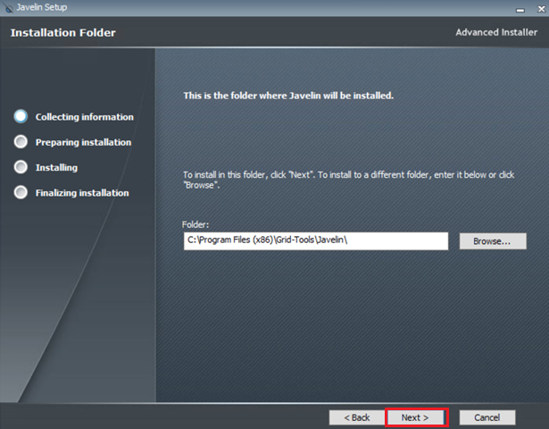

- Select “Install” to continue the installation
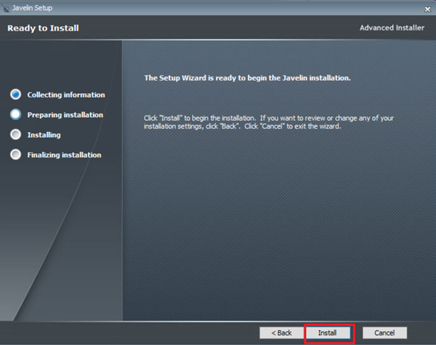

- Select “Finish” to complete the installation
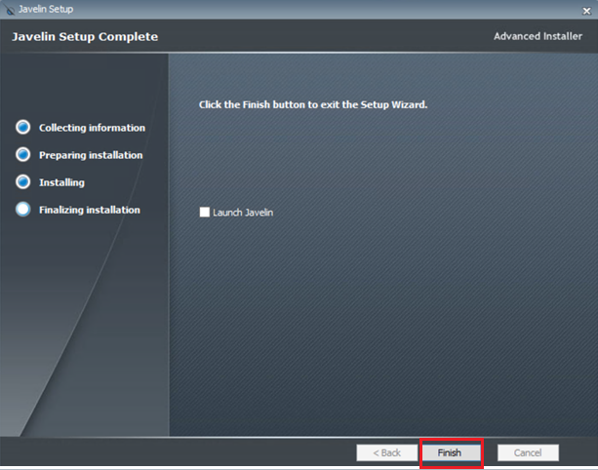
GT Server Install

- Select “Next” to continue the installation
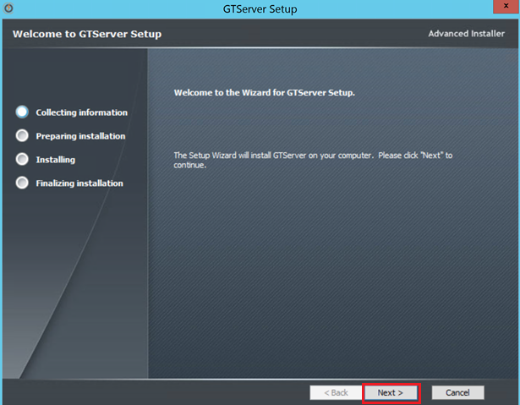

- Select “Next” to continue the installation
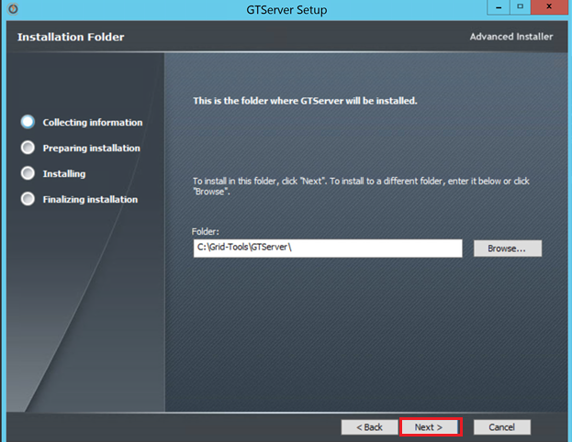

- Select “Install” to continue the installation
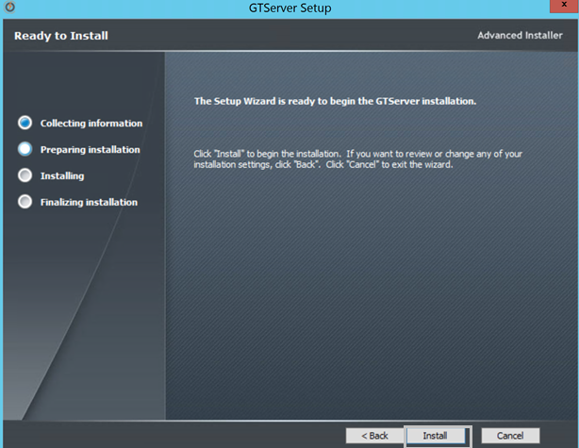

- Select “Finish” to complete the installation
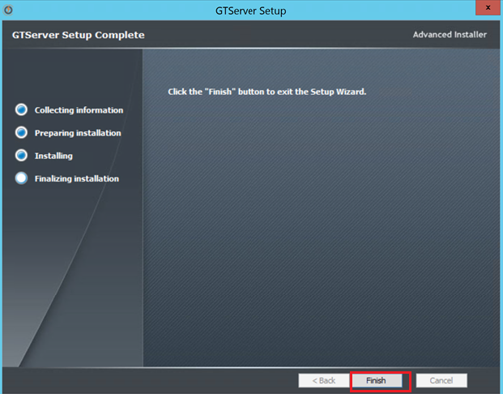

- Open the Datamaker , Right click and Run as Administrator
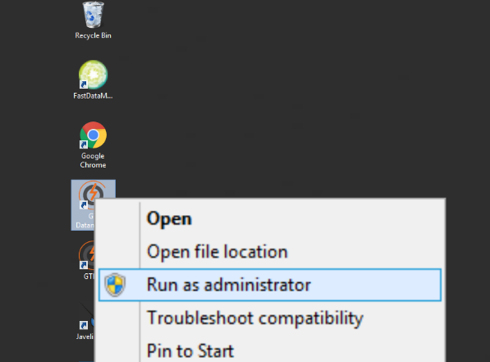
- Connect to the GTREP Profile 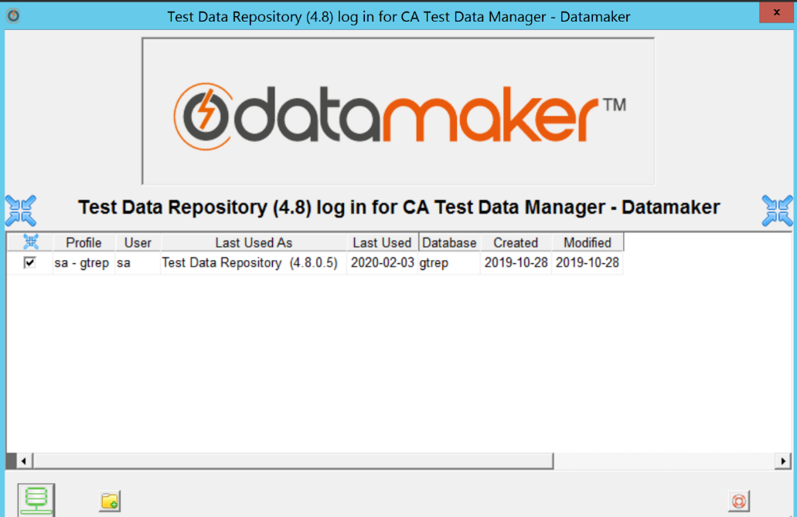

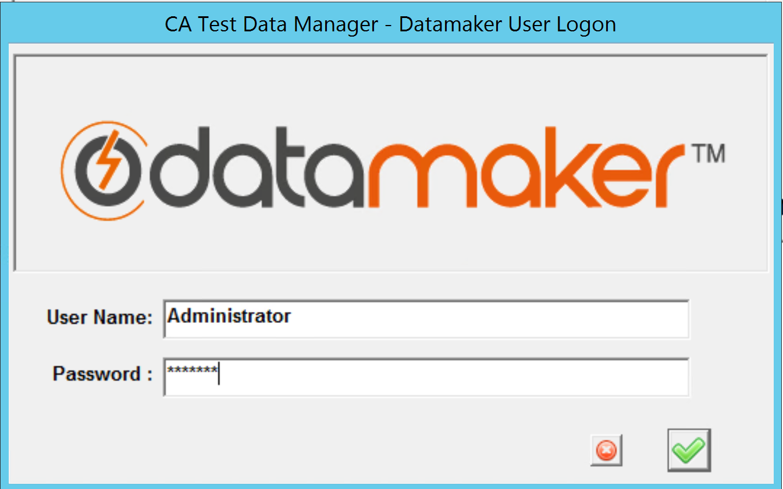

- Connect to the Source and Target Profiles
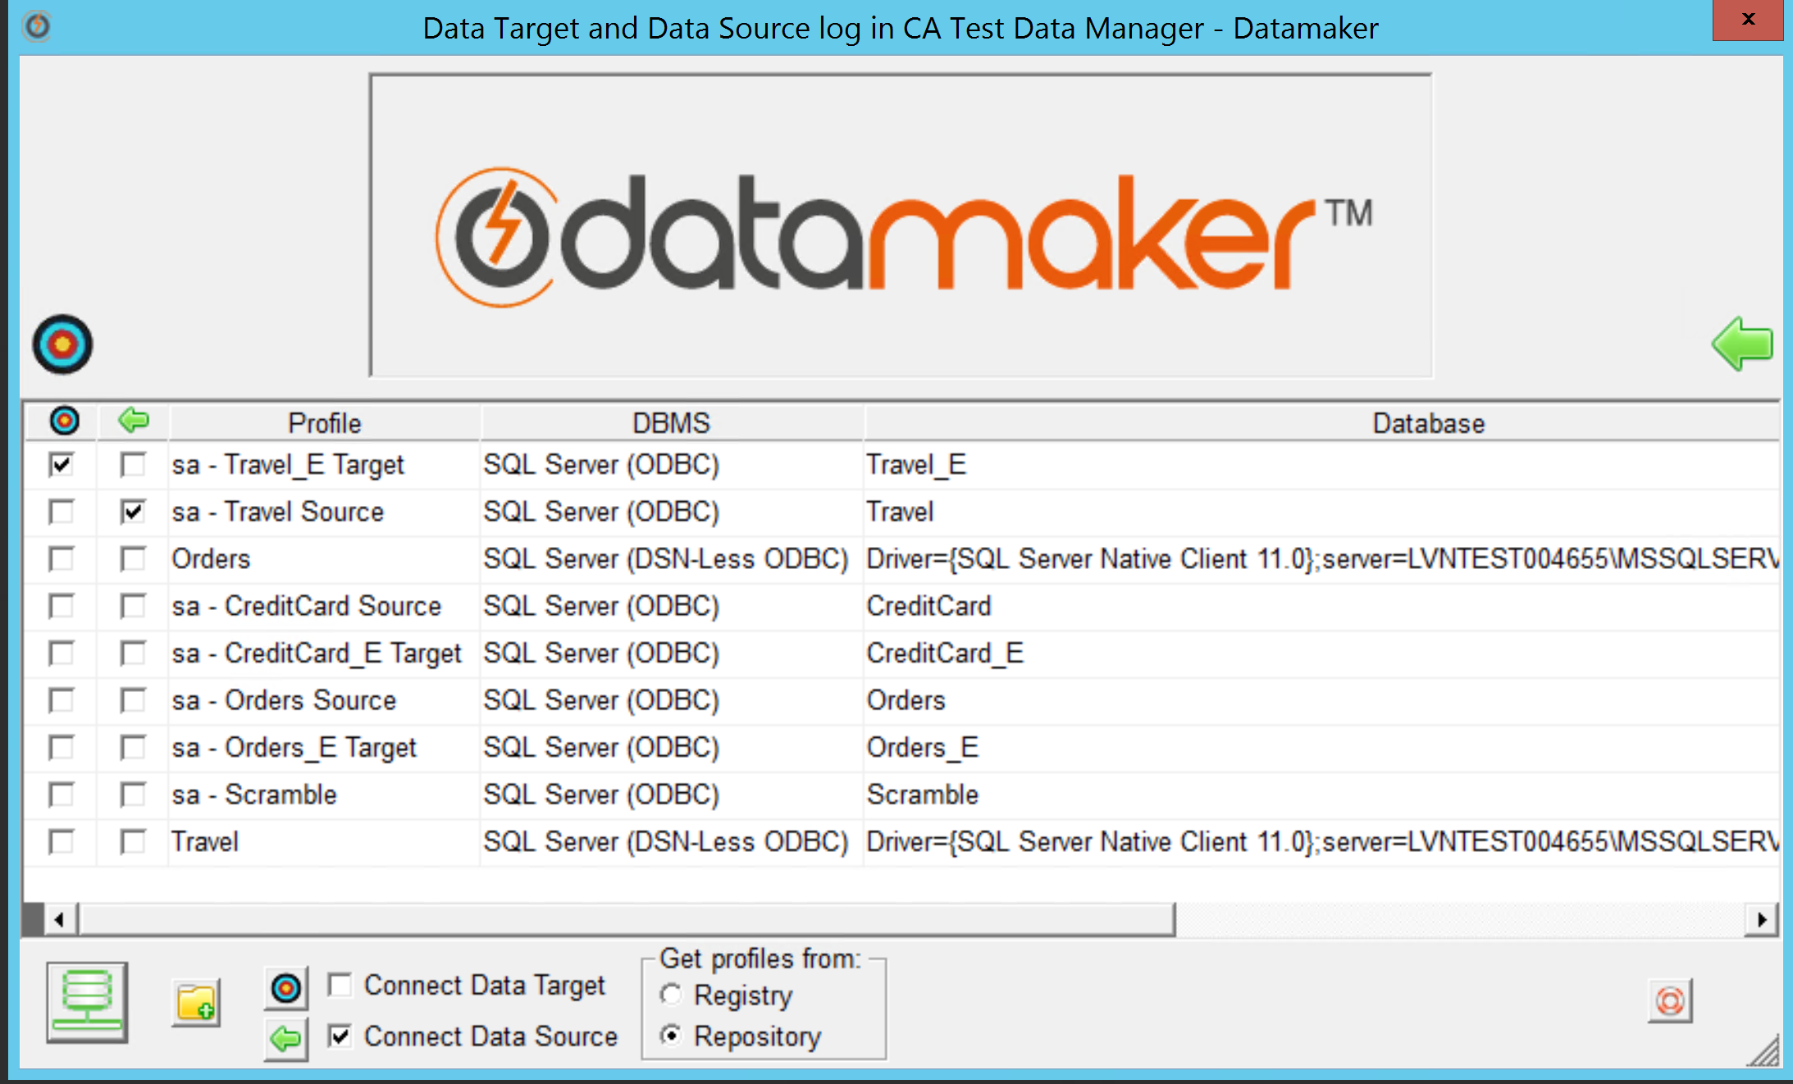

- Validate the version on the DataMaker

Post Upgrade Process
Changing Portal Logs Directory: Link
Configuring the Telemetry: Link

Upgrade Validation
Note: Common examples for validation are explained below, you can have your own validation process depending on your environment.
Validation | Comment
1 | Check the Version of TDM Portal -> Should match the version of the TDM Portal Installer | 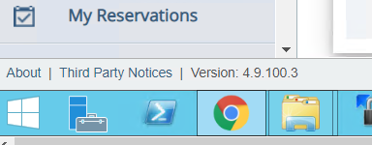
2 | Check the Version of GT DataMaker -> Should match the version of the GTServer Installer
3 | Validate the Projects in TDM Portal and DataMaker | 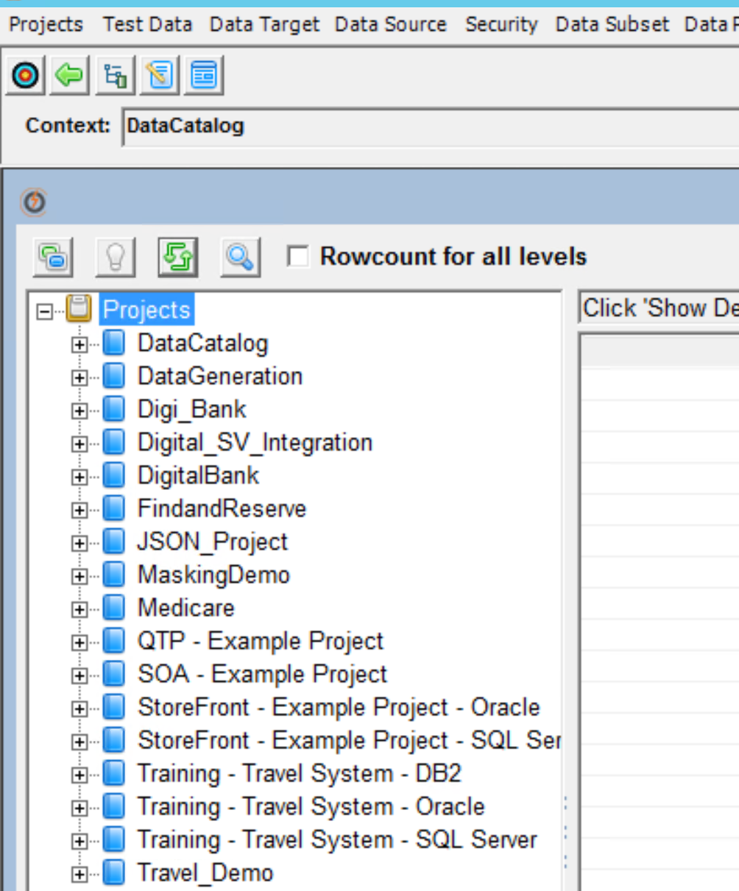
4 | Check the Connection Profiles | 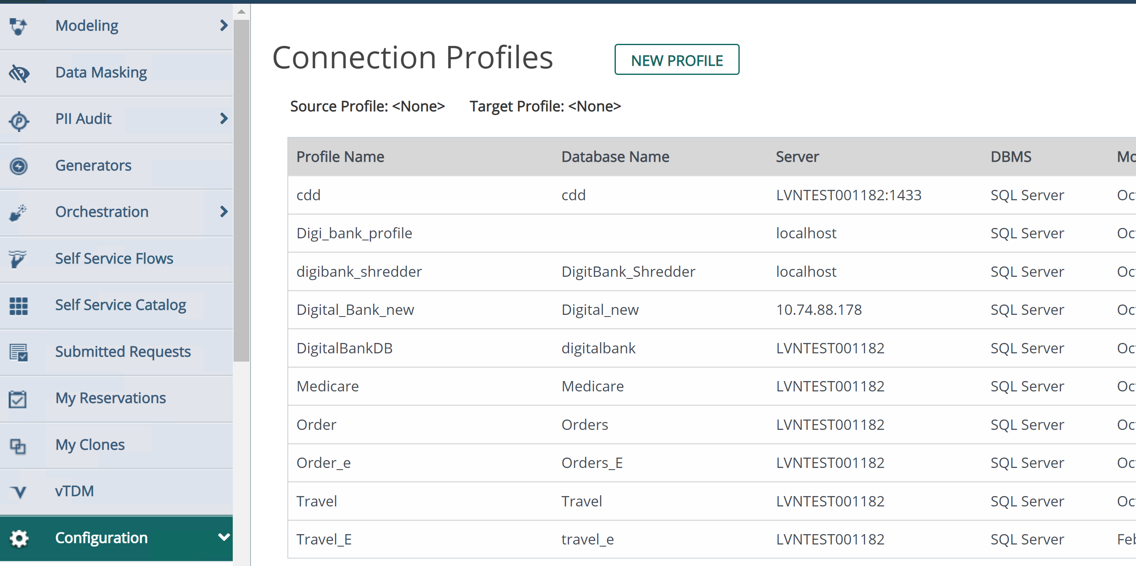
5 | Execute a sample Publish Job and it should run successfully. | 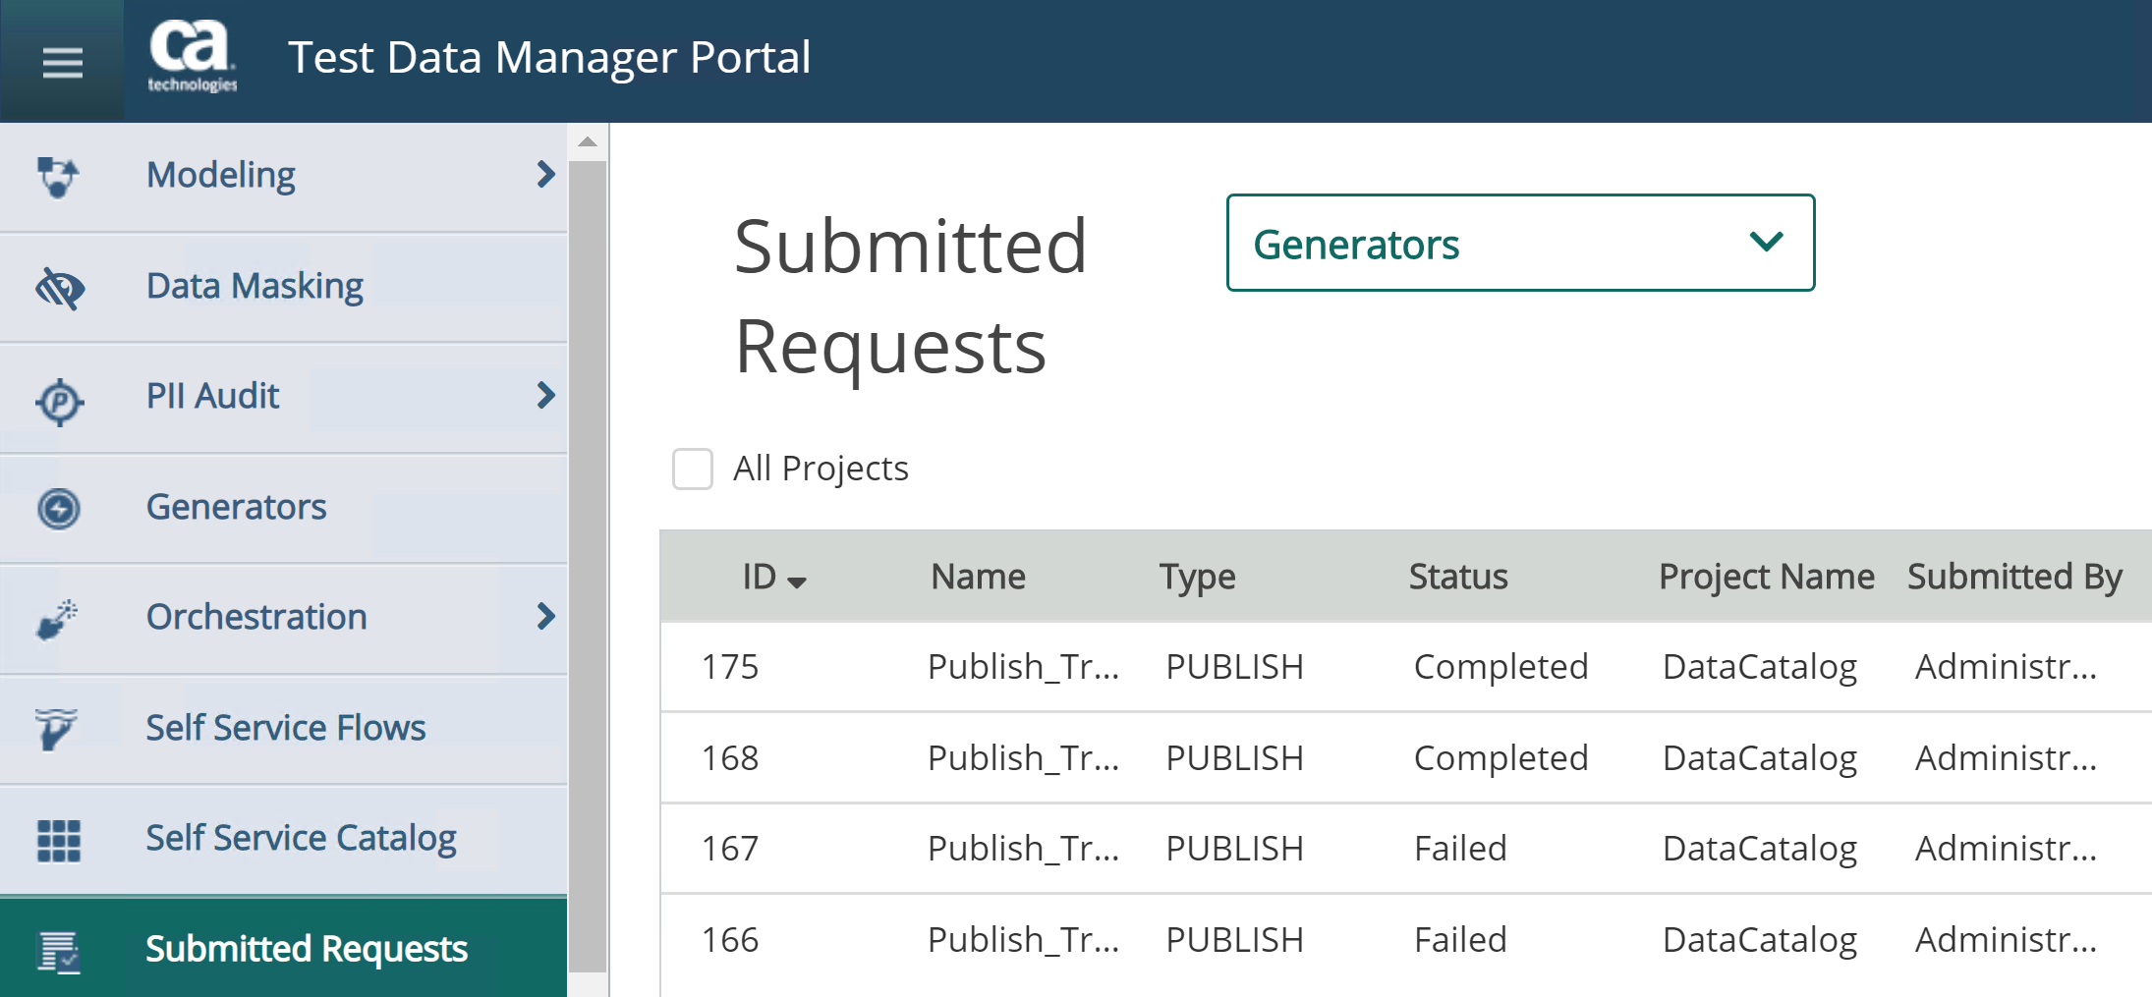

Reference Documents:
- Upgrade Documentation
- Broadcom Support
- Release Notes

