Steps to repoint a BOXI installation to a new MDB
- Log onto the Business Intelligence server. Launch the BO designer from the start menu
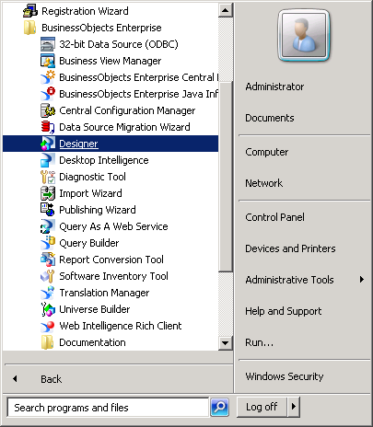

- Login as Administrator and the main design window launches
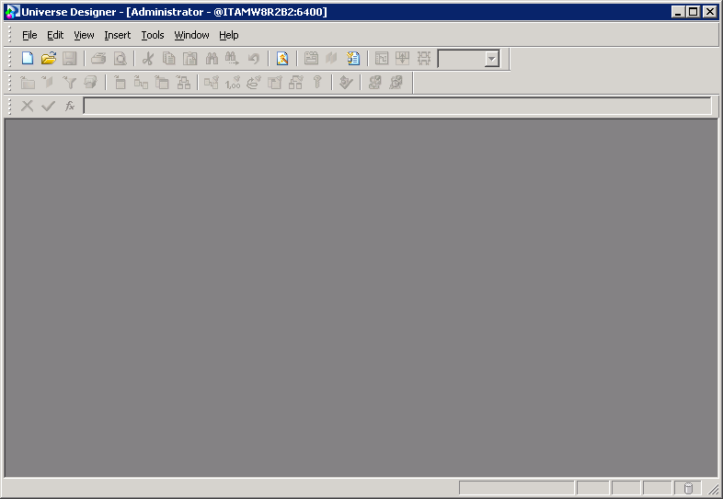

- From the File menu, select Import to import an existing universe
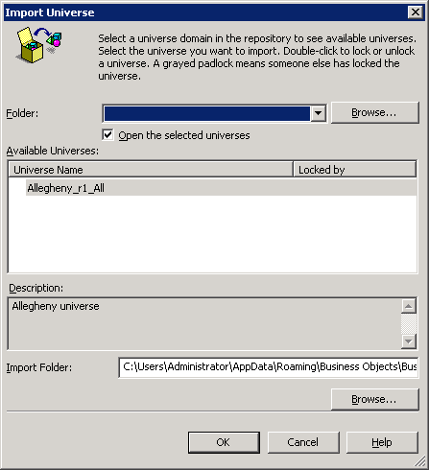

- Click Browse to locate the CA Allegheny universe and click OK.
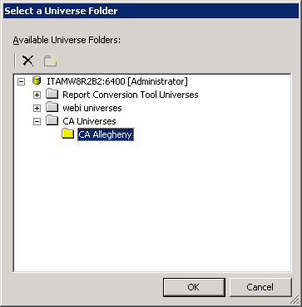

- Click OK on the next screen to import the universe.
You’ll see a message that the universe imported successfully and the following screen displays.

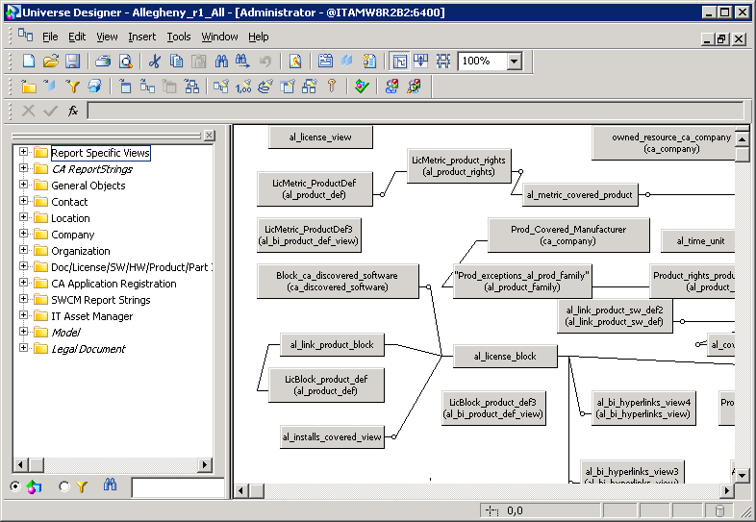

- From the File menu, choose Parameters to see this screen.
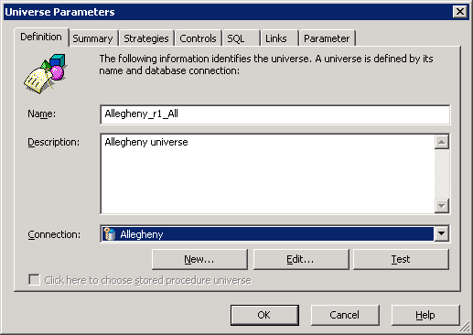
- Click EDIT to edit the Allegheny connection and see this screen.
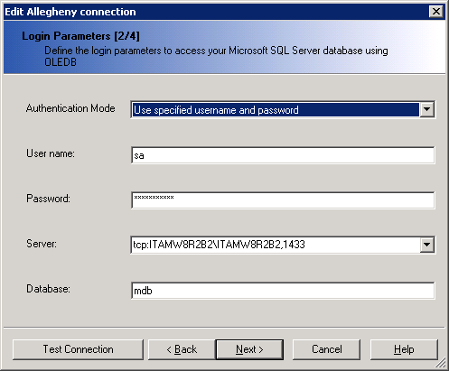

- Change the server name and the port number to point to the new MDB server name.
If the mdb is in the default instance, then typically this is port 1433.
If in doubt about the port number, consult with the sql server DBA for the port number for your mdb.
Click Test Connection to verify the connectivity.

- Click next a few times to go through all the screens (keeping defaults), then click finish.

- Click OK, to return to the main Universe window

- Close the BO designer universe screen and say yes to save changes to the universe.

- Restart the Server Intelligence Agent service from Services

