Test the configuration
Navigate to the Access Gateway Virtual Server log on page. Enter the Microsoft Active Directory user name and password used earlier to configure the OTP server. After entering your credentials, press “Log On” to continue.

A Flash SMS will be delivered to your mobile phone containing the One Time Password.
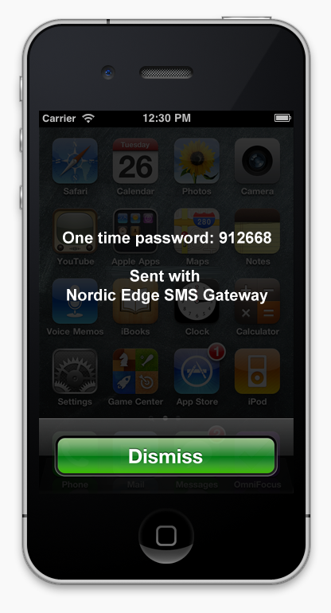

Enter the One Time Password and click on “Submit”.
