How to Install Symantec Network Access Control when SEPM is already installed and Running
About SNAC: Symantec Network Access Control ensures that a company's client computers are
compliant with the company's security policies before the computers are allowed
to access the network. Symantec Network Access Control uses a Host Integrity
Policy and an optional Symantec Enforcer to discover and evaluate which
computers are compliant.
How to enable: There are two methods to enable SNAC on already running SEPM...
Method 1: Manually copy the License file (SNAC.XML) from SNAC CD and add the packages to Client Install packages under SEPM.
a. Go to SEPM folder on SNAC CD and copy the snac.xml file.
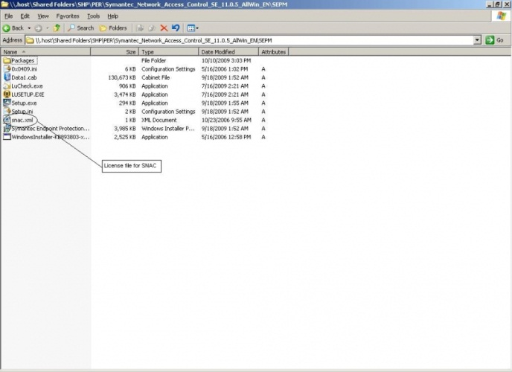
b. Paste the snac.xml file inside "Program Files\Symantec\Symantec Endpoint Protection Manager\tomcat\etc\license" folder.
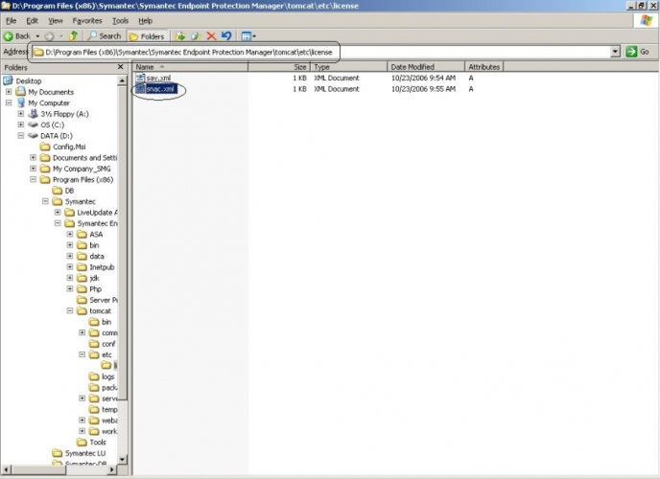
c. Restart the "Symantec Endpoint Protection Manger".
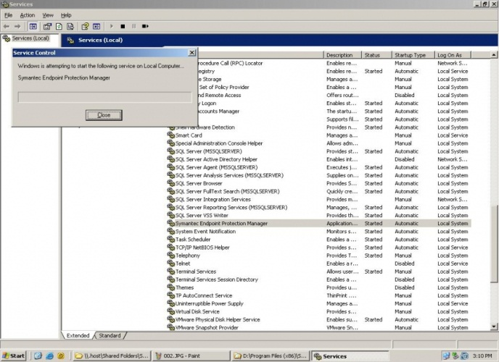

d. After completing the above steps SNAC will be enabled on your SEPM. Now you can add SNAC packages to "Client install packages". Go to Admin-->Install Packages-->Add Client install package.
browse the SNAC folder in the CD and select setup.exe file.
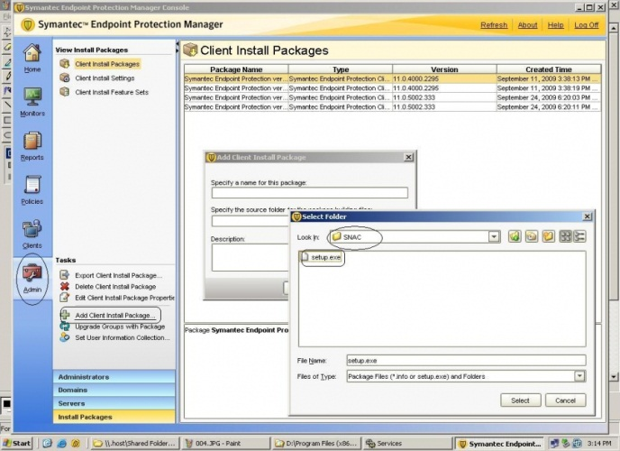
e. Same procedure can be followed for 64 bit package also. Folder name is SNACWin64.
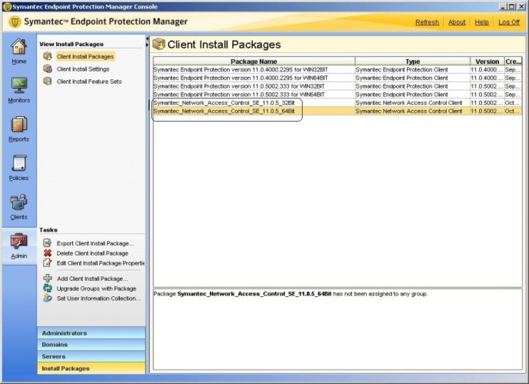

Method 2: Upgrade from CD.
a. When you put the cd "Symantec endpoint protect installation program" menu will appear. If its not coming open the CD and run setup.exe (It is there in the root directory).
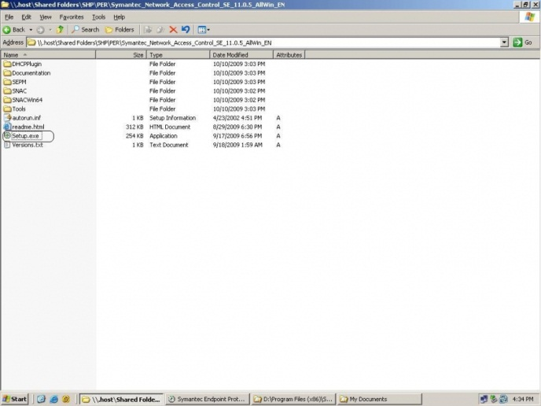
b. Select Install Symantec Network Access Control.
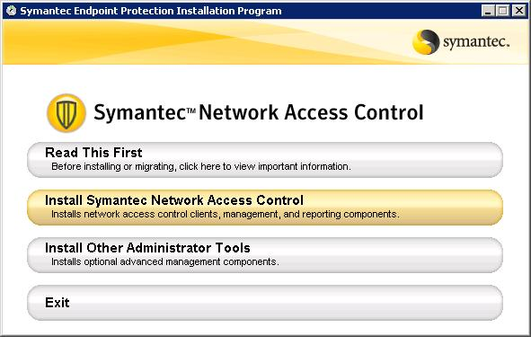
c. Select Install Symantec Endpoint protection Manger. Now it copies the License file and starts configuring SEPM.
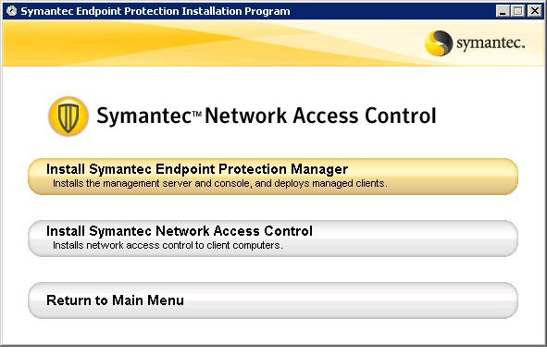
d. Once the "Management server upgrade wizard" starts click Next.
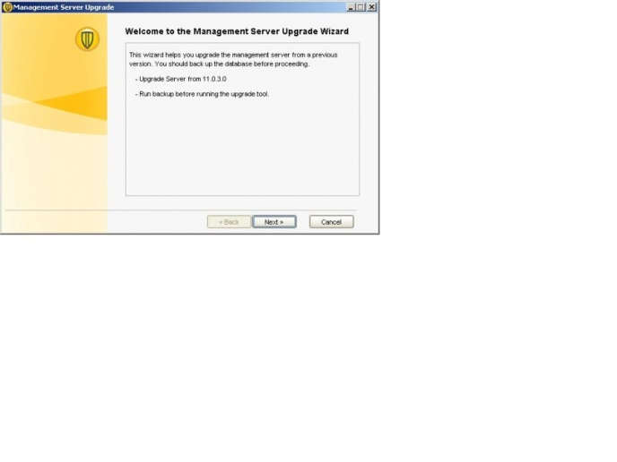
e. Once Wizard is complete click "Next" and "Finish".
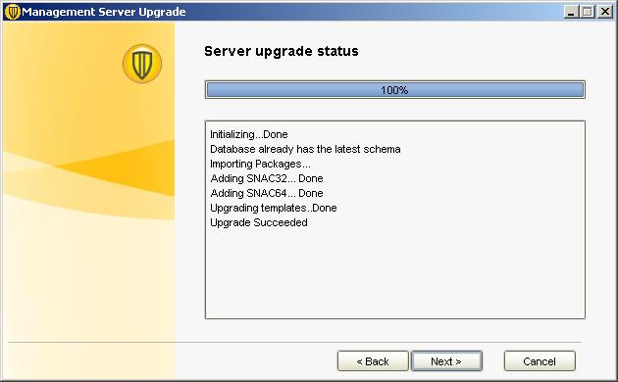
f. After the upgrade wizard SEPM configuration wizard appears.. Provide the appropriate values and complete the configuration.
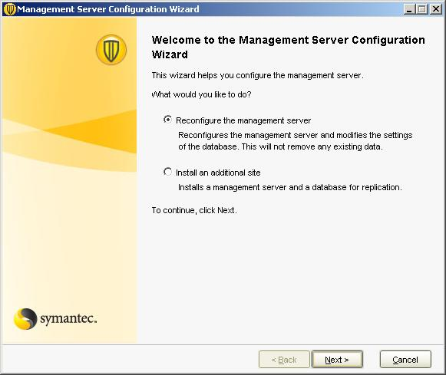
Now your SNAC installation is complete.
How to see SNAC component on SEPM and Clients:
After the installation OF SNAC "Host Integrity" policy will appear under Policies tab. Now you can modify and assign it to any group.
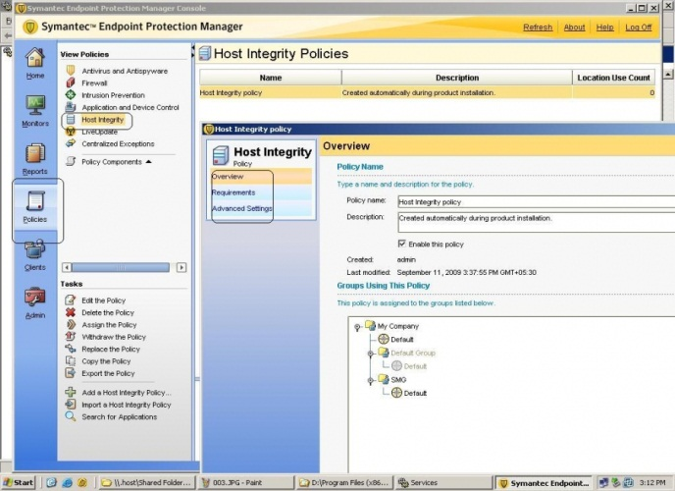
Once clients get that policy you will see Network Access Control on Client UI.
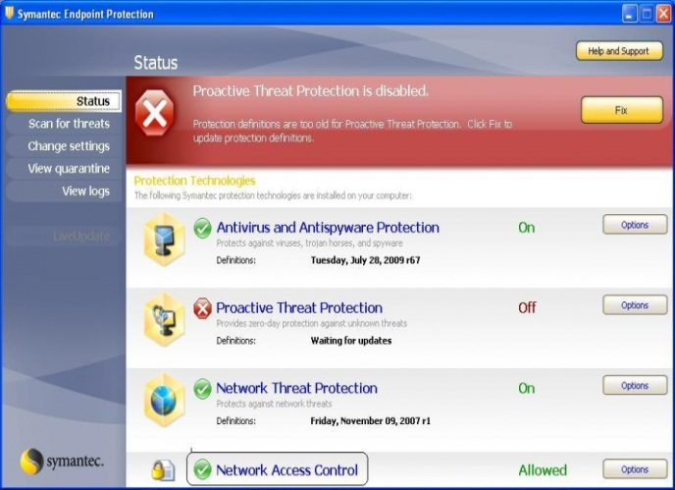
Hope this will help administrators..
In case of any correction.. please comment....

