Oracle 19c installation
- Pre-requisite (Oracle and Enforce installation on Windows OS)
  - Below steps for Two Tier (Oracle and Enforce installed on the same server) installation
  - Download Oracle and DLP Installation software
  - Extract DLP 15.8 platform files to D:\temp folder
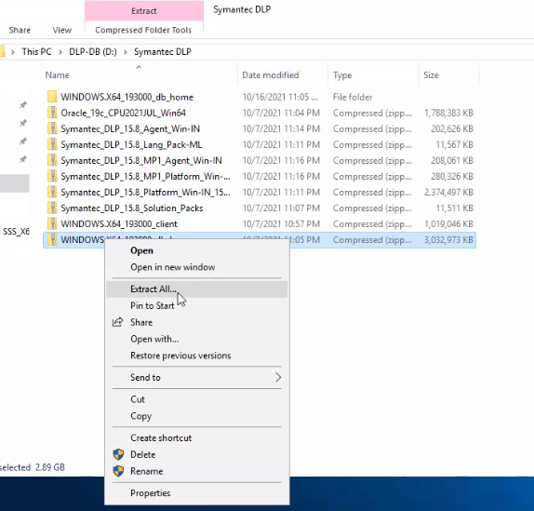

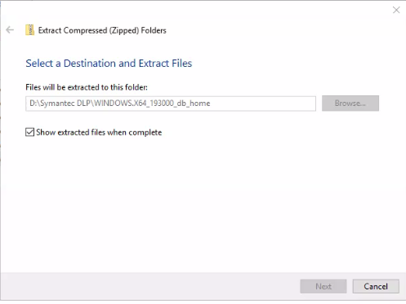

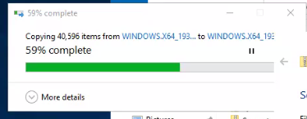
  - Prepare the Oracle installation location by completing one of the following steps based on your Oracle database installation status:
    - If you are installing the Oracle database software for the first time, complete the following steps:
      - Create the directory: D:\Oracle\product\19.3.0.0\db_1
      - Copy the Oracle 19c software file to D:\oracle\product\19.3.0.0\db_1
      - Extract the Oracle 19c software to the directory D:\oracle\product\19.3.0.0\db_1 (Wait for few minutes for the extraction process to complete).
    - Set the ORACLE_HOME environment variable by completing the following steps:
      - Go to Control Panel > System and Security > System > Advanced System Settings to display the System Properties dialog.
      - Click the Advanced tab.
      - Click Environment Variables and click New under System Variables to display the New System Variable dialog.
      - Enter ORACLE_HOME in the Variable name field.
      - Enter D:\oracle\product\19.3.0.0\db_1
      - Click New
      - Enter PATH in the Variable name field.
      - Enter D:\oracle\product\19.3.0.0\db_1 for the path variable.

- Oracle 19c Installation
  - To install the Oracle software, use the command prompt to navigate to the db_1 directory (D:\oracle\product\19.3.0.0\db_1). This is the directory where you extracted the Oracle 19c files. Run the following command (line break added for legibility):
setup.exe -noconfig –responseFile D:\Oracle\product\19.3.0.0\ db_1\tools\responsefiles\ singleinstance\Oracle_19.3.0.0_Standard_Edition_Installation_WIN.rsp
The installation wizard appears with pre-selected values that are drawn from the installation response file.

  - In Configuration Options, Select Set Up Software Only. Click Next
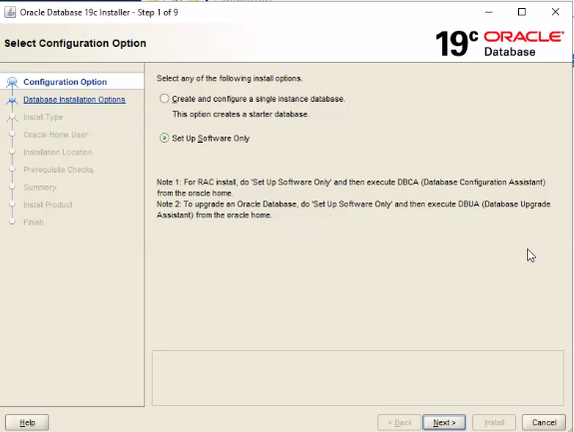

  - In Database Installation Options, select Single instance database installation and click Next.
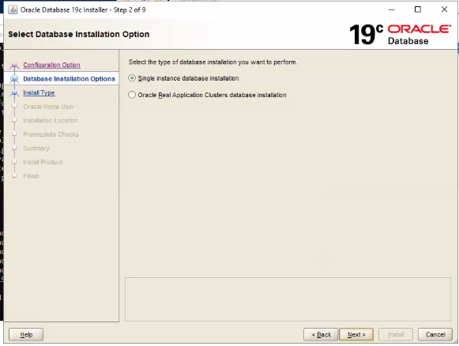

  - In Select Database Edition, select Standard Edition 2 and click Next.
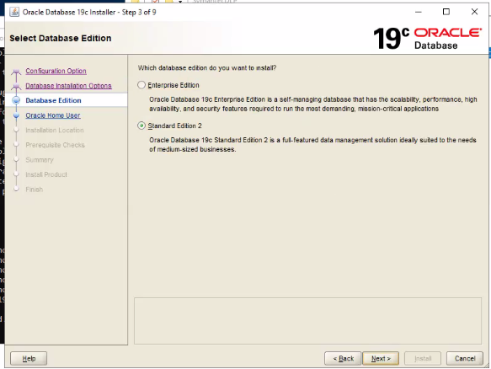

  - In Oracle Home User, Enter a user name and password for the Oracle Home User. The default name for the Oracle Home User is oracle. Click Next.
Note: The Oracle Home User is the Windows user account that runs Windows services. The Oracle Home User is different from the Symantec DLP Oracle user account.
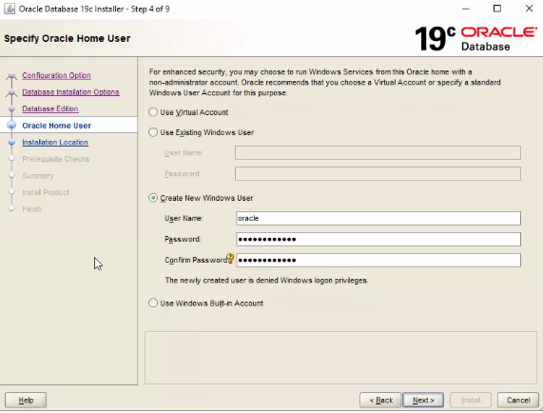
  - In Installation Location, Verify the Oracle Base and Software Location paths fields are populated with the following information and click Next.
    - Oracle Base: D:\oracle
    - Software Location: D:\oracle\product\19.3.0.0\db_1
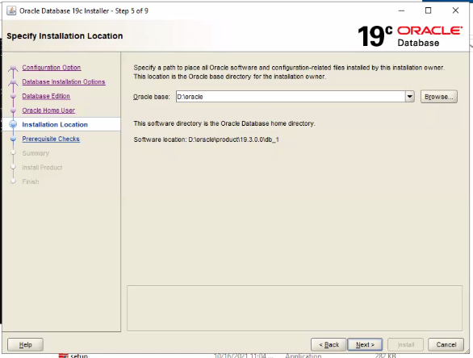

  - In Prerequisite Checks, Lists the prerequisite check status. Click Next.
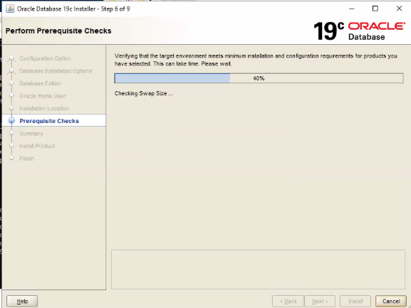

  - In Summary, verify and click Install to begin the installation. The installer application installs the Oracle 19c software to your computer.
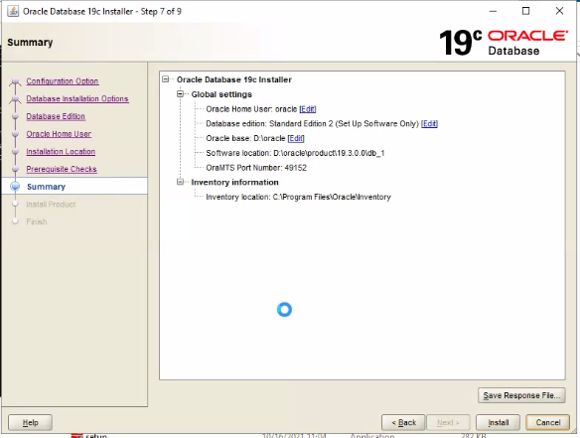
  - Wait for few minutes for the installation to complete.
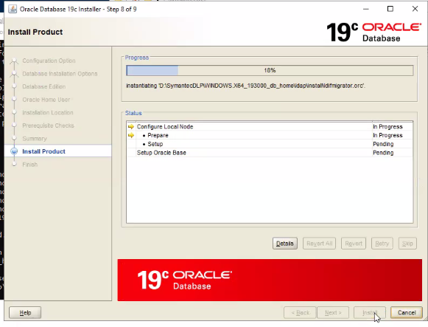

  - In Finish, click Close to exit the installer application.
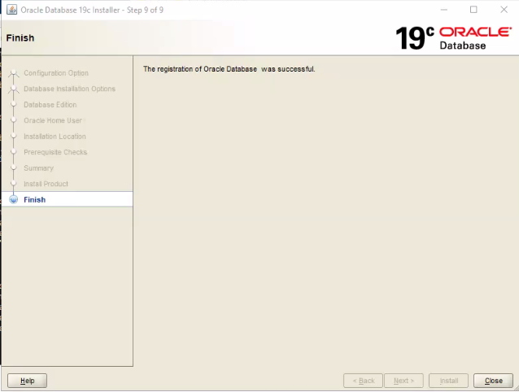

- Creation of Symantec DLP database on Windows system
  - Set the ORACLE_HOME environment variable for your new installation.
  - Open a command prompt, and enter:
set ORACLE_HOME=D:\oracle\product\19.3.0.0\db_1
  - Browse to the folder D:\Oracle\product\19.3.0.0\db_1\tools\templates\singleInstance\
  - Copy the following database files Template_for_64_bit_WIN.dbt to D:\oracle\product\19.3.0.0\db_1\assistants\dbca\templates folder
  - Via command prompt as admin, Execute the following command:
%ORACLE_HOME%\bin\dbca –createDatabase –ProgressOnly -responseFile D:\Oracle\product\19.3.0.0\db_1\tools\responsefiles\singleinstance\Oracle_19.3.0.0_DBCA_WIN.rsp
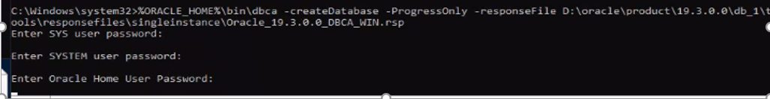
  - Enter the SYS user password at the prompt.
  - Enter the SYSTEM user password at the prompt.
  - Follow these guidelines to create acceptable passwords:
    - Passwords cannot contain more than 30 characters.
    - Passwords cannot contain double quotation marks, commas, or backslashes.
    - Avoid using the & character.
    - Passwords are case-sensitive by default. You can change the case sensitivity through an Oracle configuration setting.
    - If your password uses special characters other than _ , #, or $, or if your password begins with a number, you must enclose the password in double quotes when you configure it.
- The database creation process displays on the terminal window and can take up to few minutes to complete.
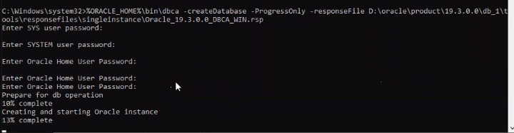

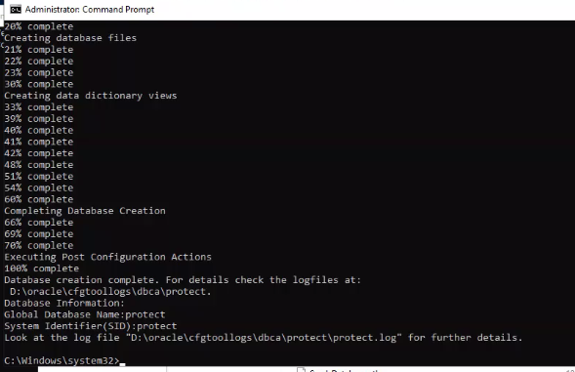

- Configuring TNS Listener and Net Service Name
Once the Oracle database is installed, configure the TNS Listener and the Net Service Name:
  - Via command prompt as admin, Start the Oracle Net Configuration Assistant by running the following command:
%ORACLE_HOME%\bin\netca
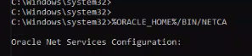

  - In Welcome, Select Listener configuration and click Next.

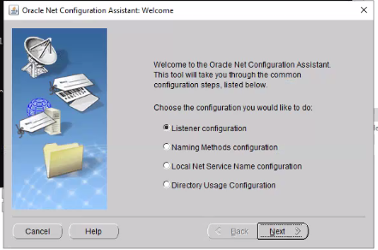

  - In Listener Configuration, Listener name. Enter a listener name and the password for your Oracle Home User, then click Next.
Note: Use the default listener name, LISTENER. Unless you must use a different name.
The Oracle Home User password. Enter the same password created during Oracle DB installation.
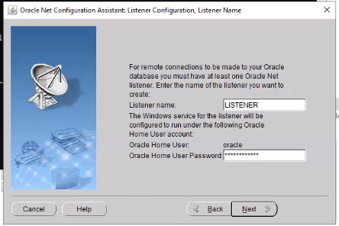

  - In Listener Configuration, Select Protocols. Selected Protocols TCP and click Next.
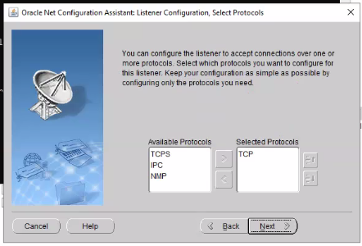

  - In Listener Configuration, TCP/IP Protocol, Select Use the standard port number of 1521 and click Next.
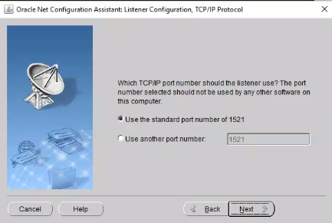

  - In Listener Configuration, More Listeners? Select No and click Next.
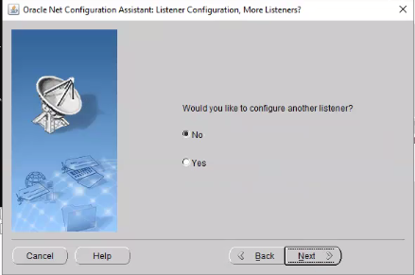

  - In Listener Configuration Done. Click Next.
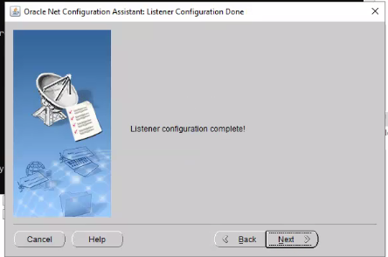

  - Configure Net service.
  - In Welcome, Select Local Net Service Name configuration and click Next.

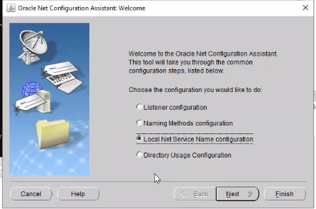

  - In Net Service Name Configuration, Select Add and click Next.
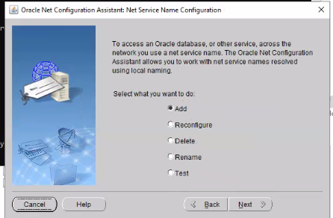

  - In Net Service Name Configuration, Service Name Enter protect in the Service Name field and click Next.
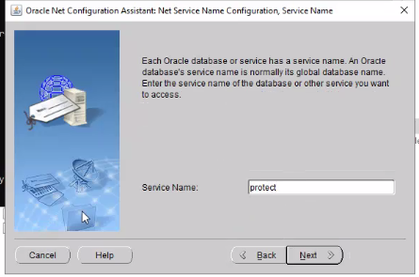
  - In Net Service Name Configuration, Select Protocols, Select TCP and click Next.
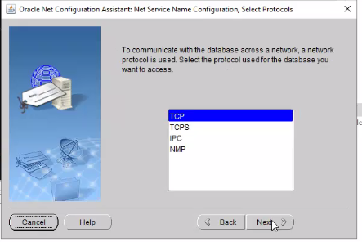

  - In Net Service Name Configuration, TCP/IP Protocol, Enter the host name / IP address of Oracle server computer in the Host name field. Select Use the standard port number of 1521 (the default value). Click Next.
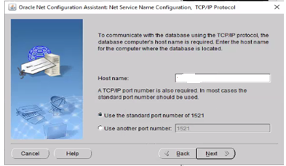

  - In Net Service Name Configuration, Test. Select No, do not test and click Next.
Do not test the service configuration, because the listener has not yet started.
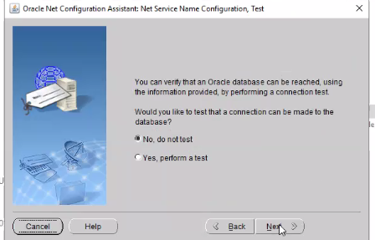

  - In Net Service Name Configuration, Net Service Name. Select and accept the default name of protect and click Next.
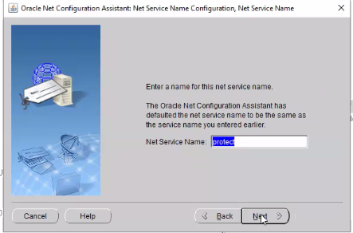

  - In Net Service Name Configuration, Another Net Service Name? Select No and click Next.
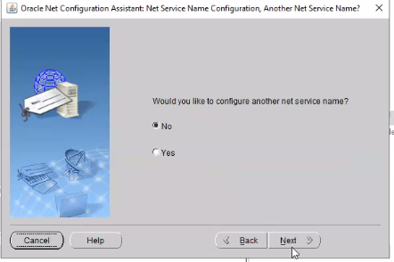

  - In Net Service Name Configuration Done. Click Next.
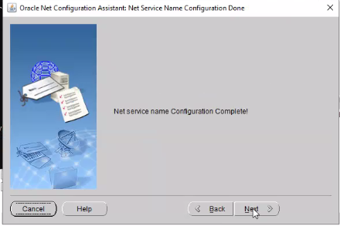

  - Click Finish.
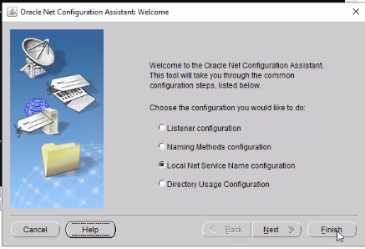

  - Modifying the listener.ora file
  - Via command prompt as an admin. Execute the following command:
lsnrctl stop
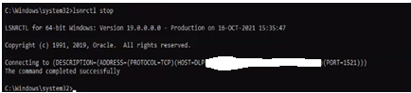

  - Open the following file in a text editor:
%ORACLE_HOME%\network\admin\listener.ora
Locate the following line: (ADDRESS = (PROTOCOL = IPC)(KEY = <key_value>)) Change <key_value> to PROTECT
Add the following line to the end of the file: SECURE_REGISTER_LISTENER = (IPC)
Save the file and close the text editor.
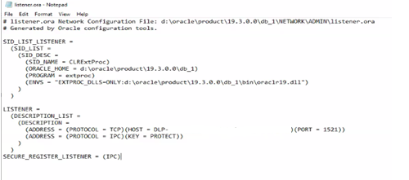

  - Via command prompt as an admin. Execute the following command:
lsnrctl start
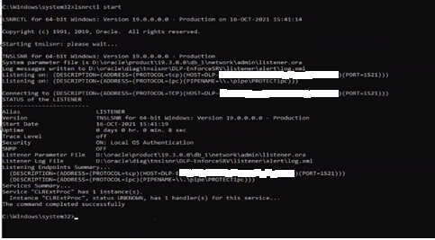

  - Via command prompt as an admin. Run the following command to connect to the database using SQL*Plus:
sqlplus sys/<password> as sysdba
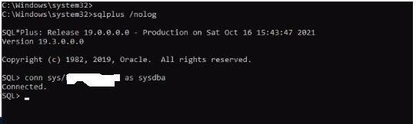

  - Once connected, Run the following command:
ALTER SYSTEM SET local_listener = '(DESCRIPTION=(ADDRESS=(PROTOCOL=ipc)(KEY=PROTECT)))' SCOPE=both;
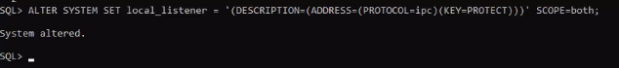

  - Run the following command to register the listener:
ALTER SYSTEM REGISTER;
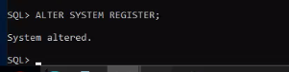

  - Exit SQL*Plus by running the following command:
exit
  - Run the following command to verify the change:
lsnrctl services
The command output will display the below message.
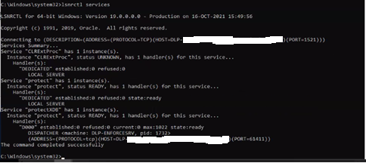

- Creation of an Oracle user account and name
  - Via command prompt as an admin. Browse to the folder D:\Oracle\product\19.3.0.0\db_1\tools
  - Run the following command using SQL*Plus to run the oracle_create_user.sql script:
sqlplus /nolog @oracle_create_user.sql

  - Please enter the password for sys user prompt, enter the password for the SYS user.
  - Please enter Oracle service name prompt, enter protect
  - Please enter required username to be created prompt, enter protect for the user name
  - Please enter a password for the new username prompt, enter password for the username protect
  - Enter
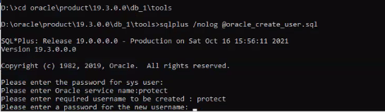

  - Follow these guidelines to create acceptable passwords:
    - Passwords cannot contain more than 30 characters.
    - Passwords cannot contain double quotation marks, commas, or backslashes.
    - Avoid using the & character.
    - Passwords are case-sensitive by default. You can change the case sensitivity through an Oracle configuration setting.
    - If your password uses special characters other than _, #, or $, or if your password begins with a number, you must enclose the password in double quotes when you configure it.
  - New user protect will be created with the required permissions
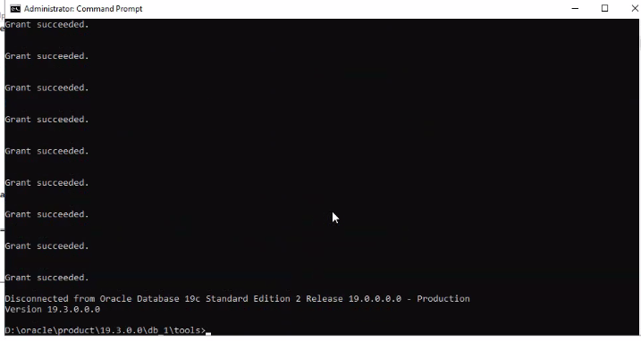

  - Confirm tablespaces are available for the Oracle user protect created by running the following SQL*Plus commands in the listed order:
sqlplus protect/<password>@protect
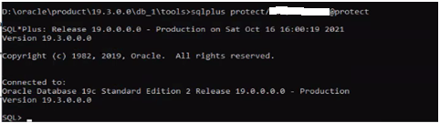

SELECT tablespace_name FROM user_tablespaces;
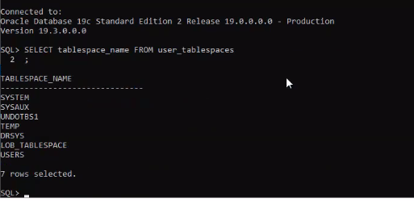
  - Exit SQL*Plus by running the following command:
Exit

- Verifying Symantec Data Loss Prevention database
  - After you create the Symantec DLP database, verify that it was created correctly.
  - Open a new command prompt as an admin. Start SQL*Plus, and log on as SYS user
sqlplus sys/<password>@protect as sysdba

  - Run the following query
SELECT BANNER_FULL FROM v$version;
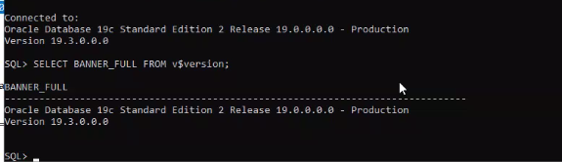
  - Verify the output from the query contains information that correctly identifies the software components for the installed version of Oracle 19c.

