AIM
The provisioning directory is configured with no access controls: if you can BIND, you can modify anything. The only accounts available with access are the built-in accounts used by the Provisioning components (Servers) to update the Directory.

However it is useful to use other (shared) accounts to access the Provisioning Directory:
- Do NOT use the built-in accounts
- Use shared accounts whose password can be changed
- Use a read-only account for investigation
- Only use an account with modify access when appropriate

HOW
Create 2 new accounts (these are shared accounts):
- DSAWrite
- DSAReadOnly
Change configuration of ALL provisioning DSAs or routers, so these now have access controls:
- Current built-in accounts (there are 2) still have access
- These 2 new accounts have appropriate access

IMPACT on service
No services need to be stopped during this change. The time taken to re-initialise each service is very small.

STEPS to enable access controls

Summary
These are the steps:
- Step 1: Create 2 shared accounts – DSAReadOnly, DSAWrite
- Step 2: Copy new file to define access-controls to all DSA servers
- Step 3: Cause Directory servers to use the new configuration
- Step 4: Check access controls

Step 1: Create 2 shared accounts
This is done ONLY ONCE:
- The accounts are in the “common” area, and so apply to all Provisioning Directories
- If using High Availability: multi-write will update all DSAs

Step | Details
LDAP browser: Logon to imps-router | Using JXplorer (or similar)  Connect as follows:  - Host: <ip-address of server>  - Port: 20391  - Protocol: LDAP v3  - Level: User+Password  - User: eTDSAContainerName=DSAs,eTNamespaceName=CommonObjects,dc=etadb  - Password: as defined when installed
Prepare LDIF file | In Appendix is a sample LDIF file.  Edit this (reset the passwords), and save locally (so the LDAPbrowser can find the file)
Import LDIF | This will create the 2 users  In JXplorer this is done as follows:  - MENU: LDIF – Import File  - Browse to and select the file you just saved  - Press OPEN
Check accounts exist | Expand the Tree (eTNamespaceName=CommonObjects,dc=etadb)  The 2 new accounts will now exist:  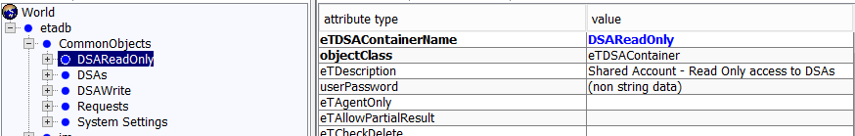

Step 2: Copy new file to define access-controls to all DSA servers
This must be done an ALL appropriate servers:
- Those running the provisioning-directory DSAs
- Provisioning Servers, which are running the routers

Step | Details
Save file on server | The file is given in the appendix. It is named impd.dxc.access  Copy the file to this path:  <Directory-home>\dxserver\config\access
Rename files so new one is used | In folder <Directory-home>\dxserver\config\access  Rename file: impd.dxc  To: impd.dxc.orig  Copy file: impd.dxc.access  And rename copy as: impd.dxc

Step 3: Cause Directory servers to use the new configuration
This must be done an ALL appropriate servers:
- Those running the provisioning-directory DSAs
- Provisioning Servers, which are running the routers

Step | Details
Logon to server | RDP, using your sys account
Run init command | Run this command:  dxserver init all  NOTE: this will cause all DSAs on this server to read the (changed) config files and now apply the access controls.  EXAMPLE:  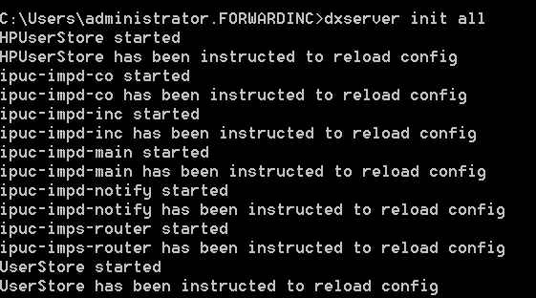

Step 4: Check access controls
It may be enough to do this only on the Provisioning Servers (allowing router to implicitly check other servers).

However, it is safest to do this check on every DSA.
- Those running the provisioning-directory DSAs (4 DSAs on each)
- Provisioning Servers, which are running the routers

Check built-in and new accounts work
Step | Details
Open LDAP browser | Using JXplorer (or similar)
CHECK 1: built-in still works | Connect as follows:  - Host: <ip-address of server>  - Port: <as defined for DSA service>  - Protocol: LDAP v3  - Level: User+Password  - User: eTDSAContainerName=DSAs,  - eTNamespaceName=CommonObjects,dc=etadb  - Password: as defined when installed  Perform tests (connect – read – update)
CHECK 2: DSAWrite works | Connect as follows:  - Host: <ip-address of server>  - Port: <as defined for DSA service>  - Protocol: LDAP v3  - Level: User+Password  - User: eTDSAContainerName=DSAWrite,  - eTNamespaceName=CommonObjects,dc=etadb  - Password: as defined when installed  Perform tests (connect – read – update)
CHECK 3: DSAReadOnly works | Connect as follows:  - Host: <ip-address of server>  - Port: <as defined for DSA service>  - Protocol: LDAP v3  - Level: User+Password  - User: eTDSAContainerName=DSAReadOnly,  - eTNamespaceName=CommonObjects,dc=etadb  - Password: as set on this user  Perform tests (connect – read – No able to update)

TESTS to be performed
These should be done against EVERY DSA on each appropriate server.
These are as follows:
Step | Details
Connect test | Can connect – and then see Provisioning Directory data: example:  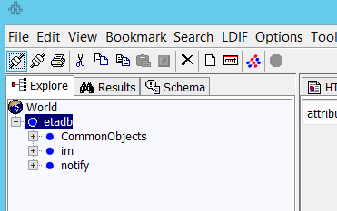
Read Test | Try reading the new accounts: Example:  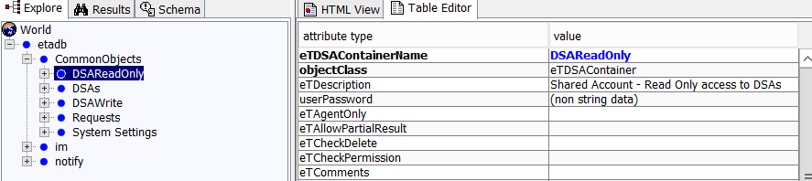
Update Test | Try updating one of the new accounts:  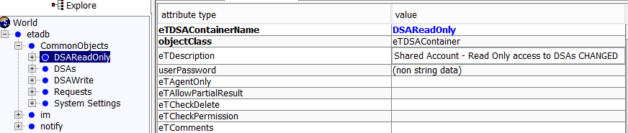  In this case:  - Changed the description  - Press SUBMIT (update the LDAP)  - View account again – check change has been applied
Update Test  (insufficient rights) | When using account DSAReadOnly and submitting an update,  you should get this error:  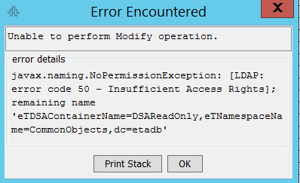

Complete Set of Tests (When using High-Availability)
If using 4 Provisioning Servers and 4 Directory Servers: all these tests will be needed:

Server  Type | DSA | Check 1  Built-in | Check 2  DSAReadOnly | Check3  DSAWrite
Provisioning 1 | Router
Provisioning 2 | Router
Provisioning 3 | Router
Provisioning 4 | Router
Directory 1 | co
 | inc
 | main
 | notify
Directory 2 | co
 | inc
 | main
 | notify
Directory 3 | co
 | inc
 | main
 | notify
Directory 4 | co
 | inc
 | main
 | notify

Appendices

Appendix: LDIF file for 2 new users
version: 1
DN: eTDSAContainerName=DSAReadOnly,eTNamespaceName=CommonObjects,dc=etadb
objectClass: eTDSAContainer
eTDescription: Shared Account - Read Only access to DSAs
eTDSAContainerName: DSAReadOnly
userPassword: changeit

DN: eTDSAContainerName=DSAWrite,eTNamespaceName=CommonObjects,dc=etadb
objectClass: eTDSAContainer
eTDescription: Shared Account - Write access to DSAs
eTDSAContainerName: DSAWrite
userPassword: changeit

Appendix: access file: impd.dxc.access
# CA Directory DXserver/config/access

# static access controls
set access-controls = true;

# dynamic access controls
set dynamic-access-control = false;

#
set super-user DSAs = {
user = <dc "etadb"><eTNamespaceName "CommonObjects"><eTDSAContainerName "DSAs">
};
set super-user DSAs = {
user = <dc "etadb"><dc "im"><eTNamespaceName "CommonObjects"><eTDSAContainerName "DSAs">
};
set super-user DSAWrite = {
user = <dc "etadb"><eTNamespaceName "CommonObjects"><eTDSAContainerName "DSAWrite">
};
set reg-user DSAReadOnly = {
user = <dc "etadb"><eTNamespaceName "CommonObjects"><eTDSAContainerName "DSAReadOnly">
subtree = <dc "etadb">
perms = read
};

